
STAFF-TEACHER HANDBOOK
A.Y. 2025-2026





OA - VISION AND MISSION
AY 2025 - 2026

Vision
Empowering learners to achieve their full potential globally with National and Islamic values.

الرؤية
تمكين المتعلمين من تحقيق إمكاناتهم الكاملة عالميًا مع القيم الوطنية الإسلامية.

Mission
Delivering quality education that builds globally competent learners who actively contribute to a diverse community with Islamic identity.

الرسالة
تقديم تعليم عالي الجودة يُنمّي متعلمين ذوي كفاءة عالمية يساهمون بنشاط في مجتمع متنوع، بهوية إسلامية.

Priorities for Academic Year 2025-2026
  - Promote student’s personal development, behavior, and welfare in a safe environment.
تعزيزالتنمية الشخصية و السلوك الايجابي للطالب في بيئة آمنة .
  - Enhance students’ higher-order thinking skills and promote independent learning through the use of diversified, student-centered learning strategies.
تحسين مهارات التفكير العليا للطلبة بإستخدامإستراتيجيات التعلم المتنوعة .
  - Improve students’ Arabic and English skills in reading and writing.
تطوير مهارات الطلاب في القراءة والكتابة للغتين العربية والانجليزية.
4. Promote Qatar Identity among students, teachers and visitors.
تعزيز الهوية القطرية بين الطلبة و المعلم

Our Values:
Kindness | اللطف | Leadership | القياد
Honest | الأمانة | Truth | الصدق
Responsibility | المسؤولية | Friendship | الصداقة
Mercy | الرحمة | Respect | الإحترام
Loyalty | الوفاء | Cooperate | التعاون

SCHOOLWIDE LEARNER’S OUTCOME (SLOs)!!!

“Today a Reader, Tomorrow a Leader…”

Academics  الأكاديميون | Leaders  القادة | Islamic Values  القيم الإسلامية
They are lifelong learners. | They are responsible. | They adhere to Islamic values and practices.
هم متعلمون مدى الحياة. | هم مسؤولون. | يلتزمون بالقيم والممارسات الإسلامية.
They are critical thinkers and creative problem solvers. | They are decision makers. | They have good morals.
هم مفكرون ناقدون ومبدعون في حل المشكلات. | هم صانعو قرارات. | يمتلكون أخلاقاً حسنة.
They are motivated achievers striving for their full potential. | They are role models. | They are respectful.
هم طلاب طموحون يسعون لتحقيق أقصى إمكاناتهم. | هم قدوة للآخرين. | محترمون.
They are bilingual. | They are active members of the community. | They are truthful.
هم متعددو اللغات / يجيدون لغتين. | هم أعضاء فاعلون في المجتمع. | صادقون.
They are independent. | They are environmentally friendly. | They are polite.
هم مستقلون. | هم صديقون للبيئة. | مهذبون.
They are confident. | They are cooperative.
هم واثقون من أنفسهم. | هم متعاونون.

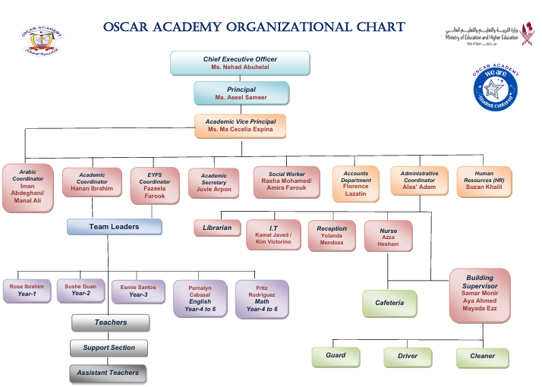


Qatar National Vision (QNV) 2030

Sustainable Development Goals in this Handbook
- Goal 3: Good Health and Well-being
- Goal 4: Quality Education
- Goal 5: Gender Equality
- Goal 6: Clean Water and Sanitation
- Goal 8: Decent Work and Economic Growth



- Goal 16: Peace, Justice, and Strong Institution

TABLE OF CONTENTS
- Academy Vision & Strategy
  - Oscar Academy Mission & Vision
  - Oscar Academy Learner’s Outcome
  - Qatar National Vision (QNV) 2030
  - Oscar Academy Organizational Chart
- Governance and Board
  - Governing Board Policy
  - Code of Ethics (MOEHE)
  - Monitoring And Evaluation Policy (Quality Assurance)
  - Child Protection Policy
- Academic Programs and Curriculum / Others
  - Curriculum Description for Oscar Academy
  - Curriculum and Extra-Curricular Activity (ECA) Policy
  - Curriculum Observation Policy and Guidelines
  - Online Teaching Policy (Class Dojo)
  - Educational Resources Policy
  - Examination Policy (Assessment Policy)
  - Substitution Policy
  - Weekly Planner Policy and Guidelines
  - Student’s Monthly Progress Report Policy
  - Entrance Test / Diagnostic Examination
  - Class Portfolio
  - After Class Club Policy
  - Morning Assembly
  - Prayer Time
  - Storage of Exam Papers Policy
- Staff Employment and HR Policies
  - Staff Recruitment & Safer Recruitment Policy
  - Attendance & Leave Policy
  - Resignation / Termination Procedures
  - Staff Benefits Policy
  - Staff Appraisal Policy
  - Teacher Evaluation and Performance Appraisal
  - Employee of the Month
  - Professional Development Policy
  - Internal Communication Policy
  - Microsoft Teams Usage Policy (For Staff Use Only)
  - Request Policy
  - Staff Related to Each Other Policy
  - Staff Social Media Policy
  - Warning And Disciplinary Policy
- Discipline, Conduct, and Safety
  - Gift and Donation Policy
  - Accident & One-on-One Situations Policy
  - Alone Working or Late Stay Policy
  - Duty Policy
  - Fire Control and Pumping Room Policy
  - Health and Safety Policy
  - Incident Report Policy
  - Cleaning Supplies Policies
  - Housekeeping
  - Parent’s Complaint Policy
- Technology and Data Policies
  - Computer Laboratory Guidelines & Policies
  - Cyber Security and Data Protection Policy
  - Closed-Circuit Television (CCTV) Policy
  - School Policy on Internet Firewall and Usage
  - Policy for Using Technology (iPads) in School
  - Shared Folder Policy
- Operations and Facility Management
  - Repair & Maintenance Procedure and Policy
  - Science Lab Policy
  - After School Club Guidelines & Policy
  - Canteen Policy & Procedure
  - Photocopy Policy
  - Library Policy
  - Gym Rules
  - Staff Room Rules Policy
  - School Clinic Policy
  - Financial Affairs Policy
  - Class Portfolio Guidelines and Policy
- Cultural and National Identity
  - Policy for Promoting Qatar National Identities
  - Qatar National School Accreditation (QNSA) Policy

2. GOVERNANCE BOARD

GOVERNING BOARD POLICY
GOVERNING BOARD POLICY Oscar Academy – Governing Body Policy

Aims:
Oscar Academy recognizes the vital role of its Governing Body in ensuring effective leadership, accountability, and continuous improvement across all aspects of school management. The Governing Body is responsible for setting the strategic direction of the academy, upholding its mission and vision, and ensuring that all operations align with Qatar’s educational standards and regulations.
Members of the Governing Body serve voluntarily and are expected to act with integrity, professionalism, and commitment to the academy’s goals, while prioritizing the safety, welfare, and holistic development of every student.

- To provide strategic leadership and direction for Oscar Academy.
- To ensure accountability for academic performance, operational effectiveness, and student well-being.
- To promote safeguarding and uphold child protection standards in all aspects of school operations.
- To support continuous improvement and holistic development of all learners.
- To engage effectively with parents, staff, and the wider community to promote transparency and trust.

Composition of the Governing Body
The Governing Body of Oscar Academy is composed of:
- Chief Executive Officer (CEO) / Chairperson
- Principal / Vice Chairperson
- Two (2) Vice Chairs
- One (1) Member – Assistant Vice Principals (AVP)
- One (1) Member – Board of Trustees/ BOT

Roles and Responsibilities
Area | Roles and Responsibilities | Responsible Members
Strategic Direction | Set the school’s mission, vision, and goals; approve strategic plans; monitor progress toward objectives. | Chairperson, Principal, Academic Head
Accountability | Hold the Principal and leadership team accountable for academic outcomes, financial management, safeguarding, and operational effectiveness. | Governing Body Members, Principal
Policy and Decision-Making | Review and approve key policies related to academics, administration, child protection, and student welfare. | Governing Body, Principal, Admin Representative
Monitoring and Evaluation | Evaluate school performance, teaching quality, and improvement initiatives through reports, audits, and regular reviews. | Principal, Academic Head, Quality Assurance Team
Safeguarding and Child Protection | Ensure robust safeguarding and child protection measures are in place, reviewed regularly, and embedded in school culture. Appoint a Designated Safeguarding Lead (DSL) to oversee implementation. | Chairperson, Principal, DSL, Governing Members
Stakeholder Engagement | Maintain open communication with parents, staff, and the community to ensure inclusivity and transparency in decision-making. | Parent Representatives, Community Members
Continuous Improvement | Participate in governance training, self-assessment, and review processes to enhance leadership capacity and school effectiveness. | All Governing Body Members

Safeguarding and Child Protection Commitment
The Governing Body affirms its duty to safeguard and promote the welfare of all students at Oscar Academy. It ensures:
- Compliance with Qatar’s child protection regulations and international best practices.
- That all staff receive regular safeguarding training.
- Immediate and appropriate response to any concerns, following the school’s Child Protection and Safeguarding Policy.
- A safe, supportive environment where students feel valued and protected.

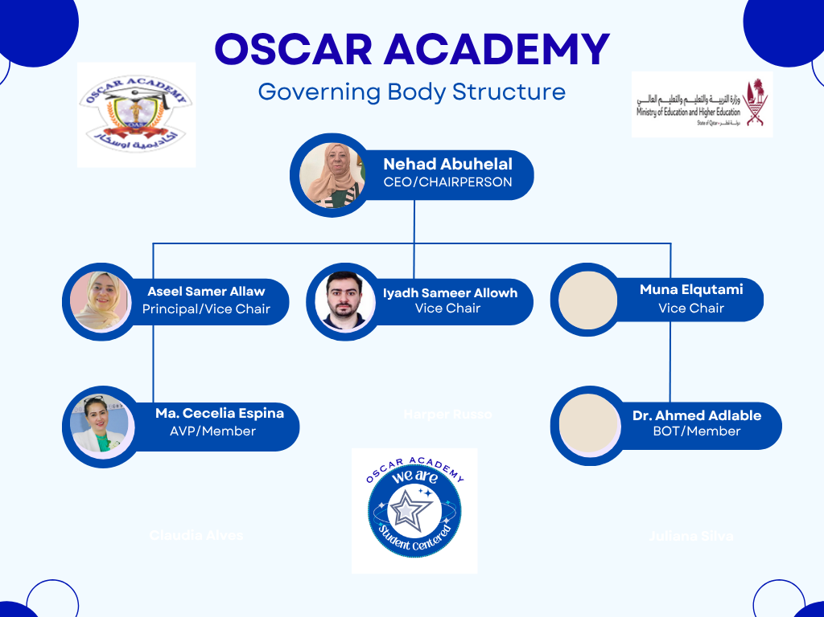

CODE OF ETHICS (MOEHE)
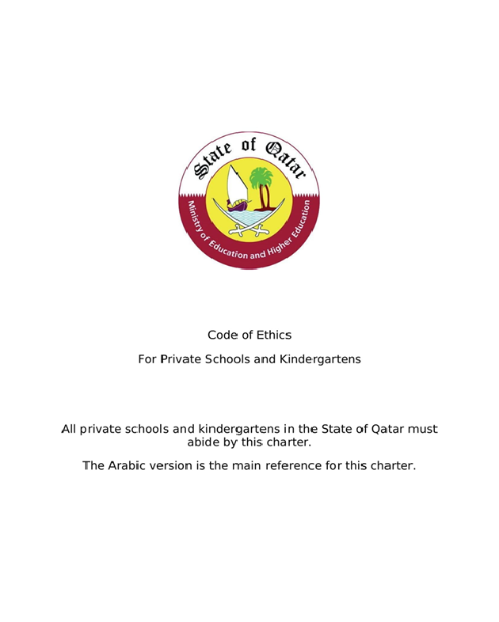

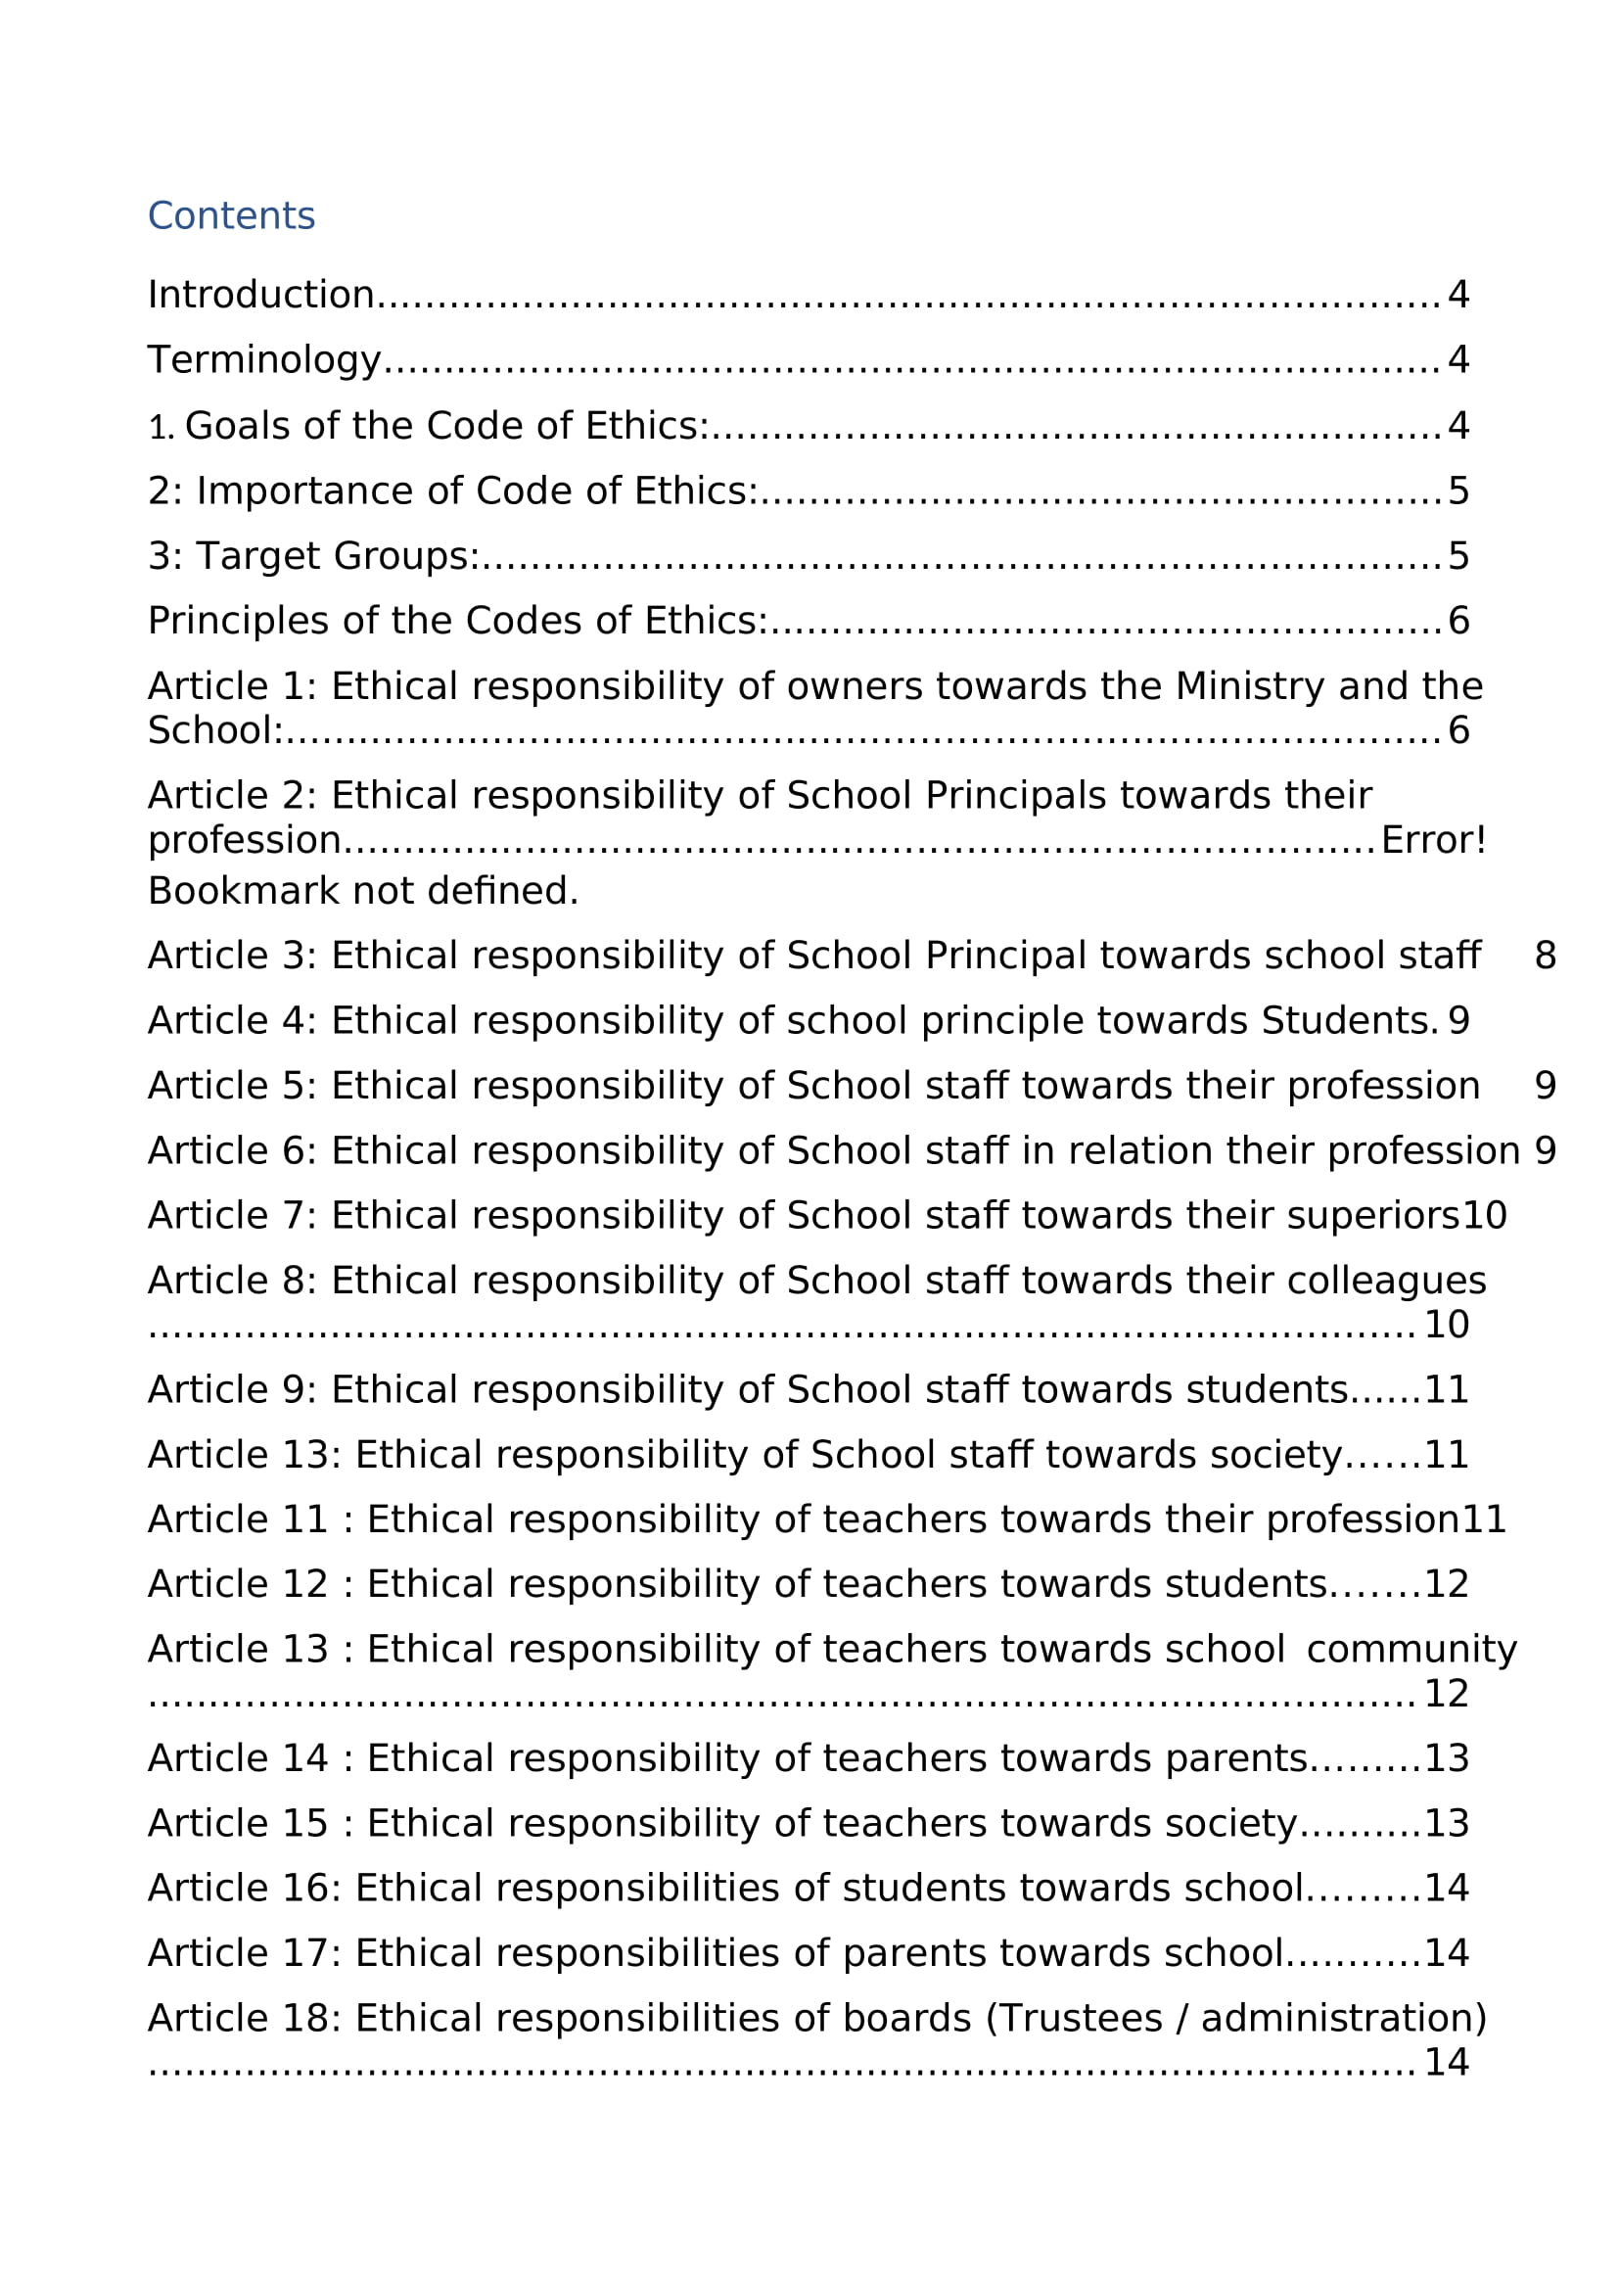
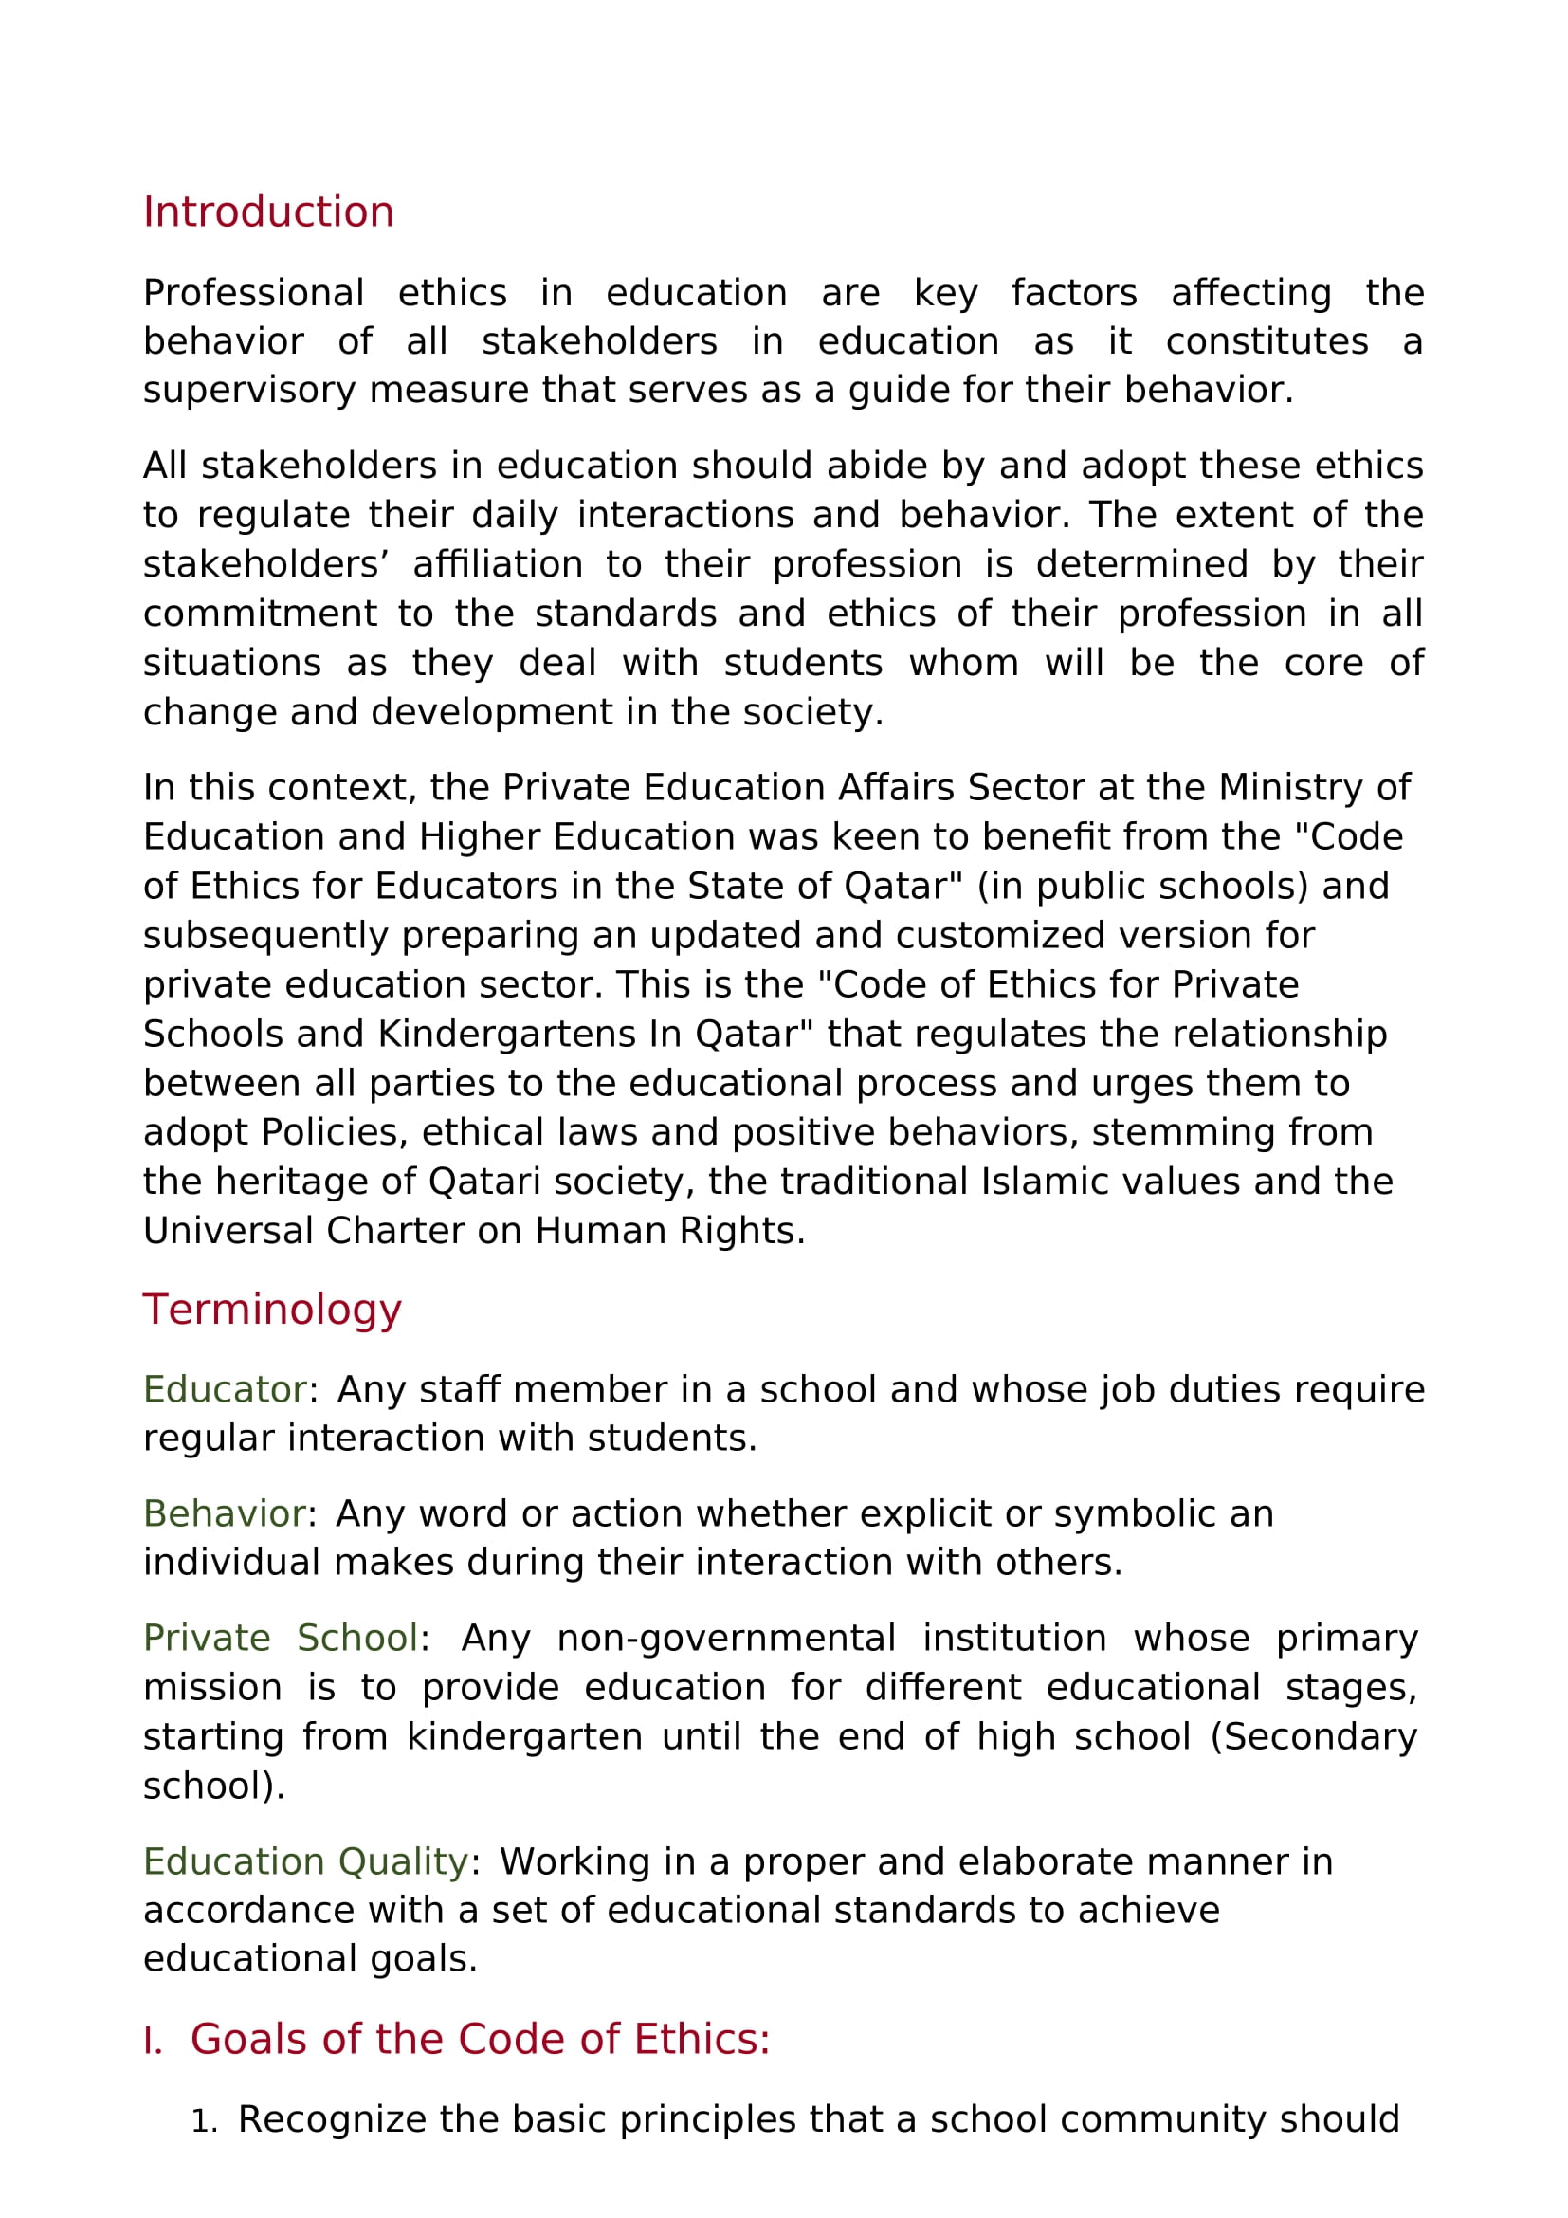
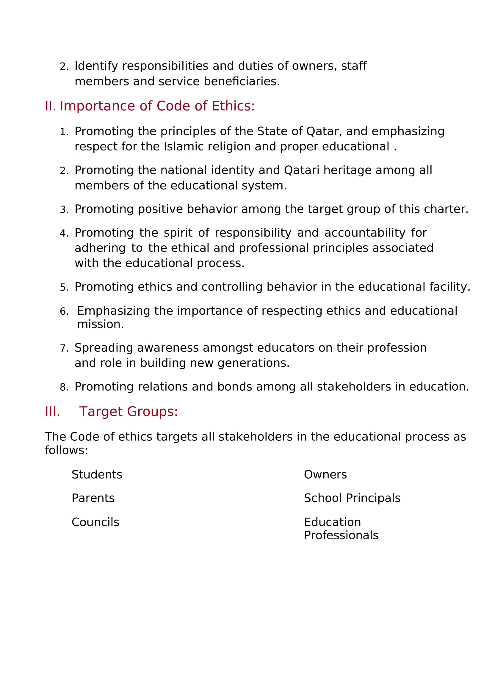
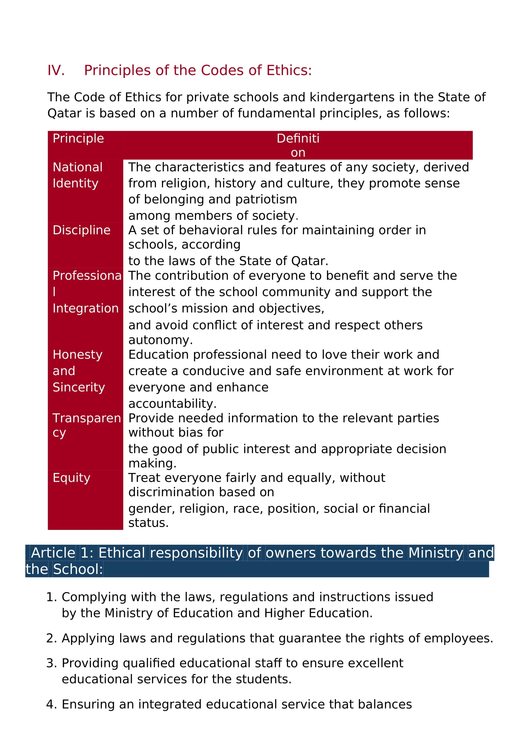
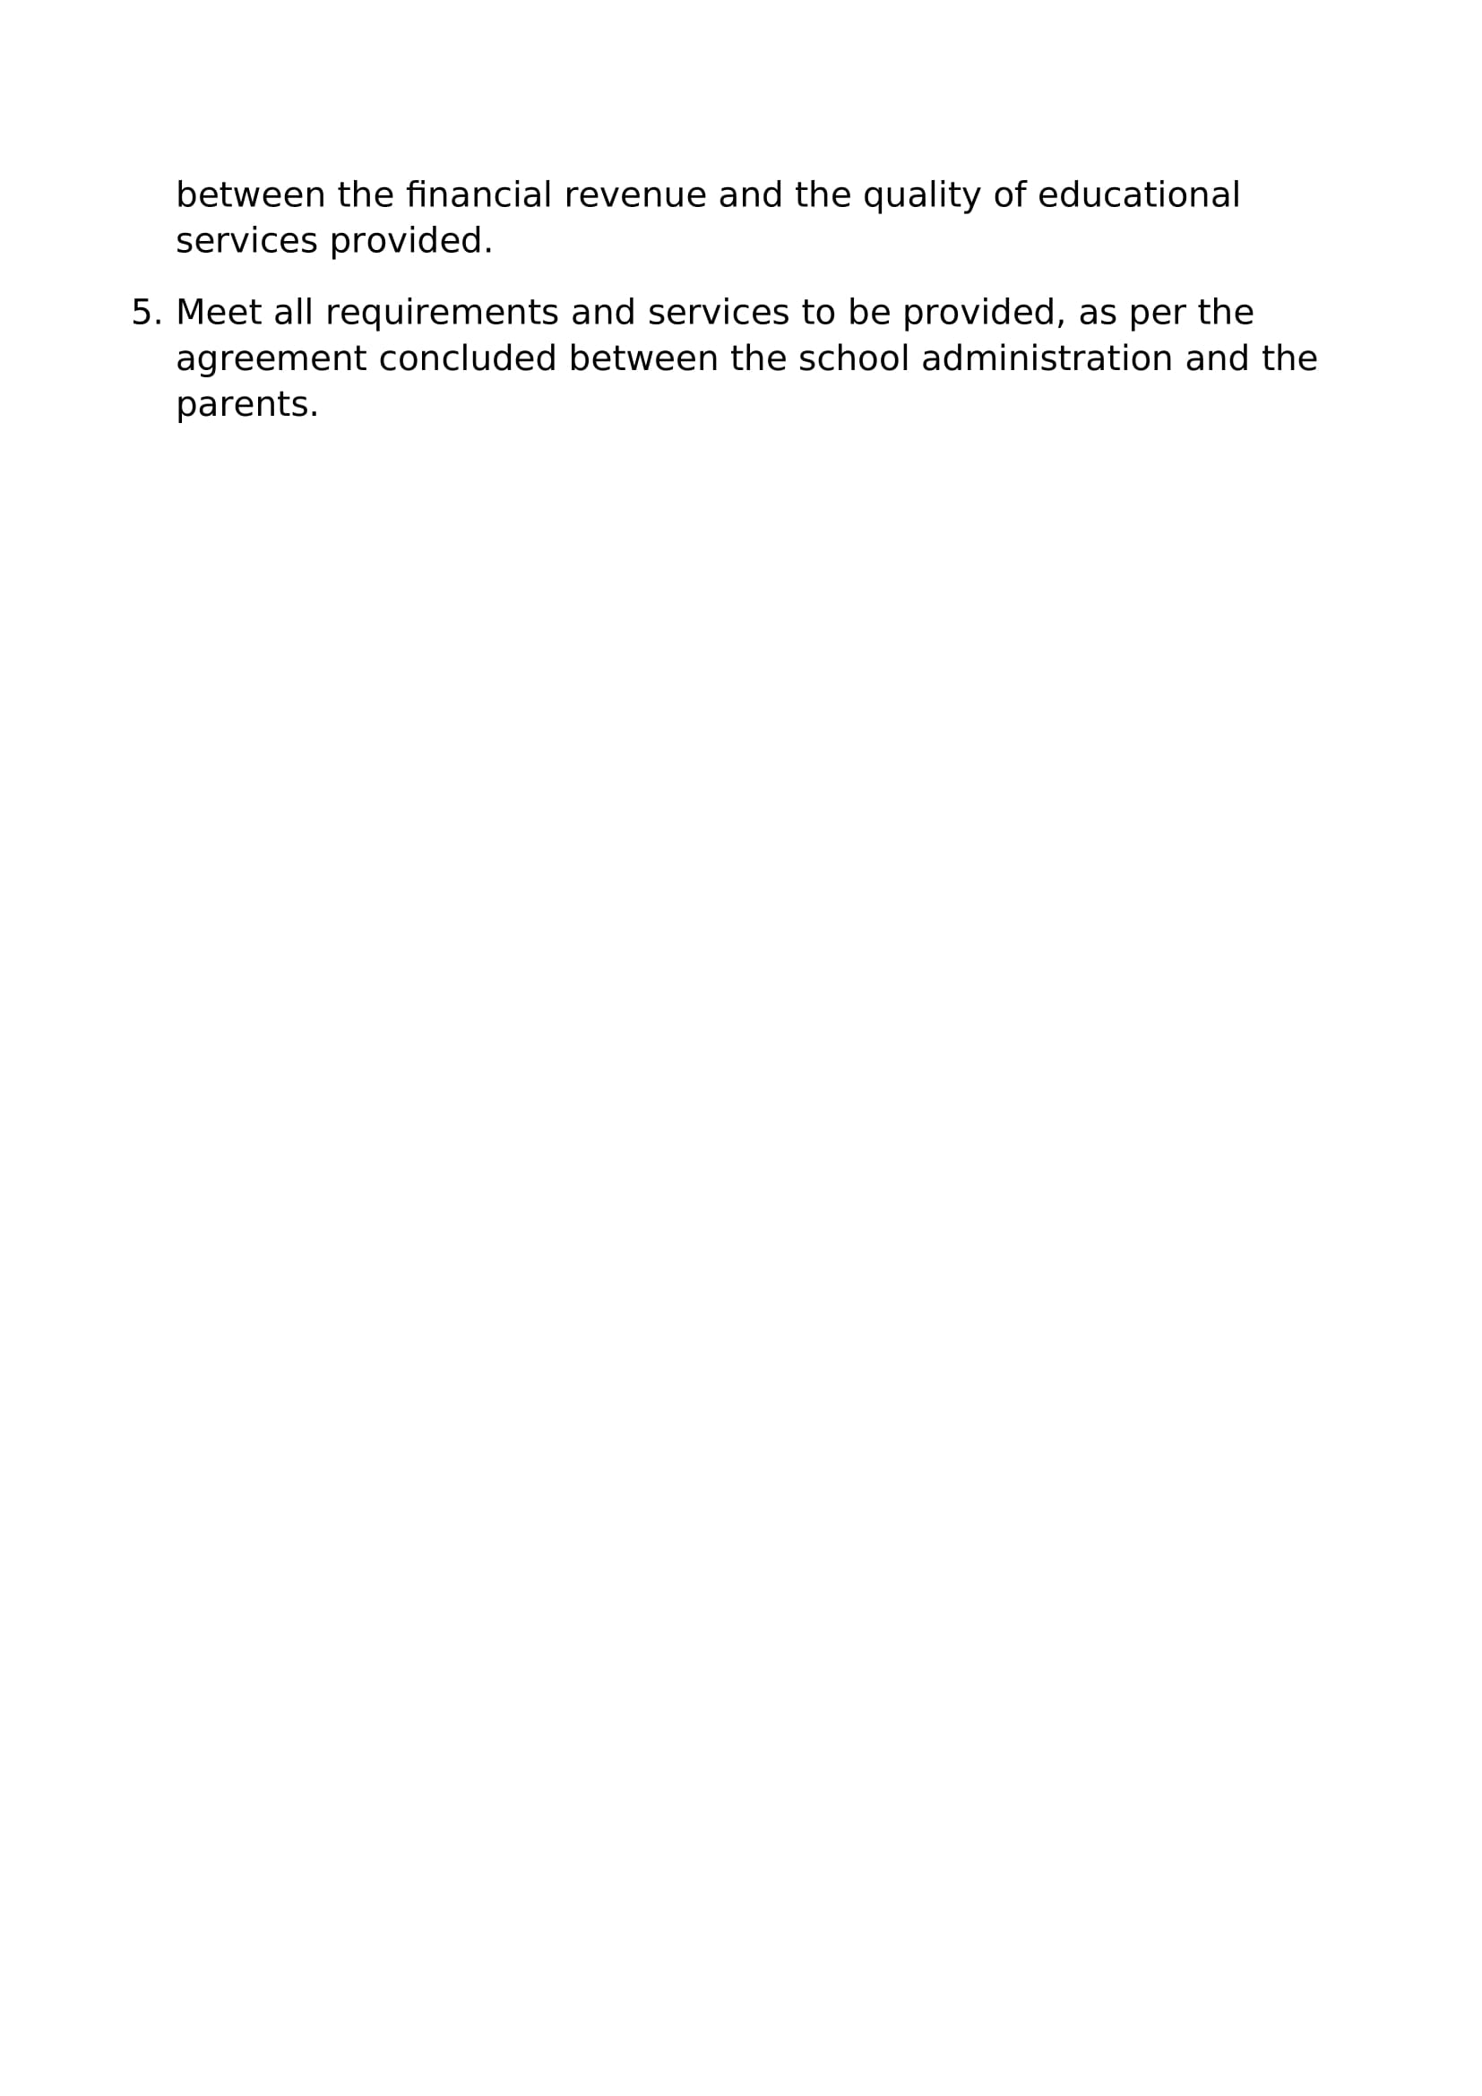

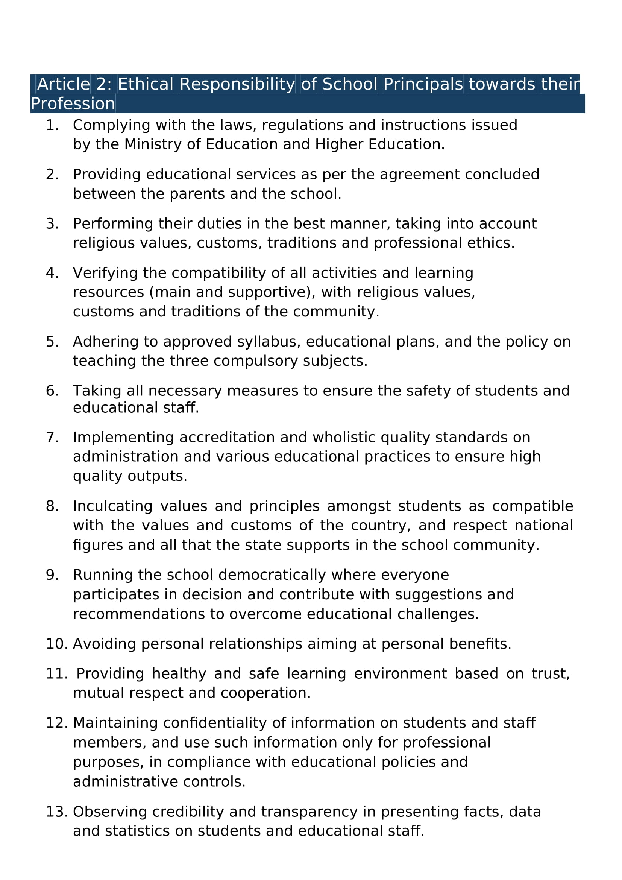
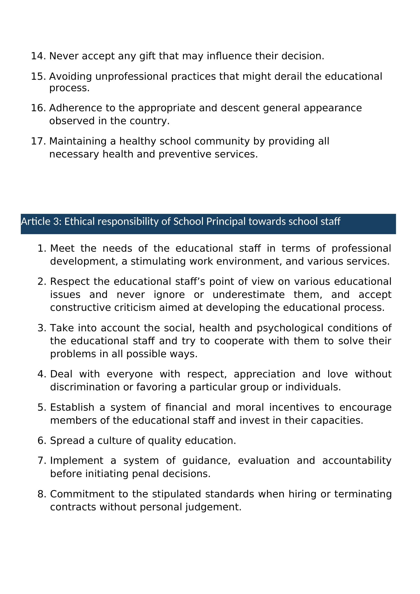
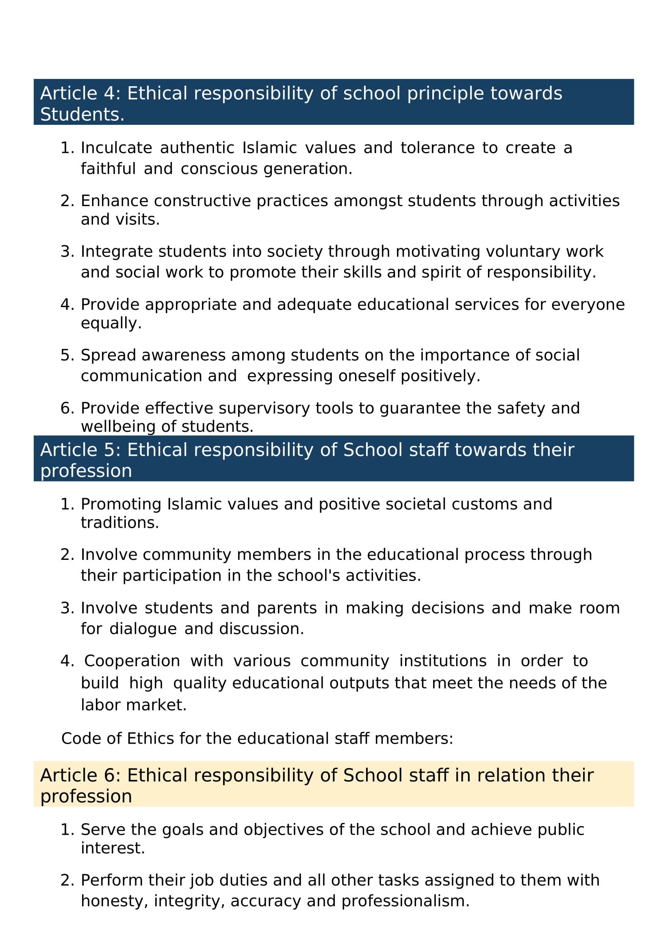
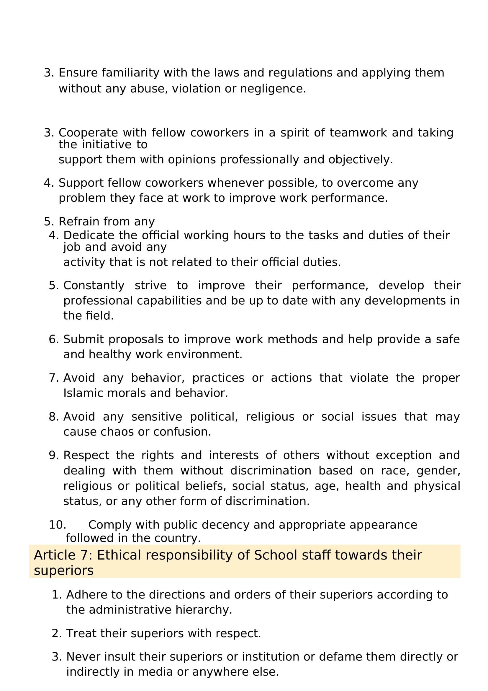
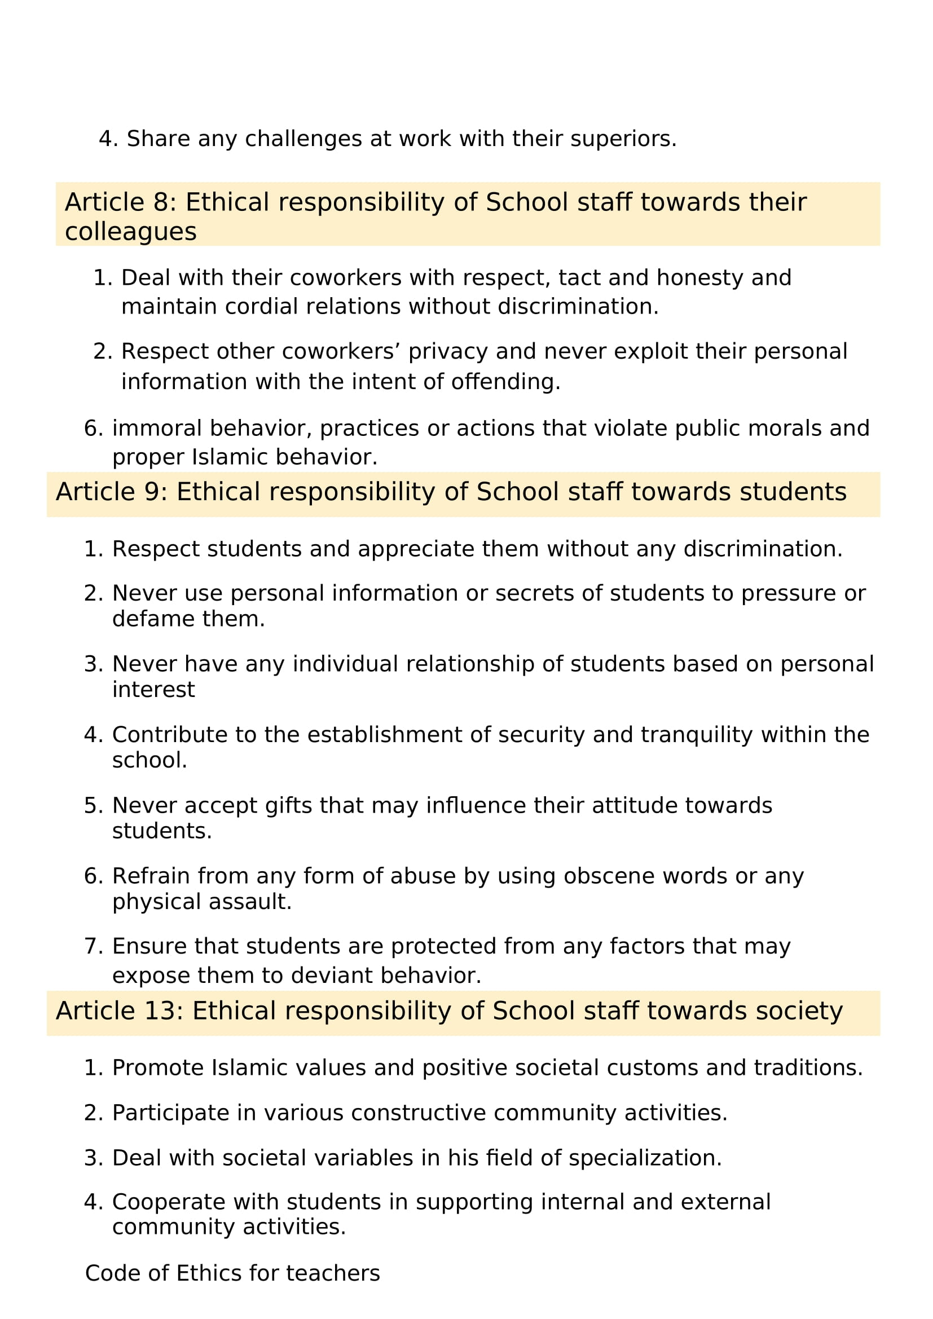
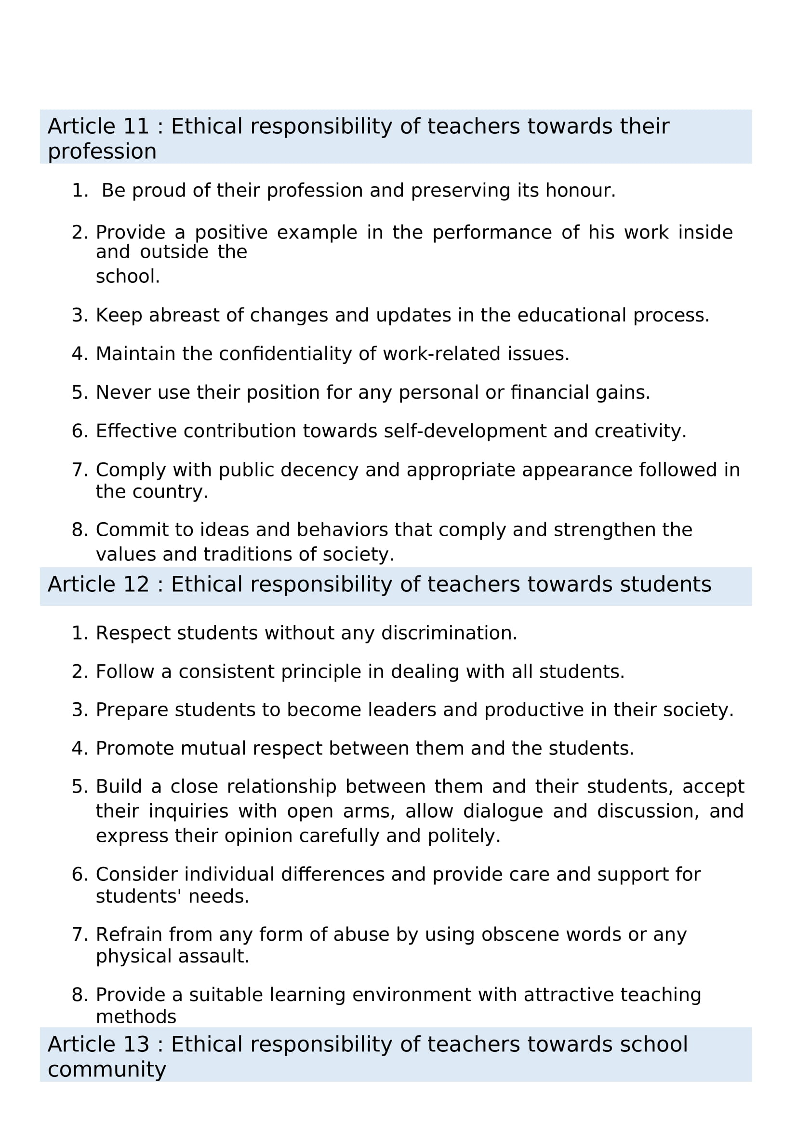
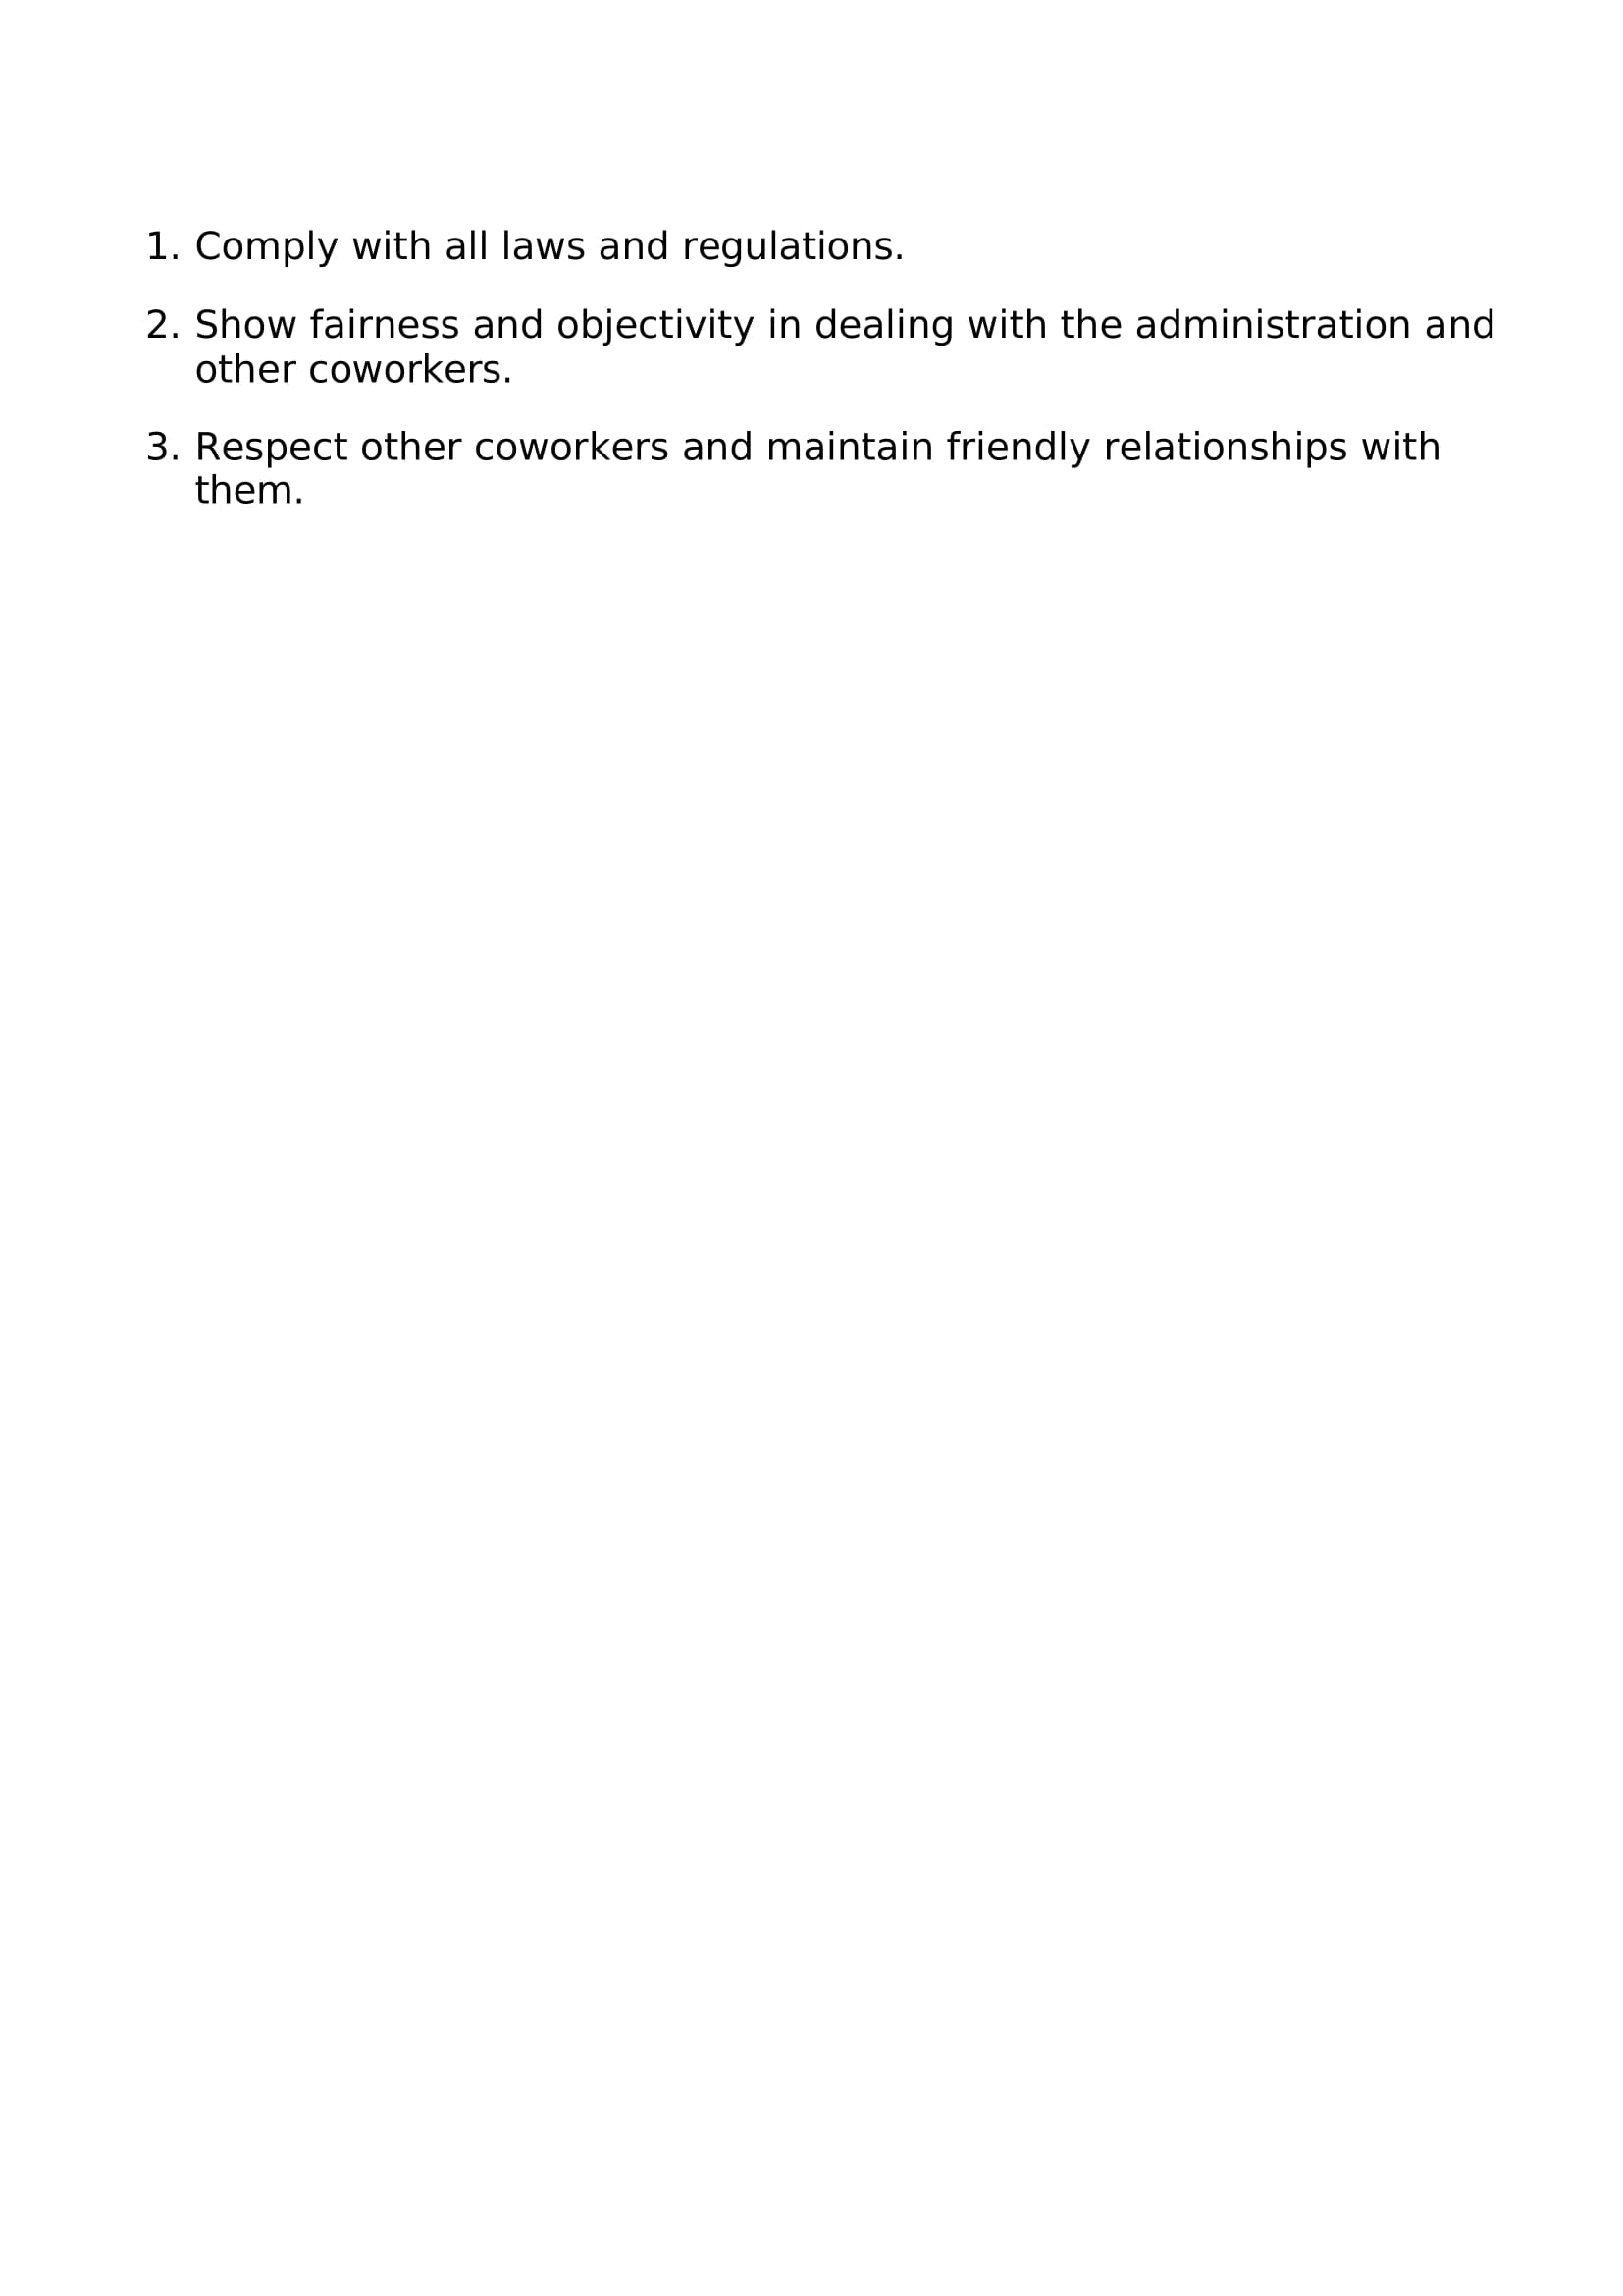
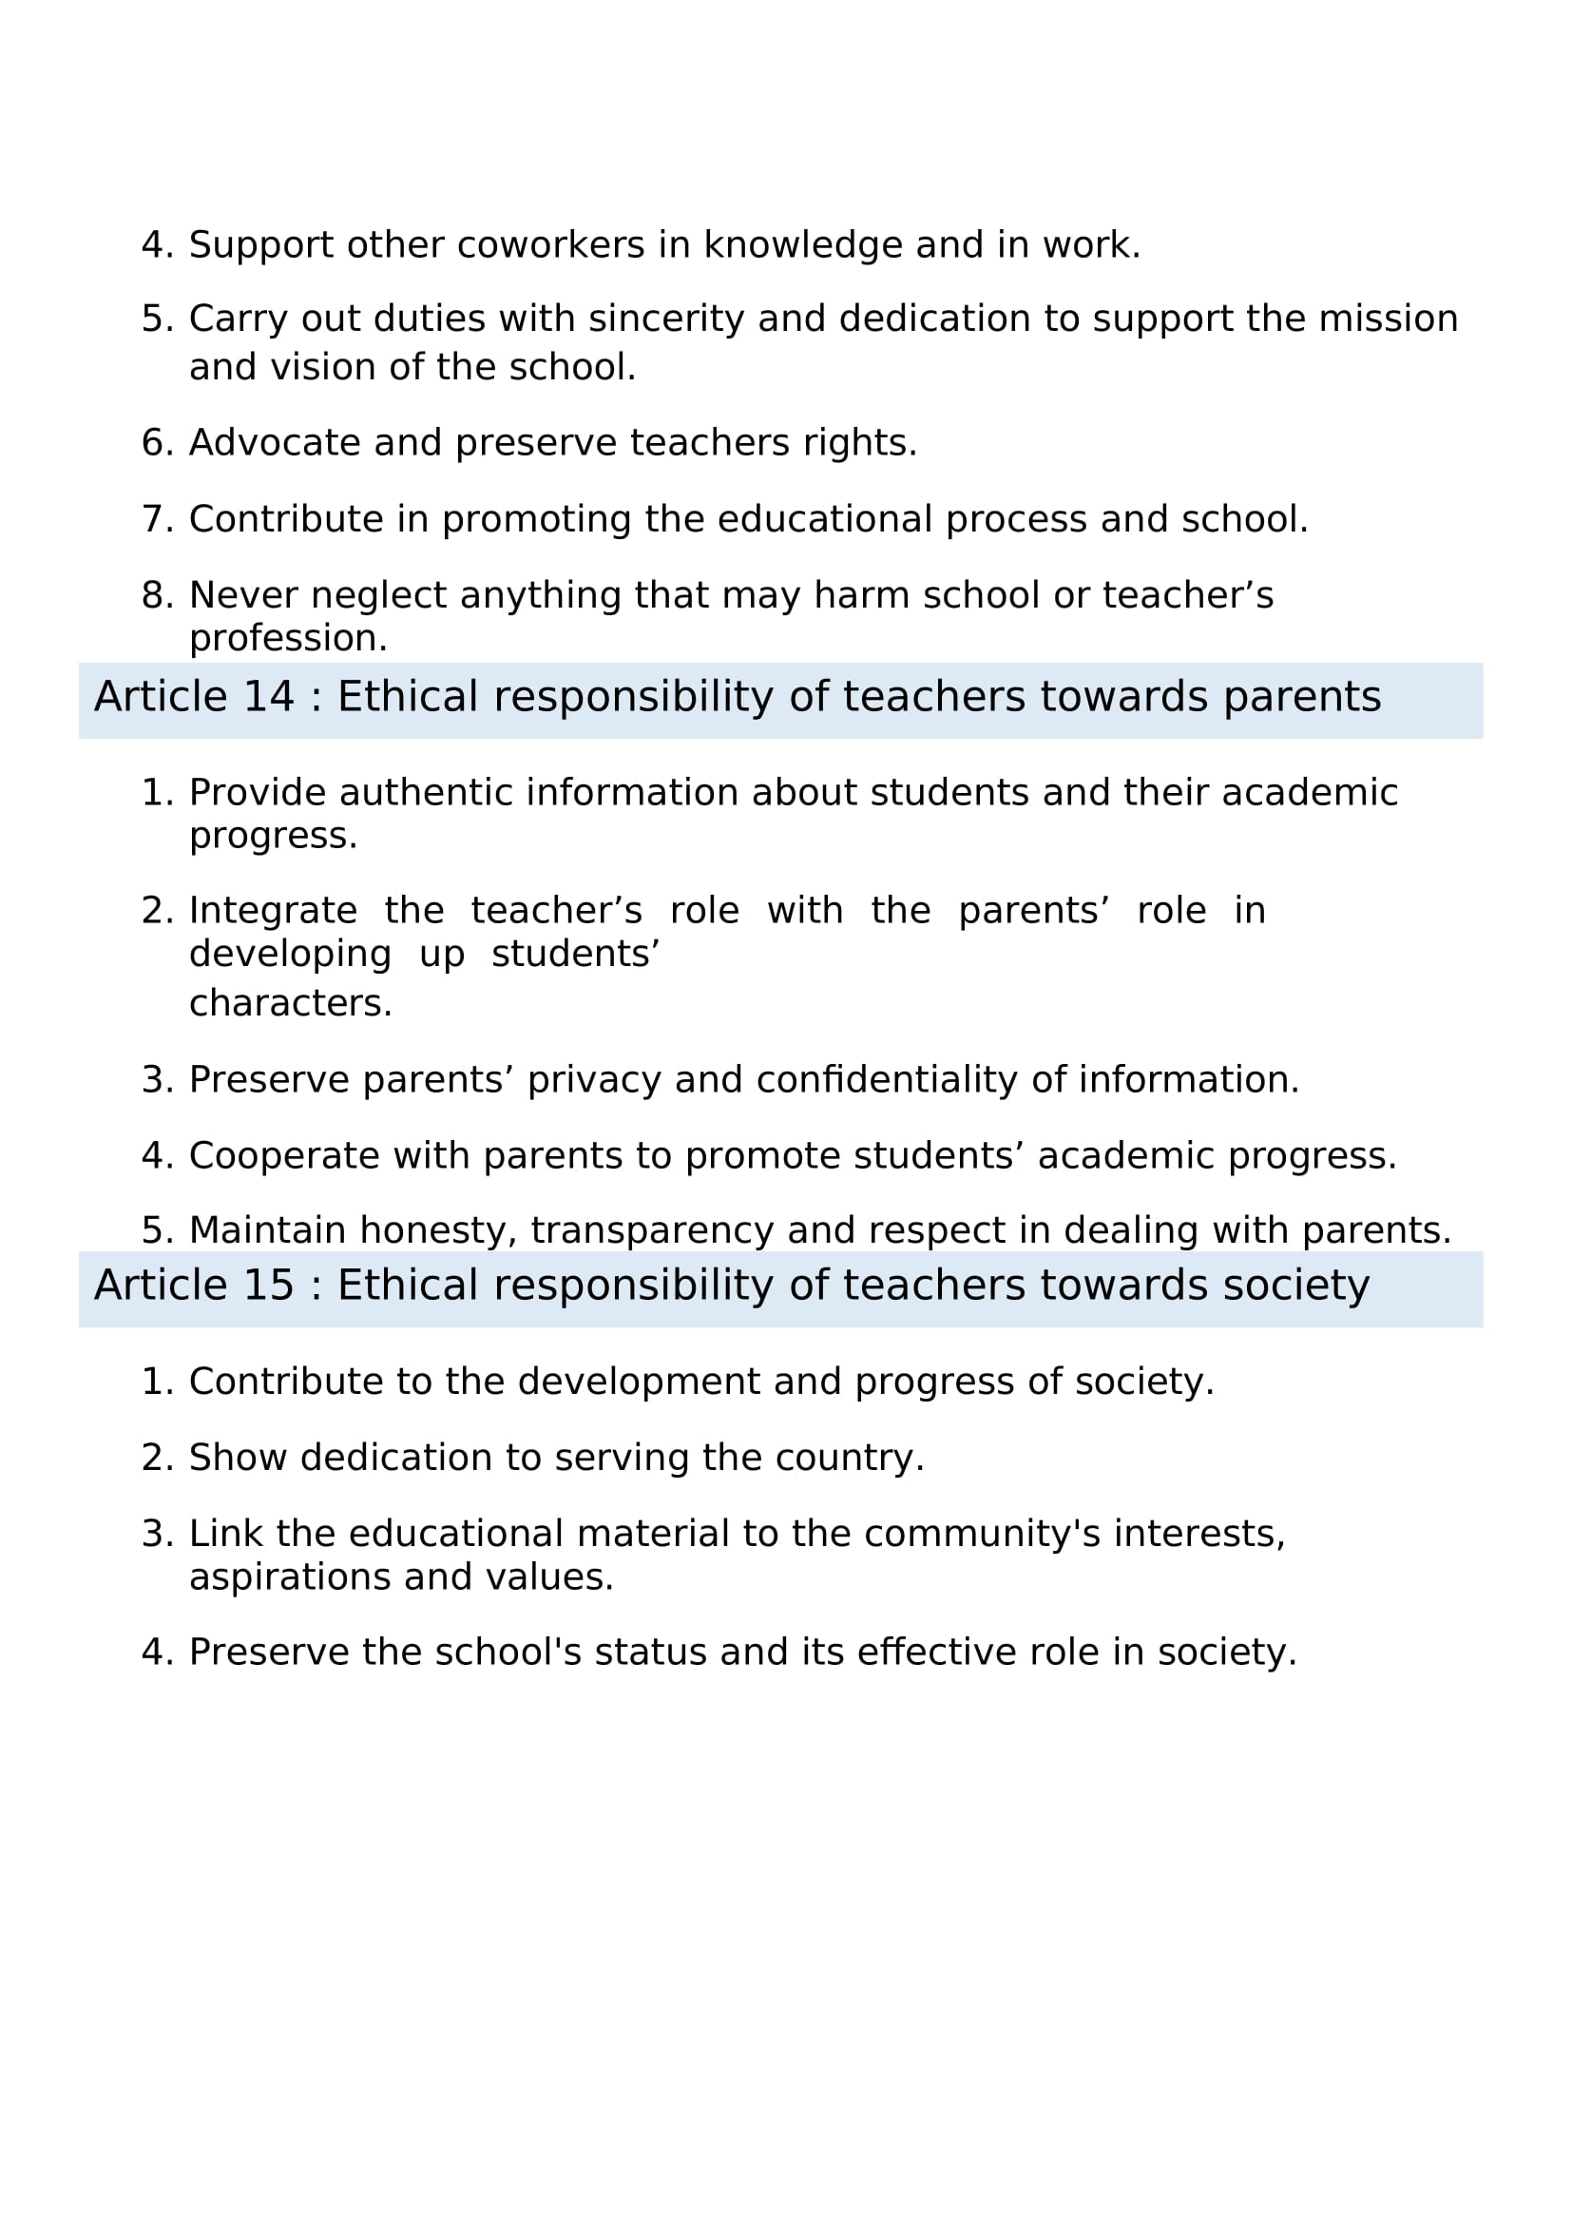
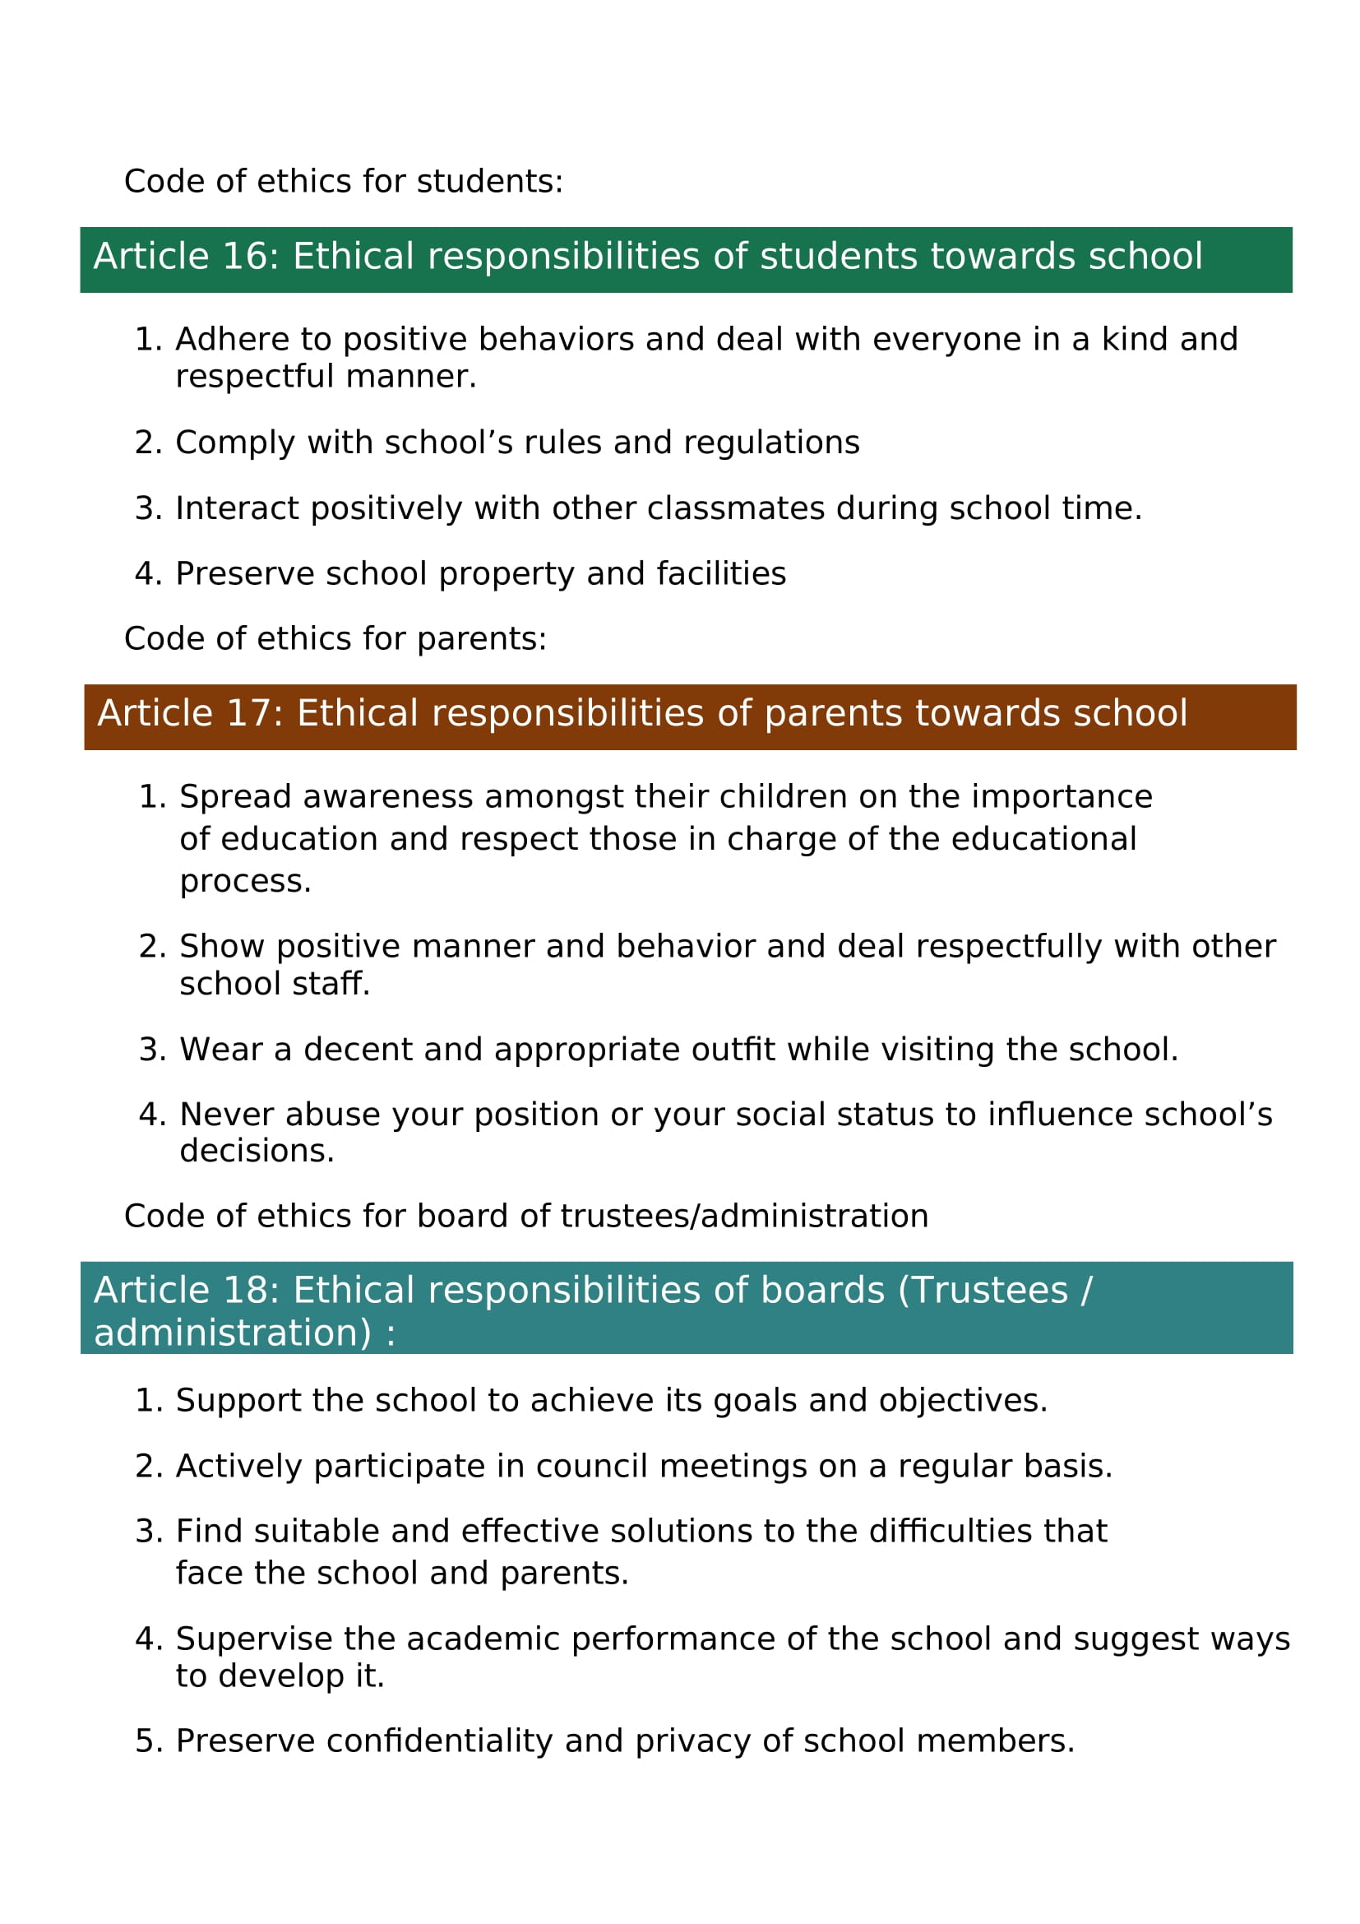

MONITORING AND EVALUATION POLICY
(QUALITY ASSURANCE POLICY)

Aim:

The aim of the Monitoring and Evaluation (M&E) Policy at Oscar Academy (aligned with Guideline for General Policies in Private Education in the State of Qatar - First Edition 2024) is to ensure that the academy consistently meets its vision and mission by implementing a systematic approach to assess and improve the quality, effectiveness, and impact of all academic, administrative, and operational activities. This policy supports the academy’s commitment to providing an excellent educational experience and fostering an environment that encourages continuous learning, growth, and excellence.

Objectives:
- Support the Achievement of Academic Excellence
-To monitor and evaluate the effectiveness of academic programs, teaching methodologies, and student performance, ensuring they align with the academy’s vision of fostering academic excellence and preparing students for a dynamic global society.
- Enhance Holistic Student Development
-To assess and enhance the impact of extracurricular activities, personal development programs, and student support services in promoting well-rounded individuals who are ready to thrive in all areas of life, both academically and socially.
- Drive Evidence-Based Decision Making
-To provide accurate, timely data that supports informed decision-making, ensuring that institutional strategies, policies, and practices are continuously adapted to meet the evolving needs of students and staff, in line with the academy’s mission to nurture critical thinking, creativity, and integrity.
- Ensure Accountability and Transparency
-To promote accountability at all levels by regularly assessing institutional performance and sharing M&E results with key stakeholders, thereby ensuring the academy remains transparent and committed to high standards of governance.
- Foster Continuous Improvement
-To use M&E data to identify opportunities for improvement and foster a culture of innovation, ensuring that the academy continually adapts to best meet the needs of its students, staff, and the broader community.
- Support Professional Growth and Development
-To assess staff performance and professional development needs, ensuring that ongoing training and development initiatives align with the mission of the academy to nurture talented educators who contribute to the success of the academy and its students.
- Maintain Alignment with National and International Standards
-To ensure the academy’s academic and operational activities meet or exceed local and international educational standards, reflecting its commitment to high-quality education and student-centered learning environments.
- Optimize Resource Allocation
-To guide effective resource allocation based on M&E outcomes, ensuring that financial, human, and material resources are utilized in a manner that supports the academy’s goals of academic excellence and holistic development.
- Enhance Stakeholder Engagement
-To measure and assess the satisfaction and engagement of all stakeholders, including students, parents, and the community, ensuring that the academy remains responsive to their needs and continues to create collaborative partnerships in line with its mission of community and parent collaboration.
- Cultivate a Culture of Responsibility and Integrity
-To ensure that all members of the academy are accountable for their roles in achieving the academy’s goals and uphold the values of integrity and ethical behavior, fostering an environment of mutual respect and responsibility.

Staff | Responsibilities | Implementation  Schedule
Principal | Provide strategic leadership in implementing Monitoring and Evaluation (M&E) processes that align with the academy’s mission and goals. | Annually / Reviewed Quarterly
Principal | Ensure that M&E activities are integrated into the academy's planning and decision-making cycles. | Each Semester / As needed
Principal | Oversee the development and execution of M&E plans for both academic and administrative departments. | Annually / Reviewed Each Semester
Principal | Ensure compliance with national education standards and internal policy frameworks. | Ongoing / Formal Review Annually
Principal | Use evaluation data to inform improvements in teaching methods, student performance, staff development, and resource allocation. | Each Semester / After major assessment
Principal | Promote a culture of accountability and evidence-based decision-making. | Ongoing / Embedded in culture
Principal | Support professional development for staff on M&E tools, techniques, and analysis. | Annually / With Mid-Year Refreshers
Principal | Ensure that staff understand the importance of data collection and evaluation in improving institutional outcomes. | Monthly briefings / As needed
Principal | Monitor the effectiveness and relevance of curricula, teaching strategies, and student support services. | Each Semester / Classroom Walkthroughs
Principal | Regularly review and update academic performance indicators and evaluation tools. | Quarterly
Principal | Ensure timely reporting of evaluation outcomes to stakeholders such as the school board, parents, and education authorities. | Each Semester / As per calendar
Principal | Communicate findings from M&E processes to promote transparency and stakeholder engagement. | Monthly Updates / End-of-Term Reports
Principal | Use M&E outcomes to refine institutional goals, strategies, and resource planning. | Each Semester / Strategic Reviews
Principal | Encourage a feedback loop where input from teachers, students, and parents feeds into ongoing improvements. | Termly via Surveys and Meetings
Principal | Monitor administrative operations and staff performance to ensure alignment with institutional goals. | Monthly / Annual Review
Principal | Oversee the admission process for new students to ensure fairness, transparency, and alignment with enrollment targets. | Annually during admission cycle
Principal | Monitor the staff recruitment process to ensure it follows set policies and meets the academy’s needs. | Per hiring cycle
Principal | Oversee the collection and analysis of data related to academic and operational performance for informed decision-making. | Monthly Reports / End-of-Term Summary
Principal | Monitor academic progress and outcomes each semester, ensuring timely interventions where needed. | Each Semester
Principal | Evaluate teacher performance regularly through classroom observations, appraisals, and student feedback. | Twice per Academic Year
Principal | Monitor the quality and effectiveness of student support services, including counseling, special education, and enrichment programs. | Termly Review / Ongoing Feedback
Principal | Ensure the effective implementation of school policies across all departments. | Ongoing / Policy Review Annually
Principal | Supervise the preparation, dissemination, and adherence to the annual school calendar. | Annually / Mid-Year Check
Principal | Monitor the implementation of health and safety protocols to ensure a safe learning and working environment. | Monthly Audits / As needed
Principal | Oversee the design and analysis of surveys for students, staff, and parents to gather feedback and guide improvements. | Termly / After each major initiative
Principal | Lead and monitor the work of the QNSA (Qatar National School Accreditation) group, ensuring compliance with standards and progress on the accreditation process. | Annually / As per QNSA –School Renewal of License
Team Leader | Ensure the implementation of M&E activities within their designated team or department in alignment with the academy’s overall policy. | Ongoing / Weekly Reviews
Team Leader | Coordinate the collection, organization, and initial analysis of data related to performance, progress, and outcomes. | Monthly / End of Term
Team Leader | Monitor team performance against set objectives, indicators, and timelines. | Monthly / Per Project Phase
Team Leader | Support team members in understanding M&E tools, methodologies, and reporting requirements. | Quarterly Workshops / As needed
Team Leader | Identify challenges, gaps, and areas for improvement based on data and provide recommendations. | Monthly Analysis / Term-end Review
Team Leader | Prepare and submit timely reports to the Principal or designated M&E coordinator. | Monthly / Term-wise
Team Leader | Foster a team culture of accountability, transparency, and continuous learning. | Ongoing / Team Meetings
Team Leader | Facilitate regular feedback sessions with team members to discuss results, progress, and necessary adjustments. | Biweekly / Monthly
Team Leader | Ensure compliance with internal policies and external standards in data handling and evaluation processes. | Ongoing / Quarterly Checks
Team Leader | Contribute to the development and refinement of evaluation tools and performance metrics. | Annually / As part of strategic updates
Academic Vice Principal (AVP) | Oversee the implementation of M&E processes across all academic programs to ensure alignment with the academy’s educational objectives and standards. | Weekly Check-ins / Each Semester
Academic Vice Principal (AVP) | Monitor academic performance indicators, including student achievement, teaching effectiveness, and curriculum delivery. | Monthly Reports / End of Term Review
Academic Vice Principal (AVP) | Analyze academic data to identify trends, strengths, and areas requiring improvement. | Quarterly / As data becomes available
Academic Vice Principal (AVP) | Support the development and continuous improvement of assessment tools, grading policies, and instructional practices. | Annually / Mid-Year Review
Academic Vice Principal (AVP) | Collaborate with department heads and teachers to ensure that evaluation findings are used to enhance teaching and learning outcomes. | Monthly Coordination Meetings
Academic Vice Principal (AVP) | Ensure that academic staff are trained and informed on M&E procedures, tools, and expectations. | Twice Yearly / Start and Mid-Year
Academic Vice Principal (AVP) | Review and validate academic reports submitted for internal review or external accountability. | Monthly / Prior to submissions
Academic Vice Principal (AVP) | Ensure that M&E results are incorporated into academic planning, professional development, and curriculum review cycles. | Each Semester / Annual Review
Academic Vice Principal (AVP) | Report regularly to the Principal on the status of academic M&E activities and outcomes. | Monthly / Term-end Reports
Academic Vice Principal (AVP) | Promote a culture of academic excellence, data-informed decision-making, and continuous improvement within the academic staff. | Ongoing / Monthly Professional Sessions
CEO | Provide overall strategic direction and leadership for the Monitoring and Evaluation framework across the academy. | Annually / Mid-Year Check-ins
CEO | Ensure that M&E policies are aligned with the academy’s vision, mission, and long-term goals. | Annual Strategic Planning
CEO | Approve and support the implementation of M&E systems and resources across all departments. | Annually / As Needed
CEO | Oversee the integration of M&E findings into institutional strategic planning, budgeting, and policy development. | Annually / Mid-Year Strategic Reviews
CEO | Hold executive accountability for ensuring that data-driven decisions guide institutional improvement and performance. | Ongoing / Quarterly Reports
CEO | Review consolidated M&E reports from the Principal and senior leadership to assess institutional progress. | Quarterly / Board Meeting Cycle
CEO | Engage with key stakeholders—including the board of directors, regulatory bodies, and external partners—using verified M&E data to demonstrate impact and compliance. | Biannually / As needed
CEO | Promote a culture of transparency, accountability, and continuous improvement at the organizational level. | Ongoing
CEO | Ensure that appropriate resources, tools, and personnel are available for effective M&E implementation. | Annual Budget Planning
CEO | Support capacity building initiatives for leadership and staff in data literacy, analysis, and application of M&E findings. | Annually / With Leadership Retreats
BOT | Provide governance oversight to ensure the effectiveness and accountability of the academy’s Monitoring and Evaluation systems. | Biannual Board Reviews
BOT | Approve the overall M&E policy and ensure it aligns with the institution’s mission, vision, and strategic priorities. | Annually
BOT | Review high-level M&E reports and institutional performance data presented by the CEO and Principal. | Quarterly Board Meetings
BOT | Hold the executive leadership accountable for implementing M&E processes and acting on evaluation findings. | Quarterly / Annually
BOT | Ensure that M&E outcomes are used to inform strategic planning, policy revisions, and resource allocation. | Annual Budget and Strategy Cycle
BOT | Monitor compliance with educational standards, regulatory requirements, and key performance indicators. | Biannual Oversight Reviews
BOT | Support a culture of transparency, integrity, and continuous improvement at the board level. | Ongoing / Every Board Session
BOT | Provide guidance and feedback on institutional priorities based on M&E evidence. | Quarterly / As Reports Are Presented
BOT | Advocate for the effective use of data in decision-making across the organization. | Ongoing
BOT | Participate in periodic reviews of the M&E framework to ensure relevance, effectiveness, and alignment with evolving educational goals. | Every 2 Years / As Strategic Needs Arise

MONITORING SCHEDULE

# | MONITORING ACTIVITY | RESPONSIBLE PERSON(S)
1 | Monitoring School Academic Plans | SMT / Principal /Academic Vice Principal
2 | School Wide Action plan | SMT / Principal /Academic Vice Principal/QNSA Team
3 | Monitoring Monthly Behavior Report | Social Worker/ Principal/ Academic Vice Principal
4 | Report Card | IT/ Academic Vice Principal/ Academic Secretary/ Principal
5 | Monitoring of Students Attendance (absence / late morning) | Building Supervisors/Academic Secretary/Social Worker
6 | Daily Monitoring for late students in the afternoon | Reception / Admin/ Social Worker
7 | Monitoring of Daily Routine Activity | Academic Vice Principal/ Admins/ Principal
8 | Monitoring Clubs | Academic Vice Principal / Social Worker/Principal
9 | Science Lab Monitoring | Academic Vice Principal / Science Team Leader
10 | Library Monitoring | Academic Vice Principal/ Librarian/ Admins
11 | Computer Lab monitoring | Academic Vice Principal/ IT/ Admin Coordinator
12 | Monitoring for Clinic | Nurse/ Social Workers / Principal
13 | Monitoring for Canteen | Admin Coordinator/ Academic Vice Principal
14 | Professional Development Monitoring | Principal / HR/ Academic Vice Principal / Team Leaders
15 | Monitoring of Extra Curricular Activity | Principal/ Academic Vice Principal/ Social Worker
16 | Monitoring for Support Class | Academic Vice Principal / Social Worker / Principal
17 | Monitoring for Foreign Students | Academic Vice Principal / Social Worker / Principal/Admin Coordinator
18 | Monitoring for Marks Analysis | Academic Vice Principal / IT / Academic Secretary/ Principal
19 | Monitoring for Questionnaire Analysis | Academic Vice Principal/ Academic Secretary/ Principal
20 | Monitoring Students Display Works (Inside/Outside Classroom) | Admins / Academic Vice Principal
21 | BOT review Committee | Principal / Academic Vice Principal / Social Worker/ CEO
22 | Budget Monitoring and Report to Board | CEO/ Principal/ HR/ External Auditors/ Accountant
23 | Monitoring of Numbers Admission and Entrance Exam | Academic Vice Principal / Admin Coordinator / Students Affairs Officer/ Principal
24 | Parents Meeting Monitoring | Principal/ Social Worker/ Academic Vice Principal
25 | Inventory Monitory | Admin Coordinator/ Academic Secretary/ Storekeeper
26 | Student's Bus Monitoring | Bus Supervisor/Admin Coordinator / Bldg Supervisor
27 | School Visitors Monitoring | Admin Coordinator / Social Worker
28 | Parents Request Monitoring | Social Worker/ Academic Vice Principal / Principal
29 | School Committee Monitoring | SMT/ Social Worker
30 | Staff Monitoring Attendance | HR / Academic Vice Principal/ Principal
31 | Monitoring Students Exam Results (internal/ External) | Academic Vice Principal/ Asst Acad Supervisor/ Principal/ IT
32 | Building / Classroom Monitoring | Admin / Vice Principal
33 | Monitoring Teacher Performance | Principal/ Academic Vice Principal/ Asst Acad.
34 | Monitoring School Calendars (Academic Activities) | Principal/ Academic Vice Principal/ Asst Acad.
35 | Labor Performance Monitoring | Principal/ Admin. Coordinator
36 | Monitoring Staff (Academic Teacher/ General Admin) | SMT
37 | Principal Monitoring Activity | SMT
38 | Monitoring / Applying Behavior Policies and procedures ( Monthly/ Annual) | Social Worker/ Principal/ Academic Vice Principal
39 | Monitoring Promoting Qatar National Identity and School Values | Social Worker/ Principal
40 | Monitoring School-Self Study | Academic Vice Principal / Principal / Ass. Acad. Supervisor
41 | Monitoring School Curriculum and Educational Resources | Academic Vice Principal / Principal
42 | Monitoring Parent’s Involvement and Satisfaction in Life | Social Worker/ Academic Vice Principal / Principal

Safeguarding and Child Protection Policy

TABLE OF CONTENTS
- Introduction
- Aim
- Scope
- Vision and Commitment
- Principles of Child Protection
- Legal and Regulatory Framework
- Creating a Safe School Environment
7.1 Safer Recruitment
7.2 Creating a Safe and Supportive Culture
7.3 Equipping students through Education
  - Staff and Parent Safeguarding Awareness
- Safeguarding Leadership – Roles and Responsibilities
8.1 Designated Safeguarding Board Member (DSBM)
8.2 Designated Safeguarding Lead (DSL)
8.3 Deputy Designated Safeguarding Leads (DDSLs)
8.4 Child Protection Officer (CPO)
8.5 Safeguarding Committee
8.6 All Staff and Teachers
- Categories of Child Protection Concerns
9.1 Abuse by Adults
9.2 Abuse by Peers (Peer-on-Peer Abuse)
9.3 Domestic Abuse
9.4 Absenteeism and Behavioural Changes
9.5 Self-Harm and Suicidal Ideation
- Indicators of Abuse and Neglect
10.1 General Signs
10.2 Home Environment Risk Factors
10.3 Specific Warnings by Category
- Student Monitoring and Supervision
11.1 Duty of Care
11.2 Monitoring Student Well-Being
11.3 Supervision Throughout the Day
- Safeguarding Students from Peer Harm
12.1 Prevention Measures
12.2 Handling Incidents
11.3 Anti-Bullying
12.4 Supporting Students
12.5 Cyberbullying Prevention
12.6 Addressing Sexual Harassment
12.7 Long-Term Safeguarding
- Safeguarding Reporting and Allegation Procedures
13.1 Child Initiated Reporting
13.2 Reporting Safeguarding Concerns
13.3 Whistle blowing
13.4 Allegations Against Staff
13.5 Responding to Allegations
13.6 Managing Low-Level Concerns
- Confidentiality
- Monitoring and Evaluation of the Policy
15.1 Monitoring Practices
15.2 Ongoing Supervision
15.3 Evaluation
15.4 Policy Review
- Online Safety
- Mobile Phones, Photography and Video
17.1 Mobile Phones
17.2 Photography and Video
- Conclusion

Appendix 1: Recruitment Application Form (Safe Recruitment)
Appendix 2: Moral Contract
Appendix 3: 5Rs Approach to Safeguarding
Appendix 4: Step-by-Step Allegation Management Protocol
Appendix 5: Safeguarding Response Protocol: Do’s and Don’ts
Appendix 6 Safeguarding Incident Reporting Form
Appendix 7: Safeguarding Referral Form

List of Abbreviations
Abbreviation | Full Term
BOT | Board of Trustees
CEO | Chief Executive Officer
DSBM | Designated Safeguarding Board Member
DSL | Designated Safeguarding Lead
DDSL | Deputy Designated Safeguarding Lead
CP | Child Protection
CPO | Child Protection Officer
KCSIE | Keeping Children Safe in Education
MOEHE | Ministry of Education and Higher Education (Qatar)
SEND | Special Educational Needs and Disabilities
SMT | Senior Management Team
NHRC | National Human Rights Committee
UNCRC | United Nations Convention on the Rights of the Child
UNICEF | United Nations International Children's Emergency Fund

Definition of Terms

- Child: Refers to any human being below the age of 18 years unless under the law applicable to the child, majority is attained earlier. (UNICEF)
- Child protection: According to UNICEF, Child Protection refers to preventing and responding to violence, exploitation and abuse against children
- Child protection Policy: A broad term which encompasses philosophies, policies, standards, guidelines and procedures to protect children from both intentional and unintentional harm.
- Harm: Harm refers to any physical, emotional, or psychological injury caused to a child, whether intentional or unintentional. This includes abuse, neglect, or maltreatment that affects the child's safety, well-being, or development.
- Safeguarding: Safeguarding refers to the actions, policies, and practices that promote the welfare of children and protect them from all forms of harm, including abuse, neglect, exploitation, and maltreatment. It involves creating safe environments, identifying and responding to concerns, and ensuring that all adults act in the best interests of every child.
- Grooming: Grooming is when an adult builds a relationship with a child to gain their trust with the intent of exploiting or abusing them. This can involve giving gifts, offering special attention, and encouraging secrecy to manipulate the child.
- Whistle blowing: Whistle blowing is the act of reporting any concerns about unethical behaviour, misconduct, or violations of policies, including safeguarding or child protection issues, within the school. This can be done confidentially, and the whistleblower is protected from retaliation.
- Allegation: An allegation is any information suggesting that a staff member or adult working with children has harmed a child, committed a related criminal offence, or behaved in a way that indicates a potential risk of harm.
- Abuse: Abuse refers to any act by another person—adult or child—that intentionally harms a child’s physical, emotional, or psychological well-being. It includes physical abuse, emotional abuse, sexual abuse, and neglect.
- Neglect: Neglect is the persistent failure to meet a child’s basic physical and emotional needs, which may result in serious harm to their health or development. This includes lack of adequate food, shelter, supervision, medical care, or emotional support.
- Disclosure: Disclosure occurs when a child shares information—directly or indirectly—indicating that they are being harmed, abused, or are at risk of harm. Staff must respond sensitively, record the information accurately, and report it following school procedures.
- Designated Safeguarding Lead (DSL): The Designated Safeguarding Lead is the staff member appointed by the school to take primary responsibility for child protection and safeguarding matters, including receiving and responding to concerns, maintaining records, and liaising with external agencies.
- Confidentiality: Confidentiality refers to the principle of keeping information about children and families private, sharing it only with those who need to know for the purpose of safeguarding or protecting the child, in accordance with legal and ethical standards.
- Best Interests of the Child: A fundamental principle derived from the UNCRC, stating that all actions and decisions concerning children must prioritize their safety, well-being, and overall development above all other considerations.
- Low-level concern: Any behaviour by a staff member or adult that is inconsistent with the school’s Code of ethics or professional expectations but does not meet the threshold for an allegation. Such concerns should still be shared with the Designated Safeguarding Lead (DSL) and recorded appropriately.

1. Introduction

At Oscar Academy, we are committed to safeguarding every child’s right to learn and grow in a safe, supportive, and nurturing environment. We believe child protection is a shared responsibility, and through trust, respect, and open communication, we ensure students feel valued, empowered, and protected. In alignment with MOEHE Circular No. 9 (27 May 2024), student safety remains our top priority. This policy also upholds the principles of the United Nations Convention on the Rights of the Child (UNCRC), ensuring that every child’s right to protection, participation, survival, and development is respected in all school practices and decisions.

2. Aim
The aim of this policy is to:
- Protect children from harm, abuse, and neglect.
- Provide clear guidance for staff and stakeholders on procedures.
- Foster a safe, nurturing, and respectful learning environment.
- Ensure compliance with Qatari law and international safeguarding standards.

3. Scope
Safeguarding is everyone’s responsibility at OSCAR Academy, and this policy applies to:
- All students enrolled at OSCAR Academy, from Kindergarten to Year 6.
- All staff members, both teaching and non-teaching, including part-time, full-time, temporary, and substitute staff.
- Visitors and any third-party service providers working with or around students.
- Parents and guardians.
- SMT and Board of Trustees.
This policy is designed to ensure that all members of the OSCAR Academy community understand and fulfil their responsibilities towards creating a safe, supportive, and respectful environment for every student, both inside and outside the classroom.

4. Vision and Commitment
At Oscar Academy, we hold a primary responsibility for the care, welfare, and safety of our students. Our commitment is to create a secure, supportive, and nurturing environment. We ensure that all concerns related to abuse or neglect are taken seriously and addressed appropriately by all staff members. Oscar Academy’s safeguarding vision reflects Qatar’s cultural and legal context, aligned with MOEHE regulations and the Child Protection Law of Qatar, while respecting Islamic values and the national identity.

5. Principles of Child Protection:
- Oscar Academy aims to be a child-safe and child-friendly institution.
- The welfare of the child is of paramount importance.
- Every child has the right to feel safe, protected, heard, and valued.
- A balance must be maintained between protecting children and respecting family rights and cultural values.
- Safeguarding involves prevention, early intervention, and protection.

6. Legal and Regulatory Framework
This policy is governed by:
- Qatar: Child Protection Law, Qatari Foundation for the Protection of Women and Children, MOEHE Circular No.9 (27 of May 2024)
- International: UNCRC, UNICEF standards
- UK reference: Keeping Children Safe in Education (KCSIE), Working Together to Safeguard Children (UK), The Education Act 2002 (UK)

7. Creating a Safe School Environment:
OSCAR Academy committed to creating a safe, nurturing environment where all students feel protected, valued, and heard. We believe safeguarding is a shared responsibility, and we take a proactive approach to ensure that every child is supported in their wellbeing and development. To fulfil this responsibility, all staff should make sure their approach is child-centred, considering at all times what is in the best interest of the child

7.1 Safer Recruitment
Oscar Academy is committed to recruiting only staff who are suitable to work with children, following a clear safer recruitment process that ensures all adults are properly vetted. This process is guided by the principle of preventing harm before it occurs, promoting the safety and well-being of every child.
- Background Checks: Police clearance and criminal record checks are mandatory.
- Job Descriptions: All posts include a child safeguarding commitment.
- Interviews: Conducted by a trained panel with safeguarding questions and case scenarios (see Appendix 1).
- Onboarding: Staff complete safeguarding training and sign the Moral contract (Appendix 2) before working with students. Induction covers safeguarding responsibilities and managing concerns about adults.
7.2 Creating a Safe and Supportive Culture
- Students are encouraged to build trusting relationships with adults in school and to speak up when they feel worried or unsafe.
- We foster an ethos of open communication, with regular child voice activities such as surveys, reflections, and awareness events like Anti-Bullying Week.
- Every child is made aware of adults they can approach when they need help.
7.3 Equipping Students through Education
Through our curriculum and programs, we equip students with age-appropriate knowledge and skills to stay safe. This includes:
- Online safety (cyber security curriculum)
- Anti-bullying awareness
- Road and pedestrian safety
- Social and emotional learning
- Identifying trusted adults and making safe choices
7.4 Staff and Parent Safeguarding Awareness
- Staff receive safeguarding induction and are made aware of reporting procedures.
- Parents are informed of safeguarding procedures through school communication channels and access to the policy.

8. Safeguarding Leadership – Roles and Responsibilities

Safeguarding is a shared responsibility across all levels of school leadership and staff. Clear roles and accountability ensure the effective implementation of this policy.
8.1 Designated Safeguarding Board Member (DSBM)
- Holds ultimate accountability for safeguarding and child protection within the school.
- Ensures that the school complies with all relevant laws and safeguarding standards.
- Approves and reviews the Safeguarding and Child Protection Policy annually.
- Appoints a Safeguarding Lead among Board members for oversight.
8.2 Designated Safeguarding Lead (DSL)
- Provides strategic leadership for safeguarding across the school.
- Ensures effective implementation of the policy and related procedures.
- Coordinates with external agencies when a referral or report is required.
- Oversees training, case management, and record keeping.
- Reports to the DSBM and Board on safeguarding matters.
8.3 Deputy Designated Safeguarding Leads (DDSLs)
- Supports the DSL in all safeguarding functions.
- Acts as the lead in the absence of the DSL.
- Maintains up-to-date records and ensures staff compliance with reporting procedures.
8.4 Child Protection Officer (CPO)
- Manages the day-to-day safeguarding operations within the school.
- Conducts follow-ups on reports and concerns.
- Liaises with teachers, parents, and students on child protection issues.
- Reports directly to the DSL.
8.5 Safeguarding Committee
- Comprises the DSL, DDSL, CPO, Social worker, nurse, administrative supervisors and teachers.
- Meets regularly to review safeguarding cases, policies, and preventive actions.
- Oversee and implement the Child Protection Policy and safeguarding procedures.
- Ensure staff are trained and aware of safeguarding requirements.
- Promote a safe culture where students can raise concerns.
- Coordinate student-focused safeguarding education (online safety, anti-bullying, wellbeing).
- Monitor safeguarding practices, incidents, attendance patterns, and recommend updates.
- Maintain confidential records, ensure clear reporting channels, and liaise with authorities.
8.6 All Staff and Teachers
- Must remain vigilant and immediately report any safeguarding concern.
- Participate in required safeguarding and child protection training.
- Model safe and respectful behaviour consistent with the school’s moral contract.
- Support student education on safety, wellbeing, and rights.

9. Categories of Child Protection Concerns
At Oscar Academy, safeguarding is a top priority. Child protection concerns are categorized into four main areas in line with international standards and Qatar’s legal context. This section defines the main forms of harm relevant to the Oscar Academy context, ensuring staff can identify physical, emotional, sexual, and neglect-related risks early. Staff must stay alert to indicators of abuse or neglect, and report concerns immediately to the Child Protection Officer (CPO). Staff are not expected to investigate, and all serious cases will follow MOEHE guidance.

9.1 Abuse by Adults
This includes any deliberate act or neglect by adults that may cause physical, emotional, or psychological harm to a child. Categories include:
- Physical Abuse: Deliberate infliction of physical harm, such as hitting, slapping, or any action that causes injury.
- Emotional Abuse: Ongoing emotional maltreatment, including criticism, intimidation, shouting, and setting unrealistic expectations.
- Neglect: Persistent failure to meet a child’s basic physical and emotional needs, including food, hygiene, medical care, and affection.
- Sexual Abuse: Any sexual activity involving a child, including inappropriate touching, grooming, or exposing the child to sexual content.
9.2 Abuse by Peers (Peer-on-Peer Abuse)
Peer-on-peer abuse includes all forms of child-on-child harm, whether in school, online, or outside school premises. Types include:
- Bullying: Repeated verbal, physical, psychological, or cyber abuse intended to intimidate or harm.
- Threatening or Manipulative Behaviour: Including gang-related violence, blackmail, or coercion.
- Sexual Harassment: Unwanted sexual comments, advances, or behaviours that create an uncomfortable environment.
- Threatening or Manipulative Behaviour: Actions like gang violence, blackmail, or coercion to control or harm others.
- Cyberbullying: Using technology to bully, harass, or intimidate peers online.

9.3 Domestic Abuse
Even without direct physical harm, exposure to domestic violence or hostile environments can cause long-term psychological and emotional damage to children.

9.4 Absenteeism and Behavioural Changes
Chronic absenteeism or sudden behavioural shifts may signal deeper safeguarding concerns.

9.5 Self-Harm and Suicidal Ideation
Self-harm and suicidal thoughts are serious safeguarding concerns that may indicate underlying abuse or emotional distress.

10. Indicators of Abuse and Neglect

10.1 General signs
A child at risk may:
- Have unexplained injuries (bruises, cuts, burns, broken bones).
- Complain of pain or discomfort without explanation.
- Appear consistently unkempt or neglected.
- Show sudden eating changes (overeating/refusing food).
- Appear anxious, withdrawn, aggressive, or fatigued.
- Miss school frequently or arrive late.
- Struggle socially or isolate themselves.
- Show reluctance to go home.
- Display age-inappropriate knowledge/behaviour, especially sexual or violent.
- Possess unexplained gifts or money.
- Difficulty concentrating or loss of motivation
- Declining academic performance

10.2 Home environment Risk Factors
- Fear of a caregiver.
- Acting much older/younger than expected.
- Caregiver shows little concern, avoids school, or gives inconsistent explanations.
- Evidence or disclosure of domestic violence, substance abuse, or mental health issues at home.
- Household members with a history of abuse.

10.3 Specific Warnings by Category
- Physical: Patterned bruises, burns, bite marks, scars at different healing stages, fractures in non-mobile children, or delays in seeking medical care.
- Emotional: Extreme behaviours (overly compliant, temper tantrums, aggressive, withdrawn), developmental delays, lack of attachment, excessive “watchfulness,” low self-esteem, suicidal ideation.
- Sexual: Inappropriate sexual knowledge/behaviour, self-harm, eating disorders, depression, unexplained pain/bleeding in private areas.
If staff observe any of these signs, they must report immediately to the Child Protection Officer (CPO). Timely reporting ensures student safety and compliance with MOEHE safeguarding requirements

11. Student Monitoring and Supervision
Oscar Academy is committed to safeguarding students through continuous monitoring and active supervision. All staff share responsibility for student safety and must remain vigilant, proactive, and accountable to identify risks early and ensure students are protected and supported at all times.
11.1 Duty of Care
- All staff have a collective responsibility to prevent harm through vigilance, timely intervention, and adherence to safeguarding reporting procedures.
- Supervision schedules are established at the start of the year, with roles clearly assigned.
- Students must never be left unsupervised on school premises or during school activities.
11.2 Monitoring Student Well-being
Staff are expected to:
- Observe behaviour, mood, and appearance for signs of distress or harm.
- Track attendance and punctuality to detect concerning patterns.
- Review behaviour and academic performance for sudden changes.
- Monitor online use to protect students from cyberbullying or exploitation.
- Record observations and report the concerns immediately to the Child Protection Officer (CPO) using the official log.
- Engage parents to discuss and address concerns when appropriate.
11.3 Supervision Throughout the Day
- Before School: Duty begins at 6:15 a.m.; no supervision is provided earlier.
- During Lessons/Activities: Students must always be supervised. Clubs and extra sessions require a responsible adult. Written consent is required for students leaving campus.
- Breaks & Lunchtime: Adequate staff patrol indoor and outdoor areas. Students may not remain in classrooms unsupervised.
- After School: Students remain supervised until collected. Parents must sign late collection logs. Staff stay until the last child leaves safely.
- One-on-One Situations: Meetings must be in visible spaces, with doors open or windows clear. Record time, date, and purpose, and avoid isolation.
- School Trips: Staff must follow MOEHE guidelines, maintain safe adult-to-student ratios, conduct headcounts, complete risk assessments, and prepare emergency plans.

12. Safeguarding Students from Peer Harm
At Oscar Academy, we are committed to protecting students not only from external harm but also from inappropriate or harmful behaviours by peers, staff or visitor.
12.1. Prevention Measures:
- Promote a positive, inclusive, and respectful school culture.
- Train staff to recognize and intervene in early signs of peer abuse.
- Share clear behaviour expectations through assemblies and classroom discussions.
- Encourage peer support through the Student Council, enabling students to mentor, mediate, and support their peers in a safe and structured manner.
12.2. Handling Incidents:
- Protect affected students immediately and provide support.
- Investigate incidents confidentially and fairly.
- Offer counselling to both victims and perpetrators.
- Apply disciplinary measures per the behaviour policy, prioritizing restorative approaches where possible.
12.3. Anti-Bullying:
- Maintain a safe, respectful, and inclusive environment.
- Follow the dedicated Anti-Bullying Policy
- Address all forms of bullying, including physical, verbal, cyber, and discrimination based on race, gender, or other differences.
- Document, investigate, and act on all reported incidents.
- Provide staff training to recognize and respond effectively.
- Give extra attention to SEND students or those at higher risk.
- Promote awareness via assemblies, classroom discussions, well-being programs, and school-wide initiatives.
- Foster empathy, kindness, and accountability among students and staff.
12.4. Supporting Students:
- Offer conflict resolution and counselling for students involved in peer conflicts.
- Involve parents in planning support and interventions.
12.5. Cyberbullying Prevention:
- Educate students on responsible online behaviour.
- Investigate and address cyberbullying incidents promptly.
12.6. Addressing Sexual Harassment:
- Report, investigate, and act on all cases with sensitivity and appropriate disciplinary measures
12.7. Long-Term Safeguarding:
- Review the safeguarding policy annually.
- Reinforce a safe and supportive environment through ongoing education and awareness programs

13. Safeguarding Reporting and Allegation Procedures
13.1. Child Initiated Reporting:
Students are encouraged to report concerns about their own or others’ safety, including bullying, abuse, or unsafe behaviour. Reports can be made to any trusted adult or anonymously via suggestion boxes. Parents may also raise concerns through teachers or by scheduling appointments with the Child Protection Officer (CPO). All reports are taken seriously, and staff will respond promptly and respectfully to ensure safety and wellbeing.

13.2 Reporting Safeguarding Concerns
All staff are required to report safeguarding concerns immediately. Oscar Academy follows the “5 Rs Approach to Safeguarding” — Recognize, Respond, Record, Report, and Refer — as outlined in Appendix 3. These principles guide staff in taking prompt and appropriate action whenever a concern arises. The process is as follows:
- Initial Disclosure: Teacher records the concern factually and informs the CPO. All safeguarding concerns must be documented using the Safeguarding Incident Reporting Form (see 67).
- Assessment by CPO: The concern is documented and assessed for severity. Serious cases are escalated to the DSL.
- Review: Parents are contacted where appropriate, and an action plan is created, implemented, and monitored.
- Escalation: If the case meets the threshold for escalation, it is referred to the Designated School Board Member (DSBM) by completing a Safeguarding Referral Form (see Appendix 7). Serious or urgent cases will be reported directly to the relevant authorities in line with legal requirements.
13.3 Whistle blowing
The school maintains a culture of openness where staff can raise concerns about unsafe practices, misconduct, or safeguarding failures without fear of retaliation.
- Staff are encouraged to report suspected inappropriate or unsafe behaviour by colleagues.
- Reports may be made confidentially and will be taken seriously and investigated promptly.
- Whistleblowers are protected from victimisation or negative consequences for reporting in good faith.
13.4. Allegations Against Staff
Any allegation of abuse, unsafe practice, or serious misconduct by a staff member, volunteer, or visitor must be reported immediately to the CPO, who will coordinate with the DSL and DSBM as needed. Detailed procedures are outlined in Appendix 4 Step-by-Step Allegation Management Procedure
- Allegations will be managed promptly, fairly, and in line with Qatar’s legal framework and school procedures.
- Confidentiality will be maintained throughout, and whistleblowers will be protected from retaliation.
- The welfare of children will always be prioritised.
13.5. Responding to Allegations
All allegations must be treated seriously and handled with urgency, fairness, and sensitivity.
- Receive & Record: Allegations may come through disclosures, written or anonymous reports, external agencies, or monitoring. Staff must listen carefully, avoid leading questions, reassure the child, and record the facts using the child’s own words. (See Appendix 5 – Safeguarding Response Protocol - Do’s and Don’ts).
- Report Immediately: Pass the record to the CPO without delay. Allegations against staff go to the CPO; allegations against the CPO go to the DSL and allegations against DSL go to the DSBM.
- Risk & Action: The CPO/DSL assesses immediate risks, preserves evidence, and may recommend suspension, restricted duties, or external reporting.
- External Authorities: Relevant safeguarding bodies are informed promptly.
- Investigation & Outcome: The school cooperates fully with authorities. Outcomes may include no action, disciplinary measures, dismissal, or referral to professional bodies.
- Review & Support: After each case, a safeguarding review is conducted, and appropriate support is provided to children, families, and staff.
13.6. Managing Low-Level Concerns
Oscar Academy promotes a transparent culture where staff feel confident to share even minor concerns about colleagues’ conduct.
- Any low-level concern, no matter how small, must be reported to the CPO or DSL without delay.
- The CPO will maintain a confidential written record of all low-level concerns, including context, actions taken, and outcomes.
- Records will be reviewed regularly by the CPO and DSL to identify patterns or training needs.
- All documentation will be stored securely according to the school’s Data Protection Policy.

14. Confidentiality
At OSCAR Academy, we handle child protection concerns with strict confidentiality:
- Reporting: Concerns from students, parents, or staff are treated confidentially. Identities are protected, but information may be shared when necessary to safeguard a child, with the reporter informed.
- Sharing Information: Child protection information is shared only on a “need-to-know” basis with the Safeguarding Team, leadership, or external agencies.
- Record-Keeping: Records of child protection concerns are securely stored and retained in line with local data protection law and MOEHE guidelines. They are shared only with authorized personnel or agencies when necessary to safeguard a child.
- Legal Requirements: Information may be disclosed to authorities if required by law or to protect a child, with efforts to inform affected individuals when possible.
- Breaches: Breaches of confidentiality are taken seriously and may result in disciplinary action.
- Peer-on-Peer Abuse: Confidentiality is maintained to prevent harm or stigma, with information shared only with relevant authorities.

15. Monitoring and Evaluation of the Policy
Oscar Academy regularly monitors staff and school processes to ensure compliance with safeguarding standards and respond promptly to risks.
15.1. Monitoring Practices:
- Internal and external safeguarding audits and leadership reviews.
- Analysis of attendance, incident logs, risk assessments, and teaching adaptations.
- Structured feedback from students, staff, and parents.
15.2. Ongoing Supervision:
CPO and senior leaders conduct regular checks, classroom observations, and audits to ensure staff understand and follow safeguarding responsibilities.
15.3 Evaluation:
- Safeguarding incidents and patterns are evaluated to assess effectiveness.
- Feedback informs improvements in procedures and child-centred practices.
15.4 Policy Review
- The policy is reviewed annually to reflect legal updates, school practices, and emerging safeguarding challenges.
- All updates are communicated to staff and stakeholders.

16. Online Safety (Aligned with Firewall Policy)
Oscar Academy ensures a safe digital environment for students and staff, promoting responsible and educational use of the internet.
- Filtered Access: Inappropriate or harmful sites are blocked via a secure firewall.
- Student Guidelines: Use the internet for school tasks only, never bypass filters, protect personal information, and report unsafe content.
- Staff Responsibilities: Monitor student use, model safe behavior, and request access to educational tools as needed.
- Cyberbullying: Prohibited and addressed through disciplinary action and pastoral support.
- Monitoring & Enforcement: IT monitors activity; violations may lead to restricted access or further action.
- Education & Awareness: Online safety is taught to students and reinforced with staff and parents; policy is reviewed annually.

17. Mobile Phones, Photography and Video
Oscar Academy recognizes the educational and communicative value of photography, video, and mobile devices, while prioritizing the safety, privacy, and well-being of students. The following guidelines apply:
17.1 Mobile Phones
- Students may not carry or use mobile phones during school hours; phones must remain off and stored securely.
- Staff must use phones appropriately, avoiding distractions during supervision or teaching, and ensure all usage is open to scrutiny.
- Content on mobile devices, including personal information, must be kept secure and not compromise student safety.
17.2 Photography and Video
- Parental consent is required before capturing or publishing student images (e.g., newsletters, website, media).
- Only school-owned or authorized equipment may be used for official purposes; staff and visitors must seek permission from the Principal/Head before photographing or recording students.
- Students must be appropriately dressed, informed about the purpose of images, and photographed in contexts that avoid one-to-one or secretive situations.
- Digital images/videos are stored securely, deleted when no longer needed, and names are not displayed without permission.
- Parents may photograph or video their children at school events for personal use only; the school is not responsible for images shared publicly.
- Mobile phone or camera use on school outings must follow risk assessment guidelines.
18. Conclusion
OSCAR Academy is committed to creating a safe environment where all children feel secure, respected, and empowered. Safeguarding is a shared responsibility. This policy serves as a guide for all stakeholders to uphold our collective duty to protect children.
---------------------------Every child is important. Reach out before it’s too late. ----------------------

Appendix 1: Recruitment Application Form (Safe Recruitment)
نموذج طلب التوظيف ( التوظيف الاّمن)
Category  (Personal Information) | التفاصيل (المعلومات الشخصية) | Details
Name | الاسم
Nickname | الاسم المختصر / اسم الشهرة
Address | العنوان
Secondary Address | العنوان الثانوي
Status (Single/Married/Other) | الحالة الاجتماعية (أعزب / متزوج )أخرى)
Spouse name (if married)/Contact Number | اسم الزوج/الزوجة (إذا كان متزوجًا) / رقم التواصل
No of Children | عدد الأبناء
Sponsor Name | اسم الكفيل
Date of Birth | تاريخ الميلاد
Phone Number | رقم الهاتف
In case of Emergency Phone Number | رقم الاتصال في حالة الطوارئ
Citizenship | الجنسية
Religion | الديانة
Secondary Citizenship | الجنسيةالثانية
Email Address | البريدالإلكتروني
Country of Residence | بلدالإقامة
Teacher/Educator Reference Number (if one exists) | رقم المرجع للمعلم /المربي (إن وجد)
Total # years living outside of country of birth and where? | اجمالي عدد السنوات التي عاشها خارج بلد الميلاد
Education (Institution/Degree/Date) | التعليم (المؤسسة / الدرجة / التاريخ)
Work History/Experience | التاريخ الوظيفي / الخبرات
Name of School (Employer/Address)previous you work with | اسم المدرسة (جهة العمل / العنوان)
Dates of Employment | تواريخ التوظيف
Reason(s) for Leaving | سبب / أسباب ترك العمل
Eligibility for Re-employment | الأهلية لإعادة التوظيف
Explanation for any gaps in work history | شرح لأي فترات انقطاع في التاريخ الوظيفي
Curriculum Experience | الخبرة في المناهج الدراسية

Applicant Interview Questions (Done by CEO/Principal/AVP)
أسئلة المقابلة للمتقدم (تجرى من قبل المدير التنفيذي/المدير/نائب المدير الاكاديمي)
- Can you give an example of something that you have done that demonstrates your commitment to protecting a child or young person during your work experience?
هل يمكنك ان تعطينا مثالاًعلى شيء قمت به يظهر التزامك بحماية طفل أو شاب أثناء خبرتك العملية؟
______________________________________________________________________ ______________________________________________________________________
- Can you give an example of a time when you became aware of someone acting unprofessionally at work? What did you do? How did you feel about what you had to do?
هل يمكنك أن تعطينا مثالاً على موقف لاحظت فيه تصرف غير مهني من أحد الزملاء في العمل؟ماذا فعلت؟وكيف شعرت بشأن ماقمت به؟
_______________________________________________________________________
_______________________________________________________________________
- Can you give us an example of finding it difficult working with someone (in a team) who did not share your values, beliefs, or ideas? Why do you think that it was difficult? How did you feel about it? What did you do to resolve the situation?
هل يمكنك أن تعطينا مثالاً على صعوبة العمل مع شخص(ضمن فريق) لا يشاركك نفس القيم أو المعتقدات او الأفكار؟لماذا كان ذلك صعباً؟كيف شعرت حيال ذلك؟وما الذي فعلته لحل المشكلة؟
__________________________________________________________________________________________________________________________________________________
- Can you tell me/us about a situation when you saw someone at work stretch or bend the rules beyond what you felt was acceptable? What action did you take?
هل يمكنك أن تخبرنا عن موقف لاحظت فيه أحد الزملاءيخرق أو يلتف على القوانين بشكل غير مقبول؟ما الإجراء الذي اتخذته؟
__________________________________________________________________________________________________________________________________________________
- What are your attitudes towards child protection policy and what do you know about it according to the MOEHE and Qatar Law?
ما هو موقفك تجاه سياسة حماية الطفل؟ وماذا تعرف عنها وفقًا لوزارة التربية والتعليم العالي وقانون دولة قطر؟
__________________________________________________________________________________________________________________________________________________

- What are your feelings about students who make allegations against staff?
ماهو شعورك تجاه الطلاب الذين يوجهون اتهامات ضد الموظفين؟
__________________________________________________________________________________________________________________________________________________
- Can you tell me/us about a time when you had to conform to a policy or procedure you did not agree with – what did you do? هل يمكنك أن تخبرنا عن موقف اضطررت فيه للامتثال لسياسة أو إجراءلم تكن موافقاً عليه – ماذا فعلت؟
__________________________________________________________________________________________________________________________________________________

Employee’s Name: ______________________________
Position: ______________________________________
Signature: ________________
Date: ________________

Appendix 2: Moral Contract
STAFF MORAL CONTRACT (INTERNAL)
A.Y. 2025-2026
- The staff will respect Qatari and Arabic culture and custom.
- The staff will observe the school timing i.e 6:30 AM to 2:30 PM
- Staff will not use any other language than English and Arabic.
- Staff will not use abusive language or words.
- The Oscar staff shall endeavor to maintain the dignity of the profession by respecting and obeying the law, demonstrating personal integrity, and exemplifying honesty.
- The staff shall not intentionally misrepresent official policies of the school or Ministry of Education and shall clearly distinguish those views from personal attitudes and opinions.
- The staff shall not use institutional or professional privileges for personal or partisan advantage.
- The staff shall accept no gratuities, gifts, or favor that impair or appear to impair professional judgment.
- The staff shall not offer any favor, service, or thing of value to obtain special advantage.
- The teacher, after qualifying in a manner established by policy, shall assume responsibilities for professional teaching practices and professional performance and shall continually strive to demonstrate competence.
- The staff shall possess mental health, physical stamina, and social care necessary to perform the duties of his professional assignment.
- The staff shall organize instruction that seeks to accomplish objectives related to learning.
- The staff shall continue professional growth.
- The staff shall comply with written school policies, Ministry of education and applicable Qatar laws.
- The staff, in exemplifying ethical relations with colleagues, shall accord just and equitable treatment to all members of the profession.
- The staff shall not reveal confidential information concerning colleagues unless disclosure shall not willfully make false statements about a colleague or the school system.
- The staff shall not willfully make false statements about a colleague or the school system.
- The staff shall adhere to written local school policies regarding dismissal, evaluation, and employment practices. ·
- The staff shall deal considerately and justly with students and shall seek to resolve problems, including discipline according to policy. The staffs are not allowed to touch any student for any reason.
- The staff shall not intentionally expose the student to disparagement.
- The staff shall not reveal confidential information concerning students unless disclosure serves professional purposes·
- The staff shall make reasonable effort to protect the student from conditions detrimental to learning, physical health, mental health, or safety.
- Staffs are not allowed to use mobile phone inside the school until allowed.
Staff Name | Signature

Appendix 3: 5Rs Approach to Safeguarding
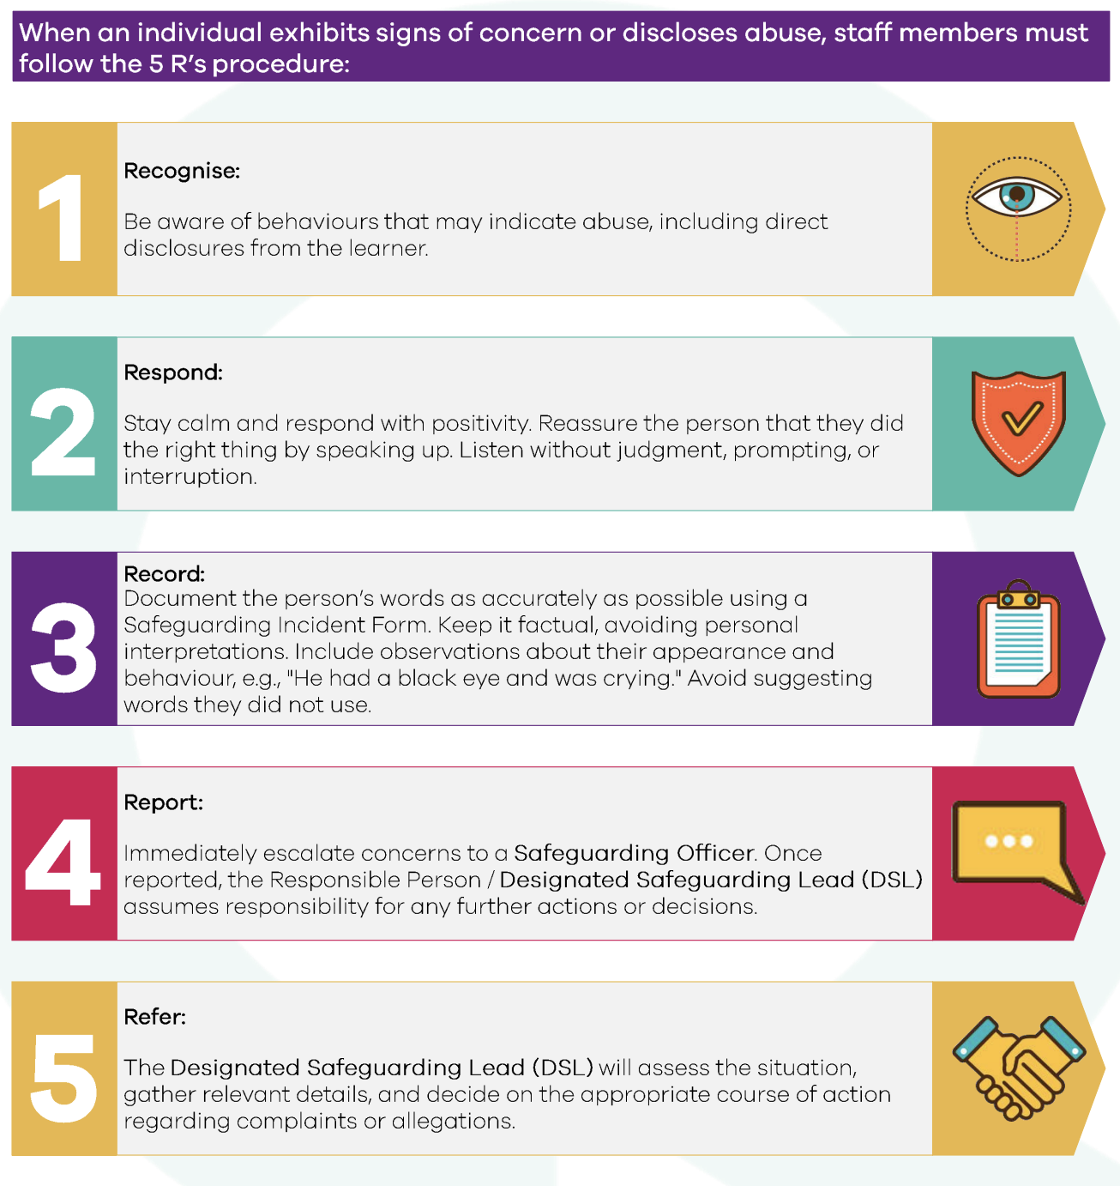

Appendix 4: Step-by-Step Allegation Against Staff Management Protocol

Step 1 Receiving an Allegation
- Allegations may arise through written statements, verbal disclosures, monitoring, anonymous reports, external sources, or legal claims.

Step 2 Immediate Actions
- Adopt a trauma-informed approach; allow the child to speak freely.
- Avoid assumptions, leading questions, or personal investigations.
- Focus on essential facts (who, where, when, other involved parties, immediate safety).
- Record details objectively using the child’s own words and submit to the CPO.
- Explain next steps in an age-appropriate way; do not promise confidentiality.

Step 3 Reporting
- Allegations against staff → report to CPO.
- Allegations against CPO → report to DSL
- Allegations against DSL → report to DSBM
- Use the safeguarding incident reporting form

Step 4 Informing External Authorities
- Preserve digital/physical evidence and consult IT/external agencies if needed.
- Notify NHRC, Aman Centre, Police, Child Protection Services, Ministry or other relevant authorities without delay.
- Determine temporary measures for the alleged perpetrator (suspension, restricted duties, supervision).

Step 6 Investigation
- Fully cooperate with external investigations.
- Internal inquiries may follow, regardless of resignation or non-cooperation.
- Do not offer compromise agreements to halt investigations.

Step 7 Decision and Outcome
- CPO/BOT decide outcomes prioritizing child safety and staff suitability.
- Possible outcomes: no action, advice/support, disciplinary action (including dismissal), referral to regulatory bodies, or safeguarding training.
- Convictions: permanent removal from child contact, mandatory reporting, record updates, and community communication as advised.

Step 8 Post-Case Review
- Conduct a learning review to evaluate procedures, identify lessons, address systemic issues, and update safeguarding policies or training.

Step 9 Support, Debriefing and Review
- Provide support to affected children, families, and staff (counselling if needed).
- Facilitate confidential staff debriefing sessions and review safeguarding practices.
Appendix 5: Safeguarding Response Protocol: Do’s and Don’ts
DO | DON’T
- stay calm and show no signs of shock  - listen and respond with empathy in a non-judgmental and open way  - consider the disclosure seriously and assume you do not have all the information.  - remain calm, supportive, and reassuring, explaining what you need to do (report to the CPO) and why.  - validate the child’s feelings and reassure the child that they have done the right thing in coming forward.  - allow the child control when feasible.  - consider the child’s language needs and whether support in another language is necessary.  - take notes and make a record as soon as possible following the disclosure; | - view images of children (rather ask for a brief description and secure a device as possible evidence for law enforcement);  - interview the child, ask leading or unnecessary questions, or provide language for the child.  - take notes during the disclosure unless it’s part of a counselling session and normalised, or to take note of a few key details and explained as such.  - make promises that may not be able to be honoured (such as promising you won’t tell anyone or that this will never happen again).  - suggest that the child may be to blame in any way for what happened; or  - ask the child to wait until another person can be present to witness the disclosure or repeatedly interview the child or children

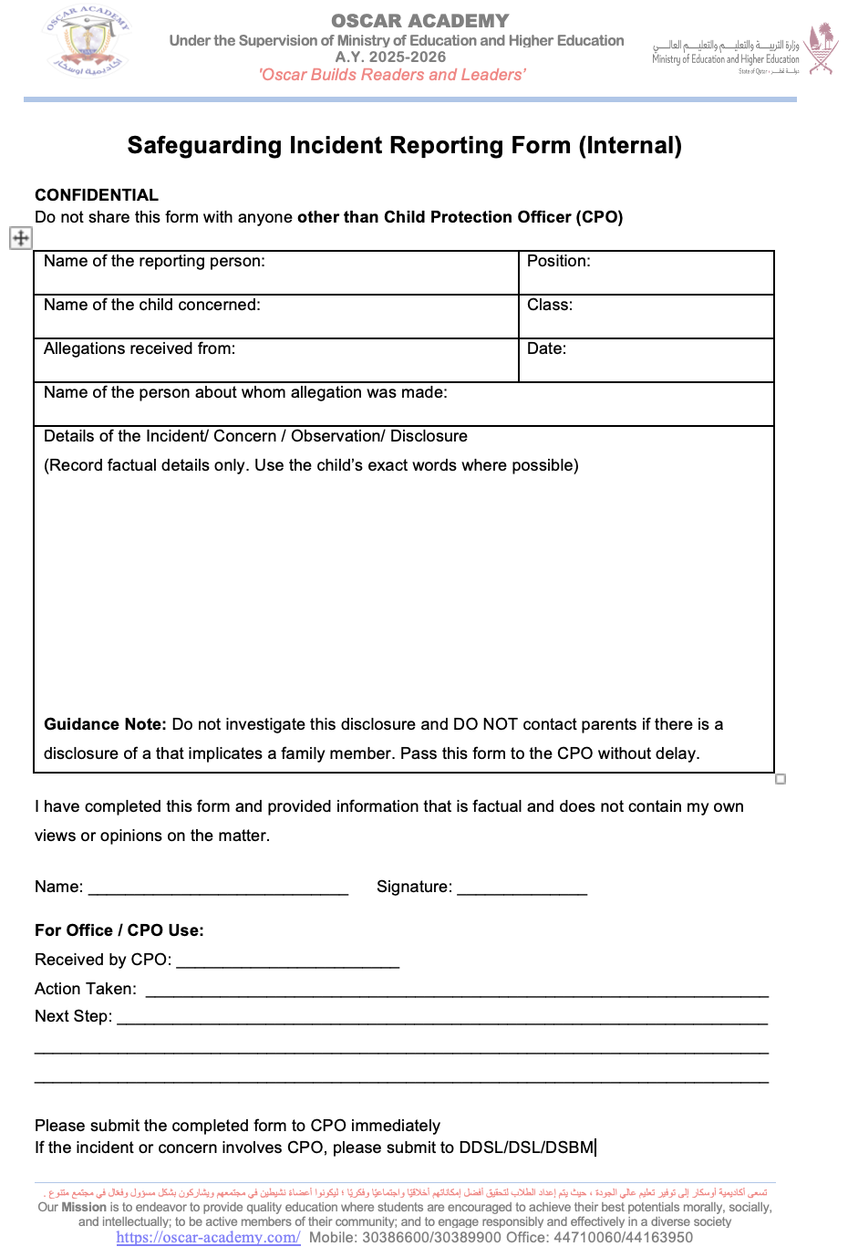
Appendix 6: Safeguarding Incident Reporting Form

Appendix 7: Safeguarding Referral Form

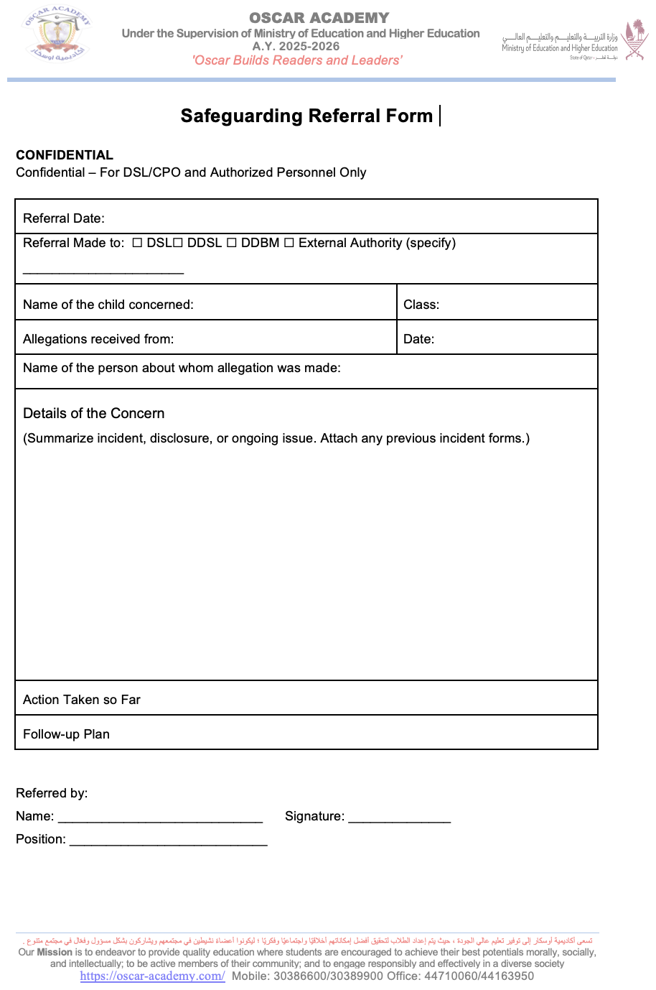

3.ACADEMIC PROGAM, CURRICULUM & OTHERS

CURRICULUM DESCRIPTION FOR OSCAR ACADEMY

School Overview
Oscar Academy is a primary school offering education from Foundation Stage through Year 6, committed to delivering a balanced and holistic learning experience to students of all nationalities and religion, creating a diverse community. The school provides a challenging, coherent and relevant international curriculum for each student that fulfils the schools’ purpose and results in student achievement of the desired outcomes: schoolwide learner outcomes, global competencies, academic standards, and major student learner needs.

Curriculum Framework
Oscar Academy provides a comprehensive curriculum directly linked to Schoolwide Learner Outcomes (SLOs), academic leadership and Islamic Values. For core subjects like English, Math, Science, and Computer Studies, the academy employs a rigorous, modified version of the National Curriculum in England. Simultaneously, subjects such as Arabic, Religion, and Qatar History adhere to the curriculum framework established by Qatar's Ministry of Education and Higher Education. This dual approach ensures the fulfilment of the school's mission and vision, alignment with global competencies and academic standards, and the reinforcement of Islamic values throughout the educational experience.
The curriculum is further structured into key components as outlined below:
- The school follows modified curriculum aligned to the National Curriculum in England for core subjects including English, Mathematics, Science, and Computer. This includes dedicated Mental Math and Spelling & Creative Writing programs, also aligned to the National Curriculum of England aimed at strengthening foundational skills and mental strategies. This framework ensures international academic standards and progressive skill development enriched by current educational research, promoting mastery learning, higher-order thinking skills, and technology integration.
- The curriculum is further enhanced by the inclusion of Arabic Language, Islamic Studies, and Qatar History, delivered in accordance with the Qatar Ministry of Education and Higher Education (MoEHE). This instils national identity and supports values integration, reinforcing students’ spiritual and moral development in line with Islamic values. In addition, Social Studies is integrated into the program to build awareness and appreciation of the local and regional heritage.
- Oscar Academy also runs a comprehensive Values Program in collaboration with the Tarbeya Center, which supports character education and the integration of Islamic values into students’ daily lives across all year levels.
- To meet the diverse learning needs of students, Oscar Academy implements support curriculum such as Road to Success (for Non-Muslim Students) Easy Arabic (for non-native speakers), and Islam is My Deen(For non-Arabic Muslim students) designed to enhance foundational skills, language acquisition, and moral development
- Oscar Academy also offers French as a foreign language, enriching linguistic skills and global readiness.
- Oscar Academy’s Modified Physical Education curriculum aligned to the National Curriculum in England and Cambridge Primary Physical Education promotes students’ physical well-being, teamwork, and healthy lifestyle choices through structured age-appropriate activities that develop motor skills, coordination, and fitness. It fosters discipline, cooperation, and resilience, contributing to students’ holistic development.
- The Modified Arts curriculum, aligned to the National Curriculum of Ireland Art Education, nurtures creativity, self-expression, and cultural appreciation through engaging lessons in visual arts and design integrating Qatar National Identity and Islamic Values. Students explore various artistic techniques while developing critical thinking and fine motor skills in a supportive and inspiring environment.

Schoolwide Learner Outcomes (SLOs)
In line with the school’s Schoolwide Learner Outcomes (SLOs), Oscar Academy ensures that all students develop the skills, knowledge, and dispositions required to succeed in a globalized world. Our emphasis on integrating technology, including AI, aligns with research that highlights the role of digital tools in personalising learning and equipping students for the demands of the 21st century and Qatar Vision 2030. These outcomes are explicitly embedded across subjects, with students expected to demonstrate various abilities
By the time students complete their primary education at Oscar Academy, they will have:
- Academic Excellence
  - Demonstrate higher-order thinking skills (application, analysis, synthesis, evaluation).
  - Achieve proficiency in core subjects (English, Math, Science) aligned with UK and MoEHE standards.
- Global Competencies
  - Critical Thinking & Creativity: Solve problems innovatively using interdisciplinary approaches.
  - Cyber Security Awareness: Practice safe digital habits (password hygiene, privacy protection)
  - Collaboration: Work effectively in teams, respecting diverse perspectives.
  - Communication: Express ideas clearly in English, Arabic, and digital platforms with confidence.
- Citizenship & Values Development
  - Values integration: Uphold Islamic values (integrity, empathy, resilience) fostering moral and spiritual growth through Islamic teachings
  - Moral and Social Growth: Demonstrate ethical behavior and foster respectful relationships in diverse communities.
  - Citizenship: Act as responsible members of Qatar’s community and global society while developing national pride and identity.
  - Digital Citizenship: Demonstrate responsibility in online spaces (cyberbullying prevention, source evaluation).
- Leadership & Identity
  - Exhibit leadership in academic and social contexts.
  - Celebrate Qatar’s national identity while having a a sense of pride in personal and cultural identity and embracing intercultural understanding.
  - Demonstrate initiative by taking on leadership roles.

OSCAR ACADEMY LEARNER’S OUTCOME!!!
“Today a Reader, Tomorrow a Leader…”
Academics | Leaders | Islamic Values
They are lifelong learners. | They are responsible. | They adhere to Islamic values and practices
They are critical thinkers and creative problem solvers. | They are decision makers. | They have good morals.
They are motivated achievers striving for their full potentials. | They are role models. | Respectful
They are bilingual. | They are active members of the community. | Truthful
They are independent. | They are environmentally friendly | Polite
They are confident. | They are cooperative.

Curriculum Implementation & Evaluation
Oscar Academy ensures a systematic, evidence-based approach in the implementation and evaluation of the curriculum.Oscar Academy ensures effective delivery & continuous improvement through:

A. Monitoring & Compliance
- Semester-wise Curriculum Review – conducted at the end of every semester by teachers and team leaders to monitor curriculum implementation, address immediate gaps, and make timely adjustments to teaching strategies and resources.
- Annual Curriculum Review Process - conducted by the Curriculum Review Committee to evaluate curriculum effectiveness.
  - Reviews include:
    - Alignment with Schoolwide Learner Outcomes (SLOs).
    - Updates based on educational research (e.g., mastery learning, AI integration).
    - Feedback from teachers, students, and parents.
Fig. Curriculum Implementation & Evaluation

CURRICULUM REVIEW PROCESS

- Semester-wise & Annual Curriculum Teaching & Learning Resource Review – Textbooks, digital tools and other resources are audited for cultural sensitivity (e.g., inclusive narratives in English/Arabic texts) and MoEHE compliance (especially for Arabic/Islamic subjects) based on the Guide for Approving Core & Supplementary Learning Resources 2021
- Ministry of Education and Higher Eduction (MoEHE) Audits - Mandatory evaluations for Arabic, Islamic Studies, and Qatar History to ensure compliance with national standards, cultural relevance and adherence to Qatar’s educational policies.
- TarbeyaCenter Integration – To embed Islamic values and ethics across subjects. Workshops for teachers and students are conducted on character education.
- Leadership Oversight - Senior Management Team (SMT) &Board of Trustees (BOT) conducts walk throughs to observe classroom implementation of the curriculum. Board of Trustees (BOT) also reviews academic progress quarterly for strategic alignment and alignment with Schoolwide Learner Outcomes (SLOs) .

B. Data-Driven Enhancements
- Internal Assessments
  - Formative Assessments:
    - Weekly quizzes, spelling tests, oral exams.
    - Project-based learning evaluations.
  - Summative Assessments:
    - Mid-term and semester exams.
    - Diagnostic tests to identify learning gaps.
- External Assessments
  - GL Assessments: To measure progress in English, and Math, against international standards.
  - TIMSS (Trends in International Math & Science Study): To evaluate STEM competency.
  - PIRLS (Progress in International Reading Literacy Study): To assess reading comprehension.
- Stakeholder Feedback (Surveys, Staff Input, Parent Newsletters)
  - Student Surveys: To gather input on engagement and difficulty levels.
  - Parent Surveys: To assess satisfaction with curriculum clarity and rigor.
  - Teacher PLCs (Professional Learning Communities): To conduct collaborative reviews of assessment data to adjust teaching strategies.

C. Vertical & Horizontal Alignment

Oscar Academy ensures both horizontal and vertical alignment of its international curriculum through structured schemes of work, collaborative planning, and alignment with international benchmarks.
- Structural Alignment
  - Schemes of Work: Standardized across year groups for horizontal consistency
  - Progression Pathways: Mapped skills from KG-Year 6 (vertical articulation)
  - Standards Alignment Checklist: Regular mapping against UK National Curriculum and Qatar MoEHE standards

SAMPLE CURRICULUM MAPPING
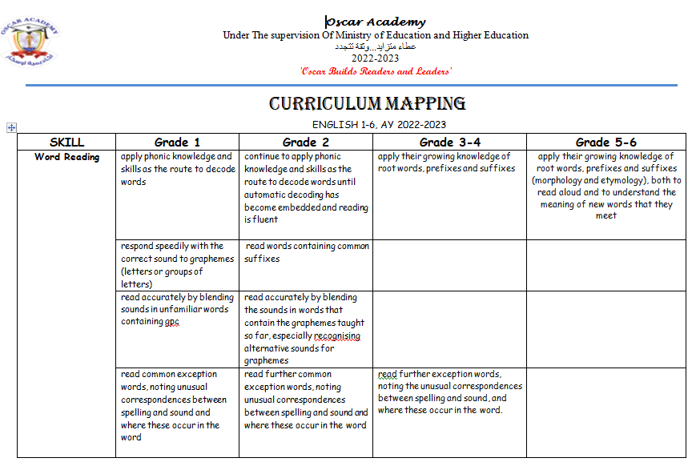
- Collaborative Processes
  - Cross-Grade Planning: Weekly departmental meetings to align instruction
  - Curriculum Mapping: Tracking of content/skill coverage each semester
  - Professional Development: Workshops on alignment strategies and curriculum review process for the teachers
- Supporting Tools
  - Unit / Chapter Summaries Topic overviews distributed

Ensuring Student Success: Access & Differentiation
Through a well-structured, multi-tiered support system, differentiated instruction and diverse programmes, Oscar Academy ensures that all students have access to a challenging, relevant, and coherent international curriculum regardless of their abilities, interests, backgrounds, or learning styles. All teachers are trained to integrate strategies to further support students un their learning. Differentiated instruction and the use of diverse resources to supplement teaching and learning is evident across departments.
- Enrichment for High Achievers are done through tiered assignments, peer- coaching, project-based learning, choice boards, higher order thinking challenges and extracurricular competitions like debates, mental math champion, super speller, Quran recitation, Quran memorization and weekly Islamic ethos awards, Best reader of the week and Mental Math Superstar. Access arrangements are also applied to both internal and external exams (TIMS/PIRLS/GL).
- Support plans are in place to address specific needs of the underperforming students, and these are compiled collaboratively by the Homeroom Teacher and the Learning Support staff. Morning and Afternoon Support lessons are in place to provide targeted assistance for students who need additional help in core subjects, reinforce key skills, close learning gaps, and offer personalized guidance to ensure all learners can progress confidently and achieve their full potential.
- Online enrichment classes are provided to support students in the enrichment of English language and Math skills every Saturday through Zoom Platform.
- Support Curriculum is provided to support students from diverse linguistic and cultural backgrounds.

Non-native speakers | Easy Arabic curriculum that focuses on practical language skills, and foundational literacy, enabling them to engage meaningfully without prior exposure to the language.
Non-native Muslims | Islam is My Deen (Religion in English) using simplified vocabulary, visual aids, and interactive teaching methods to promote inclusivity and understanding of moral and ethical values.
Non- Muslim students | "Road to Success" program offered as a character development and life skills alternative, focusing on universal values such as respect, honesty, responsibility, and community engagement.

Measuring Impact: Standards & Progress Tracking

To measure effectiveness, ensure academic growth, and maintain high standards, Oscar Academy employs a comprehensive system of monitoring, evaluating, and tracking learning outcomes is implemented. This framework includes the following key elements:

A. Learning Objectives (Shared in Every Lesson)
- Clearly defined and communicated to students at the start of each lesson.
- Ensures transparency and helps students understand expectations.
- Aligns with curriculum goals and skill development.

B. Unit / Chapter Summaries (Shared After Completion)
- Recap of key concepts, skills, and takeaways at the end of each unit/chapter.
- Reinforces learning and helps students consolidate knowledge.
- Guides targeted revision and may include visual summaries.

C. Formative & Summative Assessments
- Formative Assessments (Ongoing Checks) - Quizzes, exit tickets, class discussions, and peer reviews are used to adjust teaching strategies.
- Summative Assessments (End-of-Unit Evaluations) - Exams, projects, and performance tasks are conducted to measure mastery of content against set benchmarks.
- Rubrics - Clear grading criteria facilitate and measure student academic growth. With the internal exam grading system revised in the past year, it now ensures greater consistency and fairness while providing a more accurate and effective assessment of student learning.
D. Data-Driven Analysis
- Classroom Observations – Regular class observations monitor teaching effectiveness, student engagement, and curriculum alignment. The resulting feedback informs targeted professional development and instructional improvement. Classroom observation checklists are periodically updated to include students’ role along with the teacher’s role to measure both the student learning outcome and the impact of professional development on teaching practices
- Weekly Department Meetings – Department meetings are held regularly to review weekly practices, reflect on curriculum standards, and evaluate extracurricular activities and competitions.
- Exam Results & Performance Trends – The exam results are analysed to identify student strengths, monitor academic progress, and highlight areas that require targeted improvement after every internal and external exam.
- Teachers’ Self-Reviews – Teachers regularly engage in reflective self-evaluation to enhance instructional practices and support professional growth. A structured self-review questionnaire is completed, and findings from these evaluations guide targeted professional development sessions conducted each semester.
- Parent & Student Feedback (Questionnaires/Surveys) - Structured surveys conducted twice a year gather valuable insights on teaching quality, student support, school practices, policies & facilities and overall satisfaction from both parents and learners.

E. External Benchmarks (Standardized Assessments)
- TIMSS (Trends in International Mathematics and Science Study) – TIMSS assesses Year 5 students’ proficiency in mathematics and science, allowing comparison with international performance standards.
- PIRLS (Progress in International Reading Literacy Study) – PIRLS evaluates reading comprehension skills in Year 5 students, focusing on how well they understand and interpret written texts.
- GL Assessments – GL Assessments, initiated and funded by the school, provides standardized and externally validated data on student achievement in core subjects, English and Maths, to support benchmarking and targeted intervention typically conducted in Years 3 and 5. However, they were extended to Years 4 and 6 to measure continuous improvement and learning progression.
Alignment of Curricular and Co-Curricular Activities
The curriculum at Oscar Academy is purposefully interwoven with a rich array of co-curricular activities to create a holistic and impactful learning experience. This deliberate alignment, guided by academic standards, Schoolwide Learner Outcomes, and the Qatar National Vision 2030, ensures that learning extends beyond the classroom. The academy implements annual activities plan that strategically incorporates programmes from the Ministry of Education and Higher Education, nurturing national pride and identity through:
Academic Enrichment Activities:
- Mathematics:
• Math Breaktime Activities
• Multiplication Challenge
• Interclass Math Competition
• Inter-School Math Competition
• Mental Math Superstar
- Language & Literature:
• Best Handwriting Competition
• Dictation Competition
• Journal Essay Writing
• Essay Writing Championship (Years 4-6)
• Spelling Bee
• Story telling
• Character Day
- Science & Innovation:
• Science Breaktime Activities
• 5-Minute Science Experiments
• Science Experiment Day
Cultural & Creative Pursuits:
• Stories of the Prophets Competition
• Hadith Competition
• Qatari Heritage Activity
• Photography Contest (Qatari Landmarks)
• Arts Competition
• Arab Country Day
• Recycling Competition
• Value Based Activities
Performance & Leadership Development:
• Debate Competition
• Talent Show
• Qatar History Competition
Sports & Physical Development:
• Interclass Sports Tournaments
• Friendly football match
• Inter-school Sports Competitions
• Physical Fitness Challenges during breaktimes

Curriculum Committee
At Oscar Academy, the Curriculum Committee plays a pivotal role in shaping a curriculum that remains dynamic, inclusive, relevant, and aligned with national and international educational standards, the preservation of Qatar identity, and actively supporting the objectives of ofQatar Vision 2030 to meet the diverse needs of our students

This collaborative team consisting of members from the Senior Leadership Team (SLT), Senior Management Team (SMT), and teaching staff, works collaboratively to plan, evaluate, and enhance curriculum design and delivery. Through regular meetings, data- driven reviews, integration of stakeholder feedback, the committee ensures the curriculum supports high academic standards, nurtures 21st-century competencies, and reflects the academy’s core values and vision for student success, all while fostering an understanding and appreciation of Qatar's heritage and future aspirations as outlined in Qatar Vision 2030. The committee fosters innovation and continuous improvement in our teaching and learning environment.

Staff | Roles
SLT (BOT-CEO-Principal) | - Establishing the strategic goals and priorities for curriculum development and review to inform curriculum effectiveness.  - Overseeing the strategic direction and alignment of the curriculum with national and international standards.  - Monitoring students’ academic performance through result analysis and progress reports each semester.  - Monitoring the impact of professional development on teaching practices through classroom observations.  - Reviewing feedback from student and parent questionnaires regarding curriculum and extracurricular activities to ensure alignment with stakeholder needs.  - Allocating and overseeing the budget allocated for curriculum development, resources, and related professional development.
SMT (AVP – Team Leaders/ Academic Secretary) | - Designing and conducting professional development for all teachers regarding curriculum planning, review, and effective teaching strategies aligned with curriculum.  - Ensuring availability of teaching resources aligned with British curriculum and complying with Qatar Ministry of Education and Higher Education  - Analysing student results and teaching practice outcomes each semester to identify trends, areas for improvement, and the impact of curriculum implementation.  - Monitoring teacher performance and monitoring the extent to which curriculum standards are being applied in the classroom, as well as measuring the effectiveness of school curriculum mapping.  - Facilitating communication and collaboration among teachers and teams regarding curriculum matters.  - Leading, supporting and collaborating subject-specific curriculum development and review initiatives through Team Leaders.
Teachers | - Actively participate in curriculum planning, review, and development based on student needs and curriculum standards.  - Providing valuable insights into the practical implementation of the curriculum and its impact on student learning to inform ongoing curriculum improvement.  - Sharing timely feedback on the curriculum implementation, challenges, materials and resource needs  - Contributing to the development and revision of curriculum documents.  - Collaborating with colleagues to ensure coherence and alignment within and across grade levels and subject areas.  - Bringing innovative ideas and best practices from their classroom experiences to the committee discussions.  - Participating in pilot programs or trials of new curriculum approaches and providing feedback.

The booklist we used at OSCAR Academy which aligned with the UK curriculum:
CLASS | English | Math | Science |  | Computer
 |  |  |  | Social | Computer
Year | Macmillan | Abacus | Macmillan | for A better  Word level 1 | Computer  Club –
1 | level 1 | evolve | Science1 | for A better  Word level 1 | Win 7
 |  | level 1 |  | for A better  Word level 1
Year 2 | Macmillan | Abacus | Macmillan | for A better  Word level 2 | Computer  Club –
Year 2 | level 2 | evolve | Science2 | for A better  Word level 2 | Win 7
Year 2 |  | Level 2 |  | for A better  Word level 2
Year 3 | Macmillan | Abacus | Macmillan | for A better  Word level 3 | Computer  Club –
Year 3 | level 3 | evolve | Science3 | for A better  Word level 3 | Win 7
Year 3 |  | level 3 |  | for A better  Word level 3
Year 4 | Macmillan | Abacus  evolve | Macmillan | for A better  Word level 4 | Computer  Club –
Year 4 | level 4 | level 4 | Science4 | for A better  Word level 4 | Win 7
Year 5 | Macmillan | Abacus  evolve | Macmillan | for A better  Word level 5 | Computer  Club –
Year 5 | level 5 | level 5 | Science5 | for A better  Word level 5 | Win 7
Year 6 | Macmillan | Abacus  evolve | Macmillan | for A better  Word level 6 | Computer  Club –
Year 6 | level 6 | level 6 | Science6 | for A better  Word level 6 | Win 7

Curriculum Committee:
Name | Designation | Delegation
Ms. Aseel Sameer | Principal | Leader
Ms. Maria Cecelia Espina | Vice Principal | Assistant
Ms. Pernalyn Cabasal | Team leader | Member
Ms. Temitope Alice | Team leader | Member
Ms. Fritz Rodriguez | Team leader | Member
Ms. MarielleCenidoza | Team leader | Member
Ms MartinaUgbor | Team leader | Member
Ms. Manal Ali | Team leader | Member
Ms. Eyman Abdulghani | Team leader | Member
Ms. FrancaEnamayo | Teacher | Member
Ms. Rose Malik | Teacher | Member
Ms. Sushi Guan | Teacher | Member
Ms. Esmeralda Santos | Teacher | Member
Ms. Coker Opeyemi | Teacher | Member
Ms. Fazeela Farook | Teacher | Member
Mr. Kamal Javel Mohamed | Head IT Department | Member

CURRICULUM AND EXTRA- CURRICULAR ACTIVITY (ECA) POLICY

Aim:
To provide a balanced and holistic educational experience by integrating academic learning with diverse extra-curricular activities that foster students’ intellectual, emotional, social, and physical development. The policy ensures that both curricula and ECA programs are well-coordinated, inclusive, and aligned with the school's mission to nurture well-rounded individuals.Aligned with the Ministry of Guideline for School Activities in Private Schools and Kindergartens in Qatar, Second Edition 2023-2024.

Roles and Responsibilities

Role | Responsibilities
Principal | - Oversee curriculum and ECA integration with school vision
Principal | - Approve curriculum and activity calendar
Principal | - Monitor overall implementation and reviews
Principal | - Coordinate with external bodies for special programs
Academic Vice Principal | - Handle substitution and teacher scheduling
Academic Vice Principal | - Ensure ECA does not conflict with academics
Academic Vice Principal | - Support time coordination between ECA and academic sessions
Social Worker | - Encourage student participation in ECAs
Social Worker | - Identify students who benefit from specific activities
Social Worker | - Support emotional/social development through ECAs
Social Worker | - Communicate with parents/teachers regarding student needs
Social Worker | - Send and collect parent consent form
Social Worker | -Send SMS to parents
Admin Coordinator | - Manage logistics and space for ECAs and curriculum events
Admin Coordinator | - Coordinate schedules, staff, and materials
Admin Coordinator | - Maintain activity and academic calendars
Admin Coordinator | - Prepare reports and records
Admin Coordinator | - Take the required official approval.
Nurse | - Provide medical readiness and first aid during activities
Nurse | - Maintain health records for activity participation
Nurse | -Check Medical Cases students
Nurse | - Support physical safety protocols
Nurse | - Conduct health awareness sessions when applicable
Teachers | - Monitor students’ well-being during activities
Teachers | - Follow safety protocols and procedures for student health
Teachers | - Report any health concerns to the nurse or administration
Teachers | - Ensure students with medical conditions are properly accommodated during activities
Teachers | - Promote health awareness and preventive care among students when applicable

Types of Curriculum and ECA Activities – Oscar Academy

Category | Academic Activities | Non-Academic Activities
Internal | - English, Maths, Science lessons (Curriculum) / Breaktime Activities  - Arabic & Islamic Studies  - Reading Competitions  - GL Assessments  - PIRLS Assessment  - Support Classes  - Spelling Bee  -Math Quiz Bee  -Essay Writing  - Arabic Dictation Competition  - Best Hand Writing  - Prophets Stories (Religion Dept) | - Art & Craft Club  - Physical Education (PE)  - Storytelling  - Class Assemblies  - School Recycling Projects  -Sport’s Day  - Safety Training  -Healthy Food  -Cultural Competition  -Poster Making  - Pink Day Breast Cancer Awareness  - Diabetes Day  -Garangao Event  - Quran Competition
External | - Cambridge Primary Benchmark Exams  - Inter-school Quizzes  - Arabic Language Contests  - Educational Field Trips  - Reading Competition  -Literacy  - Essay Writing | - Art Competitions (e.g. at MIA)  - Kite Festival Participation  - Sports Meets  - Community Service Events  -Football Competition  - Quran Competition  - Field Trips

CLASS OBSERVATION POLICY AND GUIDELINES

Aims:
The aim of the Classroom Observation Policy is to ensure that Oscar Academy provides the highest quality education services by fostering an environment of continuous improvement. Classroom observations are integral to enhancing teaching practices and student learning outcomes. This policy outlines the purpose, planning, preparation, and feedback processes associated with classroom observations.
Classroom observations will contribute to:
- Improvement of teaching: Helping teachers refine their instructional methods.
- Ensuring Continuing Professional Development (CPD): Facilitating ongoing growth for all teaching staff.
- Identifying and sharing good practices: Allowing effective strategies to be communicated and adopted schoolwide.
- Monitoring the effectiveness of policies and curricula: Assessing how well the school’s and curriculum area policies are implemented in the classroom.
- Evaluating the quality of teaching and learning: Continuously assessing teaching standards at Oscar Academy.
- Prioritizing areas for development: Identifying areas that require improvement at the school, department, or individual teacher level.

Guidelines for Classroom Observation:
- Professionalism and Integrity: Classroom observations must be conducted with professionalism, integrity, and courtesy.
- Advance Agreement: Observers and teachers must agree on the process and expectations of classroom observations in advance.
- Objective Evaluation: The evaluation process will be fair, objective, and based on evidence gathered during the observation.
- Accurate Reporting: Feedback will be honest, precise, and based on the observed lesson.
- Confidentiality: The information gathered during classroom observations will remain confidential.

Planning and Preparing for Class Observations:
In line with the school’s commitment to supportive and developmental classroom observations, the Principal, Academic Vice Principal, and Team Leaders will:
- Meet with Teachers: Discuss the standards of classroom observation and set expectations for monthly (formal and informal) observations.
- Advance Notice: Teachers will be notified at least five working days in advance for formal observations.
- Agreed Timing: Observations will be scheduled at a mutually agreed time between the teacher and observer.
- Sufficient Time between Observations: Adequate time will be given between classroom observations, irrespective of their purpose.
- Qualified Observers: Classroom observations will be conducted by individuals with Qualified Teacher Status (QTS) and appropriate training to offer constructive feedback and support.

Feedback from Observations:
Classroom observations are intended to be supportive and constructive. The feedback process will include:
- Oral Feedback: Teachers will receive oral feedback on the same day as the observation, unless there are exceptional circumstances (e.g., illness).
- Written Feedback: Formal written feedback will be provided within a week of the observation. This will summarize the key points of the lesson observed and outline the development areas.
- Follow-Up Support: If a teacher receives a Satisfactory or Fair rating in consecutive observations, further support and intervention will be provided. This may include:
  - An Action Plan tailored to address areas for improvement.
  - Additional observations to monitor progress.
  - Peer coaching and mentoring by a Buddy Teacher.

Performance Descriptors:
Classroom observations will be rated using the following descriptors:
- Excellent
- Very Good
- Satisfactory
- Fair
If a teacher receives a Satisfactory or Fair rating in successive observations, there will be further intervention to support improvement. This may include:
- An Action Plan to address areas of development.
- Additional observations by Team Leaders and Senior Management Team (SMT).
- Opportunities for peer coaching with a Buddy Teacher for support and guidance.

Conclusion:
Classroom observations are key to maintaining and improving teaching quality at Oscar Academy. By providing constructive feedback, supporting professional development, and identifying areas for improvement, we aim to uphold a high standard of education. These observations serve as a mechanism to continuously evaluate teaching practices and ensure that Oscar Academy remains committed to providing the best educational experience for all students.

Types of Class Observation

In-formal
Formal

SMT
CEO
Advisor of Ministry of Education
Team Leader
Peer
Coaching
SMT
QNSA
ONLINE TEACHING POLICY (CLASS DOJO)

Aim:
- Effective Communication:
To establish more effective communication links between parents, teachers, and students.
- Enhanced Learning Support:
To enhance and support learning by creating a digital platform that fosters engagement and strengthens the partnership between home and school.

Class Dojo is an app that connects parents, teachers, and students. It serves as a communication platform to encourage children, engage parents in their child’s learning, and share updates and feedback. Teachers can create engaging content, provide feedback, and send general class updates, while parents can view their child’s work and communicate directly with teachers.
Roles and Responsibilities – Class Dojo Online Teaching Policy
Stakeholder | Responsibilities
Teachers | 1. Access Class Dojo via www.classdojo.com or the app.  2. Post regular updates such as reminders, weekly celebrations, and key events.  3. Respond to parent messages between 7:00 AM and 2:30 PM (Sunday–Thursday).  4. Maintain professionalism; arrange meetings for detailed discussions.  5. Ensure privacy by not changing passwords or sharing student photos without permission.
Parents | 1. Follow all Class Dojo rules and guidelines.  2. Use the platform to communicate with teachers about their child’s learning.  3. Respect communication hours (7:00 AM – 2:30 PM, weekdays); contact AVP for urgent matters outside these hours.  4. Support their child in uploading work and engaging positively.
Students | 1. Actively participate in Class Dojo tasks and discussions.  2. Communicate respectfully and follow the school’s digital behavior rules.  3. Upload assignments independently, with guidance if needed.  4. Use the platform responsibly and report misuse.
IT Department | 1. Provide technical support for teachers, parents, and students regarding Class Dojo.  2. Manage user access, passwords, and account setup.  3. Ensure data security and privacy compliance on the platform.  4. Train staff and provide assistance during system updates or issues.
Assistant Vice Principal (AVP) | 1. Oversee the implementation of Class Dojo policy across grades.  2. Handle urgent parent communications outside standard hours.  3. Monitor usage reports and support teachers in best practices.  4. Ensure staff are trained and using the platform effectively.
Principal | 1. Provide leadership and ensure accountability in digital communication practices.  2. Approve policy updates and budget allocations related to Class Dojo.  3. Monitor the overall effectiveness of Class Dojo as a communication and learning tool.  4. Ensure data protection and compliance with school-wide digital learning standards.  5. Monitor and analyze parent feedback through regular questionnaires related to Class Dojo use and communication effectiveness.

Note:
For any queries or assistance regarding Class Dojo, please contact the IT Department at 300090337.
This policy ensures a smooth and productive partnership between home and school, promoting student success and well-being.

EDUCATIONAL RESOURCES POLICY

Introduction:
Oscar Academy has established clear policies and procedures regarding the selection and use of educational resources to ensure that they align with the school’s vision, mission, and priorities. These resources must also comply with Qatari practices and Islamic values. This policy outlines the procedures for selecting learning resources and addressing any concerns or challenges that arise in the process. (Aligned with the Ministry of Education & Higher Education-MOEHE Guide for Approving Core and Supplementary Learning Resources in Private Schools and Kindergarten 2021)

Definition of Learning Resources:
Learning resources include textbooks, workbooks, videos, software, and instructional materials used by teachers to help students meet the learning expectations defined by the school and the Ministry of Education and Higher Education (MOEHE). This policy focuses on the core program collection of resources used in the classroom.
The Resource Committee, with recommendations from the Academic Team and SMT (School Management Team), will evaluate and approve the learning resources used in the classroom.

Learning Resources Approval Process:
- Team Leaders will meet with teachers to review educational resources that have been formally evaluated by the Resource Committee before they are used in the classroom.
- The Resource Committee will evaluate resources based on curriculum fit, pedagogy, social considerations, educational needs, and developmental appropriateness, as well as alignment with the school’s vision, mission, priorities, and Islamic values.

Policy and Guidelines:

Teacher-Only Resources:
- The Resource Committee consists of the SMT, Academic Vice Principal, TeamLeaders, and other academic staff, such as practicing teachers with expertise in the relevant year level and subject area for which the resource will be used.

Purchase of Student Textbooks:
- The Resource Committeefor student textbooks will include the SMT, Academic Vice Principal, Team Leaders, and practicing teachers with knowledge of the subject area and understanding of child development and age-specific needs.

Evaluation Criteria:
The general criteria used to evaluate and determine appropriate learning resources include:
- Curriculum Alignment: Resources must support the learning standards and outcomes of the British Education curriculum, including Big Ideas, Core Competencies, content, and skills.
- Practical Application: Resources should help students make connections between what they learn in school and its practical applications in their lives.
- Developmental Appropriateness: Resources must be suitable for the developmental and age-specific needs of students.
- Instructional Design: Resources should have effective instructional and technical design to support student learning.
- Compliance with MOEHE: Resources must meet the standards set by the Ministry of Education and Higher Education.
- Pedagogical and Social Suitability: Resources should align with Qatar’s pedagogical, social, philosophical, and religious values.
- Diversity of Learning Styles: Resources should address the diversity of learning styles in the classroom.
- Promotion of Positive Social Attitudes: Resources should encourage understanding and respect for diversity and individual learning differences.
- Representation of Diverse Experiences: Resources should help students see themselves and their experiences reflected in a pluralistic and democratic society.
- Sensitivity to Controversial Content: Resources should identify and highlight any controversial or offensive elements, ensuring they support positive social attitudes, diversity, and tolerance.
- Safety and Legality: Resources must be free from violence, licentiousness, and support for illegal activities.

Authority and Approval:
- Once the Resource Committee approves a resource, it will be submitted to the SMT for confirmation and then forwarded to the MOEHE for notification and formal approval.
- Once approved by MOEHE, the resources will be used for the academic year unless withdrawn. Teachers will continue to use the approved resources until new ones are reviewed and approved.

Types of Learning Resources:

Hard Copy Learning Resources:
- Books
- Stories
- Magazines

Soft Copy Learning Resources:
- Links
- Websites
- Applications
- Videos

Monitoring and Approving Process:
The Resource Committee will be responsible for ensuring that all learning resources are properly evaluated and approved before being used in the classroom. The resources will be regularly monitored for their relevance, compliance with school policies, and alignment with the curriculum.

REVIEW SCHOOL EDUCATIONAL RESOURCES COMMITTEE
(ARABIC & ENGLISH)

Name | School Position | Role
Safiya Mohammed | Librarian | Leader
Manal Ali AlHassan | ArabicTeacher | Member
Iman Abdulghani | Arabic Teacher | Member
Faziela Farook | Social Studies Teacher | Member
Mohammad Kamal | Computer Teacher | Member
Nahed ElAzab | Arabic Teacher | Member
Rose Ibrahim | English Teacher | Member
Hanan Soboh | English Teacher | Member
Ruveyda Naji | Religion Teacher | Member
Nancy Farid Abdlrahman | Arabic Teacher | Member
Nehal Elgarhy | Religion Teacher | Member

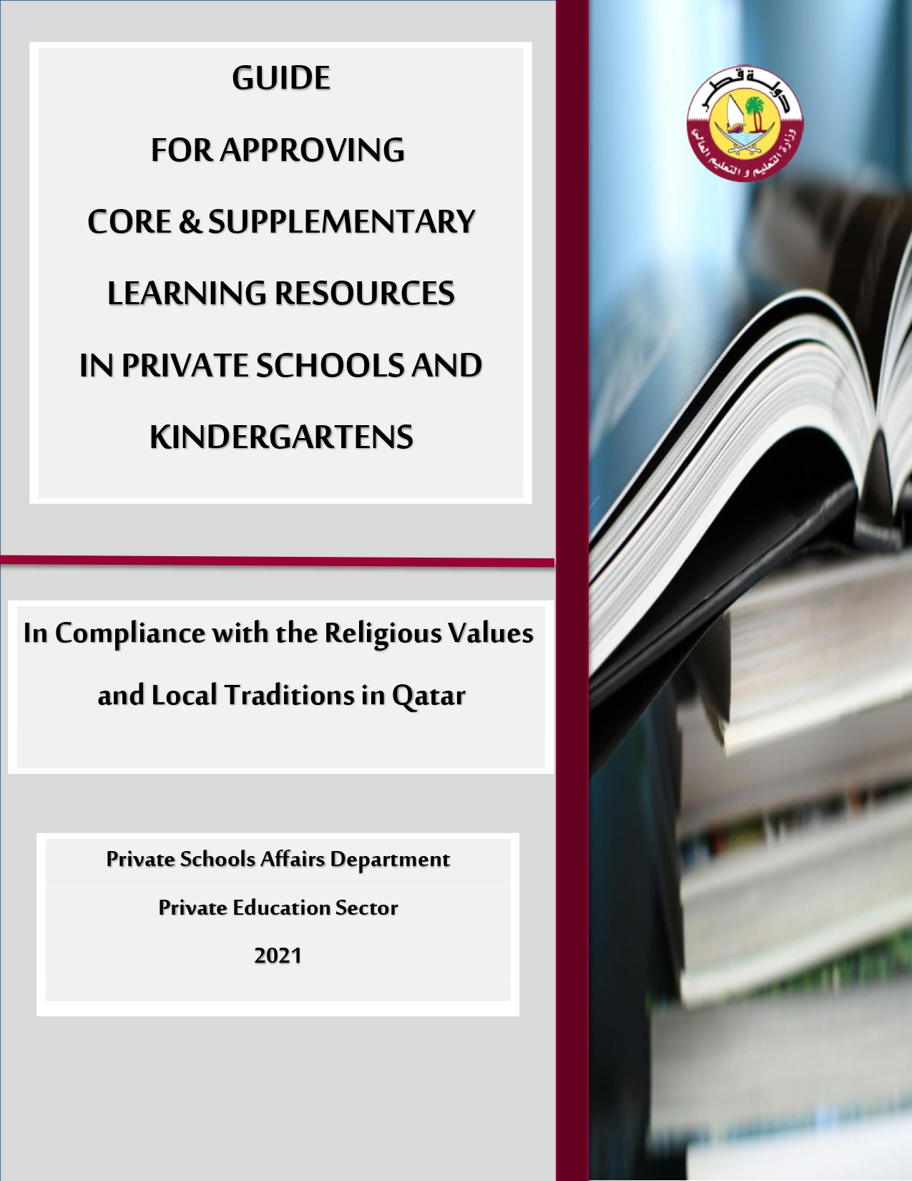
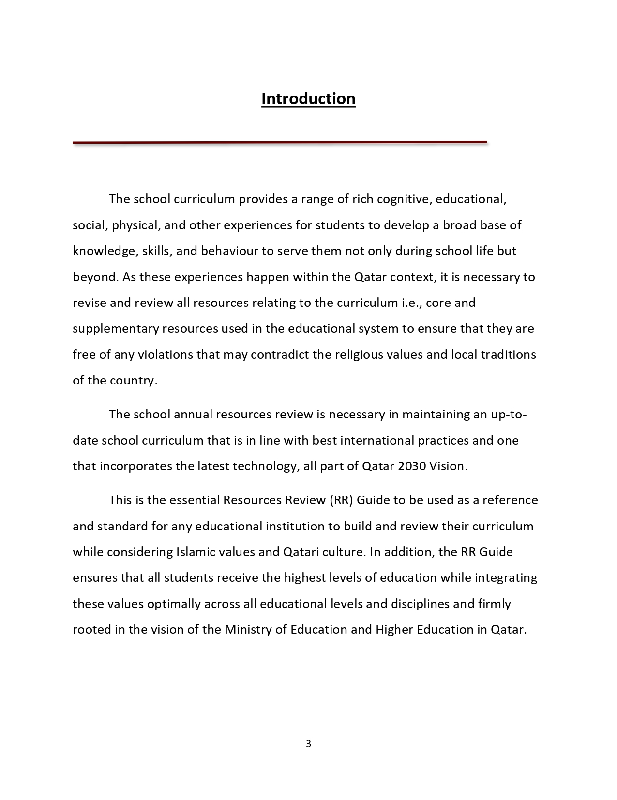
LEARNING RESOURCES GUIDE (MOEHE)

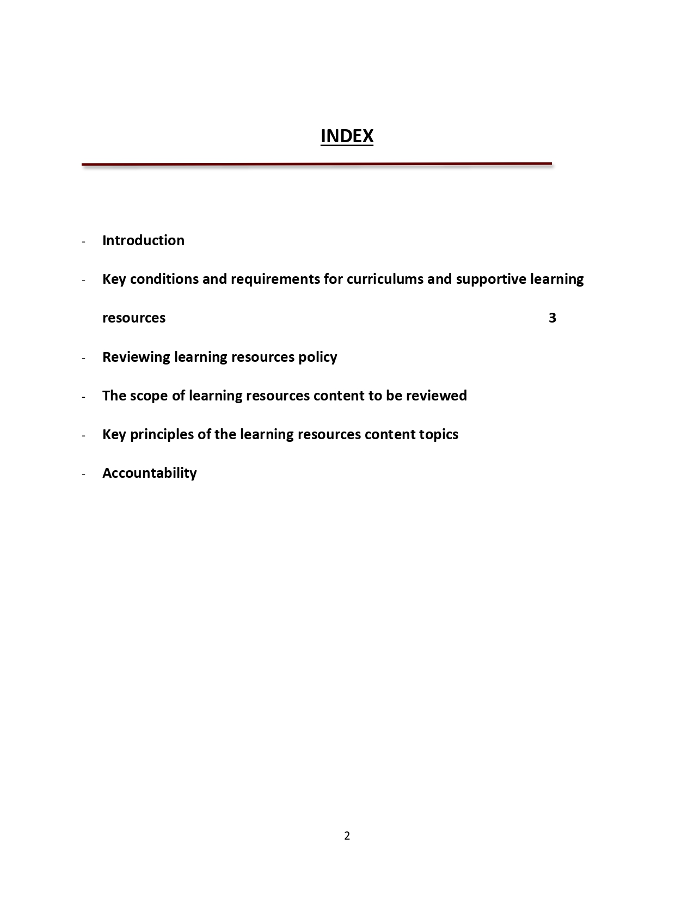
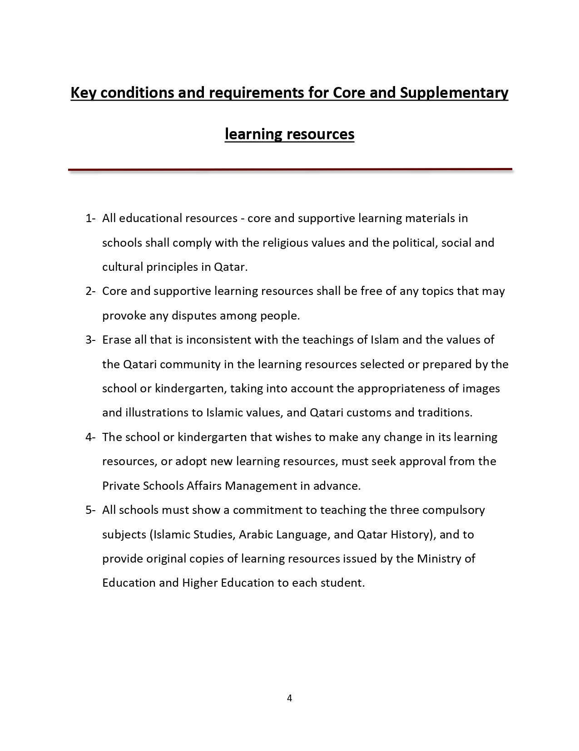

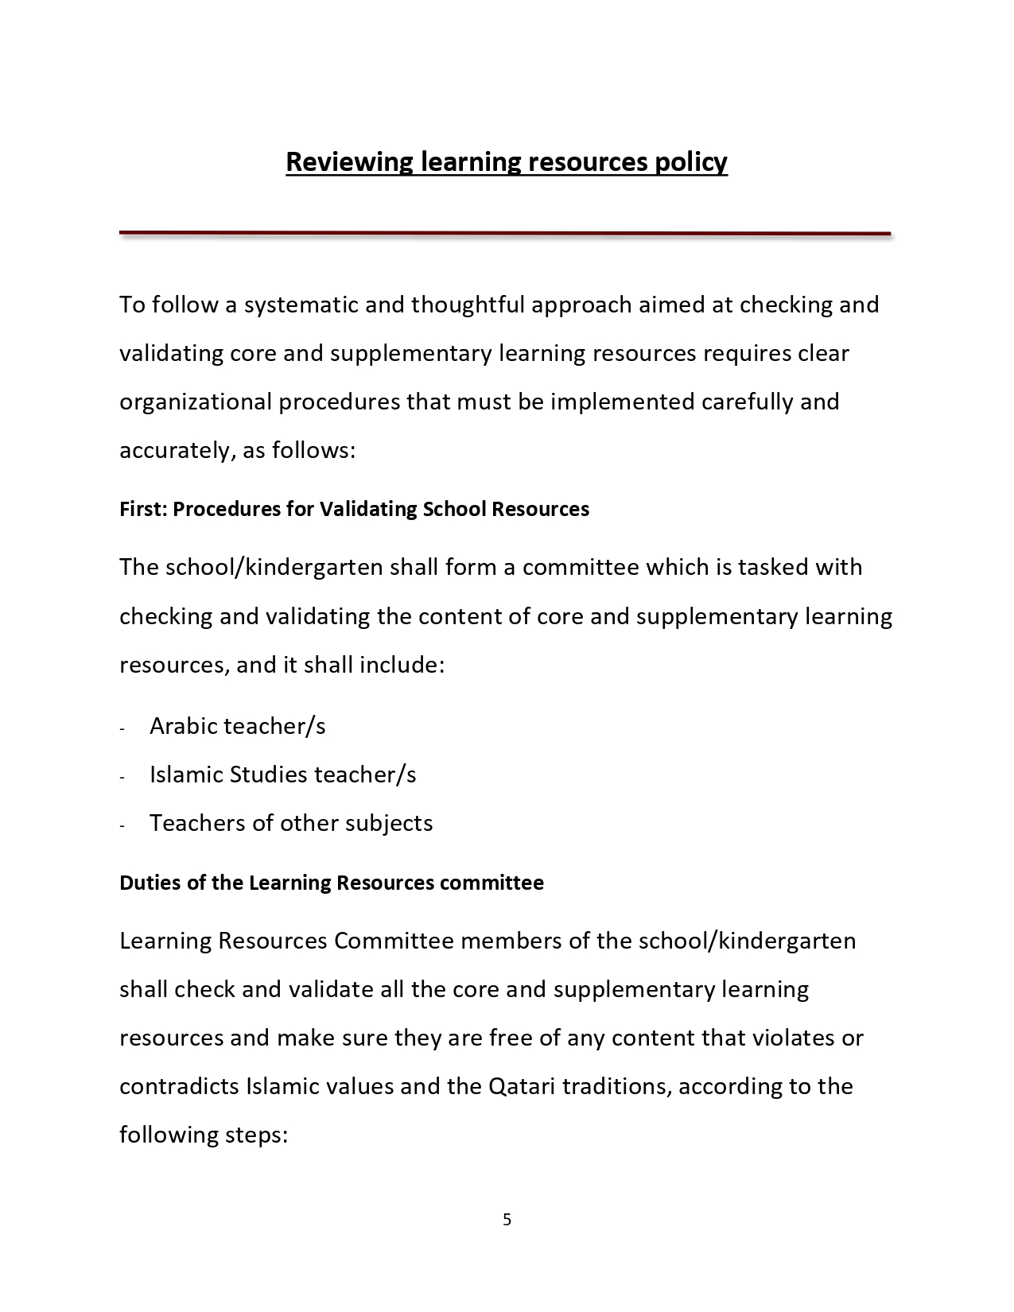
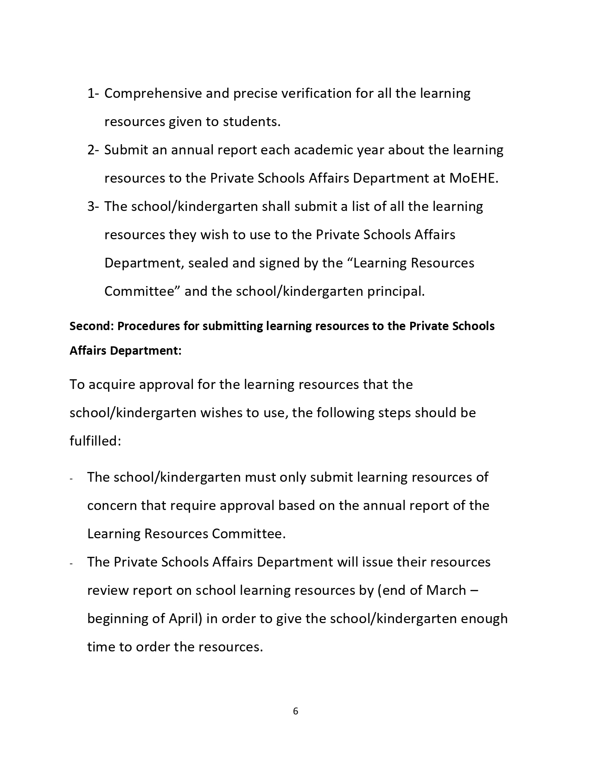

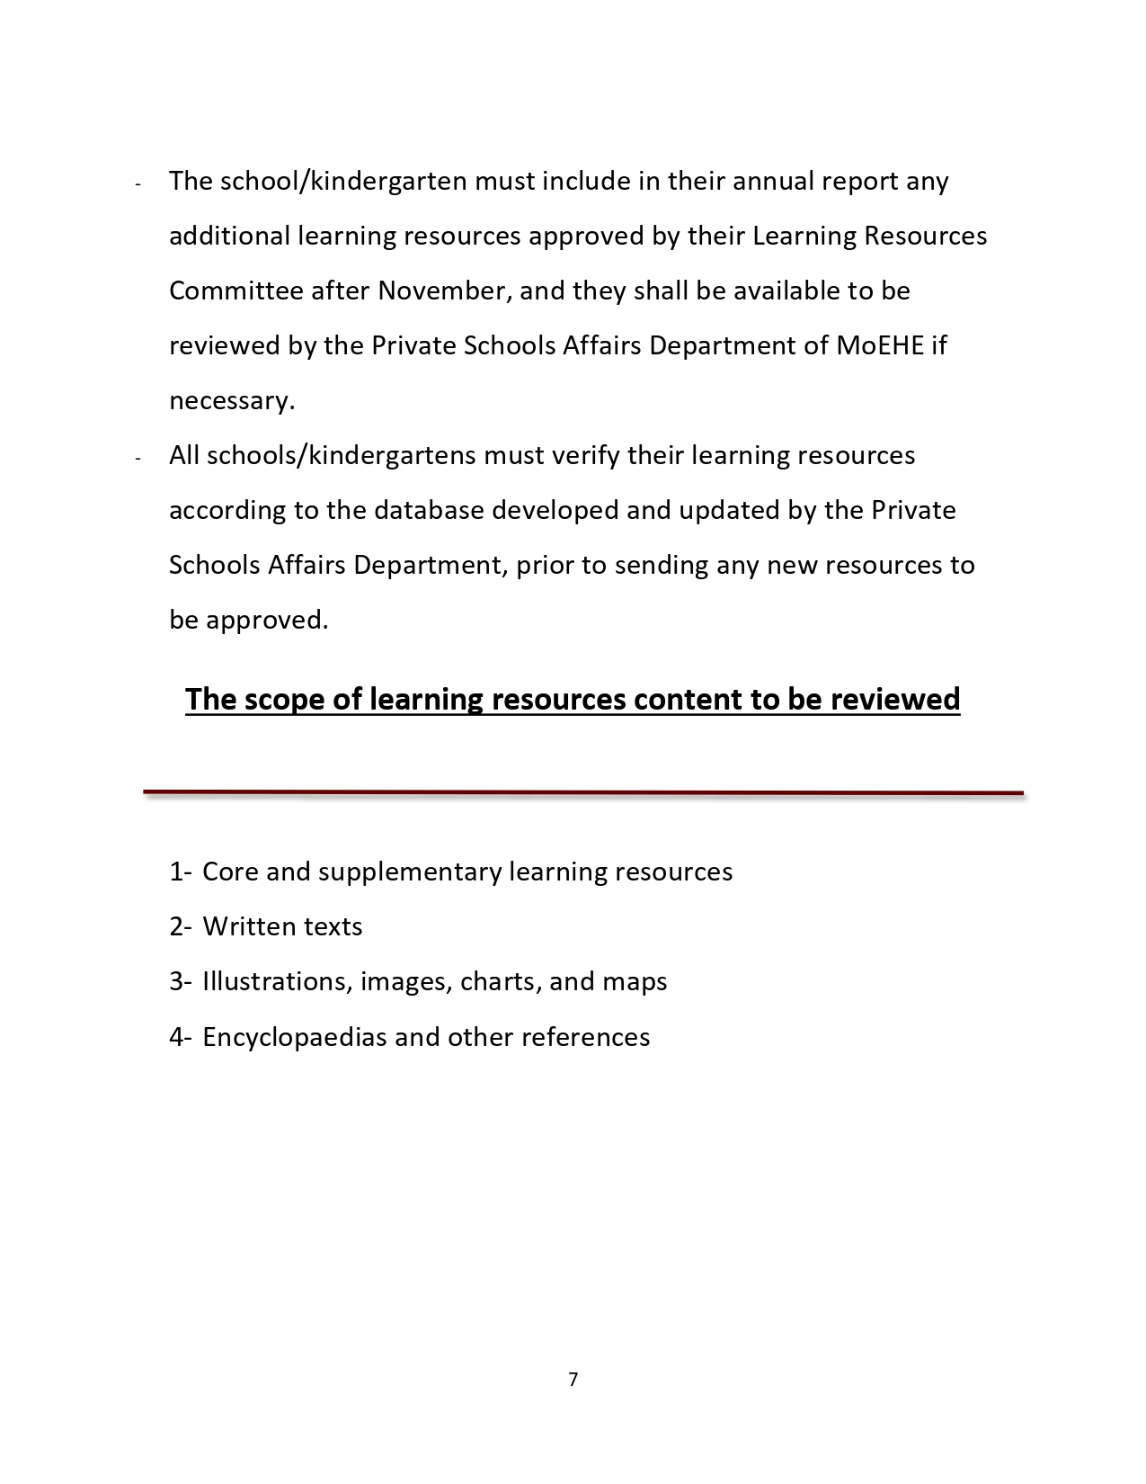

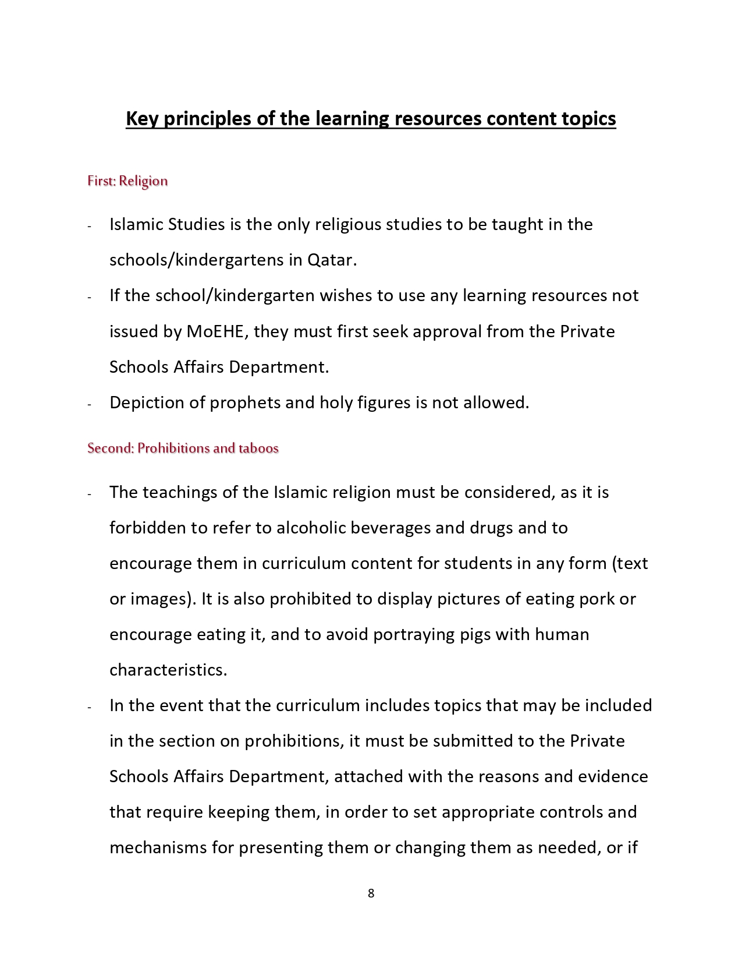
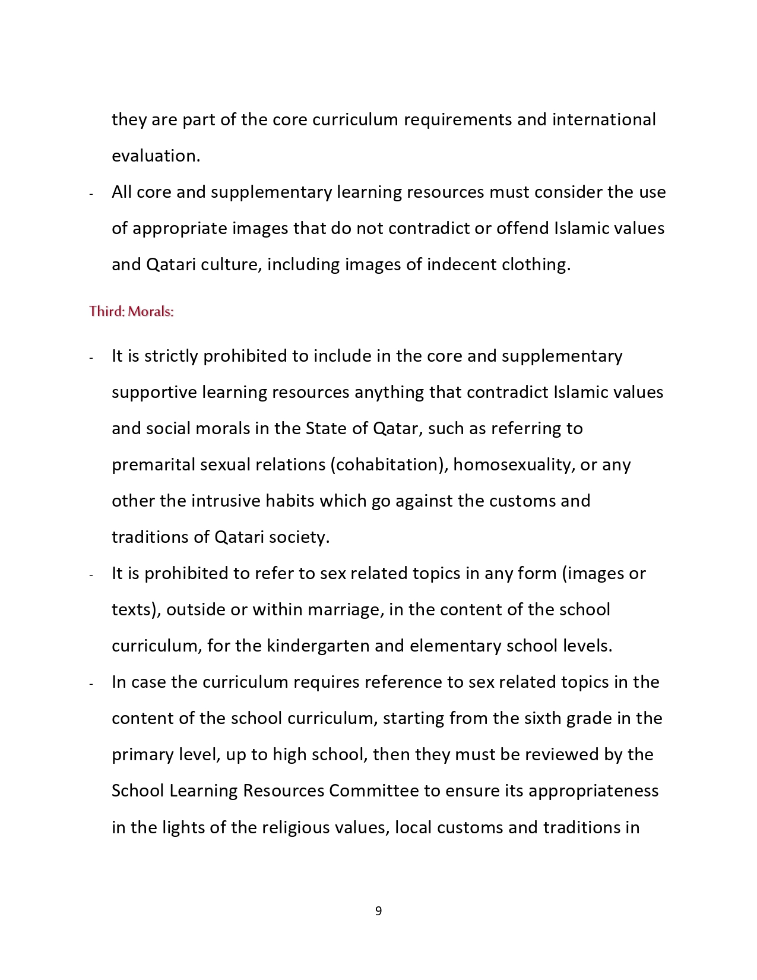
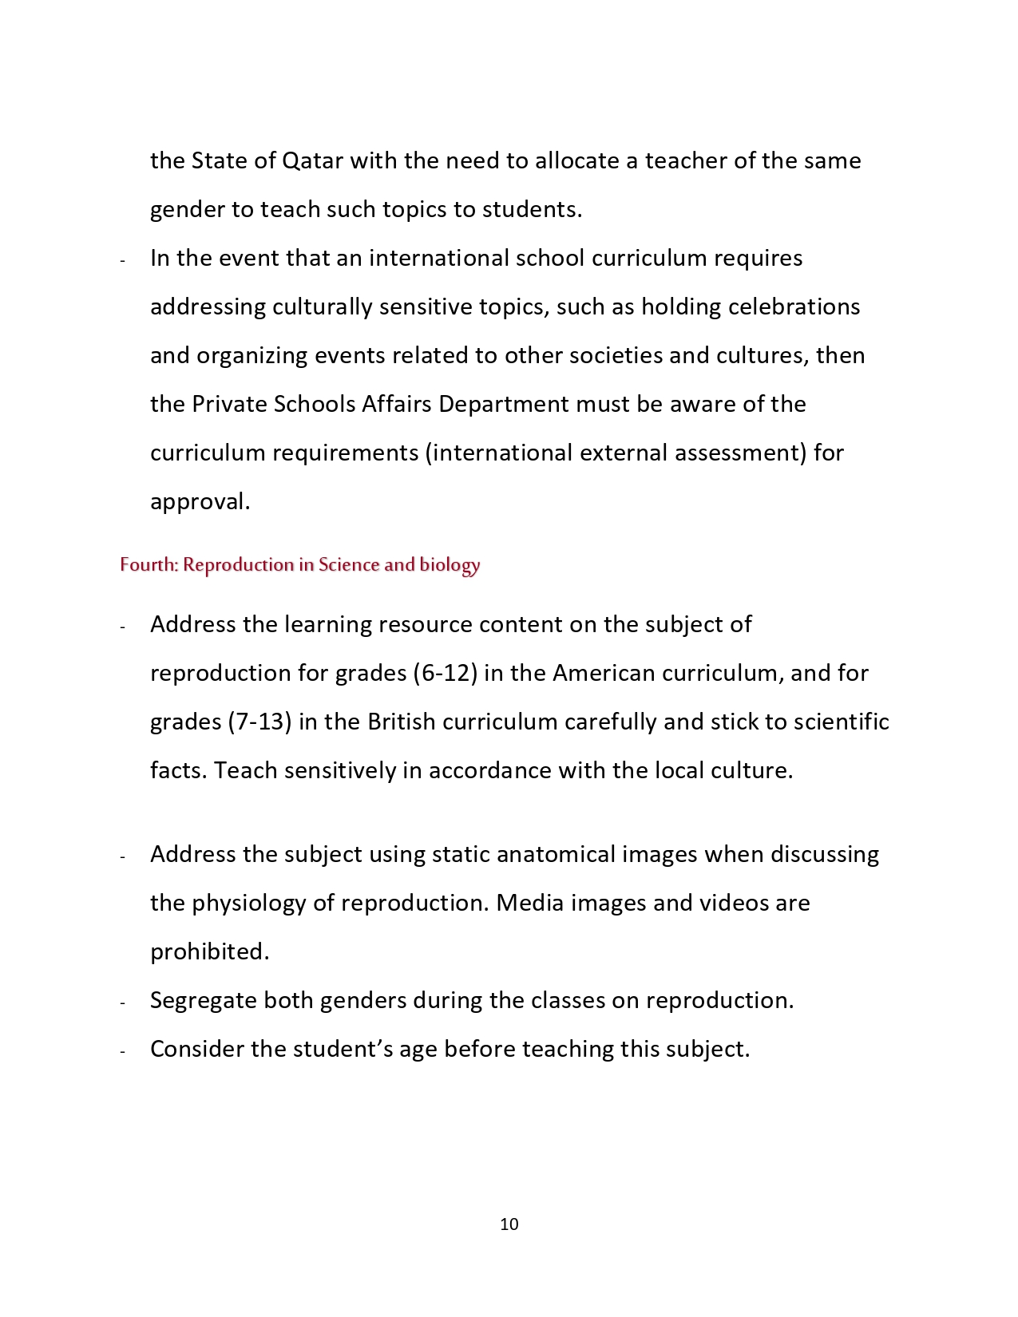
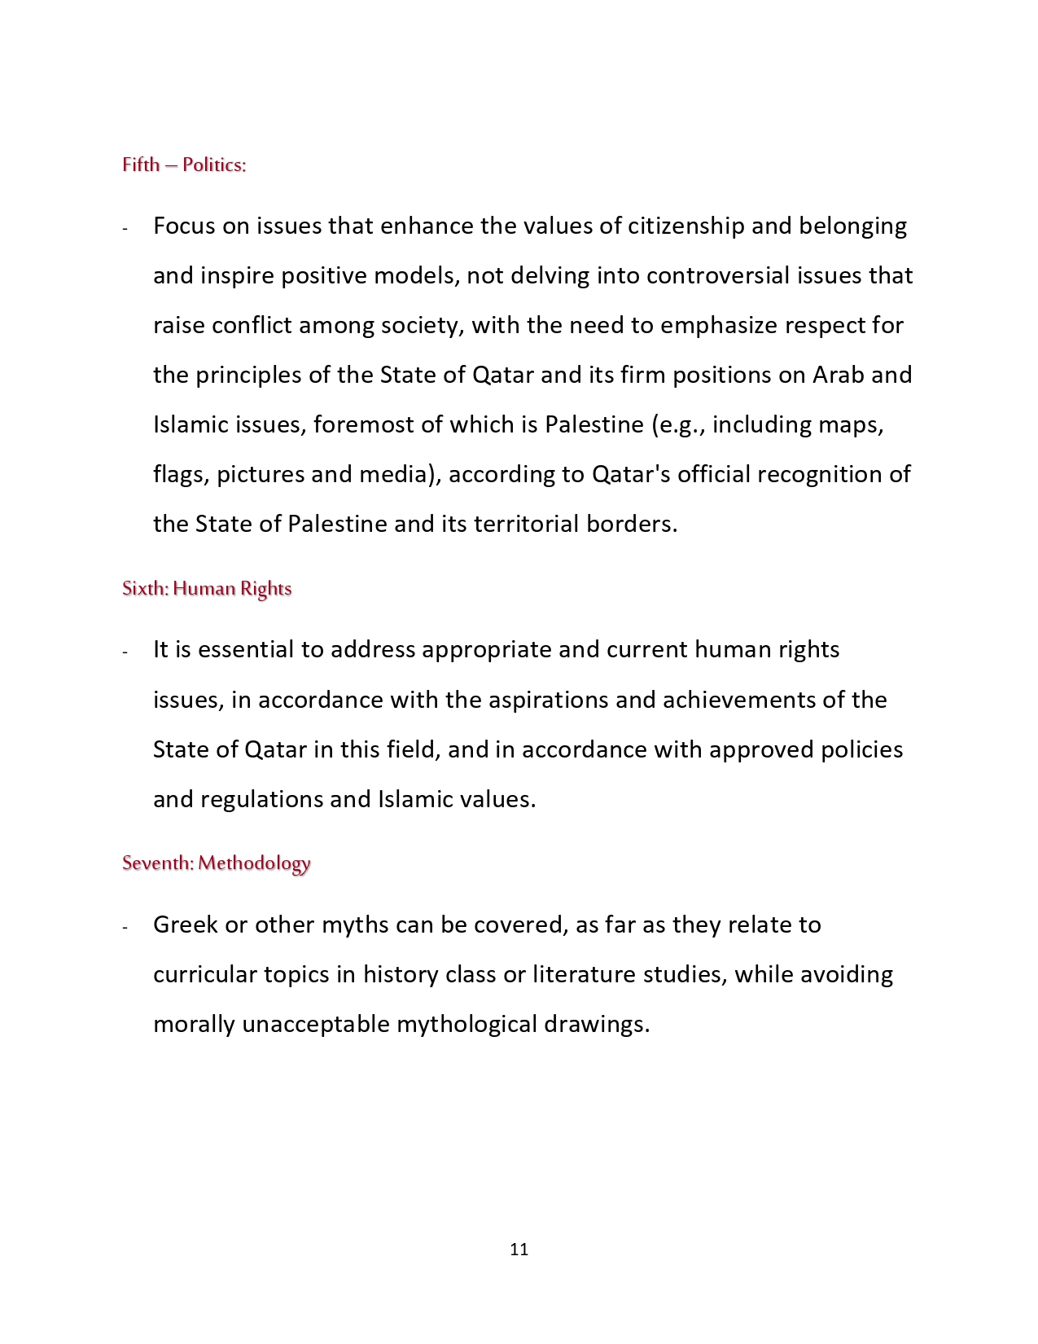
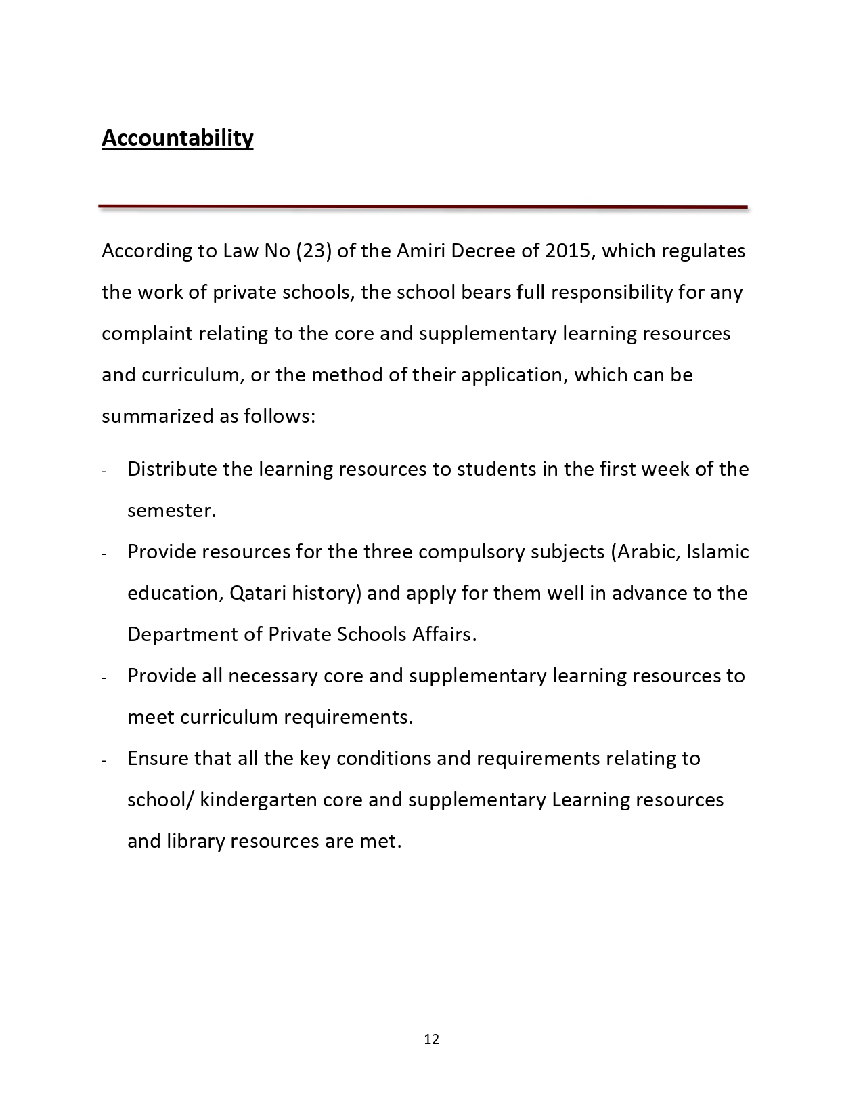

EXAMINATION POLICY (ASSESSMENT POLICY)

Exam System
* The school session has been divided into two (2) terms :
- First term from August to December
- Second term from January- June

* Each term has two exams,
- Monthly Exams
- Second Monthly Exams (2nd Semester)
- Final Semester Exams (1st and 2nd Semester)

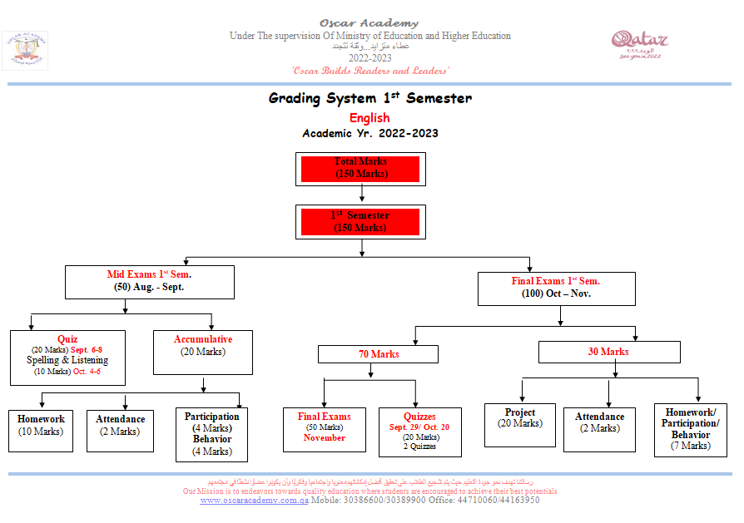

Distribution of Marks for the Second Monthly, and Final Semester Exams
Subject | Monthly October | Semester | Monthly | Final
Subject | Monthly October | December | March | June
English | 50 | 150 | 50 | 150
Math | 50 | 150 | 50 | 150
Science | 50 | 150 | 50 | 150
Social | 50 | 150 | 50 | 150
Arabic | 50 | 150 | 50 | 150
Religion | 50 | 150 | 50 | 150
Religion in English for  non native | 50 | 150 | 50 | 150
Road to Success for  Non Muslim | 50 | 150 | 50 | 150
Computer | 50 | 50 | 50 | 50
Q. History | 50 | 50 | 50 | 50
French( fromyear 3 to 6) | 50 | 50 | 50 | 50
Art | 50 | 50 | 50 | 50
Physical Education | 50 | 50 | 50 | 50
*Arabic, Religion and QH Exams are patterned according to the guidelines set by the MOEHE.
*Other subjects like English, Math and Science are based according to the standards by the Uk curriculum

.
Type of Exams:
Formative Exams:
The goal of formative assessment is to monitor student learning to provide ongoing feedback that can be used by teachers to improve their teaching and by students to improve their learning. Formative assessments are generally low stakes, which means that they have low or no point value.
- Quizzes
- Spelling
- Mental math
- Oral
- Small competitions among students groups
Summative Exams:
The goal of summative assessment is to evaluate student learning at the end of an instructional unit by comparing it against some standard or benchmark.
Summative assessments are often high stakes, which means that they have a high point value.
- Diagnostic test
- Monthly exam
- Semester exam
- Projects
- Dictation
- Oral Exam
- Mental Math

International Exams:

It is important for us to evaluate student level with international exam and analyze the results to improve the weaknesses if any.
- Students participate in TIMSS/PERLS when ever conducted to compare the level of students in Math and English
- Students also participated in Granada Learning (GL Exam) .GL Assessment is the leading provider of formative assessments to UK schools, as well as providing assessments for overseas ministries and British, bilingual and international schools in over 100 countries worldwide. This exam provides us analysis to check the level of student in English and compare to other countries.

Academic Result

Academic result is send to the parents after each exams followed by the parents’ teacher meeting to discuss the progress of the student. (Except for Final Exams)

EXAMINATION POLICY (ASSESSMENT POLICY)

Exam System
* The school session has been divided into two (2) terms :
- First term from August to December
- Second term from January- June

* Each term has two exams,
- Monthly Exams
- Second Monthly Exams (2nd Semester)
- Final Semester Exams (1st and 2nd Semester)

Distribution of Marks for the Second Monthly, and Final Semester Exams
Subject | Monthly October | Semester | Monthly | Final
Subject | Monthly October | December | March | June
English | 50 | 150 | 50 | 150
Math | 50 | 150 | 50 | 150
Science | 50 | 150 | 50 | 150
Social | 50 | 150 | 50 | 150
Arabic | 50 | 150 | 50 | 150
Religion | 50 | 150 | 50 | 150
Religion in English for  non native | 50 | 150 | 50 | 150
Road to Success for  Non Muslim | 50 | 150 | 50 | 150
Computer | 50 | 50 | 50 | 50
Q. History | 50 | 50 | 50 | 50
French( fromyear 3 to 6) | 50 | 50 | 50 | 50
Art | 50 | 50 | 50 | 50
Physical Education | 50 | 50 | 50 | 50
*Arabic, Religion and QH Exams are patterned according to the guidelines set by the MOEHE.
*Other subjects like English, Math and Science are based according to the standards by the Uk curriculum

Type of Exams:
    - Entrance test
    - Diagnostic Examination
    - Formative Exams:
The goal of formative assessment is to monitor student learning to provide ongoing feedback that can be used by teachers to improve their teaching and by students to improve their learning. Formative assessments are generally low stakes, which means that they have low or no point value.
- Quizzes
- Spelling
- Mental math
- Oral
- Small competitions among students groups

Summative Exams:
The goal of summative assessment is to evaluate student learning at the end of an instructional unit by comparing it against some standard or benchmark.
Summative assessments are often high stakes, which means that they have a high point value.
- Diagnostic test
- Monthly exam
- Semester exam
- Projects
- Dictation
- Oral Exam
- Mental Math
International Exams:
It is important for us to evaluate student level with international exam and analyze the results to improve the weaknesses if any.
- Students participate in TIMSS/PERLS when ever conducted to compare the level of students in Math and English
- Students also participated in Granada Learning (GL Exam) .GL Assessment is the leading provider of formative assessments to UK schools, as well as providing assessments for overseas ministries and British, bilingual and international schools in over 100 countries worldwide. This exam provides us analysis to check the level of student in English and compare to other countries.
Academic Result
Academic result is send to the parents after each exams followed by the parents’ teacher meeting to discuss the progress of the student. (Except for Final Exams)

MONTHLY AND SEMESTER EXAM REPORT CARD:
Monthly and semester report card has marks from the exam and class accumulative marks added together.
Final Exam Report Card:
The final report card reflects the overall performance of a child throughout the year. It includes the marks from first semester as well as second semester. The child is graded on combine marks of both the semester.
Sample report card:

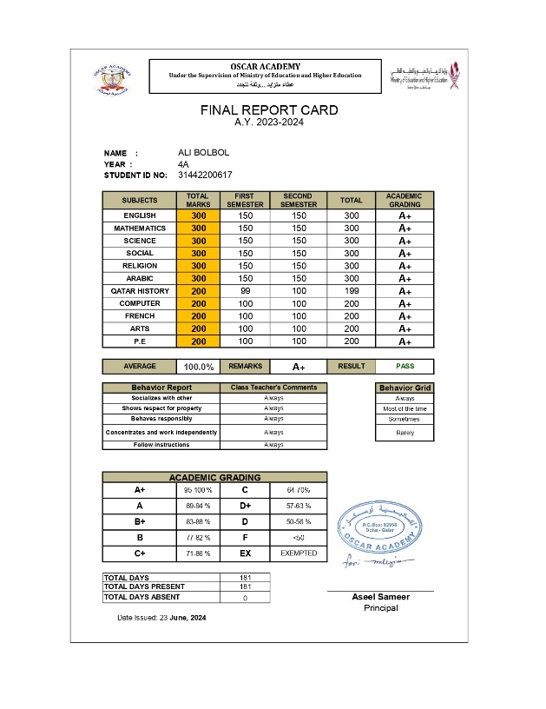
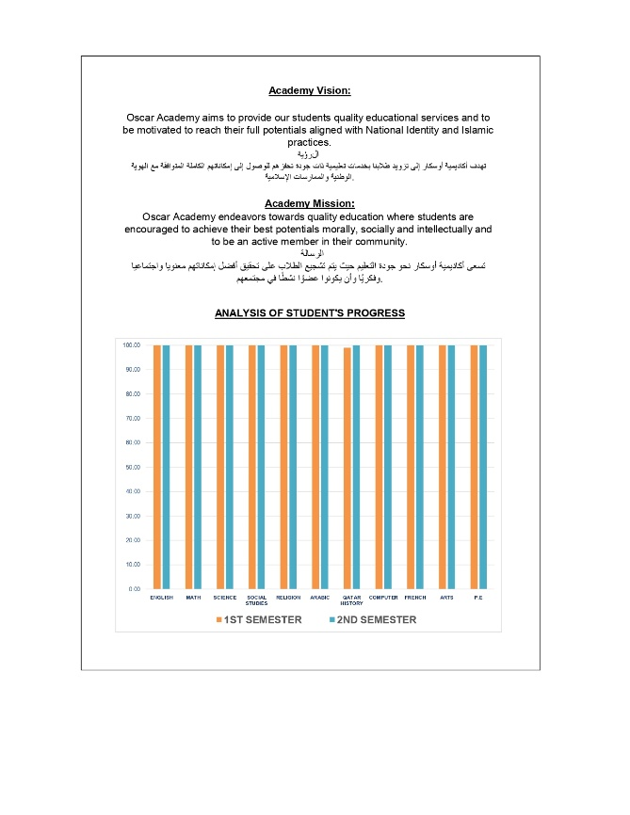
Behavior Report

Monthly Behavior Report is given to Parents every month to sign and write comments if there is any concern during the Parent’s-Teachers conference.
Sample:

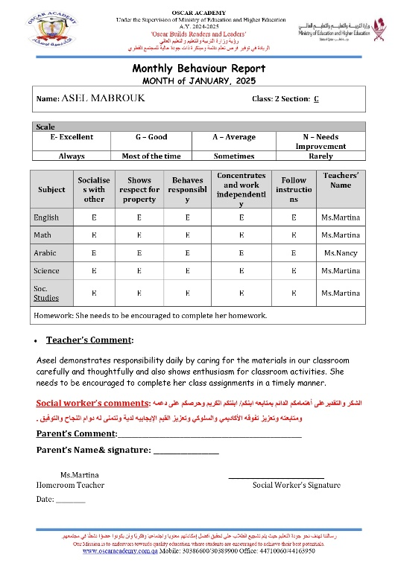
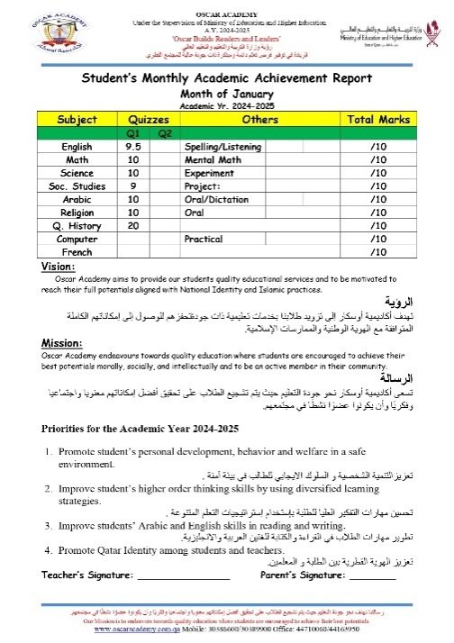

Class Accumulative Marks:
Class accumulative marks are included in monthly as well as semester exam. The accumulative marks are distributed among the following:
- Quizzes
- Projects
- Dictation
- Oral exam
- Mental math
- Spellings
- Class participation
- Homework
- Discipline
- Attendance

Sample accumulative:
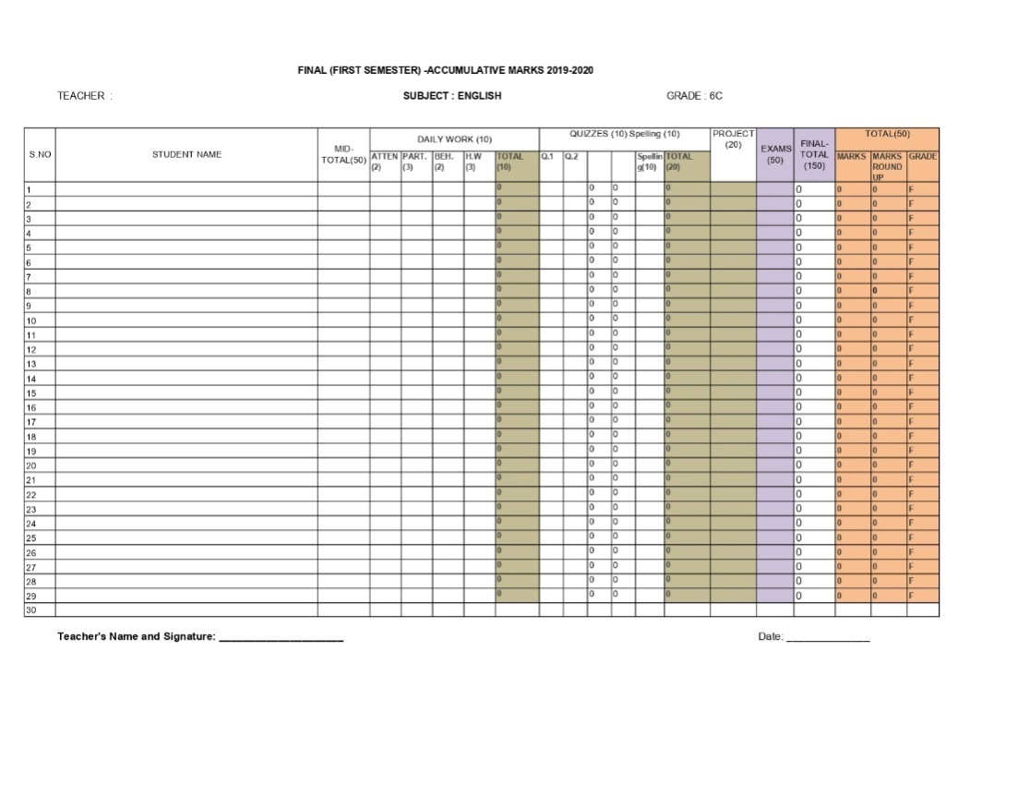
Absentees:
For any student absent from the exam following policy will be followed.
- No special exam is given without approval from the school.
- Student absent due to medical reason must provide medical certificate from Hammad hospital. Rexam will be conducted for the student
- A student travelling for emergency must get the approval from the school. Rexam will be conducted for the student
Collection of Examination paper
- Teachers and coordinators will be sent a memo regarding exam paper with due date.
- Coordinator will check and edit the exam paper and email it to Academic Vice-Principal for approval. Academic VP will check the exam papers and submit to the Principal for final approval. Exam papers will be returned to the Team leaders for the feedback made by the SMT .
- Coordinator and teacher assigned will make the desired changes and send the paper back to the Academic Vice Principal for Answer key and Printing.
- Teachers will be called to make an answer key for all the papers.
- After answer key is made, changes will be made for any mistake if found in the paper.
- Paper will be printed again after changes for filing.
- Final paper will be printed and filed and for photocopy.
- Photocopy will be made and paper will be sealed in envelopes in the presence of Academic Vice-Principal.
- Papers will be locked in Academic Vice-Principal’s office. Keys will remain with the AVP.
Distribution and collection of Exam papers on Examination Day:
- Teachers will be assigned with an exam room in a duty paper.
- Exam paper distribution is assigned to the committee.
- Papers are distributed 10 mins before the exam to the building Supervisors.
- Papers are collected as soon as it is finished.
- Building Supervisor will count the papers and hand over to exam committee.
- Papers will be counted again in presence of Academic Supervisor in her office.
Papers will be shifted to checking room.

Monitoring Of Examination:

- Examination committee will take a round during exam to monitor exam.
- For any issue regarding exam paper Academic Supervisor should be called.
- Academic Supervisor will resolve the issues.
- If subject teacher is required, she/he can be called after informing the exam committee.

Checking Procedure:

- Teachers will be assigned with checking and rechecking.
- Teachers will use red pen for checking and green/blue pen for rechecking
- Teachers are provided with the specific answer keys, rubrics and criteria for checking in each subject.
- After rechecking coordinators and AVP will recheck randomly Exam papers.
- For any dispute in checking or answer AV’s decision will be final.
- Marks will be recorded in accumulative by the subject teacher.
- After checking procedure exam will be shifted to the Exam’s room.
Exam and Promotion Policy
To ensure a fair, transparent, and consistent approach to student promotions, examinations, and academic progress in alignment with the Ministry of Education and Higher Education’s standards. The policy aims to support student success, hold students accountable for their academic performance, and maintain clear guidelines regarding exams, promotions, and attendance.

Category | Details
Promotion Criteria | - A student must secure at least 50% in each subject and 50% in aggregate to be promoted to the next class.
Promotion Criteria | - A student failing in more than two core subjects (English, Math, Science, Social Studies, Religion, Arabic) will not be promoted.
Promotion Criteria | - Students who miss any term due to late admission or approved medical leave will have their following terms’ weightage adjusted accordingly.
Re-test Policy | - Students failing in two or more subjects will be offered a re-test for the failing subjects. Parents will receive a letter about this.
Re-test Policy | - Promotion will be granted only after meeting the re-test and promotion criteria.
Attendance Policy | - Students with less than 90% attendance will not be allowed to sit for the final exam.
Attendance Policy | - Students who are absent for the final exam but have passed the accumulative exams will not be promoted unless approved by the Principal/Academic Principal.
Retake Exams | - Retake exams will be conducted for students who fail or are absent with valid approval from the Principal/Academic Principal.
Retake Exams | - Early exams will not be conducted unless approved by the Principal/Academic Principal.
Medical Leave for Re-exams | - Only medical certificates from Hamad Hospital are accepted to request a re-exam for absent students.
Behavior and Exam Rules Compliance | - Students must comply with the behavior and exam rules during exams. Failure to follow these rules will disqualify the student from taking the exam.
Reviewing of Exam Papers by Parents | - Parents can request to review their child’s exam papers within one week of the result being issued. Requests must be in writing.
Reviewing of Exam Papers by Parents | - The Academic Vice Principal will review the papers, and parents will be invited to the library between 1:00 p.m. and 2:00 p.m. within two days of the request.
Reviewing of Exam Papers by Parents | - Parents cannot use mobile phones or take photos of the exam papers during the review session.
Reviewing of Exam Papers by Parents | - For any errors or issues, parents will provide comments, and the Academic Supervisor will discuss them with the respective teachers.
Reviewing of Exam Papers by Parents | - If any changes to the result are made, a new result card will be issued after approval from the Principal.

SUBSTITUTION POLICY
Aim:
To ensure continuous learning, maintain classroom discipline, and minimize disruption during a teacher’s absence by implementing a structured and fair substitution process.

Types of Substitution
1. Short-Term Substitution
Applicable when a teacher is:
- Absent for a day (personal or emergency)
- Assigned to a workshop or other task
- Attending an urgent meeting
Procedures:
- Substitution will be assigned to teachers who have previously missed lessons or already teach the same class.
- If no such teacher is available, non-class teachers will carry out activities like “Drop Everything and Read” or use the activity file.
- Year 1 and 2: Substitutions managed within the same year team.
- Class performance monitored by the Building Supervisor, who provides feedback to the AVP.
- Substitution file for each building will be used.
2. Long-Term Substitution
Applicable when:
- A teacher is on extended emergency leave
- There is a resignation before a replacement is hired
Procedures:
- Subject specialists will cover long-term roles.
- The teacher on leave must provide lesson plans and worksheets before departure.
- The same substitute will ideally cover the same section for consistency.
- Year 1 and 2: Internal team manages substitution based on subject and class.
- SMT interview new teachers to replace if needed.

Roles and Responsibilities in Substitution Monitoring

Role | Responsibilities
Academic Vice Principal (AVP) | - Assigns and approves all substitutions
Academic Vice Principal (AVP) | - Ensures balanced distribution of substitution among staff
Academic Vice Principal (AVP) | - Follows up feedback from Building Supervisor
Academic Vice Principal (AVP) | - Reviews and adjusts plans if substitutions are repeated frequently
Building Supervisor | - Manages daily substitution implementation
Building Supervisor | - Supervises substituted classes
Building Supervisor | - Reports classroom observations to AVP
Building Supervisor | - Ensures proper use of activity files and student discipline
Teacher (Substitute) | - Delivers the assigned lesson or activity
Teacher (Substitute) | - Maintains class order and ensures student engagement
Teacher (Substitute) | - Provides brief feedback/report if needed
Principal | - Monitors substitute effectiveness through AVP reports
Principal | - Addresses of any parental or performance issues arising from substitution
Principal | - Ensures adequate staffing and initiates hiring if needed
Principal | -Acknowledge and reward teachers who handle a significant number of substitution duties each semester

WEEKLY PLANNER POLICY AND GUIDELINES

Aim:
To ensure effective academic planning, structured delivery of instruction, and transparent communication with parents by providing a consistent weekly planner. This tool helps align lessons with curriculum goals, highlight key achievements, and support student learning through clear expectations and timely information sharing.

1. Planner Content Guidelines
Teachers must ensure the weekly planner includes the following:
- Clarity and Emphasis:
Use bold, italics, and underlining to highlight key information for easy reference.
- Topics and Pages:
Clearly list the weekly topics with corresponding page numbers from the Student’s Book and Workbook.
- Homework and Quizzes:
Include all daily homework assignments and scheduled quizzes or tests.
- Materials for Activities:
List all materials required for any planned activities in the upcoming week.
- Learning Tips and Links:
Add useful learning strategies or online resources to enhance student understanding.

2. Weekly Student Highlights
Subject-specificrecognitions should be included in the planner:
- Homeroom Teachers:
  - Star of the Week
  - Class Dojo Masters
- Religion Teachers:
  - Best Student in Islamic Ethos
- Math Teachers:
  - Best Student in Mental Maths
- English Teachers:
  - Best Reader of the Week

3. Planner Submission and Updates
- Teachers must update the weekly planner using the official template provided in the shared folder.
- Updates must be completed by Tuesday of each week.
- All planned lessons and activities must follow the required format and align with curriculum objectives.

4. Roles and Responsibilities
Role | Responsibilities
Teachers | Complete and update the planner accurately and on time each week.  Give for social worker students for honor each week.
Team Leaders | Ensure that weekly events and dates are included; verify accuracy and format.
Academic Vice Principal | Review all planners to ensure they are complete, policy-compliant, and aligned with national guidelines.  Confirm that parents have received the weekly planner through follow-up and tracking.
Building Supervisors | Send the finalized weekly planner to parents via the School Broadcast every Thursday.
Team Leaders | Post weekly planner through the respective Class Dojo account.
Social Worker | Submit to the AVP the name of one student from each class for appraisal based on specific criteria (e.g., Star of the Week, Reader of the Week).

Sample of weekly planner

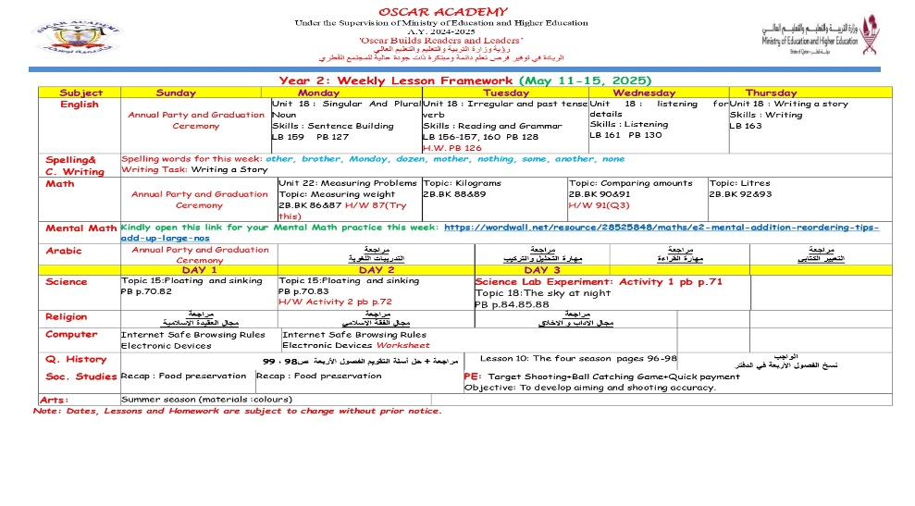

ENTRANCE EXAMINATION POLICY

Purpose
The Entrance Examination is conducted for new applicants to assess their academic readiness and determine appropriate grade placement prior to admission.

Aims
✅ Assess academic readiness of applicants based on core subject knowledge.
✅ Ensure appropriate grade placement and identify any special learning needs.
✅ Support informed admission decisions based on standardized criteria.
Note: The entrance exam is not a pass-or-fail test. It is purely diagnostic and is used to support action planning, personalized learning strategies, and academic interviews when needed.

Procedure
Step | Description
1 | Test Design: Created by subject specialists aligned with the UK curriculum.
2 | Subjects Covered: English, Mathematics, and other relevant core subjects.
3 | Timing: Scheduled prior to admission or within the first week of joining.
4 | Evaluation: Results are reviewed by the Academic Team for grade placement or remedial recommendation.
5 | Communication: Outcomes are shared with parents and recorded in the student’s admission file.

Roles and Responsibilities
Role | Responsibilities
Admissions Team | Schedule tests and coordinate with academic departments.
Subject Teachers | Prepare and review test materials; mark assessments.
SMT | Final approval of results and placement recommendations.
Parents | Support students during the process and provide required documentation.
Students | Attempt the test honestly and to the best of their ability.

Timeline
- Conducted before admission or immediately after enrollment.
- Evaluation completed within 3 working days of the test.
- Placement and feedback shared with parents after assessment.

DIAGNOSTIC TEST POLICY

Purpose
The Diagnostic Test is an internal assessment to identify students' academic strengths and weaknesses and to inform teaching strategies accordingly.

Aims
✅ Identify knowledge gaps at the beginning of each semester.
✅ Enable teachers to plan targeted lessons and support interventions.
✅ Enhance student learning outcomes and track academic progress.
✅Provide data for ongoing curriculum development and teaching refinement.

Procedure
Step | Description
1 | Pre-Diagnostic Test: Conducted at the start of Semester 1.
2 | Post-Diagnostic Test: Conducted at the start of Semester 2 to compare progress.
3 | Test Design: Aligned with UK curriculum and year-level expectations.
4 | Administration: Tests given by subject teachers in core areas like English and Mathematics.
5 | Analysis: IT Department analyzes results and provides feedback to SMT and teachers.
6 | Action Planning: Teachers develop intervention strategies and learning plans.
7 | Progress Monitoring: Comparison between pre- and post-tests to evaluate student improvement.

Roles and Responsibilities
Role | Responsibilities
SMT | Approve test content; oversee analysis and implementation.
Assessment Committee | Design, review, and revise tests each academic year.
IT Department | Analyze results and generate data reports.
Teachers | Administer tests, create individualized action plans, monitor progress.
Parents | Engage in follow-up support based on test feedback.
Students | Participate seriously and follow through with learning plans.

Timeline
- Pre-Diagnostic Test: Week 1 of Semester 1.
- Post-Diagnostic Test: Week 1 of Semester 2.
- Data Analysis & Planning: Within two weeks of each testing period.

STUDENT’S MONTHLY PROGRESS REPORT POLICY
(Academic and Behavior)
Aim:
The aim of this policy is to foster a strong partnership between parents and Oscar Academy, promoting active involvement in the student’s academic and behavioral development. The Monthly Progress Report serves as an essential tool to monitor and improve the student’s learning progress, encourage continuous improvement, and strengthen communication between the school and parents.

Purpose:
- To strengthen the partnership and involvement of parents in their child’s daily learning.
- To motivate students and parents to be actively engaged in the school’s learning achievements and progress.

Policy Guidelines:
- Accuracy and Transparency:
  - The Student’s Monthly Progress Report must accurately reflect the student’s daily academic and behavioral performance. It should be a true representation of the student’s efforts and achievements.
- Review of Quizzes and Assessments:
  - Team Leaders must ensure that the results of quizzes and assessments in all core and minor subjects are thoroughly reviewed before being uploaded to the system.
- Encouraging Comments:
  - Comments provided in the report should be positive, encouraging, and designed to motivate the student to improve both academically and behaviorally. The focus should be on growth and development rather than solely on weaknesses.
- Behavioral Insights:
  - Social Workers should input their comments on the student’s behavior to ensure that any behavioral weaknesses are identified and appropriately addressed. This ensures a holistic view of the student’s progress.
- Review and Approval:
  - The Senior Management Team (SMT) must review all progress reports and affix their signature as a form of approval, ensuring that all reports are accurate, complete, and in line with the school’s standards.
- Distribution and Discussion:
  - The Monthly Progress Report must be distributed to students and parents at the end of every month. A discussion with both the student and their parents should take place to ensure thorough monitoring of the student’s academic and behavioral progress. This will promote transparency and active involvement from parents in the improvement process.

Roles and Responsibilities for Monthly Progress Report
Role | Responsibilities
Teachers | - Accurately assess and document student’s academic and behavioral progress.  - Write constructive and motivating comments to encourage student improvement.  - Review quizzes and assessments to ensure accuracy before uploading.  - Collaborate with social workers to address behavioral aspects and include their comments.  - Submit completed reports to Team Leaders for review.
Parents | - Review the progress report carefully to understand their child's academic and behavioral progress.  - Provide support and encouragement based on the feedback.  - Participate in meetings or discussions about the report, if needed.  - Provide feedback or insights related to their child’s performance.
Senior Management Team (SMT) | - Oversee the monthly progress report process for consistency and effectiveness.  - Review and approve final reports, ensuring they meet quality standards.  - Address recurring concerns in student performance and collaborate with teachers and parents.  - Provide support to teachers regarding feedback formulation and action plans.
Students | - Actively engage in academic activities and work towards improvement in both academic and behavioral aspects.  - Reflect on the feedback provided in the report and identify areas to improve.  - Discuss the report with parents and set personal improvement goals.  - Implement suggestions and work to enhance academic and behavioral performance.  - Maintain consistent effort to achieve progress.

Conclusion:
The Monthly Progress Report is an essential tool for tracking and fostering the development of students at Oscar Academy. By ensuring that the reports are accurate, constructive, and collaborative, this policy supports the continuous growth of students both academically and behaviorally, while strengthening the partnership between the school and parents.

CLASS PORTFOLIO GUIDELINES AND POLICY
A Class Portfolio is a structured collection of student-related information that reflects academic progress, achievements, interests, and learning needs. It is a valuable tool that supports student-centered teaching and helps monitor performance across curricular areas.

Aim:
- To increase teachers' awareness of each student’s academic and social capabilities.
- To promote student-centered learning through tailored lessons and activities.
- To identify curriculum gaps and align instruction for improved learning outcomes.

Guidelines and Policy

Area | Policy Guidelines
Confidentiality | - Student information must remain confidential.  - Access is limited to teachers and the child’s parents.  - Information must never be used against any student.
File Placement | - The Class Portfolio must be placed on the right side of the board for easy access to teachers.
Access and Responsibility | - Class teachers are responsible for maintaining access control.  - The file must be accessible only to authorized teachers.
Organization | - The portfolio must be neat, well-organized, and consistently maintained.
Instructional Use | - Class activities and lessons must be based on the students’ strengths, needs, and curriculum gaps identified through the portfolio.
Curriculum Alignment | - Use the portfolio to identify gaps in curriculum coverage and adjust teaching strategies accordingly.
Professional Collaboration | - Portfolios should serve as a tool for teachers to collaborate on instructional strategies, monitor student progress, and coordinate appropriate support measures.
Student  Reflection | - Students should be encouraged to use the portfolio to reflect on their learning journey and achievements.

AFTER SCHOOL CLUBGUIDELINES &POLICY

Vision:
At Oscar Academy, our vision reflects a passionate commitment to learning and an understanding of the uniqueness of each individual learner. Guided by Islamic Values and MOEHE Regulations, we are dedicated to offering the best possible education in collaboration with parents and the local community. Oscar Academy will be a center for learning where children:
- Nurture and prioritize their well-being and development.
- Believe in themselves and in each other.
- Discover their strengths and become lifelong learners.
- Achieve more than they ever thought possible.
Our after-school clubs are designed to offer every child the opportunity to find a passion, develop a talent, or simply enjoy doing activities with others.

Aims:
- Talent Development: Implement plans to help talented students explore and enjoy diverse activities for future leisure choices.
- Exposure to New Activities: Introduce children to experiences they may not encounter during regular school hours.
- Confidence & Creativity: Promote self-confidence, well-being, and creative expression.
- Social Development: Foster cooperation and friendship across age groups.
- Inclusivity: Respect and accommodate individual differences among students.
- National Identity: Motivate students to achieve their best while upholding national values and Islamic principles.
- Oscar Academy Mission: Support the overall mission of Oscar Academy by aligning club activities with the school’s educational goals.

General Procedures:
- Responsibility: After-school club leaders and administrative supervisors are responsible for managing the after-school program. They work closely with the Senior Management Team (SMT), curriculum leads, dedicated teaching staff, and selected third-party club providers to ensure an efficient, sustainable, and high-quality program.
- Club Timing:
  - After-school activities are scheduled from 12:30 PM to 1:15 PM every Thursday.
  - Each club runs for one term.
  - A new program of clubs is offered at the beginning of each school year based on feedback from student surveys.

Supervision and Safety

(As per MOEHE Activity Manual)
- Student Safety:
  - The SMT and club leaders ensure that all children leave the building safely as per the established arrangements with teachers and the administrative supervisor.
  - Students will be guided by their respective class teacher and admin supervisors to the allocated area for club activities.
- Health and Safety:
  - A first-aider and the school nurse will always be present on the premises during the club session.
  - In case of a fire, children will be led to the school field, where the club leader will check the attendance file to ensure all students are accounted for.

Monitoring and Feedback:
To maintain the high quality and relevance of the after-school clubs, we encourage parents to complete a short questionnaire with their child after attending a club. These questionnaires should be returned to the school. All feedback is carefully considered when making decisions about the club offerings for the next semester or academic year. Teachers will also conduct questionnaires each semester to gather additional feedback on the program's effectiveness.

Club Offerings:
Our after-school clubs include a diverse range of activities to cater to the interests and talents of our students:
- Drama and Debate Club
- Arts and Craft Club
- Sports and Gymnastics Club
- Math and Chess Club
- Robotics Club

MORNING ASSEMBLY POLICY
Aim:
The aim of this policy is to establish a structured and respectful morning assembly routine every Sunday, which sets the tone for the school week. The morning assembly serves as an important opportunity to promote positive values, foster a sense of community, and reinforce the Academy's vision and mission. It is an essential part of the school’s culture, helping students to develop respect, discipline, and a sense of belonging.

Assembly Timing and Schedule:
- The morning assembly will take place every Sunday.
- Students must arrive on time to ensure the assembly begins promptly.
- All students are expected to be seated in their designated areas by 6:55 AM.

General Conduct:
- No food or drinks (except water) are allowed during the assembly.
- Students should be dressed in their full school uniform and be in a presentable manner.
- Students must line up quietly in their designated class groups before the assembly begins.
- Students should maintain silence and be attentive throughout the assembly.
- Any student arriving late should enter quietly and join the assembly without causing disruption.

Roles and Responsibilities:
Stakeholder | Responsibilities
Principal/VP | - Lead the morning assembly or designate a staff member to do so.  - Ensure that the assembly reflects the values and vision of Oscar Academy.  - Address the students with relevant messages for the week.
Teachers | - Supervise students during assembly to ensure discipline and proper behavior.  - Ensure that students are in uniform and properly lined up.  - Support the principal or other speakers during the assembly.
Students | - Attend the assembly on time and be seated by 6:55 AM.  - Maintain silence and respect while the assembly is in session.  - Participate actively when asked (e.g., singing the school anthem, reading announcements).
School Administration | - Organize and coordinate the assembly schedule.  - Ensure that the assembly space is prepared in advance (e.g., microphone, seating arrangements).  - Ensure all students are aware of the assembly schedule and any special events.

Assembly Structure:
- Opening:
  - The assembly will begin promptly at 7:00 AM.
  - A brief introduction and welcome address by the Principal or designated staff member.
- National Anthem and School Anthem:
  - Students will stand in silence while the National Anthem and Oscar Academy’s Anthem are played.
- Daily Announcements:
  - The Principal or another designated speaker will share important school news, upcoming events, and achievements.
  - Announcements related to class schedules, competitions, or school activities will be made.
- Student Participation:
  - Occasionally, a student or group of students may be selected to give short speeches, share news, or lead a prayer (if culturally appropriate).
- Reflection/Inspirational Message:
  - A brief reflection, motivational speech, or positive message will be shared with the students to inspire them for the week ahead.
- Closing:
  - The assembly will conclude with a final reminder or message, and students will be dismissed to their classrooms.

Health and Safety Guidelines:
- Students must remain in their designated assembly areas and avoid running or pushing.
- Any student with a medical condition that may affect their participation should inform their teacher or the school nurse.
- In case of inclement weather, the assembly will be held indoors in a designated area, and students will be informed in advance.
- Social distancing and health protocols will be followed as per the Ministry of Education and Higher Education (MOEHE) guidelines during periods of public health concerns (e.g., pandemics).

Special Events:
- On special occasions (e.g., holidays, celebrations, or school events), the morning assembly may include performances, speeches, or other activities designed to celebrate the occasion.
- Students may be invited to participate in special presentations or performances as part of the assembly.

Consequences of Misconduct:
- Students who fail to adhere to the assembly rules will be reminded of the importance of respectful behavior.
- Repeated disruptions during the assembly may result in disciplinary action, such as a verbal warning or a note home to parents.

Review and Adjustments:
- The Morning Assembly Policy will be reviewed annually to ensure its continued relevance and alignment with the Academy’s values and goals.
- Adjustments may be made based on feedback from students, parents, and staff to improve the assembly experience.

STUDENT PRAYER POLICY

Introduction:
Prayer is the foundation of religion, an obligation from the Lord of the worlds, and the ascension of the believers. Whoever preserves it will have light, evidence, and salvation on the Day of Judgment. Prayer is a sign of the connection between the servant and his Lord.
Based on this, and in line with Oscar Academy's vision and mission to enhance national identity and Islamic practices, a daily prayer program (Dhuhr prayer) has been organized within the school campus.

Objectives:
- Activating the rituals of Islam to strengthen national identity and Islamic values.
- Instilling in students the belief in the importance of prayer and the reason for its obligation at its designated time.
- Training students to preserve prayer at its prescribed time (through the daily prayer program).
- Correcting common mistakes in prayer through (practical application of prayer and ablution).
- Encouraging students to repeat certain supplications and remembrances offered after prayer.
- Paying attention to the developmental stage of students (through awareness lectures for mothers).

Procedures:
The academy has focused on encouraging students to pray through:
- Allocating time for prayer from 12:05 PM to 12:20 PM, from Sunday to Wednesday each week.
- Providing a designated area for prayer that accommodates all students.
- Reminding and guiding students toward good behavior and manners after prayer.
- Reciting the supplications after prayer.
- Encouraging and rewarding students who perform prayer correctly.

STORAGE OF EXAM PAPERS POLICY

Purpose/Aims:To ensure the secure handling, storage and disposal of exam papers before and after assessments, safeguarding the integrity of the examination process.
Scope:This policy applies to all teaching staff, administrative staff and exam committee involved in the preparation, administration and handling of exam papers..
Policy and Guidelines:
A. Before the Exams:
Preparation & Printing:
* Exam Papers should be prepared by authorized teachers and approved by the academic VP and Principal
Storage Location:
*Printed Exam papers must be stored in a locked cabinet in the Academic office.
Access Control:
*Only authorized personnel may handle or view exam paper before the Exam.
B. After the Exams: Storage of Exam papers:
*Corrected Exam papers will all be kept and locked in the storage room in the cabinet in Bldg 1 for three (3) years.
* Only authorized person is allowed to open the Exam’s storage room.
* Disposal:
*At the end of the retention period, outdated exam papers and answer sheets will be kept in the storage for three years.
* On the fourth year all outdated Exam Papers must be disposed of securely ( shredded or incinerated).
* Disposal should be documented and overseen by the designated Exams’ Committee member.
C. Breach of Policy:
*Any breach of exam paper policy or improper handling will be investigated and may lead to disciplinary action in line with school policies

Roles and Responsibilities
Role | Responsibilities
Teachers | - Prepare exam papers and submit for approval.  - Maintain confidentiality.
Academic Vice Principal | - Review and approve exam papers.  - Ensure secure storage before exams.
Principal | - Final approval of exam papers.  - Oversee overall policy compliance.
Administrative Staff | - Handle physical printing under supervision.  - Ensure secure placement in storage.
Exam Committee | - Monitor access control and security procedures.  - Document storage and disposal.  - Supervise the secure disposal process.  - Maintain disposal records.

DISABILITIES AND LEARNING DIFFICULTY POLICY
(Waiting for Approval from the MOEHE)

Definition of Terms
- Disability: In line with the Equality Act 2010, a person has a disability if they have a physical or mental impairment that has a substantial and long-term adverse effect on their ability to carry out normal day-to-day activities. This includes sensory impairments (visual, hearing), physical disabilities, learning disabilities, autistic spectrum conditions, speech and language difficulties, mental health conditions, and other long-term health conditions.
- Learning Difficulty: A student has a learning difficulty if they have a significantly greater difficulty in learning than the majority of others of the same age, or if they have a disability that prevents or hinders them from making use of educational facilities of a kind generally provided for others of the same age in mainstream schools. Learning difficulties can manifest in various ways, including dyslexia, dyscalculia, dyspraxia, attention deficit hyperactivity disorder (ADHD), and semantic processing difficulties.
- Special Educational Needs (SEN): A student has SEN if they have a learning difficulty or disability that requires special educational provision to be made for them, which is additional to or different from that made generally for other students of the same age.
- Special Educational Provision: Educational or training provision that is additional to, or different from, that made generally for other learners of the same age by mainstream schools.
- Reasonable Adjustments: Steps taken to avoid putting a disabled student at a substantial disadvantage compared to non-disabled students. These adjustments can include changes to policies, procedures, and practices, the provision of auxiliary aids and services, and adjustments to the physical environment.

1. Introduction

At Oscar Academy, we firmly believe that every student is a unique individual with their own strengths and learning styles. We are dedicated to fostering a welcoming, inclusive, and equitable learning environment where all students, including those with disabilities and learning difficulties, feel valued, respected, and empowered to reach their full potential. This policy reflects our commitment to providing high-quality education and support that meets the diverse needs of our student population, ensuring that every child has the opportunity to thrive academically, socially, and emotionally.

2. Purpose
This Disabilities and Learning Difficulty Policy serves as a framework for Oscar Academy's approach to identifying, assessing, and supporting students with disabilities and learning difficulties. Its primary purposes are to:
- Reaffirm the school's commitment to inclusive education and the core principlesguiding our support for students with diverse learning needs.
- Establish clear guidelines and procedures for staff, parents/guardians, and other stakeholders regarding the identification, assessment, and provision for students with disabilities and learning difficulties.
- Ensure compliance with applicable local and international laws, regulations, and best practices concerning special educational needs and disability support.
- Promote a consistent and coordinated approach to supporting students with disabilities and learning difficulties across all aspects of school life.
- Outline the roles and responsibilities of all members of the school community in creating an inclusive, respectful and supportive environment.

3. Scope
This policy applies to all students enrolled at Oscar Academy, including those in the early years and primary sections. It encompasses all aspects of school life, including:
- Admissions procedures.
- Curriculum delivery and assessment.
- Teaching and learning methodologies.
- Classroom organization and management.
- Extracurricular activities and school events.
- Communication and collaboration with parents/guardians.
- Transitions between educational stages.
- The physical environment and accessibility.
This policy is also relevant to all members of the Oscar Academy community, including:
- Governing Body members.
- School leadership and administrative staff.
- Teaching staff (including class teachers and specialist teachers).
- Support staff (including teaching assistants and other support personnel).
- Students.
- Parents/guardians.
- External professionals and agencies working with the school.

4. Core Principles and Philosophy
  - Inclusion: Oscar Academy is committed to creating an inclusive culture where all students are equally valued, respected, and feel a sense of belonging. We believe that every student has the right to access a broad and balanced curriculum and participate fully in all aspects of school life.
  - Equality: We strive to eliminate prejudice and discrimination and ensure that students with disabilities and learning difficulties are not treated less favourably than their peers. Reasonable adjustments will be made to ensure equitable access and opportunity.
  - Person-Centered Approach: We recognize that each student is unique and has individual needs. Our approach will be person-centered, focusing on identifying and addressing specific barriers to learning and participation. The views and experiences of students and their parents/guardians will be actively sought and considered.
  - Early Identification and Intervention: We are committed to the early identification of students with potential disabilities and learning difficulties. Timely and appropriate interventions will be implemented to provide the necessary support and prevent the escalation of difficulties.
  - Collaboration: We believe in working in partnership with students, parents/guardians, teachers, support staff, and external agencies to ensure a coordinated and effective approach to supporting students with disabilities and learning difficulties.
  - High Expectations: We have high expectations for all our students, including those with disabilities and learning difficulties. We are committed to supporting them in achieving their full academic and personal potential.

5. Aims:
The aims of this Disabilities and Learning Difficulty Policy are to:
- Ensure the early identification of students with potential disabilities and learning difficulties through effective monitoring and assessment procedures.
- Provide a continuous support that is tailored to the individual needs of each student, promoting their progress and well-being.
- Facilitate full access to the curriculum through differentiated instruction, reasonable adjustments, and appropriate accommodations and modifications.
- Foster a collaborative partnership between the school, students, parents/guardians, and external professionals to ensure a coordinated and holistic approach to support.
- Empower students with disabilities and learning difficulties to develop independence, self-advocacy skills, and a positive self-image.
- Promote an inclusive school culture where diversity is celebrated, and all students feel valued and belong.
- Ensure that staff are well-trained and equipped to effectively support students with a wide range of needs.
- Regularly monitor and evaluate the effectiveness of our provision and make necessary adjustments to continuously improve our practices.
- Uphold the principles of equal opportunities and non-discrimination for all students.

6. Policy Management and Review
Policy Created By:
Approval Authority:
Review Cycle: | Annual
Next Review Date:
Reviewed by | Policy Review Committee
This policy will be reviewed annually by the Policy Review Committee, with input from relevant stakeholders. The review will consider the effectiveness of the policy, changes in legislation or best practices, and feedback from the school community.
This policy will be readily available on the school website and shared with all staff, parents/guardians, and prospective families upon enrolment. Staff will be briefed on the policy during induction and ongoing professional development. Parents/guardians will be asked to acknowledge receipt and understanding of the policy as part of the admission process.

7. Admission Guidelines:
All children, regardless of ability, have a right to quality education. Admission decisions for students with disabilities or learning difficulties will be based on:
- Assessment of needs
- Availability of support services
- Parent collaboration and consent
The school does not discriminate based on disability and follows an inclusive admissions policy.

8. Acceptance Procedure
Upon receiving an application for a student with a declared or suspected disability or learning difficulty:
- The Admissions Team forwards all relevant information to the Special Educational Needs Coordinator (SENCo).
- The SENCo:
  - Reviews documentation such as diagnostic reports and records from previous educational settings.
  - Arranges a meeting with the parents/guardians to discuss the student’s needs, prior support, and learning history.
  - Involves the student in the meeting where appropriate.
  - Conduct a comprehensive assessment to determine its ability to meet the student’s needs by evaluating available resources, staff expertise, learning environment
  - Consult with relevant teaching staff and, if needed, external professionals.
  - A decision is made regarding the school’s capacity to provide effective support for the student based on a holistic evaluation:
- If the school can reasonably meet the student’s needs:
  - An offer of admission is made.
  - The offer may be conditional upon further assessments or implementation of specific support strategies.
- If the school determines it cannot reasonably meet the student’s needs:
  - The school consults with the parents/guardians.
  - Recommendations for alternative educational placements are provided in the best interest of the student.
- Upon acceptance, the SENCo begins developing an initial support plan in collaboration with parents/guardians and relevant staff to ensure a smooth transition and effective support from the first day..

9. Identification, Assessment and Review
At Oscar Academy, we recognize the importance of early and accurate identification of disabilities and learning difficulties to ensure that every student receives the support they need to thrive. Our approach follows a structured process involving early observation, collaborative assessments, and ongoing reviews. Through timely identification, professional evaluation, and regular monitoring, we aim to create responsive, individualized support plans ensuring that all students have the opportunity to access the curriculum, make progress, and thrive within our inclusive learning environment.
9.1 Early Identification
Oscar Academy will employ a range of strategies to identify students who may have disabilities or learning difficulties as early as possible. This includes:
  - Careful monitoring of student progress and attainment by class teachers.
  - Analysis of student work and assessment data.
  - Liaison with parents/guardians regarding any concerns they may have.
  - Information sharing from previous educational settings.
  - Observations of student behaviour and engagement in the classroom and school environment.
9.2 Diagnosis Procedure
While Oscar Academy can identify potential learning difficulties and disabilities through its assessment processes, formal medical or psychological diagnoses are typically conducted by qualified external professionals (e.g., pediatricians, educational psychologists, psychiatrists). The school will work collaboratively with parents/guardians and these professionals to understand the diagnosis and its implications for the student's education. Parents/guardians are responsible for providing the school with relevant diagnostic reports. Confidential records will be maintained securely and shared only with relevant staff.
9.3 Needs Assessment
When a potential need is identified, Oscar Academy will undertake a graduated approach to assessment:
- Initial Assessment by the Class Teacher: The class teacher will gather information about the student's strengths, areas of difficulty, and learning preferences. They will implement differentiated teaching strategies and monitor their impact.
- Further Assessment and Support: If the student continues to experience difficulties, the school's Special Educational Needs Coordinator (SENCo) will be involved in further assessment, which may include:
  - Standardized tests and assessments.
  - Observations in different contexts.
  - Consultation with parents/guardians and the student.
  - Advice from external specialists (e.g., educational psychologists, speech and language therapists, occupational therapists).
9.4 Individualized Education Plans (IEPs)
For students identified as having SEN, a detailed and person-centered IEP will be developed in collaboration with the student (where appropriate), parents/guardians, teachers, and relevant support staff. The IEP will be a working document that is regularly reviewed and adapted. The IEP will include:
- Clearly defined learning targets and outcomes.
- Specific strategies and interventions to be implemented.
- Details of any additional support or resources required.
- Timelines for review and evaluation of progress.
- The roles and responsibilities of all involved.
9.4 IEP Review
IEPs will be reviewed regularly semester wise to evaluate the effectiveness of the support provided and to make any necessary adjustments. Parents/guardians and the student will be actively involved in the review process. For students with more complex needs, annual review meetings will be held, involving all relevant stakeholders.

10. Accommodations and Modifications

Oscar Academy is committed to providing appropriate accommodations and modifications to ensure that students with disabilities and learning difficulties can access the curriculum and participate fully in school life. These supports are tailored to meet individual needs and are designed to promote equity, engagement, and academic success.

  - Accommodations
These are changes to the learning environment, teaching methods, or assessment procedures that do not alter the learning expectations. Oscar Academy utilizes various accommodations, such as:
  - Providing materials in alternative formats (e.g., large print).
  - Using assistive technology.
  - Providing additional time for completion of tasks or assessments.
  - Offering alternative methods of assessment.
  - Preferential seating.
  - Visual aids and organizers.
  - Quiet work spaces.
10.2 Modifications
These are changes to the curriculum content or learning expectations. Modifications are implemented when accommodations alone are not sufficient to enable the student to access and progress in the curriculum. Examples of modifications that might be used at Oscar Academy include:
  - Modifying tasks and activities.
  - Reducing the number of tasks or assignments.
  - Simplifying instructions or materials.
  - Providing alternative assessment tasks.
  - Focusing on key learning objectives.

10.3 Support in the Classroom
Students with disabilities and learning difficulties may receive a range of support within the classroom, including:
  - Support from teaching assistants under the guidance of the class teacher.
  - Peer support and collaborative learning opportunities.
  - Access to specialist equipment and resources.
  - Small group or individual interventions.

11. Student Involvement
Oscar Academy believes that students should be actively involved in decisions that affect their learning. Age-appropriate mechanisms for student involvement will be implemented, such as:
- Seeking their views and preferences during the development and review of their IEPs.
- Providing opportunities for self-reflection on their learning and progress.
- Encouraging them to advocate for their own needs.
- Involving them in problem-solving related to their learning.
- Establishing student support groups where they can share their experiences and ideas.

12. Parental Involvement
Oscar Academy recognizes the crucial role of parents/guardians as partners intheir child's education. We are committed to:
  - Maintaining open and regular communication through meetings, emails, phone calls, and progress reports.
  - Actively involving parents/guardians in the identification, assessment, and review processes.
  - Collaborating with parents/guardians in the development and implementation of IEPs.
  - Providing parents/guardians with information about relevant support services and resources.
  - Organizing parent workshops or information sessions on topics related to disabilities and learning difficulties.
  - Seeking parental consent for external assessments or interventions.

13. Integration
Oscar Academy is committed to the full integration of students with disabilities and learning difficulties into all aspects of school life, including classrooms, extracurricular activities, and social events.
Strategies for promoting integration include:
- Creating a welcoming and inclusive classroom environment.
- Educating all students about diversity and inclusion.
- Facilitating positive social interactions and peer support.
- Providing opportunities for collaborative learning and group work.
- Making reasonable adjustments to ensure participation in all school activities.
- Addressing and challenging any instances of bullying or discrimination

14. Early Childhood Support

Oscar Academy recognizes the importance of early intervention for young children with potential disabilities or learning difficulties. For students in the early years, the school will:
- Implement early screening and monitoring procedures.
- Work closely with parents/guardians to identify any emerging needs.
- Provide developmentally appropriate support and interventions.
- Collaborate with early childhood specialists and therapists as needed.
- Ensure a smooth transition to later stages of education.

15. Role of Experts and Support teachers
Oscar Academy work collaboratively with a range of experts to provide comprehensive support for students with disabilities and learning difficulties. This includes the SENCo, support teachers, and social workers. Their roles include:
  - Conducting assessments and providing diagnostic information.
  - Developing and implementing IEPs.
  - Providing specialist teaching and interventions.
  - Supporting classroom teachers in differentiating instruction.
  - Liaising with parents/guardians and external agencies.

16. Confidentiality
Oscar Academy is committed to maintaining the confidentiality of all information relating to students with disabilities and learning difficulties. Information will only be shared on a need-to-know basis with relevant staff members who are directly involved in supporting the student. All records will be stored securely in accordance with the school's data protection policy and relevant legislation. Parental consent will be obtained before sharing information with external agencies, unless there are safeguarding concerns.

17. Record Keeping
Oscar Academy maintains accurate and up-to-date records for all students with disabilities and learning difficulties. Records will be stored securely and retained in accordance with the school's data protection policy These records will include:
- Assessment reports and diagnostic information.
- IEPs and review documents.
- Records of accommodations and modifications.
- Communication with parents/guardians and external agencies.
- Progress monitoring data.

18. Evaluation Methods
The progress and outcomes of students with disabilities and learning difficulties will be evaluated through a variety of methods, including:
- Monitoring progress against IEP targets.
- Analyzing student work and assessment data.
- Teacher observations and feedback.
- Student self-assessment and reflection.
- Parent/guardian feedback.
- Where appropriate, participation in standardized assessments with necessary accommodations.
Evaluation data will be used to inform future planning, review the effectiveness of interventions, and ensure that students are making appropriate progress.

19. Assistive Devices and Technology
Oscar Academy is committed to providing students with disabilities and learning difficulties with access to appropriate assistive devices and technologies to support their learning and participation. The need for assistive devices and technology will be assessed on an individual basis as part of the IEP process. The school will explore available resources and funding options to provide necessary equipment and software. Staff will receive training on the use of assistive devices and technology.

20. Equal Opportunities
Oscar Academy is committed to providing equal opportunities for all students, regardless of their disability or learning difficulty. All students will have equitable access to the curriculum, extracurricular activities, and school resources. The school will actively promote an inclusive culture that values diversity and challenges discrimination. Reasonable adjustments will be made to ensure that students with disabilities and learning difficulties are not disadvantaged in any aspect of school life.
21. Conclusion
OSCAR Academy is committed to creating a truly inclusive and equitable learning environment where every student is valued, supported, and empowered to achieve their full potential. By adhering to the principles and procedures outlined in this document, and through ongoing collaboration, reflection, and improvement, we strive to ensure that all students, regardless of their abilities or learning differences, can flourish and make meaningful contributions to our school community and beyond. We believe that embracing diversity and providing tailored support not only benefits individual students but also enriches the learning experience for all.

--------------------------------- Every child is unique. Support their journey. -------------------------

4. STAFF EMPLOYMENT AND HR POLICIES

STAFF RECRUITMENT & SAFER RECRUITMENT POLICY

Aim:

The aim of this Staff Recruitment & Safer Recruitment Policy is to establish a transparent, fair, and efficient process for recruiting qualified and dedicated staff who are committed to upholding the values of Oscar Academy. This policy ensures that all employees, both teaching and non-teaching, are selected based on their experience, qualifications, and suitability for working with children. By adhering to the Safer Recruitment guidelines, the policy prioritizes the safety and well-being of students, ensuring that all staff members meet rigorous safeguarding standards. This approach supports the school’s commitment to maintaining a safe, supportive, and child-centered learning environment.

Types of Employment
- Sponsored Staff
Employees appointed as sponsored staff are entitled to all the benefits offered by the school.
- Aligned with Qatar Labor Law, Approval of the Guide to Classifying Professional Titles in Private Schools and KGs, Memo No. 1 (Updated 8/1/2025).
- Non-Sponsored Staff
Employees hired through local recruitment are entitled to the salary and benefits mutually agreed upon by the employee and the school.
- Temporary/Adhoc Staff
Employees hired for a specific period are not entitled to any benefits offered by the organization.

Hiring Policy
The Hiring Committee of the school is responsible for recruiting new teaching staff. Administrative staff will be hired directly by the Principal.
Academic Staff Hiring Committee Members:
- Principal
- Academic Vice Principal
Responsibilities of the Hiring Committee:
- Place an advertisement in the local newspaper or on social media.
- Receive and review resumes.
- Shortlist applicants for interviews/tests.
- Conduct tests/interviews.
- Arrange and observe a demonstration lesson for teaching positions.
- Select candidates and extend job offers based on experience, qualifications, intellectual abilities, and suitability for working with children.
- Appoint selected candidates.
- The management may also outsource recruitment to an agent in other countries. After receiving CVs, the committee will shortlist candidates and arrange interviews for final selection.

Safer Recruitment Process
Oscar Academy is committed to recruiting staff and volunteers who are suitable to work with children, adhering to a comprehensive safer recruitment process throughout the hiring stages:

A. Background Checks
- Thorough background checks, including police clearance and criminal record checks, are conducted.
- References and employment history are verified.
- Social media and internet searches are conducted (where legally permissible) to assess applicants' suitability.
B. Commitment to Child Safeguarding
- The school’s commitment to child safeguarding is visible on its public website and includes a clear statement on the importance of child protection.
- A child safeguarding commitment is included in all job descriptions and advertisements.
C. Interview Process
- Interviews are conducted by a consistent panel, with at least one member having completed safer recruitment training.
- Safeguarding-related questions, including case scenarios, are incorporated into the interview process.
- Interview notes are recorded, signed, and retained.
D. Pre-employment Checks
- The school conducts thorough checks, including verifying qualifications, criminal records, and teaching certifications.
- Enhanced police background checks are required where applicable.
- Additional reference checks may be conducted if required checks cannot be completed.
E. Onboarding Process
- Conditional letters of employment are issued, with the offer contingent upon successful background checks.
- A comprehensive and secure record-keeping system for recruitment and selection documents is maintained.
- Volunteers, staff, and contractors undergo regular safeguarding training.
- The school ensures that the Code of Conduct is signed and that safeguarding training is completed before staff engage directly with students.
- Onboarding and induction programs include child safeguarding and managing concerns about adults working with children.

Required Documents for Application (according to Qatar Labor Law)
Candidates must submit the following documents:
- Attested copies of qualifications
- Photocopy of ID card/passport
- Recent passport-size photograph
- Original attested degrees
- Passport copy
- Police Clearance Certificate
- NOC (No Objection Certificate) Letter
- Experience Letter
- Additional photographs
- No Objection Certificate from sponsor (for non-sponsored staff)
- Reference letter from previous employer

Required Documents for Staff File
The following documents must be signed and placed in the staff file:
- Letter of appointment
- Joining duty report
- Employment contract
- Moral contract / Code of Ethics
- Health form
- Renewal application
- End-of-year job offer contract for the new academic year
- Recruitment Application Form (personal interview, demo)
All appointment-related documents must be retained in the employee’s personal file.

Employee Induction
On the first day of work, the new employee will undergo an Employee Induction Program, where they will be introduced to their class, colleagues, and school policies.

Key Measures to Ensure Successful Induction:
- Introduce the new teacher to the staff.
- Introduce the new teacher during the school assembly.
- Provide the new teacher with:
a. A comprehensive job description
b. A personal timetable
c. A class timetable
d. A curriculum breakdown
e. Necessary textbooks
f. Required registers
g. Planning materials
h. Teaching resources
- Conduct a tour of the school, introducing the teacher to key staff members.
- Explain administrative procedures such as photocopying and attendance recording.
- Clarify meeting schedules, including staff and coordination meetings.
- Add the new teacher to the official Oscar Academy WhatsApp group for communication with staff and updates.
- Monitor progress at regular intervals during the first few weeks.
- Ensure that the new teacher has read and understood the school rules.
- Assign a peer teacher or administrator to serve as a mentor or shadow.
- If applicable, prepare a schedule for the new teacher to visit other classes.
- Prepare a New Employee Action Plan tailored for the new teacher.

ATTENDANCE & LEAVE POLICY

Aim:

The aim of the Attendance & Leave Policy foris to ensure the smooth operation of academic and administrative functions at Oscar Academy by maintaining an organized and transparent attendance and leave system. This policy outlines clear expectations for staff attendance, punctuality, and leave entitlements to ensure that the academic process is not disrupted and that all staff members are held accountable for their time and responsibilities. By establishing a structured approach to attendance marking and leave requests, the policy promotes fairness, consistency, and efficiency in managing staff time while maintaining high standards of performance and commitment to the school’s objectives.

Attendance Marking
All staff members, regardless of category or type, must mark their attendance upon arrival (check-in) and departure (check-out). Attendance is recorded from the 1st to the 30th/31st of each month. The following methods will be used for registering attendance:
- Fingerprint scanner
- Attendance sheet
The attendance device should be placed at the main entrance of the school office. If a teacher fails to use the fingerprint device, they will be marked absent for that day.

Leave, Short Leave & Late Arrival Rules
- Leave is a privilege, not a right. Teachers are encouraged to avoid unnecessary absences, as they disrupt the academic process.
- Staff are entitled to three casual leaves with pay per academic year, subject to approval.
- Medical leave of up to 10 days (cumulative or separate) per year is allowed. A medical certificate from a government medical authority in Qatar is required.
- Leave requests must be submitted at least one day in advance.
- Short leave or leave requests will be approved/disapproved based on urgency, academic impact, and previous leave record.
- All teaching and administrative staff must submit a short leave form for official duties.
- Two short leaves will be counted as one full leave.
- Short leave duration must not exceed three hours.
- Three instances of late arrival will be considered as one leave day without pay.
- Leave balance does not carry over to the next month.
- Emergency leave of up to 10 days with pay is granted in the event of the death of a first-degree relative.
- Maternity leave of 30 days (15 days with pay and 15 days without pay) is granted after one year of service.
- All leave must be supported by a written explanation submitted to the Principal.
- Any leave not listed above will be considered unpaid leave.
- Staff on probation is not entitled to any type of leave.
- Leave records will be considered a key factor in staff evaluations.
- Staff absent from events, meetings, after-school activities, or Saturday duties will have two days' salary deducted per absence.
- Absent staff must inform the reception, HR, Academic Vice Principal and provide a valid reason.

Leave Application Procedure
Employees must apply for leave in advance by filling out a leave application form. Approval from management is mandatory and approved leave forms will be kept in the employee's personal file. Leave applications should be submitted at least one month before the intended leave date.

Attendance & Leave Record Management
- Leave records at the HR’s Office are managed through an automated system.
- Employees must scan their fingerprints daily at check-in and check-out.
- The fingerprint system generates attendance reports daily before 7:30 AM. The Principal's secretary prints and submits the report to the Principal, while a copy is sent to the supervisor for substitute arrangements.
- At the end of each month, the attendance sheet is generated and recorded in the monthly leave roster, which is then forwarded to the Accounts Department for payroll processing.
- A notice letter is issued to staff members who are regularly late.
- A notice letter is issued to employees who are regularly absent.
- Chronic issues or violations are referred to the School Principal for further action.

RESIGNAT
ION/ TERMINATION PROCEDURES

Aim:

The aim of the Resignation and Termination Procedures at Oscar Academy is to ensure a professional, transparent, and organized process when an employee resigns or is terminated. These procedures ensure a smooth transition, safeguarding the interests of both the employee and the institution. By providing clear guidelines for resignation, termination, clearance, and the handover of responsibilities, the policy promotes professionalism, accountability, and compliance with Qatar Labor Law. The procedures are designed to minimize disruption and ensure the efficient continuation of school operations.

Resignation
Employees who wish to resign must submit a written resignation to the Academic Vice Principal. Upon receiving the resignation, the Academic Vice Principal will conduct a counseling session to understand the reason for the resignation. If the employee remains firm in their decision, the resignation will be forwarded to the Principal with remarks. Notably, no employee is permitted to resign during the academic session.
A resignation will only be considered valid if submitted in writing. Once accepted, a copy signed by the Principal must be sent to the Accounts Office. If aAcademic Vice Principal resigns, the Principal will forward the resignation to the CEO, with a copy sent to the Accounts Department.

Termination
The management reserves the right to terminate any employee for the following reasons: (given notice period according to the contract)
- Unethical behavior (as defined by the Employee Code of Ethics)
- Poor performance
- Violation of school rules and policies
- Unprofessional attitude or conduct
- Providing false or misleading information that affects any stakeholder within the school
- Breach of the Child Protection Policy or the Health and Safety Policy

Termination can be executed without a notice period; however, the decision must be supported by documented evidence such as:
- Investigation report of the case
- Written complaints
- CCTV footage
- Official documents

Preparation of Clearance Certificate
Once a resignation is accepted, a clearance certificate must be prepared and signed by all relevant departments. The clearance certificate must include:
- Employee attendance records as per the attendance sheet
- Details of any children availing concession facilities
- Notice period served or not served status
- Signatures from all relevant departments
- Final clearance signed by the Principal
The notice period is as follows (according to Qatar Labor Law)
- Employees with 5+ years of service: 2 months
- Employees with 1 to 3 years of service: 1 month
- Employees with less than 1 year of service: 15 days
If no notice period is served, the equivalent salary for the notice period must be paid by either party.Clearance will not be granted until this condition is fulfilled.

Handing Over Responsibilities
Employees who resign or are terminated must properly hand over all responsibilities, including:
- Pending and future assignments
- Computer passwords and stored information
- Confidential files and documents
- All school assets in their possession
- Physical and digital files
- Correspondence records
- Cash (if applicable)
- Any additional job-related information

STAFF BENEFITS POLICY

Aim:
To provide maximum benefits to the staff for motivation and job satisfaction.

Increment Policy:
A 20% increase in the basic salary is granted annually, subject to meeting the following criteria:
- Attendance of professional development courses recommended by the school (at least five per year for teachers, three per year for admin staff)
- Student outcomes and satisfaction (for teachers)
- Staff attitude towards work throughout the year
- Staff attendance and punctuality
- Frequency of early departures or late arrivals
- Parents’ feedback throughout the year
- Parents' end-of-year questionnaire analysis
- End-of-year staff evaluation

Discount Policy

Guidelines:
- Discounts for employees’ children are as follows:
  - 50% tuition fee discount for employees who have completed five years or more.
  - 30% tuition fee discount for employees who have completed three years and have children registered in the school.
- Discounts apply only to tuition fees.
- Registration fees, bus fees, books, and school uniforms are not included in the discount.

Early Out/Coming Late Benefit
- Employees with newborn babies are allowed an early out (one hour) for six months.

Loan Policy for Sponsored Staff

Eligibility Criteria:
- The staff members must have completed at least one year of service.
- A guarantor from within the school must sign for the staff member.
- No previous loan taken from the school in the past year.
- Loan repayment must follow the employer's terms and conditions.
- The staff member must have an active contract valid for at least six months.
Additional Benefits:
- Hajj/Umrah Leave: Employees who have completed five years of service at the school are entitled to paid leave to perform Hajj or Umrah.
- Wedding Leave: Employees with five years of service are entitled to 14 days of paid leave for their wedding.

 | Position |  | Name of the staff
 | Amount |  | Year in school
 | Return date |  | Reason for loan
 | Date of loan taken before |  | Loan taken before
 | Position |  | Name of Guarantor
I __________________________________ holding Q.ID ____________________________ take full responsibility for the loan amount_______________ taken by Mr./Ms__________________________.
If this amount is not returned by _______________________ amount can be deducted from my coming month salary.

Guarantor Sign:____________________________________________ Date:_________________

Sign of loan taker:__________________________________________ Date:__________________

For office use only:
Approved Not Approved

Principal Signature:__________________________
CEO Signature:____________________

STAFF APPRAISAL POLICY

Aim:

The aim of this Staff Appraisal Policy is to recognize, reward, and motivate staffmembers of Oscar Academy for their dedication, outstanding performance, and meaningful contributions to the school community, thereby fostering a positive, committed, and high-performing work environment.

1. Employee of the Month
- At the end of each month, the Academic Vice Principal submits recommendations to the Principal’s office for the following categories:
  - Teacher
  - Assistant Teacher
  - Administrative Staff
- Upon approval, the selected employees are announced in the morning assembly.
- A certificate is awarded to the employee.
- Monetary rewards or gifts are given as recognition.

2. Employee of the Year

- At the end of the academic year, the Principal selects the Employee of the Year based on the following criteria:
  - Yearly performance
  - Annual evaluation
  - Parents’ feedback

3. Thank You Cards
- Thank You Cards are given randomly to staff members in recognition of their hard work, extra effort, or innovative ideas.
- The cards may be issued by the Principal, Academic Vice Principal.
- Upon collecting seven cards, the staff member can present them to management to receive a reward.

4. Certificate of Appreciation
A Certificate of Appreciation is awarded to staff members for outstanding contributions in the following areas:
- Full attendance
- Substitution classes
- Additional duties
- Hard work and commitment
- Outstanding class performance based on evaluation criteria
- Representing the school in external events

EMPLOYEE OF THE MONTH (TEACHER)
A.Y. 2024-2025
Name: |  | Class:
Subject: |  | Month: .

Comments | 10 | 8 | 6 | 4 | 2 | Qualification:
Performance in class
الاداء الصفي
Classroom management
التحكم الصفي
Allied Duties
المهام والمناوبات الموكلة للمعلمة
Communication with parents
التعامل والتواصل مع أولياء الامور
Attendance / Tardiness
الحضور والنصراف والاستئذان
Relations with other team members
العلاقة بالزملاء في فريق العمل
 |  |  |  |  |  | Submission of work(quality /on time ) تسليم الاعمال الموكلة ( نوعية/ توقيت)
Relationship with and parents
العلاقة مع الطلبة
Apply professional development skills to support the teaching strategies used
تطبيق مهارات التطوير المهني لدعم استراتيجيات التعليم المستخدمة
 |  |  |  |  |  | تطبيق معايير الهوية القطرية والممارسات الاسلاميةApplying Qatari identity standards and Islamic practices

Keys: E= Excellent G= Good A= Average N= Never
< than70
70-79
80-70
90-100

AVP Comment(s):
___________________________________________________________
___________________________________________________________

Team Leader Comment(s):
___________________________________________________________
___________________________________________________________

Principal Comment(s):
___________________________________________________________
___________________________________________________________

Principals’ Approval: Yes No

______________________ Date:____________
Principal Signature
Aseel Sameer

EMPLOYEE OF THE MONTH (ADMIN)

Name: |  | Class: Sec:
Subject: |  | Month:
Years in school:

Comments | 10 | 8 | 6 | 4 | 2 | Qualification:
 |  |  |  |  |  | Performance in work
 |  |  |  |  |  | Staff management
 |  |  |  |  |  | Allied Duties
 |  |  |  |  |  | Communication with parents
 |  |  |  |  |  | Attendance / Tardiness
 |  |  |  |  |  | Relations with other staff members
 |  |  |  |  |  | Submission of work
 |  |  |  |  |  | Attitude towards
 |  |  |  |  |  | Using of new ideas and method in work
 |  |  |  |  |  | Role model for
Keys: E= Excellent G= Good Av. Average N= Never
70-79
< than70
80-70
90-100

AVP: ____________ Admin Supervisor: _________

Principals’ Approval: Yes No
Comments:
_______________________________________________________
_______________________________________________________

Principal
Aseel SameerDate:____________

EMPLOYEE OF THE MONTH (ASSISTANT TEACHER)

Name: |  | Class Sec:
Position: |  | Month:
Years in school:

Comments | 10 | 8 | 6 | 4 | 2 | Qualification:
 |  |  |  |  |  | Willingness to work
 |  |  |  |  |  | Organization
 |  |  |  |  |  | Additional Duties
 |  |  |  |  |  | Communication with parents
 |  |  |  |  |  | Attendance
 |  |  |  |  |  | Tardiness
 |  |  |  |  |  | Relations with other staff members
 |  |  |  |  |  | Completion of work
 |  |  |  |  |  | Attitude towards
 |  |  |  |  |  | Handling pressure
 |  |  |  |  |  | Role model for

Keys: E= Excellent G= Good Av.=Average N= Never
< than70
70-79
71-90
91-100

AV Principal:______________ Admin Supervisor___________

Principals’ Approval: Yes No

Comments: _______________________________________________________

Principal Date:____________
Aseel Sameer

TEACHER EVALUATION AND PERFORMANCE APPRAISAL

Aim:
The aim of the teacher evaluation and performance appraisal process at Oscar Academy is to ensure high teaching standards, promote professional growth, identify areas for improvement, and maintain a supportive and effective learning environment. The system is designed to uphold accountability while recognizing excellence and fostering continuous development among teaching staff.

 | Principal | Academic Vice Principal (AVP)
Leadership & Oversight | - Oversees the full evaluation process | – Manages daily execution of evaluation process
Leadership & Oversight | - Ensures fairness and transparency | – Coordinates schedules and timelines
Leadership & Oversight | - Makes final decisions on confirmations, extensions, and terminations | – Consolidates performance data
Performance Monitoring | - Reviews evaluation reports, classroom observations, and AERs | – Conducts classroom observations
Performance Monitoring | - Assesses teacher contributions to school culture and mission | – Evaluates lesson plans, notebooks, and student work
Performance Monitoring |  | – Monitors probationary employees
Feedback & Development | - Provides guidance on professional growth | – Gives immediate feedback post-observations
Feedback & Development | - Recommends training | – Supports corrective actions and development plans
Feedback & Development | - Recognizes high-performing staff for promotions and increments | – Acts as a liaison with Principal
Decision-Making Authority | - Approves probation extensions | – Recommends actions for new employees
Decision-Making Authority | - Issues advisory/warning letters | – Supports decisions with documented evaluations
Decision-Making Authority | - Confirms or terminates employment
Documentation & Reporting | - Reviews reports and documentation prepared by AVP | – Prepares evaluation summaries
Documentation & Reporting | - Reviews reports and documentation prepared by AVP | – Maintains probation and performance documentation
Documentation & Reporting | - Reviews reports and documentation prepared by AVP | – Assists with AER preparation

Types of Teacher Evaluations
- Classroom Observation
- Written Teacher Evaluation
- Self-Evaluation
- Final Evaluation Based on Observations

Teacher Evaluation Process
To ensure effective learning and maximize teaching quality, regular classroom observations will be conducted using a structured evaluation form. These evaluations guide teachers in improving their skills and instructional techniques.

Evaluation Criteria (Classroom observation based on QNSA recommendation)

1. Classroom Management
Seating Arrangement:
- Tables and chairs are properly arranged.
- Each student has a clear view of the board and can hear the teacher.
Discipline & Management:
- Classroom discipline is maintained.
- Teacher is well-prepared with strong subject knowledge.
- Remedial techniques are used for struggling students.
Classroom Atmosphere:
- Students are engaged and motivated.
- The classroom environment is tidy and conducive to learning.

2. Board & Teaching Aids
Presentation:
- Writing on the board is legible.
- The teacher effectively captures student attention.
Techniques:
- Effective board usage with eye contact.
- Diagrams, maps, and visual aids are integrated into lessons.

Duration:
- Discipline is maintained while using the board.
- Blackboard use is balanced, avoiding excessive writing.

3. Lesson Delivery
Planning & Content:
- Lesson plans are well-structured and build on prior knowledge.
- Question-and-answer sessions enhance engagement.

Delivery:
- Instructional techniques are engaging and effective.
- Strong communication skills are demonstrated.
Student Response:
- Students are motivated and actively participating.
- They can answer questions accurately.

4. Notebook Checking
Checking:Work is checked efficiently, with errors clearly marked and corrected.
Condition:Notebooks are neat, covered, and properly maintained.
Assignments:
- Homework is well-planned and aligned with lessons.
- Assignments encourage independent research.

5. Record Keeping
Lesson Plans:Previous lesson plans are filed and accessible.
Attendance Register &Diaries:Up-to-date and properly maintained.
Progress Tracking:
- Student progress records are updated.
- Teachers are aware of student performance and placement.

Annual Evaluation Report (AER)
Annual Evaluation Reports (AER) will be compiled for each teacher at the end of the academic year by the Principal. AERs assess academic qualifications, practical teaching experience, and student results.
Factors considered in the AER include:
- Intelligence
- Attitude
- Punctuality
- Communication skills
- Responsibility
- Subject knowledge
- Participation in co-curricular activities
Promotions and salary increments depend on AER performance in accordance with school policies.

EMPLOYEE OF THE MONTH

Aim:

The aim of the Employee of the Month program is to acknowledge and celebrate outstanding staff members at Oscar Academy who consistently exhibit exceptional work ethic, dedication, professionalism, and a positive attitude, thereby reinforcing a culture of excellence, motivation, and continuous improvement within the school community.

Criteria
To be eligible for nomination, the employee must:
- Be a permanent staff member
- Have completed at least three months at Oscar Academy

Attitude and Commitment
- Dedicated to fulfilling job responsibilities
- Demonstrates excellent customer service skills
- Consistently dependable and punctual
- Actively participates in committees, fundraisers, fairs, training, and other school activities
- Serves as a role model to others
- Exceeds job expectations
- Maintains excellent attendance and punctuality

Interpersonal Skills
- Displays a helpful, cooperative, and positive attitude towards superiors and colleagues
- Consistently friendly and approachable
- Uses effective listening skills
- Demonstrates a team-player attitude
- Voluntarily assists co-workers to complete important projects

Work Performance
- Knowledgeable of Oscar Academy policies and procedures
- Delivers high-quality performance
- Completes work assignments accurately and on time
- Handles high-stress situations calmly and tactfully
- Takes initiative and requires minimal supervision
- Willing to learn and take on new responsibilities
- Trains and mentors others when needed
- Adheres to the code of ethics, respects Islamic practices, and upholds Qatar’s identity
- Aligns with the school’s vision and mission
- Attends and applies knowledge from professional development sessions

Personal Traits
- Maintains a professional and neat appearance
- Displays a professional demeanor
- Conscientious, honest, and hardworking
- Demonstrates integrity both on and off the job

PROFESSIONAL DEVELOPMENT POLICY
Aim:
To foster a culture of continuous learning within the school, ensuring that all staff are equipped with the latest educational practices to enhance student outcomes. This policy supports the development of teachers who contribute to academic excellence, uphold the school’s mission and vision, and build a capable team that nurtures students' intellectual and emotional growth. It focuses on improving classroom practices, strengthening teaching quality, and creating a collaborative and innovative school environment.

Guidelines
- Professional development will be collaboratively planned, implemented, and evaluated based on staff needs and school priorities.
- The school will provide opportunities for staff to participate in both internal and external PD programs.
- Activities such as coaching, mentoring, collaborative lesson planning, and peer learning will be promoted.
- Participation in PD will be considered in performance evaluations and salary increment decisions.

Types of Professional Development
- Internal PD Programs: Developed by the Principal, Academic Vice Principal, and Coordinators based on school needs.
- Teacher-Led PD: Sessions designed and shared by teachers reflecting best practices.
- External Training: Programs delivered by external agencies or educational bodies.
- Ministry of Education Programs: Government-supported PD workshops and seminars.
- Inter-School Exchange: Collaborations with other schools to share expertise and experiences.

Impact on Teaching and Learning
- Improved teaching strategies, classroom management, and student engagement.
- Implementation of new methods leads to enhanced student performance.
- Teachers are expected to apply PD knowledge in their teaching and submit reflective summaries.
- Classroom observations and peer reviews will be conducted to evaluate PD effectiveness.

Roles and Responsibilities
Role | Responsibilities
CEO/Principal | - Analyzes school calendar and staff needs to plan PD.  - Approves PD sessions and monitors impact.  - Coordinates with AVP and evaluates classroom outcomes.
Academic Vice Principal (AVP) | - Designs and delivers PD activities.  - Gathers feedback and measures effectiveness.  - Observes classes post-PD for implementation.  -Monitors student results and survey feedback to assign targeted PD based on staff needs.  - Monitors feedback from parent questionnaires.  -Analyzes staff questionnaire responses regarding professional development
Admin Coordinator | - Receives external PD invitations and manages logistics.  - Maintains PD records and schedules.
Teachers | - Engage fully in PD sessions.  - Apply new knowledge in the classroom.  - Provide reflection or follow-up reports.  - Participate in internal sharing sessions.

INTERNAL COMMUNICATION POLICY

Aim:
To ensure effective communication between the management and staff for smooth operations and clarity in school procedures.

Means of Communication
Method | Purpose/Details
Notices / Circulars | For official announcements between staff and management.
Telephone | To be used only in emergencies.  • Absences must be reported via telephone.  • Only school phones may be used.  • Teachers must not use phones to communicate with each other inside school premises.
Email | • General (Admin): oscaracademyinfo@gmail.com  • Teachers’ Communication: oscarteacher123@hotmail.com
SMS / WhatsApp | For urgent announcements via the official Oscar Academy Group.
Request Forms | For official requests, grievances, or meeting requests.  • Addressed based on urgency.  • No multiple follow-ups on the same request.
Meetings | Scheduled discussions between staff and management (see below).
Shared Folder
  Accessible to all staff.
  • Contains all official policies, academic documents, and templates.
  • Used for required submissions as directed by the Academic Vice Principal.
Microsoft Teams | • Official platform for internal communication, file sharing, virtual meetings, and collaboration.  • All staff are expected to monitor Teams regularly for updates and directives.

Meetings with Management
Position | Meeting Procedure
Principal / CEO | 1. Submit request at reception.  2. Receptionist forwards request at end of the day.  3. The principal will call the staff member based on urgency.
Academic Vice Principal | 1. May be approached anytime during free periods.  2. Matter will be escalated to Principal if necessary.
General Rule | Any staff member may be called by management during school hours for urgent matters.

Meetings Structure
Meeting Type | Frequency / Participants
Ongoing Staff-Management Meetings | • Held monthly  • Involves all staff and Senior Management Team (SMT)
Departmental Meetings | • Conducted weekly (Thursday)  • Each subject or functional group meets with their respective team leader
Management-Only Meetings | • Scheduled as needed  • Includes Principal, Academic Vice Principal, Admin Supervisor, and other SMT members
Board of Trustees (BOT) Meeting | • Held periodically or as per BOT schedule  • Involves school leadership and Board members

MICROSOFT TEAMS USAGE POLICY (For Staff Use Only)

Aim:
To establish clear and professional standards for using Microsoft Teams as the official platform for internal communication and collaboration among staff at Oscar Academy, ensuring confidentiality, accountability, and alignment with institutional values and Qatari regulations.

Introduction:
This policy outlines the appropriate use of Microsoft Teams by all Oscar Academy staff members for communication, document sharing, virtual meetings, and collaborative work. It serves to maintain a secure, respectful, and efficient digital working environment.

General Guidelines:
- All staff must access Microsoft Teams using their official Oscar Academy credentials only.
- Profile pictures must be appropriate, professional, and respectful of the school’s culture and values.
- All communication must adhere to the Academy’s Code of Conduct and the cultural and professional standards of Qatar.
- Technical issues must be reported promptly to the IT Department.
- Teams should be named and organized clearly according to department, project, or purpose.
- Official announcements and circulars will be communicated through Microsoft Teams by the Principal or Academic Vice Principal.

Usage Protocols:

Meetings & Collaboration
- Schedule meetings in advance using the calendar feature.
- Use appropriate channels for discussions related to specific tasks or departments.
- End meetings promptly after use and ensure recordings (if made) are stored securely.

Content & Document Management
- Store documents in designated folders within the appropriate Team.
- Avoid duplication by checking existing files before uploading.
- Only share sensitive or official documents in secure, approved channels.

Communication Etiquette
- Respond to messages during working hours in a timely manner.
- Use respectful, clear, and concise language in chats and posts.
- Avoid posting irrelevant or personal content on official channels.

Privacy and Security:
- Do not share passwords or sensitive internal information.
- Enable two-factor authentication on all devices.
- Log out after use, especially on shared or public devices.
- Report any unauthorized access or suspicious activity to the IT Department immediately.

Consequences of Policy Violation:
Violations may lead to:
- Verbal or written warning
- Temporary or permanent restriction of Teams access
- Disciplinary action per staff policy

Roles and Responsibilities:
Role | Responsibilities
Principal | - Enforce overall compliance with Teams usage  - Oversee key communications and announcements
Academic Vice Principal | - Supervise staff communication and collaboration  - Provide support for training and implementation
All Staff Members | - Follow usage protocols and guidelines  - Maintain professionalism and confidentiality
IT Department | - Manage technical setup and user support  - Monitor system security  - Archive Teams and maintain backups

REQUEST POLICY

Aim:
To establish a structured and transparent process for submitting and managing staff requests, ensuring that all operational, academic, and personal needs are addressed efficiently, without disrupting school operations or workflow.
Types of Requests:
- Request for Material
- Request for Stationery
- Request for Transport
- Request to Meet Principal
- Request for Loan
- Request for Leave / Short Leave
- Request for Long Leave

Step | Details
1. Form Submission | A formal request form must be completed, clearly stating the nature of the request.
2. Advance Notice | Requests must be submitted at least two (2) days in advance to allow sufficient time for processing.
3. Submission Point | All requests must be submitted to the Reception, who will forward them to HR for processing and then to the relevant authority for approval.
4. Emergency Requests | In urgent situations, the Reception will immediately forward the request to the relevant member of the Senior Management Team (SMT).
5. Official Format | Only requests submitted via the official request form will be considered.
6. Follow-Up Policy | Staff are not permitted to follow up on submitted requests. Updates will be communicated as decisions are made.
7. Approval Rights | Management reserves the right to approve or reject any request.

STAFF RELATED TO EACH OTHER POLICY

Aims:
This policy aims to maintain professionalism, confidentiality, and fairness in the workplace, particularly when staff members have relatives working at Oscar Academy. It sets clear guidelines to prevent conflicts of interest, ensure privacy, and foster a respectful and impartial working environment.

Guidelines for Employees with Relatives in the School:
- Confidentiality of School Documents:
  - All employees must maintain the privacy and confidentiality of school-related documents at all levels. This includes, but is not limited to, academic records, staff performance documents, and any other official materials.
- Prohibition on Discussing Official Matters:
  - Employees are not permitted to discuss any official matters, including school policies, student performance, or administrative decisions, with their relatives working within the school.
- Restricted Access to Confidential Documents:
  - Employees working in management or administrative roles are strictly prohibited from showing any confidential documents (e.g., exam papers, salary slips, warning letters, etc.) to relatives who are also employed at the school.
- No Unwarranted Advantages or Benefits:
  - Employees are not allowed to provide unnecessary advantages or benefits to relatives, including but not limited to: photocopying, offering fewer substitution duties, or issuing appreciation certificates without merit.
- Separation of Work Time and Personal Interaction:
  - Employees should refrain from sitting with their relatives during official working hours unless they are directly working together on a school-related task or project.

Enforcement:
This policy ensures that all staff members, regardless of their relationship to one another, are treated fairly and equitably. Any violation of the guidelines will be subject to disciplinary action.

STAFF SOCIAL MEDIA POLICY

Aim:
To ensure that all Oscar Academy staff use social media and internet platforms responsibly, ethically, and in a manner that upholds the Academy's reputation, protects student privacy, and maintains professional boundaries in alignment with the school’s values and Qatar’s regulations.

1. General Guidelines
- Maintain a clear distinction between personal and professional life to avoid conflicts of interest.
- Do not engage in social media behavior that could damage Oscar Academy’s reputation.
- Avoid presenting personal opinions as those of Oscar Academy.
- Do not use social media to insult, attack, or defame students, families, colleagues, or other institutions.
- Ensure all school-related online content is accurate, professional, and transparent.

2. Personal Use of Social Media
- Do not identify yourself as an Oscar Academy employee on personal platforms.
- Personal communication with students on social media is prohibited unless they are direct family members.
- Do not use employment-related information for personal benefit or share it with others.
- Avoid contacting students’ family members via personal social media to prevent conflicts of interest.
- Interact with students only through official school channels (email or official platforms).
- Politely decline student friend/follow requests and explain the reason in class.
- Upon separation from Oscar Academy, refrain from contacting students or the school via personal social media.
- Do not share any photos, videos, or media of students or staff without written consent and approval.
- Do not use Oscar Academy’s email for personal social media registration or messaging.

3. Social Media Use during Work Hours
- Limited personal internet use is allowed; however, accessing social media for personal reasons during work hours is not permitted.
- School Wi-Fi should not be used for personal social media activities.
- Keep social media accounts private and secure with strong passwords, and avoid public visibility.
- Use a separate personal email for social networking accounts to protect your privacy.

4. Social Media Posting Policy
In a digital age where content can quickly go viral, staff must be mindful of their online presence.

Key Guidelines:
- Responsibility: You are fully accountable for anything you post online.
- Compliance: Follow all Oscar Academy policies. Inappropriate behavior, including discriminatory or threatening content, will lead to disciplinary action.
- Respect: Be professional when discussing the school or its stakeholders. Use internal channels to address concerns, not social media.
- Accuracy: Share only truthful, verified information. Correct mistakes publicly and promptly.
- Confidentiality: Do not share internal documents, policies, or confidential data online.
- Representation: Do not act as a spokesperson unless authorized. If discussing Oscar Academy, include disclaimers such as:
“The postings on this site are my own and do not necessarily reflect the views of Oscar Academy.”

5. Use of Social Media at Work
- Do not use personal social media during working hours unless it is for authorized school-related activities.
- Use Oscar Academy platforms and emails exclusively for official purposes.
- Registration to blogs or sites for personal use must not involve Oscar Academy credentials.

6. Retaliation
- Retaliation against employees who report violations or participate in investigations is strictly prohibited and will result in disciplinary measures.

7. Monitoring
- Internet and email usage may be monitored without prior notice.
- Users should not expect privacy regarding content sent, received, or accessed through the school’s ICT systems.

8. Breach of Policy
- Any breach may result in disciplinary action.
- Serious violations involving confidentiality, reputation damage, or legal exposure may result in termination.

9. Official School Social Media Accounts
- Facebook: Oscar Academy International School
- Instagram: Oscar Academy School
- Website:https://oscaracademyqatar.com/

WARNING AND DISCIPLINARY POLICY

Aim:

The aim of the Warning and Disciplinary Policy is to uphold a professional, respectful, and accountable work environment by clearly defining behavioral expectations and consequences for policy violations. This policy ensures that disciplinary actions are fair, consistent, and progressive, while providing staff with the opportunity to correct behavior and align with Oscar Academy’s standards of conduct and institutional values.

Disciplinary Actions Table
Examples are not indicators of all possible violations that may occur.
Violation Type | Examples of Violations | Issuing Authority
Minor Infractions | • Wearing inappropriate attire (as directive by the MOEHE) | • Principal
Minor Infractions | • Using a mobile phone for the first time | • Academic Vice Principal
Minor Infractions | • Leaving school premises without permission (first offense) | • Admin Supervisor
Minor Infractions | • Keeping the staffroom or workspace untidy | • Social Worker
Minor Infractions |  | • Building Supervisor
Repeated Minor Infractions / Operational Disruption | • Arriving late at class twice a week | • Principal
Repeated Minor Infractions / Operational Disruption | • Leaving class early twice a week | • Academic Vice Principal
Repeated Minor Infractions / Operational Disruption | • Repeated use of a mobile phone in school | • Admin Supervisor
Repeated Minor Infractions / Operational Disruption | • Posting school-related content on social media without approval
Repeated Minor Infractions / Operational Disruption | • Shouting at staff members
Repeated Minor Infractions / Operational Disruption | • Refusing to sign official letters or memos
Repeated Minor Infractions / Operational Disruption | • Arriving late to assembly
Repeated Minor Infractions / Operational Disruption | • Talking to other teachers during assembly or duty time
Repeated Minor Infractions / Operational Disruption | • Failing to submit work on time
Serious or Repeated Violations After Prior Warnings | • Repeating offenses after Observation/Notice Letter | • Principal
Serious or Repeated Violations After Prior Warnings | • Arriving late at school twice | • Academic Vice Principal
Serious or Repeated Violations After Prior Warnings | • More than two absences in a month | • Admin Supervisor
Serious or Repeated Violations After Prior Warnings | • Failing to attend assigned duties
Serious or Repeated Violations After Prior Warnings | • Submitting incorrect/incomplete work
Serious or Repeated Violations After Prior Warnings | • Providing false information
Serious or Repeated Violations After Prior Warnings | • Physically hitting/inappropriately touching a student
Serious or Repeated Violations After Prior Warnings | • Smoking in the school premises
Continuous Serious Violations (After 3 Warnings) | • Repeating the same offense after three warning letters | • Principal
Continuous Serious Violations (After 3 Warnings) | • Violation of Health and safety of Students
Continuous Serious Violations (After 3 Warnings) | • Break the Child Protection Policy

5.DISCIPLINE, CONDUCT AND SAFETY

GIFT AND DONATION POLICY

Aim:
- To prevent favoritism and ensure staff members do not provide special treatment in exchange for gifts or favors from parents.
Policy:
- Staff members are strictly prohibited from requesting favors or gifts from parents, visitors, or colleagues.
- Any gift received by staff must be submitted to the reception for management approval.
- If management disapproves of the gift, it will be returned to the sender.
- Staff members must not announce personal birthdays in class. Any gifts received in this manner will be confiscated.
- Staff must not solicit parents for private lessons or monetary benefits. Violations will result in disciplinary action.
- Staff members are not permitted to collect money within the academy without management approval.
- SMT will follow Ministry of Education & Higher Education (MOEHE)- Code of Ethics for Private Schools and Kindergartens, dated 18 February 2022.

ACCIDENT & ONE-ON-ONE SITUATIONS POLICY

Purpose:
To ensure staff respond appropriately to accidents and maintain professional, safe conduct in one-on-one situations with students, following internal procedures and Qatar safety regulations.
Section A: Accident Response Procedures (Staff Guidelines)
In the event of an accident involving a student or colleague:
Procedure | Details
1. Stay with the injured person | Never leave a student or staff member unattended after an accident.
2. Do not move the injured | Especially if unconscious or suspected of a fracture, unless guided by a medical professional.
3. Notify Admin Supervisor immediately | Contact the Admin Supervisor through the designated internal channel.
4. Call for medical assistance | Request the school nurse and, if required, external emergency services (999).
5. Do not give food or drink | Wait for medical clearance.
6. Ensure comfort | Keep the individual calm, warm, and supported.
7. Control the environment | Prevent crowding; reassure bystanders and redirect other students back to routine.
8. Wait for medical professionals | Do not accept medical advice from untrained individuals.
9. Nurse involvement is mandatory | The school nurse must manage the situation and communicate with parents as needed.
10. Report and document | Complete an incident report and submit to Academic Vice Principal and HR within the day.

Section B: One-on-One Situations (Staff Conduct Policy)
Staff must follow these safeguarding principles when working individually with students:
Guideline | Staff Expectation
1. Be Risk-Aware | Avoid creating situations of perceived or actual vulnerability (e.g., private tutoring, secluded meetings).
2. Remain Visible | Hold meetings in open spaces, with doors open or glass panels unobstructed.
3. Keep a Log | Record the time, date, student’s name, and purpose of the meeting. Share details with the Academic Vice Principal.
4. Limit After-Hours Interaction | Do not remain alone with a student after school hours unless pre-approved by SMT. Another staff member must be informed.
5. Maintain Professional Boundaries | Avoid personal conversation or physical proximity beyond what is required.
Section C: Emergency Contact Procedures
Emergency | Contact
Medical or Injury | Academic Vice Principal, School Nurse, call 999 if necessary
Severe Behavioral Issues | Social Worker, Academic Vice Principal
Fire or Security Threat | Building Supervisor, activate alarm
Parental Contact Required | Through Reception as guided by Academic Vice Principal
Any Critical Event | Inform Principal directly after ensuring safety procedures are underway

ALONE WORKING OR LATE STAY POLICY

Aim:
Ensuring the health, safety, and well-being of all individuals who may be required to work alone on school premises or during school-related activities is a critical responsibility.This policy outlines measures in place to manage the specific risks associated with lone working and to ensure that appropriate support and protection are always provided.
In accordance with the regulations of the State of Qatar and recognized international best practices, Oscar Academy is committed to fostering a culture of risk awareness, clear communication, and shared responsibility. We aim to ensure that all lone working or late-stay activities are conducted safely, with full regard for the welfare and security of every member of our school community.
Roles | General Responsibilities
Principal | Ensure that all staff members are aware of the policy and procedures related to lone working or staying late on school premises.
Principal | Conduct risk assessments to identify and mitigate any potential hazards related to lone working or late stays.
Principal | Provide training staff on the safe practices for working alone, including emergency procedures and communication protocols.
Principal | Designate a colleague or supervisor for all staff who may be required to work alone, ensuring regular check-ins before and after the lone working period.
Principal | Ensure that all staff have access to working communication devices (such as mobile phones or radios) during late stays or when working alone.
Principal | Develop and maintain emergency contact information for staff working alone and ensure they are aware of evacuation procedures.
Principal | Regularly monitor and review alone working arrangements to ensure the safety of individuals and address any emerging concerns.
Principal | Ensure that all staff working alone or staying late are aware of the potential risks and have clear procedures to follow in case of an emergency.
Principal | Foster a culture of open communication, where staff feel comfortable reporting any safety concerns related to lone working or late stays.
Principal | Review and update the lone working policy periodically to ensure that it aligns with school safety standards and regulations.
Principal | The form should be filled out by the Principal
Administration Officer | Ensure that all administrative staff are informed of the policy and procedures related to lone working or staying late on school premises.
Administration Officer | Monitor and keep a record of staff members working late or alone, ensuring that they have checked in and out with a designated colleague or supervisor.
Administration Officer | Ensure that all staff working alone or staying late have access to working communication devices, such as mobile phones or radios, to maintain contact with school authorities.
Administration Officer | Assist in conducting risk assessments for tasks requiring lone work, ensuring that safety protocols are in place.
Administration Officer | Maintain and regularly update emergency contact details for staff working alone and ensure they are aware of evacuation procedures.
Administration Officer | Ensure that any staff members working alone have clear access to emergency resources, such as first-aid kits or fire extinguishers, if applicable.
Administration Officer | Organize and oversee regular check-ins for staff working alone to ensure their safety and well-being.
Administration Officer | Report any safety concerns, incidents, or near misses to the Principal or relevant authorities, and ensure follow-up actions are taken.
Administration Officer | Assist in ensuring that staff working alone are aware of the risks involved and are properly trained in emergency procedures.
Administration Officer | Maintain a log of all lone working arrangements, check-ins, and any incidents, and review these regularly to ensure compliance with the policy.
Staff | Adhere to the policy and procedures related to lone working or staying late, ensuring that safety measures are followed at all times.
Staff | Check in with a designated colleague or supervisor before starting the task and check out upon completion to ensure their whereabouts are known.
Staff | Ensure that communication devices, such as mobile phones or radios, are kept in working order and are readily accessible during lone working activities.
Staff | Be aware of and follow the school’s emergency procedures, including knowing the location of emergency exits, first-aid kits, and other safety resources.
Staff | Notify a colleague or supervisor immediately if experiencing any difficulties, health concerns, or unusual situations during lone working hours.
Staff | Attend any required training on risk management, emergency procedures, and safe working practices for late-stay or lone working activities.
Staff | Report any incidents, accidents, or near misses to the Administration Officer or Principal for documentation and follow-up actions.
Staff | Take reasonable precautions to minimize risks while working alone, such as ensuring that work areas are secure and well-lit.
Staff | Ensure that any tasks involving lone working are within their physical capabilities and do not put their health or safety at risk.
Staff | Remain in contact with the designated colleague or supervisor throughout the lone working period to ensure immediate assistance can be provided if needed.
Guard | Ensure the security and safety of the premises during late-night shifts or when staff are working alone.
Guard | Monitor the entrances and exits to ensure that only authorized personnel remain on the premises after hours.
Guard | Be aware of the location of all individuals working alone, ensuring they are in safe areas and following established safety procedures.
Guard | Maintain constant communication with the Administration Officer or designated school supervisor to report any concerns or emergencies.
Guard | Be prepared to respond promptly in the event of an emergency, including providing assistance with evacuation, first aid, or other safety measures.
Guard | Conduct regular checks around the school premises to ensure no security risks or hazards are present, especially when lone working or staff are staying late.
Guard | Report any incidents, unusual behavior, or safety hazards to the Principal or Administration Officer as soon as possible.
Guard | Assist staff who are staying late or working alone by providing a visible presence to ensure they feel safe and supported.
Guard | Follow all procedures for the use of communication devices, ensuring that mobile phones or radios are in working order and available for emergencies.
Guard | Ensure that the premises are securely locked after the staff member has finished their work and has left the premises, if applicable.

Sample of late stay form:

STAFF REQUEST TO STAY IN SCHOOL AFTER SCHOOL

Name of the staff: ___________________________ Position: _________________

Date when staying in school: __________Area where staying: _________________

Reason for staying: ___________________________________________________________________

Duration of stay:____________
Date submitted the request: ________________________

Approved: Not approved

Academic Vice Principal: _______________
Principal Signature:__________________

DUTY POLICY

Aim:

To ensure student safety, discipline, and operational smoothness during all school hours by assigning clear and structured responsibilities to staff for all supervisory duties.

Duty Assignment & Monitoring
Responsibility | Person in Charge
Assigning Duty | Academic Vice Principal, Administrative Coordinator
Monitoring | Principal, Admin Supervisor, Administrative Coordinator, Social Worker
Daily Monitoring
- Morning Duty: Admin Supervisor / Nurse / Principal / Social Worker
- Break Duty: Academic Vice Principal
- Afternoon Duty: Academic Vice Principal /Social Worker
- Prayer Time Duty: Academic Vice Principal, Admin Supervisor
- Traffic Duty: Teacher/ Guard
- Bus Supervision Duty: Bus Supervisor / Admin
- Saturday Duty: Admin /Teachers

Duty Areas and Timings
Duty | Time | Location(s)
Morning Duty | 6:15 a.m. – 7:00 a.m. | School Gate, Building 1, 2, 3, Playgrounds 1–3
Break Time Duty | 10:25 a.m. – 10:45 a.m. | Playgrounds 1–3, Cafeteria
Afternoon Duty | 2:00 p.m. – 2:30 p.m. | Building 1, Waiting Area, Gym
Prayer Time Duty | 11:30 a.m. – 11:45 a.m. | Prayer Area, Building 3
Traffic Duty | 6:15 a.m. & 2:00 p.m. | Outside Main Gate & Parking Area
Saturday Admin Duty | 7:30 a.m. – 12:00 p.m. | Admin Office, Reception, Premises Monitoring

Detailed Duty Descriptions

1. Morning Duty
- Arrival by 6:15 a.m. is mandatory.
- Ensure students’ safety and orderly entrance.
- Remain alert and report any accidents immediately to Admin and Nurse.
- Teachers late or absent must arrange a substitute.
- Penalty: 2 missed duties/month = 1-day salary deduction.

2. Break Time Duty
- All teachers (Arabic & Non-Arabic) must supervise.
- Y1–Y2: Homeroom teachers/assistants must accompany students.
- Ensure safety, discipline, and accident response.
- Y3–Y6 teachers must be present from 10:25–10:45 a.m..
- Cafeteria duty includes:
  - Supervision of queues, preventing overcrowding.
  - Smooth purchasing process.
- Penalty: 5 missed duties/month without approval = 1-day salary deduction.

3. Afternoon Duty
- Supervision from 2:00 p.m. until the last student leaves.
- Record late pickups and issue parent notices after 2:30 p.m. (after two delays).
- Engage students with reading, drawing, or videos.
- Ensure area cleanliness and safety.
- Penalty: 2 missed duties/month = 1-day salary deduction.

4. Prayer Time Duty
- P.E. Teacher: Ensure microphone is set at 11:30 a.m.
- Religion & Arabic Teachers: Supervise and guide Salah.
- Religion Coordinator: Monitor prayer process and deliver educational reminders.
- Teachers must ensure students arrive/depart orderly.
- Building Supervisor: Oversee shoe arrangement.

5. Bus Supervisor Duty
- Monitor boarding/deboarding.
- Ensure students’ safety on buses.
- Report misbehavior or safety violations to Admin.
- Maintain bus attendance records.

6. Traffic Duty
- Assigned staff must manage traffic during arrival and dispersal times.
- Guide parents and students for safe movement in parking and gate areas.
- Report unauthorized parking or traffic hazards.

7. Saturday Admin Duty
- One admin staff assigned rotationally.
- Supervise school cleaning, maintenance checks, and parent queries.
- Handle urgent administrative matters and communication.
- Must sign Saturday attendance and duty log.

Monitoring & Evaluation
- The Duty Book maintained daily with staff signatures.
- Late or absent entries reported to the Academic Vice Principal/Admin Supervisor.
- Random checks by Principal.

Incentives & Recognition
- Teachers with consistent and efficient duty performance will receive appreciation from school management in meetings or awards.

In Absence of a Supervisor
If a designated monitor is absent, an alternate staff member will be delegated according to the Delegation Policy.
In Absence of Staff Duty
If a staff member assigned to duty is absent, the concerned supervisor or coordinator must immediately arrange a substitute from the available staff. The replacement must be informed of their responsibilities to ensure continuity of supervision and safety. Repeated failure to report for duty without valid reason may result in administrative action.

HEALTH AND SAFETY MANUAL

List of Abbreviations
Term | Definition
CoSHH | Control of Substances Hazardous to Health
DSE | Display Screen Equipment
PD | Professional Development
SLT | Senior Leadership Team
MoPH | Ministry of Public Health (Qatar)
HR | Human Resources
SMT | Senior Management Team
IT | Information Technology
DPIA | Data Protection Impact Assessment
HVAC | Heating, Ventilation, and Air Conditioning
PPE | Personal Protective Equipment

Definition of Terms
Term | Definition
First Aider | A staff member trained to provide immediate care during medical emergencies until professional help arrives.
Risk Assessment | The process of identifying hazards and implementing measures to control risks associated with school activities.
Manual Handling | Activities that involve lifting, moving, or supporting loads by hand or bodily force.
Lone Working | A situation where an individual works alone without close or direct supervision.
Evacuation Drill | A planned, practiced procedure to evacuate the premises in case of an emergency such as a fire.
Hazardous Substance | Any chemical or material that can pose health risks if not properly handled or stored.
Cybersecurity | Measures and protocols implemented to protect school digital systems and data from unauthorized access or attacks.
Accident Log | A documented record of all accidents, near-misses, or safety-related events that occur on school premises.
Incident Log | A documented record of all classroom incidents, completed by the teacher at the time of the incident. It also serves as a communication tool with the social worker and administrators. Examples in62clude: missing books, not listening, leaving the classroom without a pass card, speaking in a different language, or using foul language.

1. Introduction
Oscar Academy is fully committed to providing a safe, healthy, and supportive environment for all students, staff, visitors, and stakeholders. In alignment with the Health and Safety regulations and requirements of the Ministry of Education and Higher Education (MOEHE) in the State of Qatar-Guideline to Security, Health and Safety in Private Schools and Kindergarten (Circular No. 9, issued 27thof May 2024), this policy outlines our proactive approach to identifying, managing, and minimizing risks across all areas of school operations.
We recognize that the physical and emotional well-being of every child and adult in our school community is fundamental to achieving high standards of learning and personal development. Therefore, we aim to maintain a culture of safety, responsibility, and continuous improvement, ensuring that everyone is aware of their role in upholding health and safety standards.
Our aims and objectives include:
- Ensure full compliance with all applicable health, safety, and environmental laws, regulations, and Ministry of Public Health requirements.
- Prevent accidents and incidents through proactive planning, risk assessments, and effective communication.
- Provide and maintain safe and healthy working conditions, equipment, and systems of work that minimize risks across all academy operations.
- Empower staff and students through awareness and training to actively contribute to a culture of safety and well-being.
- Establish clear and effective procedures for responding to emergencies, including first aid, fire safety, and other critical incidents.
- Allocate safety responsibilities appropriately, based on comprehensive risk assessments and in compliance with legal and organizational standards.
- Continuously review and improve our safety policies and practices to align with best practices, updated guidance, and changes in the school environment.
This Health and Safety Policy applies to all school activities, both on-site and off-site, and serves as a framework for a safe, inclusive, and nurturing school environment.
This policy will be reviewed by the Oscar Academy Governing Authority:
- At regular intervals
- After accidents, incidents, and near misses
- After any significant changes to the workplace, working practices, or staffing
- After any form of official notice has been served

2. Key Health and Safety Areas
This section outlines the key health and safety areas that form the foundation of the school’s overall approach to maintaining a safe and healthy environment. These areas are designed to address the diverse risks and challenges that can arise within the school setting, ensuring the well-being of students, staff, and visitors alike.
Each key area focuses on specific aspects of health, safety, and well-being, from the physical environment to the management of daily school activities. By identifying and addressing these key areas, the school ensures that health and safety practices are embedded in every aspect of school life.
The following sections provide detailed guidelines and protocols for managing each of these key areas, in alignment with the standards set by the Ministry of Education and Higher Education in Qatar. These measures will help raise a culture of safety, prevent accidents and injuries, and create a secure learning environment for all.
2.1 Safeguarding and Safe Behavior

This policy outlines Oscar Academy’s commitment to maintaining a safe and supportive environment, in full compliance with the laws of the State of Qatar and international safeguarding standards. We are dedicated to promoting safe behaviour and advancing a culture of vigilance, ensuring that all members of our community are always protected and respected.

Staff Responsibilities
- All staff must follow the school's code of conduct and safeguarding policies
- Staff must never use physical punishments or any form of degrading treatment
- Staff must report any concerns about colleagues' conduct toward students
- Staff must complete mandatory safeguarding training annually

Student Responsibilities
- Students must follow school rules and behave responsibly
- Students must report any concerns about their safety or the safety of others
- Students must not bring prohibited or dangerous items to school
- Students must follow instructions given by staff during emergencies

Bullying Prevention
Oscar Academy has a zero-tolerance approach to bullying. All incidents are taken seriously and dealt with promptly according to the school's anti-bullying policy.

Role | General Responsibilities
Principal | Ensure that safeguarding and behavior policies are in place, up to date, and effectively implemented.
Principal | Promotes a whole-school culture of safety, respect, and accountability.
Principal | Ensures clear procedures are in place for reporting concerns (including to the Ministry of Education if required).
Principal | Make sure all staff receive regular training in child protection and safe behavior practices.
Principal | Acts as the key contact for external safeguarding authorities and supports investigations where needed.
Teacher | Identifies and responds to signs of abuse, neglect, bullying, or unsafe behavior among students.
Teacher | Integrate health and safety in informal and formal setup
Teacher | Models respectful, safe, and inclusive behavior at all times.
Teacher | Builds trust with students so they feel safe to report concerns.
Teacher | Maintains a physically and emotionally safe classroom environment.
Teacher | Keeps incident records and reports promptly based on the Standard Operating Procedure.
HR Team | Ensures that all staff hired has proper background checks in order to ensure that there is no evidence of offences involving children or abuse.
HR Team | Makes sure staff understands and sign off on the school’s safeguarding and behavior policies.
HR Team | Organizes ongoing training and ensures compliance with legal safeguarding requirements in Qatar
Senior Leadership Team (SLT) | Collaborates in creating and reviewing safeguarding and behavior policies.
Senior Leadership Team (SLT) | Ensures the consistent application of policies across year levels and departments.
Senior Leadership Team (SLT) | Provides structures for student support, such as pastoral care, counselling, and behavior intervention plans.
Senior Leadership Team (SLT) | Conducts risk assessments related to student safety (e.g., trips, school buses, playgrounds).

2.2 School Security
Oscar Academy prioritizes the safety and protection of all students, staff, and visitors. In accordance with the Health and Safety guidelines of the Ministry of Education and Higher Education in Qatar, the school implements strict security measures, including controlled entry, visitor registration, and regular site monitoring. These procedures ensure a safe, secure, and supportive environment where education can thrive.

Access Control
- All visitors must fill in the visitor's book at the security guard post
- All visitors must report to the main reception upon arrival
- Visitors must sign in, wear visible identification, and be escorted if necessary
- Access to the school premises is controlled through electronic access systems
- CCTV cameras monitor key areas of the school

Perimeter Security
- The school perimeter is secured with appropriate fencing and gates
- Gates are locked during school hours except for designated entry/exit times
- Security personnel monitor the perimeter throughout the day

Staff Responsibilities
- Staff must wear identification badges at all times
- Staff must challenge unidentified visitors and report concerns
- Staff must not share access codes or keys with unauthorized individuals
- Staff must ensure doors and gates close securely behind them

Emergency Lockdown Procedures
- Lockdown procedures are in place for situations requiring immediate security
- Staff and students practice lockdown drills regularly
- Clear communication systems are established for lockdown situations

Role | General Responsibilities
Principal | Oversee the implementation of effective measures to keep the school campus secure from unauthorized individuals, ensuring a safe learning environment for all students and staff.
Principal | Monitors the arrival and dismissal of students to ensure that parents or guardians remain within designated pick-up and drop-off zones.
Principal | Conducts routine checks on the maintenance of the visitor logbook and reviews the daily incident report, sharing important information with the Administration Officer, relevant staff, and Oscar Academy leadership as required.
Principal | Communicate any significant updates or developments regarding school safety with staff members when appropriate.
Principal | Ensures that the school premises are locked and secured promptly after school hours. No students should remain on-site without prior approval from the Section Head and proper notification to the Administration Officer.
Principal | Ensure there are designated waiting and meeting areas for guests and that all administrative and teaching staff understand how to direct visitors appropriately.
Security Guard | Monitors and secures the school entrance during official school hours, including designated times before and after school.
Security Guard | If positioned at the school gate, verifies that all individuals entering the premises have proper authorization. This includes parents or guardians picking up students, visitors with appointments, scheduled guests, or Oscar Academy staff.
Security Guard | Requires all visitors to identify themselves before entering the building. Denies access uncooperative or suspicious individuals and immediately informs the Principal if such action is taken.
Security Guard | Issues visitor badges to guests who are not acting as guardians, are not employed by Oscar Academy, or are not present solely for student pickup. (Reception staff may issue passes depending on the academy's structure.)
Security Guard | Directs visitors to the appropriate area — whether for student collection or to the Reception for further assistance.
Security Guard | When stationed inside the building, ensures that all visitors arriving outside of dismissal times report to Reception to sign in. Restricts any unauthorized adult from entering classroom areas unless they have properly registered. Ensures all individuals collecting students remain within the approved waiting zones.
Staff members | Remain alert and attentive to any potential security risks or suspicious activity on the school premises.
Staff members | Immediately report any concerns or suspicions of unauthorized individuals or potential trespassers to the Principal and on-duty security personnel.
Staff members | Document any incidents that may impact the safety and well-being of students, staff, or visitors by completing an entry in the incident log at the school office.
Staff members | When holding meetings with external visitors, ensure the discussions take place in designated meeting rooms — not in corridors or open school areas — to maintain security and minimize disruption.
Administration Officer | Collaborate with the Principal to implement actions addressing any identified security risks, including overseeing the placement of evacuation signage by the Fire Marshall or other designated staff.
Administration Officer | Ensure all security access systems, such as the intercom/entry phone and key codes, are functioning properly. Regularly update electronic key codes for doors and alarm systems, especially when staff changes occur.
Administration Officer | Monitor visitor presence during evacuations, ensuring that all visitors are accounted for and that all rooms are cleared, with clear signs indicating room status.
Administration Officer | Assist the Principal in maintaining the security of the school by ensuring that scanners or detectors are in place, and support the enforcement of policies that restrict students from bringing phones onto school premises.
Teachers | At the beginning and end of each school day, ensure that any adults dropping off or picking up students remain in designated or permitted areas only.
Teachers | Prevent any unauthorized adult from entering a classroom if their visitor badge does not clearly identify them or if the adult is behaving in an aggressive or hostile manner.
Receptionist | Ensure that all adult visitors sign in and out of the Visitors Book at the reception area and wear an identification badge at all times while on school premises. (Note: In some academies, security may oversee the Visitors Book.)
Receptionist | Direct visitors to the designated waiting area or room as advised by the Head of School/Principal.
Receptionist | In the event of a fire or other emergency requiring evacuation, pass visitor information to the Administration Officer to ensure that all visitors are accounted for.
Senior Leadership Team (SLT) | Assist the Principal in ensuring the security of the campus and the well-being of staff and students. Review and approve requests for funding aimed at improving security measures on school grounds.
Senior Leadership Team (SLT) | Regularly monitor and assess the effectiveness of security and safety procedures to maintain a secure environment for everyone on campus.

2.3 First Aid and Accidents
The health, safety, and well-being of all students, staff, and visitors are of utmost importance. The school is committed to providing immediate and effective first aid support in the event of illness, injury, or accidents. In line with the Ministry of Education and Higher Education guidelines in Qatar, trained personnel, appropriate equipment, and clear procedures are in place to ensure that incidents are managed promptly, professionally, and with care. All accidents are recorded, reported, and reviewed to maintain a safe and responsive school environment.

First Aid Provision
- Designated first aiders are available at all times during school hours
- First aid kits are located at strategic points throughout the school
- A medical room is available for treating injuries and illness
- The school nurse is on duty during school hours

Accident Reporting
- All accidents must be reported in the accident book
- Serious accidents must be reported to the Health and Safety Coordinator immediately
- The Principal must be informed of all serious incidents
- Major incidents will be reported to the relevant authorities as required by law

Emergency Medical Procedures
- In case of serious injury, school nursewill call emergency services (999)
- Parents/guardians will be contacted as soon as possible
- A staff member will accompany the injured person to hospital if necessary
- All emergency contact information is stored securely and is accessible to authorized staff

Medication Administration
- Only prescribed medication will be administered by authorized staff
- Written parental consent is required for administration of any medication
- All medication must be stored securely in the clinic
- Records of all medication administered will be maintained

Role | General Responsibilities
Principal | Holds overall responsibility for managing First Aid provision and accident response procedures across the school, ensuring a safe and supportive environment for students, staff, and visitors.
Principal | Ensures that there is an adequate number of trained First Aiders (minimum of eight) available on-site and that their names and roles are clearly communicated to all staff.
Principal | Ensures all staff are familiar with the school’s First Aid procedures, the location of First Aid Kits, and the process for reporting incidents and injuries.
Principal | Oversee the maintenance of up-to-date medical information for students, ensuring that staff are made aware of specific medical needs and that First Aid Kits are readily available for use during break times and off-site school activities.
Principal | Takes leadership in the event of an accident or medical emergency, ensuring that appropriate first aid is administered, emergency services are contacted if needed, and proper communication is established with parents or next of kin.
Principal | Ensure that all accidents and incidents are recorded accurately in the school’s official log and that these records are stored securely and confidentially in the school office.
Principal | Reviews the accident and incident logs regularly, identifies any trends or recurring issues, and takes corrective actions where needed, including updating risk assessments and staff protocols.
Principal | Notifies the SMT of serious incidents and ensures that resources and support are allocated as required to maintain high standards of health and safety.
Nurse | Responsible for managing the administration of medication and supporting the school's First Aid and health care procedures, ensuring that all practices align with approved safety standards and parental consent requirements.
Nurse | Maintains awareness of each student’s medical history, including known allergies and prescribed medications, and conducts appropriate risk assessments before administering any treatment.
Nurse | Maintains accurate and up-to-date medical records for all students, regularly reviewing and updating them as new information is received.
Nurse | Shares relevant medical information with teaching and support staff at the start of each semester and provides immediate updates if changes occur during the school year.
Nurse | Ensures that medical details of students participating in extracurricular activities and school trips are communicated to supervising staff, and that appropriate medical resources and plans are in place.
Nurse | Maintains fully stocked First Aid Kits, ensuring availability for staff during break times and off-campus activities. Regularly checks kits for completeness and expiry of supplies.
Nurse | Coordinates, or in collaboration with the Administration Officer, arranges for basic or specific medical training for relevant staff, such as training in the use of EpiPens or other emergency medications.
Nurse | Provides immediate first aid when necessary, monitors students recovering from minor ailments, and advises on further medical steps if required, referring serious cases to the Principal and/or emergency services as needed.
Nominated First Aider | The Nominated First Aider is responsible for providing immediate assistance in the event of an injury or medical emergency involving a student, staff member, or visitor.
Nominated First Aider | Provides Basic First Aid support promptly and effectively, remaining calm and reassuring while managing the situation until further medical help is available.
Nominated First Aider | Immediately notifies the Principal, School Nurse, or the next available senior leader of any incident requiring medical attention or further intervention.
Nominated First Aider | In coordination with the Principal or senior leader, contacts emergency services (ambulance or medical assistance) when required, ensuring clear communication of the nature and severity of the incident.
Nominated First Aider | Completes a detailed and accurate incident report, ensuring it is recorded in the school’s official log. The report must include the date, time, nature of the incident, actions taken, and any follow-up required.
Nominated First Aider | Maintains confidentiality and ensures that the incident log is submitted to the appropriate school authority for secure filing and further review if necessary.
Administration Officer | Responsible for overseeing the logistical coordination and support of the school's First Aid and health safety systems, ensuring that all procedures and resources are maintained to a high standard.
Administration Officer | Ensures that notices identifying the location of First Aid containers and the names of trained First Aiders are clearly displayed in prominent areas throughout the school for easy reference in an emergency.
Administration Officer | Regularly checks that a First Aid container is stationed in the appropriate school office and that it includes a current First Aid guide and emergency procedures manual.
Administration Officer | Oversee the maintenance of all First Aid containers across designated areas of the school, ensuring they are fully stocked at all times. Works with assigned staff in each area to monitor stock levels and replenish supplies as needed.
Administration Officer | Organizes and coordinates First Aid training and refresher courses for staff, ensuring that a minimum of eight trained First Aiders are always maintained on-site. Ensures that the names and contact information of these individuals are clearly displayed in key locations around the school.
Administration Officer | Verifies that enough trained First Aiders are present during all school operating hours and that at least one trained First Aider accompanies students and staff during trips, excursions, and school events.
Administration Officer | In the event of the presence of bodily fluids (e.g. blood, vomit, or excrement) on school grounds, ensures the area is immediately cordoned off and properly cleaned in accordance with hygiene and infection control protocols.
Administration Officer | Take all necessary safety precautions when dealing with any biohazard material, including the use of disposable gloves and adherence to basic hygiene procedures.
All School Staff | Expected to read, understand, and comply with the Health and Safety Policy, and report any situation they believe could compromise the safety of students to the Principal or Head of School without delay.
All School Staff | Staff are responsible for ensuring that all curriculum-related and extracurricular activities under their supervision are conducted in a safe manner. If any risk to student safety is identified, the staff members must conduct a risk assessment and share it with the Head of School before the activity begins.
All School Staff | Maintains awareness of relevant medical information for students under their care—whether during regular classes, extracurricular activities, or school excursions.
All School Staff | Collects First Aid Kits for use during break duties and school trips as directed by senior leadership.
All School Staff | In the event of an incident or injury, contacts a Nominated First Aider immediately. If none are available, the School Nurse or Principal must be contacted without delay.
All School Staff | Provides immediate assistance to injured students where appropriate, including offering comfort and support while waiting for First Aid personnel to attend.
All School Staff | For students feeling unwell (e.g. experiencing a headache, stomach ache, asthma symptoms, nosebleeds, or vomiting), escorts or refers them to the school office or health clinic, where the Nurse or a First Aider can provide appropriate care.
All School Staff | Reports all accidents and injuries immediately to the Head of School and cooperate fully with any investigation into the cause or circumstances surrounding the incident.
All School Staff | Completes the appropriate First Aid Log and communicates with parents regarding any minor accidents, illnesses, or injuries. Staff are responsible for filling in and sending home the relevant First Aid Form (standard accident/sickness form or head injury form). While this task is typically carried out by the School Nurse, staff may be required to complete the documentation if they are the first responder.
All School Staff | Ensure that First Aid and Accident forms are completed immediately and in sufficient detail following treatment and that the documentation is added to the First Aid and Accidents Folder.
All School Staff | Notifies the Administration Officer in the event of any bodily fluid (e.g. blood, vomiting, excrement) being found on site to ensure proper hygiene measures are taken.
All School Staff | Does not administer any short-term medication (e.g. painkillers) to students unless written parental consent has been provided. In emergency situations, verbal parental consent via a phone call is required and must be documented accordingly.
Senior Leadership Team (SLT) | Plays a key strategic role in overseeing and maintaining high standards of safety for students, staff, and visitors across the school.
Senior Leadership Team (SLT) | Works collaboratively to review existing Health & Safety and First Aid policies and procedures, ensuring they are up-to-date, relevant, and compliant with current regulations and best practices. Updates are made in consultation with relevant staff and stakeholders.
Senior Leadership Team (SLT) | Ensures that all approved and revised policies are circulated to the school Principals, who are responsible for disseminating them to all staff members and ensuring awareness and implementation.
Senior Leadership Team (SLT) | Undertakes quality assurance checks on Health & Safety and First Aid systems, procedures, and records to verify consistency, effectiveness, and compliance.
Senior Leadership Team (SLT) | Supports the Principal and designated staff in the implementation and evaluation of safety protocols, and facilitates access to necessary resources, training, and support.

Qualified First Aid certified by Red Crescent last September 5, 2024
Ma. Cecelia espina | Pernalyn Cabasal
Mohammad Kamal Javed | TirhasHaddush Kahsay-KG
Kim Jerico Victorino | Yolanda De Guia Mendoza
AmiraHanafy Farouk | Maria Pilar De Guzman-KG
Mayada Ezz Farag | Florence Lazatin
Martina Ugbor | Nashwa Abdelmoniem Abdelaziz-KG
Nancy Mohamed Farid | Eugenia Castro-KG
Jeremy Villanueva | Rasha Nagi Ibrahim
Fritz Ann Rodrigues | Esmeralda Santos

2.4 Managing Infections, Communicable Diseases, and Head Lice (Covid-19 Policy)
The school is committed to effectively managing the risks associated with infections, communicable diseases, and head lice in accordance with the guidelines of the Ministry of Education and Higher Education in Qatar. Clear procedures are in place to prevent the spread of illnesses, ensure timely communication with parents, and maintain a healthy school environment for everyone.

Prevention Measures
- Enhanced cleaning protocols for high-touch surfaces
- Hand hygiene facilities available throughout the school
- Education on hygiene practices for students and staff
- Regular health checks and monitoring for signs of illness

Response Procedures
- Immediate isolation of suspected cases
- Communication protocol with parents and health authorities
- Implementation of enhanced cleaning protocols
- Possible closure of affected areas or temporary school closure

Notification Requirements
- Reportable diseases will be notified to Qatar public health authorities
- Parents will be informed of any infectious disease outbreaks
- Regular updates will be provided during any outbreak
- Confidentiality of affected individuals will be maintained

Return to School Guidelines
- Clear criteria for when students/staff may return after illness
- Medical clearance requirements where applicable
- Accommodation for extended absences due to illness
- Support for students returning after prolonged absence

Roles | General Responsibilities
Principal | In the event of an outbreak or suspected outbreak of a communicable disease (defined as an unusual number of cases within a specific time frame), the Principal is responsible for immediately contacting the Ministry of Public Health (MoPH) to seek guidance and support.
Principal | Maintains a detailed record of all communication with MoPH, including the names of officials contacted and the advice provided. The Principal follows all instructions issued by MoPH and any additional directives from relevant governmental agencies they are referred to.
Principal | In the case of a head lice outbreak, ensures that any affected student is discreetly removed from the classroom environment and that they are prevented from having prolonged head-to-head contact with other students until the issue is resolved.
Principal | Communicates promptly and respectfully with the parents or guardians of affected students, clearly outlining the concern and providing relevant health information and treatment guidelines.
Principal | Follows up with families to confirm that appropriate treatment has been administered, and that the student is clear of infection before returning to the classroom setting.
Nurse | Ensure that students and staff exhibiting signs of illness remain at home in accordance with health guidelines and recommendations from medical professionals to prevent the spread of infection.
Nurse | Implements and monitors appropriate health precautions for pregnant staff members, including conducting individual risk assessments and advising staff to consult their General Practitioner (GP) should they have any medical concerns related to communicable disease exposure.
Nurse | In the event of a head lice outbreak, they communicate with parents to request that a thorough lice check is conducted at home for the affected student and all household members, offering guidance on treatment where necessary.
Nurse | If a student is identified as having recurrent cases of head lice, initiates a referral to an appropriate community health professional and follows up with any recommended actions to safeguard the wider school community.
Receptionist / Registration Staff | Ensures that emergency contact details for all students and staff are accurately always recorded and kept up to date.
Receptionist / Registration Staff | Works in coordination with the Human Resources (HR) department and other relevant teams to obtain, verify, and update emergency contact information as needed.
Receptionist / Registration Staff | Oversees and maintains the centralized records of emergency contacts, ensuring that changes are logged promptly and accessible to authorized personnel in the event of an emergency.
Receptionist / Registration Staff | Acts as the key point of contact for collecting updated contact information from parents, guardians, and staff, and ensures that this information is securely stored in accordance with data protection protocols.
All School Staff | Immediately notify the School Nurse if a student is suspected of having head lice or if a parent reports that their child has lice, to ensure appropriate follow-up and discretion.
All School Staff | Informs both the School Nurse and the Principal if made aware of any suspected or confirmed outbreaks of communicable diseases, ensuring a prompt and coordinated response.
All School Staff | Always promotes and models good hygiene practices within classrooms and around the school. Encourages students to follow proper hygiene procedures and reinforces guidance provided by the School Nurse to support a healthy school environment.
Administration Officer | Supports the Principal in ensuring that all health and hygiene guidance issued by external authorities (e.g., Ministry of Public Health) and communicated by the Principal or School Nurse is implemented consistently across the school.
Administration Officer | Takes an active role in applying and monitoring compliance with the guidance provided, helping to maintain a safe, hygienic, and healthy environment for students, staff, and visitors.
Administration Officer | Follows all health-related instructions provided by the Principal or School Nurse in response to directives from outside agencies, ensuring that necessary precautions and procedures are properly executed.
Senior Leadership Team (SLT) | Ensures that the SLT is promptly informed of any suspected outbreak of a communicable disease and is kept regularly updated on developments, actions taken, and guidance received from health authorities.

2.5 School Trips and Activities
School trips are an important part of the educational experience, offering students the opportunity to enhance their learning beyond the classroom. All trips are carefully planned and supervised to ensure the safety, well-being, and enjoyment of every participant, following the health and safety regulations set by the Ministry of Education and Higher Education in Qatar.Aligned with the Ministry of Education and Higher Education (MOEHE) –Guidelines for School Activities in Private Schools and Kindergartens in Qatar Second Edition 2023-2024.

Planning and Approval
- All trips require advance approval using the school's trip planning form
- Comprehensive risk assessments must be completed before approval
- Parent/guardian consent must be obtained for all off-site activities
- Transportation arrangements must meet safety standards

Supervision Requirements
- Appropriate staff-to-student ratios based on age and activity risk (1 teacher : 10 students)
- A First Aid kit must be available at all times.At least one staff member must be first-aid trained
- Clear roles and responsibilities for all supervising staff
- Emergency contact arrangements for all trips

Safety During Activities
- Pre-visit site checks where possible
- Safety briefings for all participants
- Communication systems between staff and with the school
- Regular head counts and supervision throughout
- Activity providers must demonstrate appropriate safety standards and insurance

Emergency Procedures
- Written emergency response plan for each trip
- Medical information and emergency contacts carried by staff
- First aid kits and necessary medication available
- Clear procedures for incidents, accidents, or student illness
Roles | General Responsibilities
Principal | Ensures that all staff involved in organizing or supervising school visits and excursions are provided with and adhere to the Educational Visits Policy.
Principal | Confirms that comprehensive risk assessments are completed for all trips and activities, and that appropriate safety measures are in place to safeguard students and staff.
Principal | Keeps SLT informed of any Health and Safety matters related to off-site activities, ensuring that necessary resources and support are available to maintain a high standard of safety throughout.
Nurse | Prepares and circulates a list of students with medical conditions to relevant staff prior to any educational visits or school trips, ensuring that appropriate arrangements are in place to support students’ health needs throughout the activity.
Receptionist | Ensures that emergency contact details for students and staff are accurately maintained and regularly updated, coordinating with HR and relevant departments as needed to keep records current.
Receptionist | Monitors daily student attendance and informs the Educational Visits Organiser of any absentees relevant to planned trips or trips.
All School Staff | Liaises with the Registrar to ensure that a completed consent form from parents is obtained for all school trips. This includes the generic consent form signed by parents upon their child’s enrolment. As outlined in the form, written consent is generally not required for on-site activities (except for KG students), as these are considered part of the normal school curriculum.
All School Staff | Ensures communication with parents by sending letters detailing the destination, purpose, and any additional safety measures associated with planned trips, so that parents are fully informed about where their child will be and what precautions are in place.
All School Staff | Follows the provided health and safety checklist for school trips, which serves as a comprehensive guide to identify key health and safety considerations for all staff involved. This checklist can be utilized by teachers, teaching assistants, premises staff, or department heads, and should be tailored to meet the needs of each specific trip or activity.
Trip Leader | Organizes and leads school trips, ensuring that comprehensive risk assessments are conducted to identify potential hazards at trip venues, and taking necessary actions to manage and control risks.
Trip Leader | Visits the trip venue in advance to assess the location and potential risks, ensuring all safety measures are in place prior to the trip.
Trip Leader | Evaluates the effectiveness of existing safety measures at the venue to ensure risks are reduced to an acceptable level. If additional measures are required, the Trip Leader decides on appropriate actions to minimize risks further.
Trip Leader | Ensures that a First Aider is present on the trip when needed to provide medical assistance in case of an emergency.
Trip Leader | Communicates all relevant information about the trip to colleagues, students, and parents, including any necessary precautions or safety measures. This communication should occur during the routine briefing/induction prior to departure to ensure everyone is informed and focused on safety.
Trip Leader | Responds to accidents or incidents during the trip, calling the First Aider to the scene. If necessary, the Trip Leader will contact emergency services and notify the school, which will then inform the parents of the situation.
First Aider | A First Aider must be present on all school trips to provide immediate medical assistance when needed.
First Aider | If, for any extenuating reason, a First Aider cannot attend, the Trip Leader will take responsibility for carrying the first aid container and will serve as the first point of contact in the event of an emergency.
Administration Officer | Ensures that a trained First Aider is available to accompany approved school excursions, ensuring the health and safety of students during the trip.
Administration Officer | Coordinates with the school’s First Aiders to ensure that there are sufficient trained First Aiders remaining on the school premises during the trip, to handle any first aid needs that may arise on-site while the trip is taking place.
Senior Leader Team (SLT) | Collaborates with senior leaders to regularly review existing policies and procedures, ensuring they are updated as necessary to align with the latest safety standards and best practices.
Senior Leader Team (SLT) | Circulates updated policies to Principals for dissemination to staff, ensuring all staff are informed and equipped to follow the latest protocols.
Senior Leader Team (SLT) | Ensures quality assurance of processes and procedures related to the safety and well-being of both students and staff, taking steps to continually improve and maintain high standards of safety throughout the school.

2.6 Fire Safety and Emergency Evacuation
The Fire Drill and Evacuation Policy of Oscar Academy has been developed through comprehensive consultation with staff members and the school's safety team. The policy’s primary aim is to ensure the safety and well-being of students, staff, and visitors during a fire emergency or any other event that requires evacuation. This policy reflects the school’s commitment to maintaining a safe environment for all stakeholders and complies with relevant health, safety, and welfare regulations.
In addition to the outlined procedures, the following provisions are included:
Yearly Contract with Aldeyaa: Oscar Academy maintains a yearly contract with Aldeyaa to ensure the provision of regular safety checks, fire safety equipment maintenance, and support for fire drills. Aldeyaa’s involvement is integral to ensuring the school’s compliance with fire safety standards.
Annual Fire and Safety Training: All staff will undergo yearly training on fire safety and evacuation procedures, ensuring they are equipped with the knowledge and skills needed to respond effectively in case of an emergency. This training will be reviewed and updated regularly to reflect any changes in regulations or best practices.
Upgraded School Exits: In line with safety recommendations and to further ensure the well-being of all building occupants, the school’s exit doors have been upgraded to fire-rated doors this year. These upgrades provide enhanced fire resistance, ensuring that the evacuation routes are safe and effective in the event of an emergency. This policy outlines the procedures for fire evacuation, detailing the roles and responsibilities of all staff members and the measures in place to facilitate a swift and effective evacuation. It also includes the school’s commitment to regular drills, risk assessments, and staff training to ensure preparedness in the event of an emergency.
By implementing these procedures, Oscar Academy School seeks to minimize the risks associated with fire and other emergencies while ensuring the safety of all individuals on the premises.
2.6.1 Fire Evacuation Procedures
In the event of a fire alarm being activated, the immediate priority for all staff members is the safety and well-being of the pupils under their supervision. Staff members are responsible for leading their classes to safety, taking the most appropriate and secure evacuation route. Classroom teachers will lead from the front, while Teaching Assistants, where available, will act as designated Fire Marshals, ensuring the room and adjacent toilets are fully evacuated and following at the rear.
The Head Teacher, or a delegated member of the administrative staff in their absence, will be responsible for checking the staff toilets and administrative areas on the ground floor. Clearly marked fire escape routes and evacuation maps will be visibly displayed in each classroom and communal area.
Hot File – A file kept in each classroom containing all students' names, contact information, and color-coded cards: green for completed medical cases and red for ongoing or incomplete medical cases.

Roles | General Responsibilities
Safety Leader | Responsible for ensuring the school complies with all civil defense regulations, working closely with Aldeyaa to meet safety needs and standards. This collaboration ensures the school’s safety systems and procedures align with local safety requirements.
Safety Leader | Maintains detailed records and monitors the civil defense equipment, ensuring it is regularly maintained with checks done monthly, quarterly, and annually to guarantee functionality and compliance. In addition, the Safety Leader ensures the school’s safety licenses are always updated by liaising with the relevant authorities to keep operational permits current.
Safety Leader | Prepare and organize yearly professional development (PD) sessions for all staff, focusing on safety procedures and evacuation training. These sessions ensure that staff are equipped with the knowledge and skills needed to respond to emergencies effectively. Additionally, the Safety Leader organizes training for students at the start of each academic year to ensure they are familiar with safety protocols and evacuation procedures.
Safety Leader | Responsible for preparing and leading the school-wide evacuation drills, ensuring they are executed smoothly and the evacuation process is monitored for efficiency and safety. In the case of an emergency, the Safety Leader must act swiftly by triggering the school alarm and notifying the Ministry of Defense for a rapid response to protect everyone on campus.
Safety Leader | Responsible for reviewing and updating the school’s safety policies and evacuation map on an annual basis, ensuring they reflect any changes in building layout, safety requirements, or lessons learned from previous drills or emergencies.
Principal | Ensures that fire safety and emergency evacuation procedures are clearly established and regularly reviewed.
Principal | Makes sure all staff and students are aware of and trained in emergency protocols.
Principal | Leads the implementation and monitoring of safety drills and evacuation practices.
Principal | Promotes a culture of safety and preparedness within the school.
Principal | Communicates regularly with the Senior Leader Team (SLT) regarding health and safety matters.
Principal | Ensures the school receives adequate support and resources to maintain high safety standards.
Principal | Oversees compliance with health and safety regulations and internal policies.
Teacher | Acts as the Fire Marshal for their class if teaching or on duty, and is responsible for the safe and swift evacuation of all pupils under their care.
Teacher | On hearing the alarm, immediately stops teaching and evacuates the class using the nearest safe exit route, ensuring students walk calmly and do not run.
Teacher | Does not delay evacuation to collect personal belongings, tidy up, or engage in conversation.
Teacher | Guides students to the designated assembly point and lines them up in an orderly manner.
Teacher | Takes the class register to ensure all students are accounted for.
Teacher | Only returns to the building when instructed by the designated Fire Marshal who has confirmed it is safe.
Teacher | Assists any visitors by directing or escorting them safely to the nearest exit.
Building Supervisors/Admin | Conducts daily checks of all escape routes, emergency exits, and passageways to ensure they are free from obstructions and combustible materials and are in good condition.
Building Supervisors/Admin | Performs weekly checks of all fire extinguishers to confirm they are in the correct locations and operational.
Building Supervisors/Admin | Ensures the fire alarm system is tested weekly, verifies that the fire alarm panel is active, and records the test in the fire alarm log.
Building Supervisors/Admin | Oversees the inspection of all fire safety signs and notices to confirm they are legible, correctly placed, and intact.
Building Supervisors/Admin | Carries out monthly testing of emergency lighting, records the results in the emergency lighting log, and reports any faults to the Principal immediately.
Building Supervisors/Admin | Organizes and conducts a fire drill once every term involving all staff and students.
Building Supervisors/Admin | Ensures annual servicing of emergency lighting, fire extinguishers, and the fire alarm system by a qualified technician.
Building Supervisors/Admin | Verifies that all weekly, monthly, termly, and annual checks are logged and completed by a senior member of staff.
Building Supervisors/Admin | Informs staff that the designated assembly point is outside the school car park or another clearly identified area.
Building Supervisors/Admin | Makes sure signage and notices are appropriately placed throughout the school to identify escape routes, firefighting equipment, and call points.
Building Supervisors/Admin | Ensures signs include clear instructions on how to use fire extinguishers and the actions to take during a fire.
Building Supervisors/Admin | Regularly checks signs and notices to maintain visibility and legibility.
Building Supervisors/Admin | Monitors the sign-in log daily to ensure all staff and visitors are accounted for during an evacuation.
Nurse | Assists in the safe evacuation of students, particularly those with medical needs, disabilities, or injuries.
Nurse | Ensures that emergency medical supplies (e.g., first aid kit, student medication) are easily accessible and brought to the assembly point if safe to do so.
Nurse | Provides first aid to anyone injured during the evacuation process or while at the assembly point.
Nurse | Maintains up-to-date medical records and emergency information for all students, especially those requiring special evacuation support.
Nurse | Participates in evacuation drills and supports staff in responding to health-related concerns during emergencies.
Nurse | Informs the Principal immediately of any health issues or injuries that occur during or after an evacuation.
Nurse | Helps ensure calm and reassurance among students during emergency situations.
Nurse | Assists in checking student health conditions post-evacuation and keeps records of any incidents.
Fire Marshalls | Takes overall responsibility for leading and coordinating the evacuation of assigned areas during a fire or emergency.
Fire Marshalls | Ensures that all occupants in their designated zones are evacuated safely, including staff, students, and visitors.
Fire Marshalls | Checks all rooms, restrooms, corridors, and hidden areas to confirm no one is left behind before exiting.
Fire Marshalls | Closes doors and windows (if safe to do so) to prevent the spread of fire and smoke.
Fire Marshalls | Wears a high-visibility vest or armband to be easily identifiable during emergencies.
Fire Marshalls | Guides individuals calmly to the nearest safe exit and toward the assembly point.
Fire Marshalls | Communicates with the Principal or Emergency Lead to report that their zone is clear.
Fire Marshalls | Prevents re-entry into the building until the all-clear is given by emergency services or authorized personnel.
Fire Marshalls | Participates in fire drills and supports staff training related to evacuation procedures.
Fire Marshalls | Reports any hazards, obstructions, or concerns found during routine fire safety checks.
Fire Marshalls | Assists in maintaining order and reassurance among students and staff during evacuations.
Senior Leader Team (SLT) | Oversees the development, implementation, and regular review of the school’s fire safety and emergency evacuation procedures.
Senior Leader Team (SLT) | Ensures all staff are trained and aware of their roles and responsibilities during emergencies.
Senior Leader Team (SLT) | Coordinates with Fire Marshalls, the Principal, and administrative staff to ensure all zones are cleared and accounted for.
Senior Leader Team (SLT) | Supports the organization and supervision of termly fire drills and evaluates their effectiveness.
Senior Leader Team (SLT) | Maintains clear communication with emergency services and provides them with relevant information upon arrival.
Senior Leader Team (SLT) | Ensures accurate and up-to-date records of fire safety equipment checks, drills, and staff training are kept.
Senior Leader Team (SLT) | Supports the inclusion of students with special needs or medical conditions in evacuation planning.
Senior Leader Team (SLT) | Monitors the sign-in/out records to ensure all individuals (staff, students, visitors) are accounted for during an evacuation.
Senior Leader Team (SLT) | Reviews and addresses any concerns or incidents reported during fire drills or real emergencies.
Senior Leader Team (SLT) | Promotes a culture of safety and preparedness across all levels of the school.

2.7 School Bus
Safeguarding of students during transportation is regarded as an essential extension of our duty of care. This policy outlines our commitment to ensuring that all school transport services operate to the highest standards of safety, supervision, and efficiency.Aligned with the Ministry of Education and Higher Education (MOEHE) Circular No. 9 – Guidelines for Security, Health, and Safety in Private Schools and Kindergartens, 1st Edition, dated 27 May 2024.
In strict adherence to the legal requirements of the State of Qatar and aligned with recognised international best practices, we are dedicated to maintaining well-regulated transport procedures, thorough vehicle maintenance, and the promotion of appropriate student conduct. Through the cooperation of staff, parents, and service providers, we strive to provide a secure and respectful environment for every student's journey to and from school.
Roles | General Responsibilities
Principal | Ensure that the school’s transportation services comply with local regulations and safety standards.
Principal | Oversee the implementation of school bus safety policies and procedures, including regular inspections and maintenance schedules.
Principal | Ensure that all school bus drivers and attendants are properly trained, licensed, and briefed on student safety and emergency protocols.
Principal | Monitor the daily operation of school transportation to ensure punctuality, efficiency, and the safety of all students.
Principal | Collaborate with the transportation coordinator and administration officer to address any concerns related to bus routes, behavior, or driver performance.
Principal | Respond promptly to any incidents or emergencies involving school transport, ensuring that appropriate actions and follow-up measures are taken.
Principal | Communicate with parents regarding school bus procedures, schedules, safety rules, and any changes in transport arrangements.
Principal | Ensure that clear records are maintained for bus rosters, driver documentation, vehicle inspections, and incident reports.
Principal | Promote a culture of safety and responsibility among students while using school transportation.
Principal | Evaluate and improve school transport services regularly to meet the needs of students and ensure their safety and well-being.
Bus Supervisor | Ensure the safety and well-being of all students during pick-up, transit, and drop-off.
Bus Supervisor | Take daily attendance of students boarding and leaving the bus to ensure that no child is left behind.
Bus Supervisor | Assist younger students in boarding and exiting the bus safely and in an orderly manner.
Bus Supervisor | Ensure students remain seated, wear seatbelts (if available), and follow bus rules throughout the journey.
Bus Supervisor | Maintain discipline on the bus by managing student behavior calmly and respectfully.
Bus Supervisor | Report any incidents or concerns related to student behavior or safety to the Principal or designated school staff.
Bus Supervisor | Ensure that emergency contact details and student lists are always available and updated.
Bus Supervisor | Assist the driver in keeping the bus clean and safe, reporting any issues or damage immediately.
Bus Supervisor | Support the driver in managing emergency situations, including evacuations, breakdowns, or accidents.
Bus Supervisor | Communicate respectfully with parents during pick-up and drop-off, and report any issues or concerns to school authorities.
Bus Supervisor | Ensure that students are picked up and dropped off at the correct designated locations as per the approved list.
Administration Officer | Supervise and double-check all school buses in the morning after students are dropped off to ensure that no student or item is left behind.
Administration Officer | Organize a dedicated staff group to receive and verify photographic confirmation that all buses are empty after student drop-off.
Administration Officer | Monitor and confirm the safe arrival of each bus to the school every morning.
Administration Officer | Double-check each bus in the afternoon before departure to ensure that all assigned students are present, seated safely, and accounted for.
Administration Officer | Maintain communication with bus drivers and assistants to track bus movements and address any concerns promptly.
Administration Officer | Ensure all buses follow the approved schedules, routes, and safety protocols.
Administration Officer | Coordinate with the Principal and SLT to address any delays, incidents, or safety violations.
Administration Officer | Keep a log of morning and afternoon bus checks, including student attendance and any issues noted.
Administration Officer | Ensure clear communication between the school, drivers, assistants, and parents regarding student transport.
Administration Officer | Support emergency procedures related to school transportation, including ensuring readiness for fire, breakdown, or security threats during transit.
Teacher | Ensure that students are safely escorted to and from the designated bus boarding area.
Teacher | Help maintain order and discipline among students during bus boarding and dismissal times.
Teacher | Report any concerns related to student behavior, safety, or punctuality during transport to the Principal or Administration Officer.
Teacher | Reinforce school bus safety rules with students and remind them of proper conduct while riding the bus.
Teacher | Collaborate with the bus supervisor to ensure that students are accounted for and safely handed over to parents or guardians.
Teacher | Support students with special needs or younger children during boarding and drop-off as needed.
Teacher | Immediately report any observed safety hazards or transportation issues to school authorities.
Teacher | Encourage students to be respectful toward drivers, bus supervisors, and peers while on the bus.
Teacher | Ensure that students do not run, push, or engage in unsafe behavior near bus zones.
Bus Driver | Ensure the safe and timely transportation of students to and from school and on approved school trips.
Bus Driver | Conduct daily pre-trip and post-trip inspections of the bus to ensure it is in safe operating condition.
Bus Driver | Follow all traffic laws, transportation regulations, and school policies during operation.
Bus Driver | Maintain a clean, well-maintained bus environment that is free from hazards.
Bus Driver | Drive safely and attentively, prioritizing student safety at all times.
Bus Driver | Communicate respectfully and professionally with students, parents, and school staff.
Bus Driver | Collaborate with the bus supervisor to ensure that all students are safely boarded, seated, and accounted for during the journey.
Bus Driver | Immediately report any vehicle issues, safety concerns, or behavioral incidents to the school’s Administration Officer or Principal.
Bus Driver | Follow the designated route and ensure pick-up and drop-off occur only at approved stops.
Bus Driver | Ensure that emergency equipment (such as fire extinguishers and first-aid kits) is present and functional on the bus.
Bus Driver | Act appropriately and calmly during emergencies, including accidents or breakdowns, and follow the school’s emergency protocol.
Bus Assistant | Assist students in boarding and exiting the bus safely and in an orderly manner, especially younger children and those with special needs.
Bus Assistant | Ensure students are seated properly and wearing seatbelts (if available) throughout the journey.
Bus Assistant | Maintain order and supervise student behavior on the bus to ensure a safe and respectful environment.
Bus Assistant | Take attendance of students during pick-up and drop-off to ensure no child is left behind.
Bus Assistant | Help students safely cross the road or reach their guardians during drop-off when needed.
Bus Assistant | Support the bus driver in maintaining safety and discipline throughout the trip.
Bus Assistant | Report any incidents, injuries, or concerns immediately to the school administration.
Bus Assistant | Ensure students are picked up and dropped off at the correct designated locations as per the list provided.
Bus Assistant | Maintain regular communication with the school regarding any changes, delays, or concerns during transportation.
Bus Assistant | Ensure emergency exits are accessible and assist in evacuating students safely during emergencies.
Security Guard | Monitor the arrival and departure of all school buses during morning drop-off and afternoon pick-up to ensure student safety and order.
Security Guard | Assist in maintaining a secure and controlled environment at the school gates and bus loading zones.
Security Guard | Help guide buses into designated parking areas and ensure smooth, safe traffic flow during busy times.
Security Guard | Support the Administration Officer and SLT in double-checking that no students or belongings are left on the bus after drop-off.
Security Guard | Verify student movement from the bus to the school building and vice versa, watching for any unusual activity or concerns.
Security Guard | Stay alert for unauthorized vehicles or individuals near the bus areas and take immediate action if needed.
Security Guard | Report any safety hazards, suspicious activity, or transportation-related concerns to the Principal or Administration Officer.
Security Guard | Ensure that students board the correct buses in the afternoon and assist with managing crowd control during loading times.
Security Guard | Assist in emergency evacuation procedures if an incident occurs during bus operations.
Security Guard | Maintain a visible and approachable presence to reassure students, staff, and parents during school transportation hours.
Senior Leader Team (SLT) | Oversee the implementation and enforcement of the school’s transport safety policies and procedures.
Senior Leader Team (SLT) | Monitor and evaluate the effectiveness of the daily bus monitoring system to ensure student safety.
Senior Leader Team (SLT) | Support the Administration Officer in organizing and supervising morning and afternoon double-checks of all school buses.
Senior Leader Team (SLT) | Ensure staff members are assigned and trained to verify that no student or belongings are left on the bus after arrival.
Senior Leader Team (SLT) | Supervise the creation and management of communication groups used to share photos and confirmations of empty buses after student drop-off.
Senior Leader Team (SLT) | Address any issues or incidents reported by the bus team and ensure corrective measures are taken immediately.
Senior Leader Team (SLT) | Communicate with parents and guardians regarding transport-related concerns and updates.
Senior Leader Team (SLT) | Conduct periodic reviews of bus routes, timings, and staffing to improve safety and efficiency.
Senior Leader Team (SLT) | Ensure that all transport staff, including drivers and assistants, adhere to school standards for student care and conduct.
Senior Leader Team (SLT) | Promote a safety-first culture within the transport system by reinforcing accountability and active supervision.

2.7.1 Drop-Off and Pick-Up Policy

Aim:This policy outlines the procedures and responsibilities during student drop-off and pick-up times to ensure the safety, security, and orderly movement of all students on school premises. It complements our school transportation policy and reinforces our duty of care during critical transition periods of the school day.Aligned with MOEHE Circular No. 9 – Guidelines for Security, Health, and Safety in Private Schools and Kindergartens (1st Edition, 27 May 2024)

General Guidelines
All parents, guardians, drivers, and staff must adhere to the following rules during drop-off and pick-up to maintain a secure, efficient, and respectful environment.

Drop-Off Procedures (Morning Arrival)
- Student Supervision:
  - The guardian must accompany the student to the school gate and ensure that the child has entered the premises safely.
  - Do not leave students unattended or allow them to walk alone into the school.
- Traffic Safety:
  - Vehicles must be fully parked with the engine turned off while students are exiting.
  - Avoid blocking access points or creating traffic congestion.
- Line Formation:
  - Follow the designated school lanes and do not reverse your vehicle unnecessarily.
  - Line up in an orderly manner to ensure smooth flow of traffic.
- Electronic Device Use:
  - Guardians must not use mobile phones while walking with the child or while driving near school zones.
- Responsibility Transfer:
  - Do not rely on the school security or other students to receive your child. It is the guardian’s responsibility to confirm safe handover.

Pick-Up Procedures (Afternoon Dismissal)
- Designated Areas:
  - Students will be dismissed only from assigned pick-up zones under the supervision of school staff.
- Student Hand-Over:
  - Students will only be released to authorized guardians or designated drivers, as per school records.
- Guardian Conduct:
  - Guardians should remain visible and alert, keeping their child in front of them at all times.
  - Do not allow the child to walk unaccompanied through the parking or traffic zones.
- Traffic Management:
  - Park in assigned areas and wait for your turn in queue to avoid congestion.
  - Do not double park, block exits, or create traffic delays.
- Late Pick-Up:
  - Students not picked up on time will be directed to the school’s designated waiting area and may be subject to late supervision procedures.

Violations and Consequences
In case of any safety violations, including but not limited to unsafe driving, child neglect during drop-off, or unauthorized pick-up:
- Parents, drivers, or guardians will be held legally accountable by school administration and may be reported to the relevant authorities.
- Repeated violations may result in revocation of drop-off/pick-up privileges and require the guardian to meet with school leadership for corrective action.

Important Notes
✅ Student safety is a shared responsibility between the school and families.
✅ Cooperation with security and staff is essential to ensure the well-being of all children.
✅ Clear communication and adherence to school protocols help maintain a safe and respectful environment for all.

2.8 House Keeping
Effective housekeeping is essential to maintaining a clean, safe, and orderly environment . Good housekeeping practices help prevent accidents, promote health and hygiene, and create a positive atmosphere for students, staff, and visitors. All members of the school community share responsibility for keeping the premises clean and hazard-free, in line with the health and safety standards of the Ministry of Education and Higher Education in Qatar.
Roles | General Responsibilities
Principal | Ensure the school environment is maintained in a clean and hygienic condition to reduce health hazards.
Principal | Oversee that all areas of the school, including classrooms, corridors, bathrooms, and common spaces, are regularly cleaned and sanitized.
Principal | Ensure that the school’s facilities, including furniture, fixtures, and equipment, are well-maintained and safe for use.
Principal | Regularly assess the condition of school grounds, buildings, and classrooms to identify and address potential safety hazards.
Principal | Collaborate with cleaning and maintenance teams to ensure that tasks are carried out efficiently and in compliance with health and safety regulations.
Principal | Ensure that waste disposal and recycling processes follow safe and environmentally responsible practices.
Principal | Enforce and ensure that health and safety policies are being followed by all staff and students.
Principal | Regularly review health and safety protocols and update them as needed.
Principal | Make sure that classrooms and other spaces are adequately ventilated and properly lit to support a safe and healthy learning environment.
Principal | Promptly address any health or safety concerns raised by staff, students, or visitors, taking corrective actions when necessary.
Principal | Maintain records of incidents, inspections, and actions taken to rectify safety issues.
Principal | Ensure that all staff members are trained in basic health and safety protocols, including emergency procedures and cleanliness practices.
Principal | Raise awareness among students and staff regarding the importance of maintaining a clean and safe school environment.
Principal | Foster a culture of wellness by encouraging healthy habits to prevent illness and promote well-being.
All School Staff | Maintain cleanliness in classrooms, corridors, bathrooms, and other shared spaces.
All School Staff | Ensure personal workspaces and areas used by students are free of hazards and clutter.
All School Staff | Follow health and safety protocols for hygiene, including proper handwashing, sanitizing surfaces, and using cleaning supplies safely.
All School Staff | Report any health and safety hazards, such as broken equipment, spills, or unsanitary conditions, to the Principal or Administration Officer immediately.
All School Staff | Assist with waste disposal and recycling, ensuring proper procedures are followed.
All School Staff | Ensure that all furniture and equipment are in good condition and safely arranged to prevent accidents.
All School Staff | Take necessary precautions when handling materials or supplies to avoid accidents or exposure to health risks.
All School Staff | Participate in health and safety training and be aware of the school’s emergency procedures.
All School Staff | Follow the school's guidelines for ventilation, lighting, and temperature to create a safe and comfortable environment for learning.
All School Staff | Ensure that fire exits, emergency routes, and equipment are clear of obstructions.
All School Staff | Encourage students to maintain a clean and organized environment in their classrooms and personal spaces.
Administration Officer | Ensure that the school’s housekeeping staff are carrying out their duties effectively and in line with health and safety standards.
Administration Officer | Monitor and maintain a clean and safe school environment by regularly inspecting classrooms, hallways, bathrooms, and other common areas for potential hazards.
Administration Officer | Oversee the proper storage and disposal of cleaning supplies and materials to prevent contamination or accidents.
Administration Officer | Ensure that any health and safety concerns, such as maintenance issues, spills, or damaged equipment, are reported to the Principal for prompt resolution.
Administration Officer | Keep track of the school’s cleaning and maintenance schedules, ensuring tasks are being completed on time.
Administration Officer | Ensure that all waste disposal and recycling practices meet health and safety regulations.
Administration Officer | Coordinate with external cleaning and maintenance contractors to ensure compliance with school health and safety policies.
Administration Officer | Maintain records of cleaning and maintenance activities, including any inspections and actions taken.
Administration Officer | Ensure that health and safety signs (such as emergency exits, fire safety, and hygiene protocols) are clearly visible and in good condition.
Administration Officer | Assist the Principal in ensuring that all staff are properly trained in health and safety protocols.
Administration Officer | Ensure the proper functioning and cleanliness of the school’s sanitation facilities, including toilets and handwashing stations.
Administration Officer | Conduct regular checks of school supplies, including cleaning agents, to ensure they are safe to use and properly stored.
Senior Leader Team (SLT) | Support and supervise the implementation of the school’s health and safety policies related to cleanliness and hygiene.
Senior Leader Team (SLT) | Monitor the effectiveness of housekeeping routines across all school areas and ensure consistent standards are maintained.
Senior Leader Team (SLT) | Conduct regular walkthroughs and inspections to identify any health or safety issues within the school premises.
Senior Leader Team (SLT) | Ensure that staff are aware of and follow proper hygiene and housekeeping procedures to maintain a safe learning environment.
Senior Leader Team (SLT) | Liaise with the Administration Officer and Principal to address any issues related to cleanliness, repairs, or hazards.
Senior Leader Team (SLT) | Ensure that learning and office spaces are organized and free of unnecessary clutter or obstructions.
Senior Leader Team (SLT) | Promote awareness among staff and students about maintaining a clean, safe, and organized environment.
Senior Leader Team (SLT) | Support and reinforce waste disposal, recycling, and sanitation procedures throughout the school.
Senior Leader Team (SLT) | Take part in reviewing and updating the school’s health and safety housekeeping guidelines as needed.
Senior Leader Team (SLT) | Encourage a school culture where cleanliness, orderliness, and safety are a shared responsibility.

2.9 Manual Handling
Oscar Academy is committed to upholding best practices in accordance with recognized standards for Manual Handling Operations. Manual handling refers to tasks involving lifting, carrying, moving, holding, pushing, lowering, pulling, or restraining objects or individuals.
To ensure a safe working environment for all staff and students, the Academy will provide appropriate information, instruction, and training related to safe manual handling for everyday duties. Where reasonably practicable, the Academy aims to eliminate or reduce the need for manual handling tasks that present a risk of injury.
Risk assessments are conducted by the Principal to identify potential hazards. These assessments guide the development of safe working systems and determine necessary measures to reduce risks to the lowest practicable level.
While the Academy takes steps to minimize workplace risk, all staff and students are expected to take personal responsibility in line with health and safety legislation and school policy.
Roles | General Responsibilities
Principal | Ensures that all activities are planned and conducted in a way that eliminates the need for manual handling wherever possible.
Principal | Maintains an up-to-date manual handling guidance file in the school office for staff to access further information and recommended safe handling practices.
Principal | Arranges induction and refresher training for all staff, along with providing regular updates and relevant information to promote a safe working environment for employees, students, and visitors.
All School Staff | Take responsibility for their own health and safety, as well as for others who may be affected by their actions.
All School Staff | Follow safe systems of work as outlined by risk assessments and school policy.
All School Staff | Use mechanical aids provided for lifting or moving objects, ensuring they are used as instructed and reporting any faults immediately.
All School Staff | Operate all equipment according to the manufacturer's instructions.
All School Staff | Attend all required manual handling training sessions and apply the learned techniques in daily tasks.
All School Staff | Report all accidents, incidents, or near misses to their line manager, whether or not they resulted in injury.
All School Staff | Inform management if they are unable to perform manual handling duties due to health or physical limitations.
All School Staff | Avoid attempting any manual handling task they believe is beyond their capacity or unsafe.
All School Staff | Follow school policy on suitable attire, such as footwear and removal of jewelry, to prevent injury during manual handling.
All School Staff | Avoid unnecessary lifting, carrying, pushing, or pulling tasks whenever possible.
All School Staff | Use trolleys, hoists, or other equipment to mechanize handling tasks that cannot be avoided.
All School Staff | Ensure risk assessments are followed, considering the task, environment, and their individual capacity.
Administration Officer | Ensure that manual handling tasks are planned and organized to eliminate or minimize risk whenever possible.
Administration Officer | Keep an up-to-date manual handling guidance file in the school office, accessible to staff for reference on safe handling techniques.
Administration Officer | Organize induction and refresher training sessions on manual handling for all employees.
Administration Officer | Provide relevant information and updates to staff to promote a safe working environment.
Administration Officer | Monitor staff compliance with manual handling procedures and follow up on any reported concerns or difficulties.
Administration Officer | Coordinate with the Principal to review risk assessments regularly and implement necessary safety measures.
Administration Officer | Ensure mechanical aids and equipment are available, functional, and properly maintained for staff use.
Administration Officer | Record and report any incidents, near misses, or concerns related to manual handling operations.
Administration Officer | Would you like to include this in a broader health and safety manual?
Senior Lead Team (SLT) | Lead in promoting a culture of safety and adherence to manual handling procedures across the academy.
Senior Lead Team (SLT) | Ensure that all departments are implementing safe manual handling practices as outlined in school policy.
Senior Lead Team (SLT) | Support the Administration Officer and Principal in organizing regular training, risk assessments, and updates related to manual handling.
Senior Lead Team (SLT) | Monitor staff compliance and address any reported incidents, near misses, or challenges related to manual handling operations.
Senior Lead Team (SLT) | Ensure that necessary equipment and mechanical aids are available and appropriately used across the school.
Senior Lead Team (SLT) | Collaborate in reviewing and updating manual handling risk assessments to maintain a safe working environment.
Senior Lead Team (SLT) | Reinforce staff accountability for maintaining safe practices and using equipment correctly.
Senior Lead Team (SLT) | Oversee the communication of manual handling expectations during staff meetings, trainings, and briefings.

2.10 Alone Working or Late Stay
Ensuring the health, safety, and well-being of all individuals who may be required to work alone on school premises or during school-related activities is a critical responsibility.This policy outlines the measures in place to manage the specific risks associated with lone working and to ensure that appropriate support and protection are provided at all times.
In accordance with the regulations of the State of Qatar and recognized international best practices, Oscar Academy is committed to fostering a culture of risk awareness, clear communication, and shared responsibility. We aim to ensure that all lone working or late-stay activities are conducted safely, with full regard for the welfare and security of every member of our school community.
Roles | General Responsibilities
Principal | Ensure that all staff members are aware of the policy and procedures related to lone working or staying late on school premises.
Principal | Conduct risk assessments to identify and mitigate any potential hazards related to lone working or late stays.
Principal | Provide training staff on the safe practices for working alone, including emergency procedures and communication protocols.
Principal | Designate a colleague or supervisor for all staff who may be required to work alone, ensuring regular check-ins before and after the lone working period.
Principal | Ensure that all staff have access to working communication devices (such as mobile phones or radios) during late stays or when working alone.
Principal | Develop and maintain emergency contact information for staff working alone and ensure they are aware of evacuation procedures.
Principal | Regularly monitor and review alone working arrangements to ensure the safety of individuals and address any emerging concerns.
Principal | Ensure that all staff working alone or staying late are aware of the potential risks and have clear procedures to follow in case of an emergency.
Principal | Foster a culture of open communication, where staff feel comfortable reporting any safety concerns related to lone working or late stays.
Principal | Review and update the lone working policy periodically to ensure that it aligns with school safety standards and regulations.
Administration Officer | Ensure that all administrative staff are informed of the policy and procedures related to lone working or staying late on school premises.
Administration Officer | Monitor and keep a record of staff members working late or alone, ensuring that they have checked in and out with a designated colleague or supervisor.
Administration Officer | Ensure that all staff working alone or staying late have access to working communication devices, such as mobile phones or radios, to maintain contact with school authorities.
Administration Officer | Assist in conducting risk assessments for tasks requiring alone working, ensuring that safety protocols are in place.
Administration Officer | Maintain and regularly update emergency contact details for staff working alone and ensure they are aware of evacuation procedures.
Administration Officer | Ensure that any staff members working alone have clear access to emergency resources, such as first-aid kits or fire extinguishers, if applicable.
Administration Officer | Organize and oversee regular check-ins for staff working alone to ensure their safety and well-being.
Administration Officer | Report any safety concerns, incidents, or near misses to the Principal or relevant authorities, and ensure follow-up actions are taken.
Administration Officer | Assist in ensuring that staff working alone are aware of the risks involved and are properly trained in emergency procedures.
Administration Officer | Maintain a log of all lone working arrangements, check-ins, and any incidents, and review these regularly to ensure compliance with the policy.
Staff | Adhere to the policy and procedures related to lone working or staying late, ensuring that safety measures are followed at all times.
Staff | Check in with a designated colleague or supervisor before starting the task and check out upon completion to ensure their whereabouts are known.
Staff | Ensure that communication devices, such as mobile phones or radios, are kept in working order and are readily accessible during lone working activities.
Staff | Be aware of and follow the school’s emergency procedures, including knowing the location of emergency exits, first-aid kits, and other safety resources.
Staff | Notify a colleague or supervisor immediately if experiencing any difficulties, health concerns, or unusual situations during lone working hours.
Staff | Attend any required training on risk management, emergency procedures, and safe working practices for late-stay or lone working activities.
Staff | Report any incidents, accidents, or near misses to the Administration Officer or Principal for documentation and follow-up actions.
Staff | Take reasonable precautions to minimize risks while working alone, such as ensuring that work areas are secure and well-lit.
Staff | Ensure that any tasks involving lone working are within their physical capabilities and do not put their health or safety at risk.
Staff | Remain in contact with the designated colleague or supervisor throughout the lone working period to ensure immediate assistance can be provided if needed.
Guard | Ensure the security and safety of the premises during late-night shifts or when staff are working alone.
Guard | Monitor the entrances and exits to ensure that only authorized personnel remain on the premises after hours.
Guard | Be aware of the location of all individuals working alone, ensuring they are in safe areas and following established safety procedures.
Guard | Maintain constant communication with the Administration Officer or designated school supervisor to report any concerns or emergencies.
Guard | Be prepared to respond promptly in the event of an emergency, including providing assistance with evacuation, first aid, or other safety measures.
Guard | Conduct regular checks around the school premises to ensure no security risks or hazards are present, especially when lone working or staff are staying late.
Guard | Report any incidents, unusual behavior, or safety hazards to the Principal or Administration Officer as soon as possible.
Guard | Assist staff who are staying late or working alone by providing a visible presence to ensure they feel safe and supported.
Guard | Follow all procedures for the use of communication devices, ensuring that mobile phones or radios are in working order and available for emergencies.
Guard | Ensure that the premises are securely locked after the staff member has finished their work and has left the premises, if applicable.

2.11 Building and Site Maintenance

Maintaining the school’s buildings and site is vital to ensuring a safe, functional, and welcoming environment for students, staff, and visitors. Regular inspections, timely repairs, and proactive maintenance activities are essential to prevent hazards and uphold high standards of health, safety, and accessibility. This school committed to adhering to the guidelines set by the Ministry of Education and Higher Education in Qatar, ensuring that all facilities are maintained to promote the well-being and security of the entire school community.

Note: Annual contract with Valence Company for building maintenance and air conditioning (AC) services.
Roles | General Responsibilities
Principal | Oversee and ensure that regular building inspections are carried out as per the established schedule (monthly, quarterly, annually).
Principal | Ensure that documented checklists for maintenance staff are in place and followed.
Principal | Review reports on maintenance issues and ensure timely resolutions.
Principal | Supervise the implementation of the preventative maintenance program and ensure it is followed to minimize future repairs.
Principal | Ensure the proper functioning and maintenance of facility systems, including HVAC, electrical, and plumbing, through regular inspections and servicing.
Principal | Oversee the inspection and maintenance of external areas, ensuring that playground equipment, sports facilities, and pathways meet safety standards.
Principal | Approve contractor lists and ensure that contractors meet all safety and regulatory requirements.
Principal | Ensure that contractors follow the permit-to-work system and are properly supervised during hazardous activities.
Administration Officer | Organize and track scheduled building inspections, ensuring they are carried out and documented according to the schedule.
Administration Officer | Ensure that maintenance staffs have access to checklists and are completing necessary tasks during inspections.
Administration Officer | Establish and manage a reporting system for maintenance issues and ensure timely follow-ups and resolutions.
Administration Officer | Oversee the preventative maintenance program and ensure it is implemented effectively.
Administration Officer | Keep records of HVAC system maintenance, electrical inspections, plumbing checks, and structural monitoring.
Administration Officer | Ensure external areas, including playground equipment and sports facilities, are regularly inspected and maintained.
Administration Officer | Maintain clear communication with contractors to ensure they meet safety requirements, follow permit-to-work procedures, and complete their work according to school standards.
All School Staff | Report any maintenance issues, safety concerns, or needed repairs immediately through the established reporting system.
All School Staff | Ensure that all school areas, both internal and external, remain clean, organized, and in good repair during daily activities.
All School Staff | Cooperate with maintenance staff during regular inspections by providing access to areas as needed.
All School Staff | Support the maintenance of external areas, including keeping pathways clear and reporting any hazards.
All School Staff | Ensure playground equipment and sports facilities are used safely, reporting any malfunctions or wear to the Administration Officer.
All School Staff | Assist in maintaining appropriate lighting in external areas, reporting any lighting issues to the Administration Officer.
All School Staff | Follow safety protocols when contractors are on the premises and report any concerns or irregularities to the Administration Officer or Principal.

2.12 Bomb Threats
Oscar Academy prioritizes the safety of all students, staff, and visitors and has clear procedures in place in the event of a bomb threat. The goal is to ensure a calm, efficient, and safe response while minimizing risk.
If a bomb threat is received, it is important that the individual receiving the threat remains calm and gathers as much information as possible. In the case of a phone call, the exact words of the caller should be noted, along with the time of the call, any background noises, and distinguishing features of the caller’s voice. Efforts should be made to ask where the bomb is located, what it looks like, when it is set to go off, and why it was placed. If the threat is received in writing or electronically, the message should be preserved without being handled unnecessarily.
Once a threat has been identified, emergency services must be contacted immediately. The school will also notify the appropriate educational authorities. Any decision to evacuate the premises will be made based on guidance from emergency responders.
If evacuation is required, it must be done swiftly and calmly. Everyone will exit the building using the safest and most direct routes available. Assembly points may differ from the usual fire evacuation location depending on the nature and location of the threat. Personal belongings should not be collected during the evacuation, and mobile phone use near the suspected area is to be avoided, as it could pose a risk of triggering a device.
At the assembly area, all individuals will be accounted for using attendance registers and sign-in logs. No one will re-enter the premises until the site has been inspected and declared safe by the appropriate authorities.
Once the situation is under control, the school will issue timely and accurate information to families and stakeholders through official communication channels. Emotional support and follow-up care will be available to those affected, and a full review of the incident will be conducted to strengthen future preparedness.
Oscar Academy remains committed to maintaining a secure environment by regularly reviewing and practicing emergency procedures, including those for bomb threats.
Roles | General Responsibilities
Principal | Responds promptly to a bomb threat and makes the decision to evacuate or shelter-in-place.
Principal | Notifies emergency services and the SLT.
Principal | Communicates with parents, staff, and other stakeholders to provide timely updates.
Principal | Directs the safe and orderly evacuation of the school.
Principal | Ensures accountability of all students, staff, and visitors at the assembly point.
Principal | Coordinates with emergency services and ensures the building is cleared and safe to re-enter.
Principal | Leads a debriefing session after the incident and ensures emotional support is provided to those affected.
Receptionist (or Staff Receiving the Call) | Remain calm and attentive when receiving the bomb threat.
Receptionist (or Staff Receiving the Call) | Gather as much information as possible from the caller, such as the location of the bomb, when it will go off, what it looks like, and any other details about the threat.
Receptionist (or Staff Receiving the Call) | Record the exact time of the call, any distinguishing features of the caller’s voice, and background noises.
Receptionist (or Staff Receiving the Call) | Avoid hanging up on the caller and try to keep them on the line for as long as possible.
Receptionist (or Staff Receiving the Call) | Immediately inform the Principal and other senior staff members about the threat.
Receptionist (or Staff Receiving the Call) | Contact emergency services without delay to report the bomb threat.
Receptionist (or Staff Receiving the Call) | Preserve any written or electronic bomb threat messages for further investigation.
Receptionist (or Staff Receiving the Call) | Follow any instructions from the Principal or emergency services, including coordinating with staff for evacuation or lockdown procedures.
Receptionist (or Staff Receiving the Call) | Ensure that all visitors and staff entering or exiting the building are informed and directed to safety as needed.
All School Staff | Remain calm and ensure the safety and well-being of students and visitors.
All School Staff | Follow instructions from the Principal, Senior Leadership Team (SLT), or emergency services promptly.
All School Staff | If aware of a bomb threat, immediately report it to the Principal or the designated staff member handling the situation.
All School Staff | Evacuate students calmly and quickly using designated fire or emergency exits, ensuring no one is left behind.
All School Staff | Follow pre-established evacuation routes and do not stop to collect personal belongings.
All School Staff | Guide students to the designated assembly point without rushing, ensuring they remain calm and safe.
All School Staff | Ensure that all students are accounted for at the assembly point and report any missing individuals to the Principal.
All School Staff | Refrain from using mobile phones near the suspected threat area to prevent triggering any potential device.
All School Staff | Do not return to the building until officially cleared by emergency services or the Principal.
All School Staff | Provide support and reassurance to students, especially those who may be anxious or distressed.
All School Staff | Participate in post-incident debriefs and follow-up actions, including any necessary emotional support or counseling.
Administration Officer | Receive and log any bomb threat information accurately, ensuring details such as the time, location, and nature of the threat are recorded.
Administration Officer | Immediately inform the Principal, Senior Leadership Team (SLT), and emergency services about the bomb threat.
Administration Officer | Maintain clear communication with staff, ensuring they are aware of the threat and follow the evacuation procedures.
Administration Officer | Ensure that visitor logs and staff registers are readily available to account for all individuals on school grounds during the emergency.
Administration Officer | Assist with coordinating the evacuation process, ensuring all staff and students are directed to the appropriate exit routes.
Administration Officer | Oversee the management of the assembly point, ensuring all students, staff, and visitors are accounted for and no one re-enters the building without authorization.
Administration Officer | Act as a liaison between the Principal, SLT, emergency services, and Ta’allum Head Office, providing updates on the situation as needed.
Administration Officer | Ensure that all emergency communication channels (phone, email, etc.) are operational and available for use during the incident.
Administration Officer | Support the Principal in ensuring that post-incident reports and evaluations are completed and that any necessary follow-up actions, including counseling or support, are arranged.
Senior Leader Team (SLT) | Immediately respond to the notification of a bomb threat and assess the situation in coordination with the Principal and emergency services.
Senior Leader Team (SLT) | Ensure that all staff members are informed of the bomb threat and follow the appropriate evacuation or lockdown procedures.
Senior Leader Team (SLT) | Support the Principal in making critical decisions, including whether to evacuate the building and determining the safest assembly points.
Senior Leader Team (SLT) | Oversee the evacuation process to ensure that all students, staff, and visitors leave the premises safely and efficiently.
Senior Leader Team (SLT) | Assist in directing staff to their designated areas for evacuation, ensuring that all students are accounted for at the assembly point.
Senior Leader Team (SLT) | Coordinate with the Administration Officer to ensure that all visitor and staff registers are available for tracking and accountability.
Senior Leader Team (SLT) | Monitor communication with emergency services, keeping the Principal and staff updated on any new developments or instructions.
Senior Leader Team (SLT) | Ensure that no one returns to the building until it has been declared safe by emergency services.
Senior Leader Team (SLT) | Lead or assist in post-incident debriefings with staff, addressing any concerns, reviewing the response, and implementing any necessary improvements.
Senior Leader Team (SLT) | Facilitate the communication with parents and guardians, ensuring they are informed of the situation and the safety of their children.
Senior Leader Team (SLT) | Support any required follow-up actions, including arranging counseling or emotional support for students and staff affected by the incident.

2.13 Environmental Statement
Oscar Academy acknowledges its responsibility to educate students about the importance of caring for the environment and the world we live in. We believe the best way to instill this value is through leading by example. Our goal is to promote sustainable practices within the school community by:
- Reducing our consumption of natural resources.
- Supporting the sustainable production of materials by purchasing renewable, reusable, recyclable, and recycled products.
- Minimizing the use of toxic substances and ensuring that any necessary use complies with local environmental regulations.
- Promoting recycling across the school through accessible recycling bins, integrated into the curriculum and classrooms.
- Taking active steps to reduce the amount of waste generated, while encouraging strategies to reuse and recycle waste that cannot be avoided.

2.14 Workplace Safety
Oscar Academy is committed to ensuring that the school environment and workplace remain safe for students, staff, and visitors. This includes maintaining tidy, organized classrooms and corridors that are free from safety hazards, such as loose wires. We expect all individuals to wear appropriate clothing and exhibit good conduct, as these practices contribute to a safe and healthy environment.

2.14.1 SCIENCE LAB POLICY

Aims:
- Enhancing Mastery of Subject Matter:
Laboratory experiences are integral in enhancing students' understanding of scientific facts and concepts, as well as how these concepts are organized within various scientific disciplines.
- Developing Scientific Reasoning:
Lab experiences promote students' ability to identify scientific questions and develop concepts that guide scientific inquiry and reasoning.

School Science Lab Safety Guide:
The safety of students and staff in the science laboratory is a priority. This guide outlines the safety measures for the safe storage and handling of potentially hazardous chemicals and materials.
- Administration Support:
Effective safety requires the strong support of both administrative staff and teachers. Administrators must provide resources, assign authority and responsibility, and ensure training and accountability for all involved.
Laboratory Policies
- Equal Access: The lab is open to all students committed to learning and discovery in life sciences( according to schedule set for each class).
- Efficiency & Cleanliness: Everyone must work efficiently and keep the lab clean and organized.
- Shared Responsibility: Teachers and students share responsibility for lab upkeep.
- Safety Program: The Science Department manages lab safety and ensures all safety rules are followed.
- Labeling: All containers must be clearly labeled with content names and hazard warnings.
- No Food or Drinks: Eating, drinking, or storing food in the lab is not allowed.
- Approved Activities Only: Only authorized experiments are permitted.
- Proper Attire: Wear lab coats or aprons during lab work.
- Personal Hygiene: Wash hands, face, and arms before leaving the lab.
- No Solo Work: Never work alone in the lab.
- Permission for Materials: Do not remove lab items without SMT approval.
- Session Records: Keep records of each lab session (date, topic, teacher, attendance).
- Electrical Safety: Ensure all electrical devices are grounded to avoid shock.

Science Teacher Responsibilities:
Science teachers are responsible for ensuring the safety and efficiency of laboratory activities. Their duties include:
- Leading by Example:
Teachers must adhere to lab safety rules, procedures, and recommendations, using the required personal protective equipment (PPE), and promoting safety practices.
- Ongoing Monitoring:
Teachers must continually monitor for unsafe conditions and conduct regular self-inspections to ensure compliance.
- Corrective Actions:
Teachers should take prompt and effective corrective actions when necessary to address unsafe conditions.
- Enforcement of Safety Rules:
Teachers are responsible for enforcing lab safety rules and maintaining discipline where appropriate.
- Pre-Experiment Safety Review:
All lab experiments should be reviewed for safety prior to implementation, ensuring that potential hazards are identified and addressed.
- Prohibition of Labware as Containers:
Lab equipment and glassware must not be used as food or beverage containers.
- Emergency Procedures:
Teachers must ensure that emergency procedures are in place and that safety measures are prominently displayed in the lab.
- Safety in Lab Storage and Facilities:
Teachers are responsible for ensuring that safety precautions are in place in both laboratory and lab storage areas.

Science Lab Committee:
The Science Lab Committee is responsible for overseeing the implementation of safety policies and practices in the laboratory. The committee includes:
- Senior Management Team (SMT)
- Academic Supervisor
- Team Leaders
- Science Teachers
- Building Supervisors
Allowed Chemical Equipment
🔹 Basic Glassware & Plasticware
(Prefer plastic where possible for safety)
- Plastic beakers (100–250 ml)
- Plastic test tubes with racks
- Graduated plastic measuring cylinders
- Plastic droppers and pipettes
- Funnels (plastic)
- Stirring rods (plastic or glass)
🔹 Safe Heating Tools (used under supervision only)
- Spirit lamps or candle burners (not Bunsen burners)
- Heat-resistant mats
- Small hot plates with safety shut-off
- Tongs and heat-proof gloves
🔹 General Lab Tools
- Magnifying glasses
- Measuring spoons and cups
- Spatulas (plastic or stainless steel)
- Watch glasses (for small samples)
- Mortar and pestle (plastic or ceramic)
🔹 Safety Equipment
- Child-size safety goggles
- Lab aprons or smocks
- Gloves (nitrile or vinyl)
- First aid kit
- Eye wash bottle
- Fire blanket (in teacher’s reach)
- Clearly labeled chemical storage box (teacher-only access)

✅ Additional Safety Guidelines
- All chemical experiments must be pre-approved by the Science Lab Committee.
- Only low-risk materials (e.g., vinegar, baking soda, salt, sugar, food coloring) may be used by students.
- All activities must be teacher-led, with no solo or unsupervised experiments.
- Clear, child-friendly lab rules must be displayed and reinforced.

2.15 Occupational Health and Managing Work Related Stress

The institution recognize that the health, safety, and wellbeing of all staff are fundamental to maintaining an effective and supportive learning environment. Our Occupational Health commitment ensures that employees are protected from work-related illnesses and injuries by promoting good health practices, early intervention, and the provision of appropriate support. In line with the Ministry of Education and Higher Education guidelines in Qatar, the school strives to create a workplace where physical, mental, and emotional wellbeing are prioritized, enabling all staff to perform their duties safely and effectively.

2.16 Selecting and Managing Contractors
It is essential that any company or individuals contracted to carry out work on the school premises or maintenance activities adhere to the highest health and safety standards. They must also be fully aware of Oscar Academy's policies and procedures.
The Principal, in collaboration with the Administration Officer, is responsible for selecting and overseeing the management of contractors.

Subject | Contractor name/ Agency | Renewal Date
CCTV | Al Tamyeez Security Systems | 2 Years Contract
Fire Alarm/ Fire Protection | Aldeyaa Fire Protection & Eng. services | Annual Contract
IT Department | Valence Group | Annual Contract
Water Cooler/ Tank | Doha Pearl | Annual Contract
Garbage | Green Waste Magement | Annual Contract
AC | Jawad Company | 5 Years Warranty

2.17 Control of Substances Hazardous to Health (CoSHH)
The safe management of substances that may pose health risks is essential to maintaining a safe school environment. The school guarantees that all hazardous substances used or stored on the premises are identified, assessed, and properly controlled in line with the health and safety standards set by the Ministry of Education and Higher Education in Qatar. Staff must be trained to handle such substances safely, and appropriate measures must be taken to minimize exposure, prevent accidents, and protect the health of students, employees, and visitors.
Roles | General Responsibilities
Principal: | Oversee the development and implementation of procedures related to hazardous substances.
Principal: | Ensure compliance with local health and safety regulations regarding hazardous materials.
Principal: | Ensure regular reviews of hazardous substances inventory and risk assessments.
Principal: | Facilitate staff training and awareness on safe handling, storage, and emergency procedures.
Facilities Manager or Administration Officer: | Maintain and regularly update the inventory of hazardous substances on site.
Facilities Manager or Administration Officer: | Ensure that safety data sheets are available for all hazardous substances.
Facilities Manager or Administration Officer: | Monitor the proper storage of hazardous substances, ensuring they are correctly labeled and stored according to compatibility.
Facilities Manager or Administration Officer: | Ensure the availability and proper functioning of emergency response equipment such as spill kits, eye wash stations, and emergency showers.
Facilities Manager or Administration Officer: | Conduct regular risk assessments, implementing control measures and reviewing alternatives for safer substances.
All School Staff: | Follow safe handling, storage, and disposal procedures for hazardous substances as per the school’s guidelines.
All School Staff: | Report any incidents or safety concerns related to hazardous substances immediately.
All School Staff: | Ensure that hazardous substances are used only for their intended purpose and in compliance with the prescribed safety measures.
All School Staff: | Participate in training sessions regarding the safe use of hazardous substances and emergency response procedures.
Cleaners: | Follow the specific handling and disposal procedures for hazardous cleaning substances.
Cleaners: | Ensure that hazardous cleaning products are properly stored in designated areas.
Cleaners: | Report any issues or accidents involving hazardous substances to the Facilities Manager or Administration Officer.
Cleaners: | Use personal protective equipment (PPE) when handling hazardous substances.

2.18 Canteen Policy and Students Meals Policy and Procedure
Oscar Academy recognizes the vital role that nutrition plays in supporting the health, well-being, and academic success of our students. In alignment with the Ministry of Education and Higher Education guidelines in Qatar, our Canteen Policy aims to ensure that all food and beverages provided within the school environment promote healthy eating habits, contribute to students' physical and cognitive development, and adhere to the highest standards of food safety and hygiene.
This policy establishes clear procedures and expectations regarding the management and operation of the school canteen. It outlines the responsibilities of canteen staff, school management, and other stakeholders in maintaining a safe, clean, and nutritionally balanced food service. It also emphasizes our commitment to creating a supportive environment where students learn to make informed and positive choices about their diet.
The policy is reviewed regularly to ensure compliance with national regulations, to reflect best practices, and to respond to the evolving needs of our school community.
Aligned with the Ministry of Education and Higher Education (MOEHE) Circular No. 9 – Guidelines for Security, Health, and Safety in Private Schools and Kindergartens, 1st Edition, dated 27 May 2024, which has been actively involved in promoting healthy eating habits among students through various initiatives and regulations, this policy aims to reinforce the importance of nutrition for our students.

Canteen Hall :
- The size of the canteen hall shall be proportional to the number of students, and it shall be located within the school walls.
- Sanitary facilities such as drinking water and sanitation shall be appropriate, with appropriate lighting and ventilation and hand-washing basins provided.
- The canteen floor shall be sound, smooth and easy, free of cracks or fractures, and prevent falls.
- Providing an electric shock device for insects.
- Providing the canteen with waste drums with covers.
- Fixing all health certificates for canteen workers in a visible place on the walls of the canteen in the designated place.
- Providing a healthy drinking source by eliminating unhealthy foods.
- Providing a canopy in front of the canteen to protect students from the summer heat and winter rain.
- Providing a price list fixed in a clear place, taking into account the sensitivity that students suffer from when choosing food.
- Providing meals for students with diabetes.
- Ensuring that there are no cartons in the canteen.

Canteen Furniture :
- Providing non-iron cabinets to place and organise food.
- Providing a refrigerator and a cooling fan.
- Ensuring that foods are kept in closed containers to ensure that they are not exposed to bacterial and insect contamination.
- Providing the canteen with a fire extinguisher.

Canteen Procedure
Procedure:
- Canteen will be open three times in a day during the break time of the classes.
- All students from grade 1 and 2 must be accompanied with teacher or assistant teacher.
- Assistant teacher/teachers make sure that students are buying in a queue.
- All duty teachers during break must ensure smooth transition of students from classes to the canteen.
- Two teachers should be assigned near the canteen for break time of grade 3 to 6
- Duty teachers ensure that students are buying in queue.
- Duty teachers ensure that buying procedure is fast and students leave the place as soon as they buy.
Student Meals Policy
- Students are permitted to bring food from home, provided it is in appropriate portions that suit their age, dietary needs, and eating habits.
- Students also have the option to purchase healthy meals and snacks from the school canteen.
- Parents are kindly requested not to send large quantities or a wide variety of food items in order to promote healthy decision-making and to limit excessive choices.
- It is recommended that parents vary the types of food provided periodically to maintain students' interest and encourage a balanced diet.
- Students may only eat during designated break times as scheduled by the school.
- Teachers will encourage students to eat in a positive and supportive manner; however, they are not responsible for compelling students to eat if they refuse.
- The heating or reheating of any food on school premises is strictly prohibited.
- Should parents wish to provide food for a special occasion (such as a birthday or class celebration), they must inform the school secretary in advance and follow school guidelines regarding approved food items.
- Any food items that are prohibited by the school’s health and safety standards will be removed and returned to the student’s parent or guardian at the end of the day.
Allowed Foods | Prohibited Foods
Healthy sandwiches | All types of carbonated drinks
Juice or milk (in cartons or plastic) | Sweets (gum/candies)
A type of fruit or vegetable (cut) | Ice cream
Yogurt / Crème caramel | All types of chips
Pasta / Nuggets (not daily) | Liquid foods (soups, etc.)
Biscuits

Role and Responsibility:
Role | Responsibilities
Administrative Coordinator | - Oversee implementation of the Canteen and Student Meals Policy.  - Ensure compliance with MOEHE regulations.  - Coordinate communication between school management, canteen staff, and external stakeholders.  - Monitor and approve all food-related communications and updates sent to parents.  - Maintain records of policy reviews and updates.  - Ensure all food safety certifications and licenses are up to date.
Admin/Social Worker | - Supervise student behavior during meal and break times.  - Support teachers in maintaining order in the canteen area.  - Address student concerns related to food or peer behavior during meals.  - Observe and report any food allergy or nutritional concerns to the Nurse and parents.  - Liaise with parents regarding acceptable food practices and school guidelines.  - Assist in educating students on healthy eating habits and social conduct in the canteen.
School Nurse | - Inspect cleanliness and hygiene of the canteen daily at 8:00 a.m. with the Canteen-in-Charge.  - Check and record expiration dates of food items and notify the accountant of any expired goods.  - Ensure all canteen staff have valid health certificates and conduct periodic health checks.  - Educate staff and students on proper hygiene and nutrition practices.  - Provide emergency care for food-related allergic reactions or accidents.  - Monitor compliance with the no-nut policy and report violations.

2.19 Health Care Policy
The health and safety of every individual on our premises is a fundamental priority, and we recognize the vital role that effective healthcare provision plays in promoting a positive learning environment. Hence, this policy is regulated by the following:
- Parents are required to provide complete and accurate health information at the time of registration, including any specific medical conditions, previous surgeries, or ongoing treatments. The Academy will not be held responsible for any medical conditions that have not been disclosed in advance.

- Students exhibiting any of the following symptoms should not attend school: a high fever (≥ 40°C), vomiting, diarrhea, jaundice, skin rash, redness or swelling of the eyes, or excessive nasal discharge.

- Students diagnosed with any contagious or communicable disease must remain at home until they are medically cleared to return to school.

- In the event of a student's absence due to illness lasting more than one day, parents must notify the school administration promptly.

- Should a student exhibit symptoms of illness during the school day, the parent or guardian will be contacted immediately using the emergency contact numbers provided during registration. Parents must be prepared to collect their child from school if requested.

- No medication should be sent to school with the student without prior notification to the administration (nurse or secretary). Parents must complete and sign the required consent form in person, authorizing the school nurse to administer the medication as prescribed.

2.20 Risk Assessment
The school is dedicated to creating and maintaining a safe environment for all students, staff, and visitors. Risk assessments are an essential part of our health and safety management system, identifying potential hazards and implementing appropriate control measures to minimize risks. In accordance with the Ministry of Education and Higher Education guidelines in Qatar, risk assessments are regularly conducted, reviewed, and updated to ensure that all school activities, facilities, and operations uphold the highest standards of safety and well-being.
Roles | General Responsibilities
Principal | Oversee the entire risk assessment process to ensure compliance with safety regulations and school policies.
Principal | Ensure that all risk assessments (general, specific, and dynamic) are conducted regularly and are aligned with Oscar Academy’s safety standards.
Principal | Review and approve risk assessments for school trips, events, and activities.
Principal | Promote a culture of safety across all levels of the school by encouraging proactive risk identification and mitigation.
Principal | Ensure that all staff are trained in risk assessment principles and practices.
Trip Organizer / Event Organizer | Conduct specific risk assessments for all school trips and events, considering potential hazards associated with activities and locations.
Trip Organizer / Event Organizer | Ensure that dynamic risk assessments are performed as needed, especially during off-site activities.
Trip Organizer / Event Organizer | Communicate the findings of risk assessments to all staff involved in the trip or event.
Trip Organizer / Event Organizer | Coordinate with relevant school personnel to implement control measures and ensure the safety of students and staff during trips and events.
Supervisors | Actively participate in the risk assessment process by identifying and reporting potential hazards in their respective areas.
Supervisors | Ensure that all activities under their supervision are carried out following the control measures specified in risk assessments.
Supervisors | Monitor the effectiveness of the implemented control measures and make adjustments when necessary.
Supervisors | Ensure staff and students adhere to safety protocols during school activities and special events.
Administration Officer: | Maintain records of all risk assessments, ensuring they are regularly reviewed and updated.
Administration Officer: | Ensure that relevant staff members receive the necessary training on risk assessment principles and procedures.
Administration Officer: | Facilitate communication of risk assessment findings and control measures to the school community.
Administration Officer: | Support the Principal and other staff in ensuring compliance with safety regulations and risk mitigation strategies.
All School Staff | tay informed about risk assessments relevant to their roles and responsibilities.
All School Staff | Follow all safety protocols and apply the control measures outlined in risk assessments.
All School Staff | Immediately report new or potential hazards to supervisors or administration.
All School Staff | Participate in relevant training and safety briefings.
All School Staff | Remain vigilant and perform dynamic risk assessments during unexpected or changing situations.
All School Staff | Support the school's mission to maintain a safe learning and working environment for everyone.
Senior Leadership Team (SLT) | Provide strategic oversight for the risk assessment process, ensuring alignment with the school’s vision and commitment to health and safety.
Senior Leadership Team (SLT) | Ensure that all staff, including teachers and support staff, understand and implement risk assessment procedures in their daily activities.
Senior Leadership Team (SLT) | Lead the review and revision of risk assessments based on feedback, incidents, or changes in regulations.
Senior Leadership Team (SLT) | Ensure that adequate resources, training, and support are available to staff for carrying out effective risk assessments.

2.21 Cyber Security and Data Protection Policy
Oscar Academy is committed to maintaining a secure and resilient digital environment that safeguards the personal, academic, and operational data of our students, staff, and broader school community. This policy outlines comprehensive guidelines and procedures to protect the confidentiality, integrity, and availability of our information systems while ensuring compliance with applicable data protection laws.

As an educational institution operating in Qatar, we recognize our legal and ethical responsibility to implement strong cyber security and data protection measures aligned with international best practices and local regulations, including Qatar’s Data Protection Law. This policy also supports our mission to foster a culture of digital responsibility, cyber awareness, and safe data handling across all levels of the school community.

Through this policy, Oscar Academy ensures that data is collected, processed, stored, and shared in a secure, lawful, and transparent manner. The school is committed to protecting sensitive information from unauthorized access, accidental loss, and misuse, while empowering students and staff with the knowledge and tools to act as responsible digital citizens.

2.21.1 Roles and Responsibility

Roles | General Responsibilities
Senior Leadership Team (SLT) | Lead the strategic implementation of cybersecurity and data protection across the academy.
Senior Leadership Team (SLT) | Approve and periodically review the Cybersecurity and Data Protection Policy to ensure alignment with legal requirements and best practices.
Senior Leadership Team (SLT) | Allocate resources and ensure staff are trained and supported in maintaining a secure IT environment.
Senior Leadership Team (SLT) | Respond to major cybersecurity incidents, coordinating with relevant authorities and stakeholders.
Senior Leadership Team (SLT) | Ensure third-party providers comply with school policies on data access and security.
IT Department | Manage and secure all school-owned networks, systems, and digital infrastructure.
IT Department | Implement technical controls such as firewalls, antivirus software, encryption, and user access restrictions.
IT Department | Monitor systems for potential threats, vulnerabilities, or breaches.
IT Department | Maintain a secure backup and disaster recovery system.
IT Department | Support incident response efforts and conduct regular system audits.
IT Department | Ensure software, hardware, and systems are updated and compliant with security standards.
Data Protection Officer (if designated) or Assigned Personnel | Oversee compliance with data protection laws and internal school data handling procedures.
 | Maintain and update the data inventory (including sensitive and personally identifiable information).
 | Conduct Data Protection Impact Assessments (DPIAs) when required.
 | Train staff on data privacy, secure data handling, and incident reporting.
 | Serve as the contact point for data protection inquiries and liaise with regulatory bodies when needed.
All School Staff (Teaching, Administrative, and Support) | Use school IT systems and data responsibly and in accordance with the policy.
All School Staff (Teaching, Administrative, and Support) | Protect login credentials and report any suspicious activity or data breaches immediately.
All School Staff (Teaching, Administrative, and Support) | Ensure sensitive student or staff data is stored securely and only shared when authorized.
All School Staff (Teaching, Administrative, and Support) | Avoid using unauthorized applications or devices on school networks.
All School Staff (Teaching, Administrative, and Support) | Participate in training sessions on cybersecurity awareness and data protection.
Students | Follow the school's acceptable use policies when using school devices, networks, or systems.
Students | Keep passwords confidential and never attempt to access unauthorized systems or data.
Students | Report any cyberbullying, suspicious activity, or data-related incidents to a teacher or staff member.
Students | Use technology respectfully and responsibly, both in school and remotely.
Students | Understand the basic principles of digital safety and responsible online behavior as taught in class.

2.21.2 Access Control Policy
Oscar Academy implements user access management based on the principle of least privilege, ensuring that each user is granted only the minimum level of access necessary for their role. All users are required to have unique identifiers (usernames), and access rights are reviewed on a quarterly basis. When a user's role changes or their employment/enrollment ends, access rights are promptly updated or revoked.
Access authorization is formalized, requiring approval from system owners before access is granted. All access requests must be documented and approved by the relevant supervisors, with temporary access clearly specifying an expiration date. Privileged access rights are strictly controlled; administrative access is limited, and all activities under such accounts are logged and monitored. These privileged accounts must not be used for daily, routine activities.
Multi-factor authentication is mandatory for all administrative access, remote access to school systems, access to sensitive data, and use of school email accounts. This ensures an additional layer of protection against unauthorized entry.
2.21.3 Data Classification and Protection
School data is categorized as public, internal, confidential, or restricted. Each classification level has defined handling procedures regarding storage, transmission, sharing, and disposal. Confidential and restricted data must be encrypted when stored and should reside only on approved school systems, not personal devices. Regular backups are required for all critical data.
Data is retained only for the duration necessary for its purpose, with retention periods adhering to Qatari education regulations and laws. When no longer needed, data must be securely disposed of in accordance with established procedures.
2.21.4 Network Security
Oscar Academy’s network is segmented to differentiate administrative, staff, student, and guest traffic. Security is enforced through firewalls, intrusion detection and prevention systems, and the use of strong encryption for all wireless connections.
Only authorized devices may connect to the network, and guest access is restricted to a separate, isolated network. All network access is monitored and logged. Remote access is conducted through secure VPN connections and protected with multi-factor authentication. Idle remote sessions are configured to automatically disconnect. All network traffic is continuously monitored for threats, and suspicious activities are logged and investigated.
2.21.5 Device and System Security
All school-owned devices must run approved antivirus and anti-malware software, which is regularly updated. Personal devices used for school work must comply with minimum security standards. A patch management system ensures that all operating systems and applications are kept up-to-date with the latest security fixes.
Mobile devices owned by the school are enrolled in a Mobile Device Management (MDM) system and are password-protected. Lost or stolen devices must be reported immediately. Use of removable media such as USB drives is restricted, and all media must be scanned for malware before use. Confidential and restricted data may not be stored on such media unless encrypted.
2.21.6 Email and Communication Security
Email security is maintained through filtering mechanisms to minimize spam and malware. Staff and students are trained to recognize phishing attempts, and sensitive data must not be transmitted via email unless encrypted. School email accounts must be used strictly for school-related communication. Automatic email forwarding to personal accounts is not allowed, and any suspicious emails must be verified before responding.
Only approved communication platforms may be used for school activities. Secure messaging options are made available, and video conferencing tools must be configured with appropriate security settings.
2.21.7 Internet Usage
Internet access is intended for educational and administrative use only. Access to inappropriate or illegal content is prohibited, and users are not allowed to bypass internet filters. A web filtering system blocks unsuitable content, with different levels of filtering applied to staff and students. Requests to unblock educational content are reviewed promptly. Internet usage is monitored to ensure compliance and security, and users are informed that privacy is not guaranteed when using school internet services. Monitoring activities are conducted in accordance with privacy laws.
2.21.8 Password Management
Passwords must be at least 12 characters long and include uppercase letters, lowercase letters, numbers, and special characters. Easily guessable elements such as names and birthdates are not permitted. Passwords must be changed every 90 days, cannot be reused for a year, and must differ across systems.
Password confidentiality is critical—passwords must never be shared or written down in unencrypted formats. Users are encouraged to use secure password managers for storage.
2.21.9 Incident Response
Any suspected cybersecurity incident must be reported immediately through a clear and accessible procedure. Reports are encouraged and protected from retaliation. A Cybersecurity Incident Response Team (CSIRT) is established, with defined roles and publicly available contact information.
When an incident occurs, the school follows a structured response process: assess the situation, contain the threat, eradicate the cause, recover affected systems, and document lessons learned to improve future responses. Notifications to affected individuals, authorities, and the school community are made according to Qatari laws.
2.21.10 Staff Training and Awareness
All staff participate in a cybersecurity awareness program, which is refreshed annually and addresses current threats and best practices. IT personnel and staff handling sensitive data receive specialized training, and the effectiveness of training is regularly reviewed. Security bulletins and updates are shared with staff, ensuring timely communication of new threats and reminders of secure practices.
2.21.11 Student Cybersecurity Education
Cybersecurity is integrated into the student curriculum, teaching age-appropriate skills in online safety, privacy, and digital citizenship. Students are encouraged to report concerns and are recognized for demonstrating positive cybersecurity behavior. Parents are also engaged through resources, workshops, and open channels for communication on security issues.
2.21.12 Remote Learning Security
Oscar Academy ensures that only approved and securely configured learning platforms are used. Online classroom access is restricted, and teachers are responsible for monitoring security during remote sessions. Student privacy is a key priority. Families receive guidance for securing their home learning environments, and support is provided for resolving security issues. Remote assessments are conducted using secure and fair methods.
2.21.13 Third-Party Service Providers
All third-party providers must meet the school’s minimum security standards, which are clearly defined in service contracts. Providers handling sensitive data are required to implement strong safeguards. Prior to engagement, providers undergo a security assessment, and periodic reviews are conducted thereafter. Providers must notify the school of any data breaches. Formal Data Processing Agreements are signed, complying with Qatari legal requirements and ensuring lawful data transfer mechanisms.
2.21.14 Compliance With Qatar Laws And Regulations
This policy complies with Qatar's Data Protection Law, the Ministry of Education and Higher Education guidelines, Communications Regulatory Authority standards, and the Cybercrime Law (Law No. 14 of 2014). Personal data is handled lawfully, with privacy notices provided to all stakeholders. Data subject rights are respected, and the school monitors its legal obligations to ensure continued compliance. Compliance gaps are addressed promptly, and legal updates are reflected in the policy.
2.21.15 Policy Review and Updates
The Cybersecurity Policy and Data Policy is reviewed annually, considering technological developments, evolving threats, regulatory changes, and stakeholder feedback. Updates are formally approved by school leadership and clearly communicated to all affected parties. A version control system ensures that policy changes are tracked. Continuous improvement is achieved through regular testing of controls, analysis of security metrics, and the adoption of emerging best practices.

3. Record Keeping, Monitoring and Review

Oscar Academy is committed to maintaining the highest standards of health and safety across all areas of school life. This policy outlines our approach to record keeping, monitoring, and the regular review of our health and safety practices, ensuring ongoing compliance with the legal requirements of the State of Qatar and international best practices.

We understand that effective record keeping and monitoring are essential for tracking safety performance, identifying areas for improvement, and ensuring accountability. Through systematic documentation, regular audits, and a structured review process, we continuously assess the effectiveness of our health and safety measures, making necessary adjustments to uphold the safety and wellbeing of all members of the school community.

3.1 Health & Safety File
Content of the File:
Includes the current health and safety policy, risk assessments, emergency procedures, safety data sheets, inspection reports, accident records, and training records.
Maintenance of the File:
A designated member of staff, usually under the supervision of the Administration Officer, maintains the file with regular updates. Outdated documents are archived, and both electronic and hard copy versions are maintained.
Access to Information:
The location of the file is made known to all staff. Clear guidance is provided regarding confidentiality and procedures for accessing information, with regular communication about updates and changes.

3.2 Health and Safety Records
These include accident and incident reports, staff training records, inspection and maintenance logs, and risk assessment documentation.
Documentation Control:
All documents are version-controlled and stored securely. Sensitive records are accessible only to relevant staff. Regular audits are conducted to ensure consistency, completeness, and currency.

3.3 Performance Monitoring
Performance is monitored using key indicators, including incident frequency, training compliance, and inspection outcomes. Regular reports are presented to the Senior Leadership Team (SLT), and trend analysis is used to identify recurrent issues. Benchmarking is done against similar institutions to maintain high standards.

3.4 Policy Review
The health and safety policy is reviewed annually or as required following significant changes in regulations or internal incidents. Lessons learned from incidents are incorporated into updated practices. Input from staff, students, parents, and external experts may be considered during the review.

3.5 Roles and Responsibilities
Roles | General Responsibilities
Principal | Holds ultimate accountability for the school’s health and safety performance.
Principal | Ensures that resources are allocated for maintaining effective health and safety systems.
Principal | Oversees the annual policy review and ensures implementation of regulatory changes.
Principal | Communicates key safety updates to the school community and external authorities as necessary.
Senior Leadership Team (SLT) | Supports the Principal in leading the school’s health and safety strategy.
Senior Leadership Team (SLT) | Monitors the implementation of the health and safety policy at all levels.
Senior Leadership Team (SLT) | Reviews performance reports, audits, and incident trends.
Senior Leadership Team (SLT) | Coordinates with the Administration Officer and relevant staff to ensure timely updates of records.
Senior Leadership Team (SLT) | Ensures all staff receive appropriate training and are aware of safety responsibilities.
Academic Team (Heads of Departments, Coordinators, and Teachers) | Implements safety protocols within classrooms and learning environments.
 | Conducts and updates risk assessments for academic activities, labs, and educational trips.
 | Reports incidents and hazards promptly and participates in investigations when necessary.
 | Ensures students follow safety rules and guidelines during all activities.
 | Provides input during policy reviews based on observed risks and operational needs.

INCIDENT REPORT POLICY

Aim:
To implement a clear and effective system for managing incidents, with the goals of:
- Promoting the safety, dignity, and well-being of all students, staff, and visitors.
- Ensuring that all incidents are reported and investigated promptly and accurately(specially inside classes minor incident).
- Reducing the likelihood of future incidents through proper risk assessment, preventive actions, and continuous improvement of safety protocols.
Scope:
This policy applies to all members of the school, including permanent, temporary, and contract staff, students, and any other individuals involved in an incident or exposed to hazards during school-related activities (both on and off-campus, including trips, tours, or camps).
Role | Responsibilities
Principal | - Provide overall leadership and accountability for the incident management system.
Principal | - Approve all major incident investigations and safety reports.
Principal | - Ensure the incident reporting policy is effectively communicated and enforced across the school.
Principal | - Liaise with external authorities (e.g. Ministry, legal advisors) when required.
Principal | - Monitor trends and initiate school-wide safety improvements based on reports.
Academic Vice Principal (AVP) | - Coordinate with teachers to ensure timely submission of incident reports.
Academic Vice Principal (AVP) | - Support Heads of Sections in investigating academic-related incidents.
Academic Vice Principal (AVP) | - Review and endorse incident logs before forwarding to the Principal.
Academic Vice Principal (AVP) | - Facilitate professional development on incident response procedures.
Academic Vice Principal (AVP) | - Collaborate with the Admin Coordinator on scheduling safety drills and simulations.
Social Worker | - Provide emotional and social support to affected individuals after an incident.
Social Worker | - Conduct student debriefing sessions where necessary.
Social Worker | - Inform and involve parents when social/emotional wellbeing is impacted.
Social Worker | -Monitor the incident file in each classroom (e.g., frequent missing of books, not completing homework, making noise, leaving class without permission or without a class pass, sleeping in class)
Social Worker | - Monitor students involved in recurring incidents and recommend interventions.
Social Worker | - Support conflict resolution and restorative practices.
Teachers | - Immediately report any student injury, behavioral incident, or hazard observed.
Teachers | - Fill out the Incident Report Book without delay after the incident occurs.
Teachers | - Notify the School Nurse or Admin if medical attention is needed.
Teachers | - Supervise students to minimize preventable risks during school activities.
Teachers | - Cooperate in incident investigations and safety reviews.

CLEANING SUPPLIES POLICIES

Aim:
To ensure the effective management, secure storage, and proper usage of cleaning supplies at Oscar Academy, maintaining a clean and safe environment for students and staff. This policy aims to establish clear guidelines for the distribution, tracking, and storage of cleaning materials, as well as the responsibilities of key personnel.

General Guidelines:
Area | Policy/Procedure
Distribution of Cleaning Materials | All cleaning materials are distributed to cleaners in bulk.
Log Book Usage | Cleaners must sign the logbook every time they use cleaning materials to ensure proper tracking.
Log Book Maintenance | The logbook will be maintained by the Administrative Coordinator to ensure accuracy and accountability.
Storage of Cleaning Materials | All cleaning materials must be kept in the designated storage area located under the stairs of each building.
Storage Area Security | The Building Supervisor and cleaner are responsible for ensuring the storage room is locked, and no materials are left outside.
HR | Provide a monthly budget for purchasing materials.

Roles & Responsibilities:
Role | Responsibilities
Administrative Coordinator | - Maintain and update the cleaning supplies logbook.
Administrative Coordinator | - Ensure the proper distribution of cleaning materials to cleaners.
Administrative Coordinator | - Monitor and review the logbook regularly for accuracy.
Admin Supervisor | - Oversee the daily operations of cleaning, including ensuring that cleaners adhere to the storage and logbook policies.
Admin Supervisor | - Ensure that the storage area is secured and all cleaning materials are kept inside the designated area.
Admin Supervisor | - Handle violations of the cleaning supplies policies in collaboration with the Building Supervisor.
Cleaner | - Sign the logbook each time cleaning materials are used and ensure the proper use of materials.
Cleaner | - Ensure all cleaning materials are stored correctly in the designated area after use.
Storage Keeper | - Ensure the cleaning materials are locked in the storage area at all times.
Storage Keeper | - Take immediate action if cleaning materials are found outside the storage area or if the storage area is unlocked.
Storage Keeper | - Assist with monitoring and reporting any violations of the policy regarding cleaning materials.

Consequences for Violations:
Violation | Consequence
Failure to Lock Storage Area or Materials Left Outside | A one-day salary deduction for both the cleaner and the Building Supervisor, and a warning letter will be issued.
Repeat Violations | After receiving three warning letters for repeated violations, the employee may face termination by the management due to breaches of safety and health regulations.

HOUSE KEEPING
Effective housekeeping is essential to maintaining a clean, safe, and orderly environment . Good housekeeping practices help prevent accidents, promote health and hygiene, and create a positive atmosphere for students, staff, and visitors. All members of the school community share responsibility for keeping the premises clean and hazard-free, in line with the health and safety standards of the Ministry of Education and Higher Education in Qatar.

Roles | General Responsibilities
Principal | Ensure the school environment is maintained in a clean and hygienic condition to reduce health hazards.
Principal | Oversee that all areas of the school, including classrooms, corridors, bathrooms, and common spaces, are regularly cleaned and sanitized.
Principal | Ensure that the school’s facilities, including furniture, fixtures, and equipment, are well-maintained and safe for use.
Principal | Regularly assess the condition of school grounds, buildings, and classrooms to identify and address potential safety hazards.
Principal | Collaborate with cleaning and maintenance teams to ensure that tasks are carried out efficiently and in compliance with health and safety regulations.
Principal | Ensure that waste disposal and recycling processes follow safe and environmentally responsible practices.
Principal | Enforce and ensure that health and safety policies are being followed by all staff and students.
Principal | Regularly review health and safety protocols and update them as needed.
Principal | Make sure that classrooms and other spaces are adequately ventilated and properly lit to support a safe and healthy learning environment.
Principal | Promptly address any health or safety concerns raised by staff, students, or visitors, taking corrective actions when necessary.
Principal | Maintain records of incidents, inspections, and actions taken to rectify safety issues.
Principal | Ensure that all staff members are trained in basic health and safety protocols, including emergency procedures and cleanliness practices.
Principal | Raise awareness among students and staff regarding the importance of maintaining a clean and safe school environment.
Principal | Foster a culture of wellness by encouraging healthy habits to prevent illness and promote well-being.
All School Staff | Maintain cleanliness in classrooms, corridors, bathrooms, and other shared spaces.
All School Staff | Ensure personal workspaces and areas used by students are free of hazards and clutter.
All School Staff | Follow health and safety protocols for hygiene, including proper handwashing, sanitizing surfaces, and using cleaning supplies safely.
All School Staff | Report any health and safety hazards, such as broken equipment, spills, or unsanitary conditions, to the Principal or Administration Officer immediately.
All School Staff | Assist with waste disposal and recycling, ensuring proper procedures are followed.
All School Staff | Ensure that all furniture and equipment are in good condition and safely arranged to prevent accidents.
All School Staff | Take necessary precautions when handling materials or supplies to avoid accidents or exposure to health risks.
All School Staff | Participate in health and safety training and be aware of the school’s emergency procedures.
All School Staff | Follow the school's guidelines for ventilation, lighting, and temperature to create a safe and comfortable environment for learning.
All School Staff | Ensure that fire exits, emergency routes, and equipment are clear of obstructions.
All School Staff | Encourage students to maintain a clean and organized environment in their classrooms and personal spaces.
Administration Officer | Ensure that the school’s housekeeping staff are carrying out their duties effectively and in line with health and safety standards.
Administration Officer | Monitor and maintain a clean and safe school environment by regularly inspecting classrooms, hallways, bathrooms, and other common areas for potential hazards.
Administration Officer | Oversee the proper storage and disposal of cleaning supplies and materials to prevent contamination or accidents.
Administration Officer | Ensure that any health and safety concerns, such as maintenance issues, spills, or damaged equipment, are reported to the Principal for prompt resolution.
Administration Officer | Keep track of the school’s cleaning and maintenance schedules, ensuring tasks are being completed on time.
Administration Officer | Ensure that all waste disposal and recycling practices meet health and safety regulations.
Administration Officer | Coordinate with external cleaning and maintenance contractors to ensure compliance with school health and safety policies.
Administration Officer | Maintain records of cleaning and maintenance activities, including any inspections and actions taken.
Administration Officer | Ensure that health and safety signs (such as emergency exits, fire safety, and hygiene protocols) are clearly visible and in good condition.
Administration Officer | Assist the Principal in ensuring that all staff are properly trained in health and safety protocols.
Administration Officer | Ensure the proper functioning and cleanliness of the school’s sanitation facilities, including toilets and handwashing stations.
Administration Officer | Conduct regular checks of school supplies, including cleaning agents, to ensure they are safe to use and properly stored.
Senior Leader Team (SLT) | Support and supervise the implementation of the school’s health and safety policies related to cleanliness and hygiene.
Senior Leader Team (SLT) | Monitor the effectiveness of housekeeping routines across all school areas and ensure consistent standards are maintained.
Senior Leader Team (SLT) | Conduct regular walkthroughs and inspections to identify any health or safety issues within the school premises.
Senior Leader Team (SLT) | Ensure that staff are aware of and follow proper hygiene and housekeeping procedures to maintain a safe learning environment.
Senior Leader Team (SLT) | Liaise with the Administration Officer and Principal to address any issues related to cleanliness, repairs, or hazards.
Senior Leader Team (SLT) | Ensure that learning and office spaces are organized and free of unnecessary clutter or obstructions.
Senior Leader Team (SLT) | Promote awareness among staff and students about maintaining a clean, safe, and organized environment.
Senior Leader Team (SLT) | Support and reinforce waste disposal, recycling, and sanitation procedures throughout the school.
Senior Leader Team (SLT) | Take part in reviewing and updating the school’s health and safety housekeeping guidelines as needed.
Senior Leader Team (SLT) | Encourage a school culture where cleanliness, orderliness, and safety are a shared responsibility.

PARENT’S COMPLAINT POLICY

Aim:

To ensure that all parent concerns are acknowledged, addressed, and resolved transparently and efficiently, in accordance with the Ministry of Education and Higher Education (MOEHE) guidelines and MOEHE Circular No. 4, 2023 dated August 26, 2024 (Complaints Committee). This policy promotes open communication and strengthens the partnership between the school and parents to support student well-being and success.

Channels for Submitting Complaints:
Parents may register complaints or suggestions through the following means:
- Lesson Diary
- Phone Call
- Written Complaint/Suggestion Form (available at Reception/ Parent-Student Handbook)
- Email: Oscar.parentrequest@hotmail.com
- SMS

Categories of Complaints:
Complaints are categorized and directed to the relevant department
- Academic
- Behavioral
- Facilities
- Transport
- Fees/Payments
- Others

Complaint Handling Procedure:
Step | Action
1 | Parent submits a complaint through one of the approved channels.
2 | Reception logs the complaint or directs the parent to complete a Complaint Form with full details.
3 | Academic complaints are forwarded to the Academic Supervisor.
4 | Non-academic complaints are directed to the Social Worker.
5 | The concerned person investigates the issue, prioritizing according to urgency.
6 | For serious complaints (e.g., corporal punishment), CCTV footage is reviewed, and appropriate action is taken.
7 | A meeting with the parent is conducted to discuss the concern and proposed action.
8 | The Complaint Form is updated with actions taken, signed by the concerned staff and parent.
9 | Every complaint must be resolved or responded to within two working days.
10 | If the complaint is urgent, a meeting will be conducted with the school SMT (Principal, AVP, Social Worker) on the same day.
11 | The Social Worker maintains records of all complaints and outcomes for ministry compliance and follow-up.

Roles and Responsibilities – Parent’s Complaint Policy
Stakeholder | Roles and Responsibilities
Principal | - Lead and oversee the overall complaint resolution process, especially for urgent or serious complaints.  - Ensure transparency, fairness, and compliance with MOEHE guidelines.  - Participate in meetings with parents when necessary.  - Approve final resolutions and follow-up actions.  - Assign committee members.  - Provide training on how to receive and handle complaints.  - Monitor and follow up on complaints on a monthly basis.
Academic Vice Principal (AVP) | - Supervise the handling of academic-related complaints.  - Support the investigation and resolution process.  - Coordinate with Team Leaders and teachers to implement corrective measures.  - Ensure timely communication with parents.
Complaint Committee Members  (SMT including Principal, AVP, Social Worker) | - Review and evaluate complaints, especially serious or urgent ones.  - Convene same-day meetings for urgent issues.  - Maintain confidentiality and professionalism in handling sensitive matters.  - Ensure appropriate disciplinary or corrective actions are taken.
Social Worker | - Serve as the first point of contact for non-academic complaints.  - Maintain and update complaint records for each case.  - Monitor resolution timelines and escalate unresolved complaints to SMT.  - Provide support to students and parents in behavioral or social issues.
All School Staff | - Respond respectfully and promptly to parent concerns.  - Cooperate during investigations by providing necessary information or context.  - Implement recommendations or action plans following complaint resolution.
Parents | - Submit concerns through the designated channels, providing clear and accurate information.  - Participate in meetings and discussions related to their complaint.  - Respect the school’s process and timelines for resolution.  - Collaborate in implementing agreed solutions to support their child's well-being.

MEANS OF COMMUNICATION WITH THE COMPLAINTS COMMITTEE

Tel Number | Name | Position
31113868  70046900 | رشا غرباوي /Rasha  Maria Cecelia | الشكاوي الاكاديمية  Academic Complaints
30046212  30046448 | أميرة حنفي /Amira  عزة هاشم Azzah | الشكاوي السلوكية  Behavioral Complaints
44710060  77703866 | الاء ادم /Alaa Adam  سوزان خليل / Suzan Kahlil | الشكاوى الادارية  Administrative Complaints
Oscarparents.academic@gmail.com |  | ايميل مباشر لمديرة الاكاديمية  Direct Email to the Principal

6.TECHNOLOGY AND DATA POLICY

COMPUTER LABORATORY GUIDELINES & POLICIES

Aim
To ensure the safe, responsible, and secure use of the computer laboratory by all students and staff in alignment with Oscar Academy’s educational standards and MOEHE Circular No. 9 – Guidelines for Security, Health, and Safety in Private Schools and Kindergartens, 1st Edition, dated 27 May 2024. The policy aims to promote a productive digital learning environment while safeguarding hardware, software, and users' welfare.

Policy Highlights
- Supervision and Monitoring
Teachers must remain in the laboratory during their assigned classes and supervise student conduct at all times. Any necessary absence must be reported to the IT Department.
- Pre-use Inspection
Students must inspect equipment before use and report any damage or missing parts immediately. Teachers must escalate issues to IT support.
- Prohibited Items and Behavior
No bags, food, drinks, or chewing gum allowed. Littering, eating, and drinking inside the lab are strictly prohibited.
- Data Responsibility
Students are responsible for saving files on personal storage devices. Data saved on lab computers will be deleted after rebooting.
- Configuration Restrictions
Changing settings, deleting files, or tampering with configurations/IP settings is forbidden.
- Device Use Restrictions
No attaching or detaching of peripherals or personal devices without IT permission.
- Access Restrictions
Accessing inappropriate sites (e.g., hate, discrimination, torrents) is strictly prohibited.
- Software Control
Installation or updates require IT Department approval.
- Gaming
Games are not permitted unless they are part of a lesson and approved by the teacher.
- Behavior and Conduct
Hostile, disruptive, or threatening behavior will lead to immediate removal.
- Printing
Only program listings are permitted to be printed. No personal or unrelated documents.
- Lab Etiquette
- No trash should be left behind.
- Computers must be turned off and peripherals arranged properly.
- No hats or caps.
- Chairs returned to proper places.
- Dismissal should be orderly and supervised.
- Consequences for Violations
- Warning
- Suspension of lab privileges
- Permanent exclusion from the lab
- Expulsion for serious offenses (e.g., theft, vandalism)

Roles and Responsibilities Table
Stakeholder | Roles & Responsibilities
Students | - Follow all lab rules and safety protocols.  - Report any damages or unsafe conditions.  - Use equipment responsibly and ethically.  - Avoid tampering, gaming, or unauthorized installations.
Computer Teachers | - Supervise student behavior in the lab.  - Report any IT issues promptly.  - Enforce etiquette and lab rules.  - Get prior approval from IT for software use.
IT Personnel | - Maintain and secure all lab equipment.  - Monitor configurations and prevent unauthorized access.  - Approve requests for installations or hardware changes.  - Report recurring violations to SMT.
SMT (Senior Management Team) | - Oversee implementation and enforcement of policy.  - Provide updates based on MOEHE circulars.  - Review and act on reported violations.  - Support infrastructure and compliance.

Data Protection Policy
CONTENTS
- Introduction
- Vision and Commitment
- Core Principles and Philosophy
- Policy Statement
- Purpose
- Scope
- Policy Management and Review
- Key Principles of Data Protection
- Protection of Personal Data and Information
- Access Control
- Protection of Institutional Data and Information
- Data Classification and Protection
- Network Security
- Data Collected
- Data Sharing and Disclosure
- Data Integrity and Accuracy
- Data Retention and Disposal
- Data Breach Management
- Rights of Data Subjects
- Compliance and Enforcement
- Role and Responsibilities
- Training and Awareness
- Conclusion

List of Abbreviations
Abbreviation | Full Term
BOT | Board of Trustees
CEO | Chief Executive Officer
CY | Calendar Year (if used contextually for reporting)
AY | Academic Year
SLT | Senior Leadership Team
SMT | Senior Management Team

Definition of Terms
- Personal Data: Any information relating to an identified, or identifiable, individual. This may include the individual’s:
- Name (including initials)
- Identification number
- Location data
- Online identifier, such as a username It may also include factors specific to the individual’s physical, physiological, genetic, mental, economic, cultural or social identity.
- Biometric Data: Fingerprints, hand measurements, or other physical characteristics
- Institutional Data: Internal records related to school operations
- Data Subject: The individual whose data is collected (student, parent, staff)
- Data Processor: The person or system handling data
- Data Controller: A person or organisation that determines the purposes and the means of processing of personal data.
- Data Breach: Unauthorized access, loss, alteration or misuse of data
1. Introduction
Oscar Academy recognizes the importance of protecting personal and institutional data in an increasingly digital world. This policy outlines the principles, responsibilities, and procedures for managing data securely and ethically, in accordance with Law No. (13) of 2016 concerning personal data privacy in Qatar.
2. Vision and Commitment:
Oscar Academy envisions a safe and respectful educational environment where all personal and institutional data is handled with the highest standards of care, transparency, and responsibility.
We are committed to:
- Upholding the rights of students, staff, and families to data privacy and protection
- Implementing robust systems and procedures that align with national data protection laws
- Fostering a culture of digital ethics and accountability within our school community
- Continuously improving our data management practices to respond to emerging risks and technologies
3. Core Principles and Philosophy
At Oscar Academy, we believe that the protection of personal and institutional data is not merely a legal requirement, but a reflection of our commitment to trust, respect, and integrity in education. Our philosophy is rooted in the belief that:
- Students thrive in environments where their identities and personal data are respected and protected.
- Families and staff members have the right to know how their information is being used and safeguarded.
- Data protection is essential to upholding ethical standards in education and leadership.
4. Policy Statement
Oscar Academy ensures responsible collection, processing, sharing, and retention of personal and institutional data, upholding integrity and confidentiality.
5. Purpose
To ensure responsible, lawful, and secure handling of personal and institutional information and to promote accountability and transparency in data protection practices.
6. Scope
This policy applies to:
- All staff, contractors, volunteers, and third parties handling data on behalf of Oscar Academy
- All formats of data: digital, paper, audio, visual
- All categories of personal, academic, health, biometric, and institutional data
7. Policy Management and Review
Policy Created By: | Senior Management
Approval Authority: | CEO, BOT
Review Cycle: | Every year
Reviewed by | Policy Review Committee
Reviewed on | 12 June 2025
This policy will be reviewed by the Policy Review Committee, with input from relevant stakeholders. The review will consider the effectiveness of the policy, changes in legislation or best practices, and feedback from the school community.
This policy will be readily available on the school website and shared with all staff, parents/guardians, and prospective families upon enrolment. Staff will be briefed on the policy during induction and ongoing professional development. Parents/guardians will be asked to sign a consent form as part of the admission process.
8. Key Principles of Data Protection:
Oscar Academy is guided by the following principles:
- Lawfulness, fairness, and transparency: Data is processed in a lawful, fair, and transparent manner.
- Purpose limitation: Data is collected only for specific, clear, and legitimate purposes.
- Data minimization: Only data strictly necessary for educational and operational needs is collected.
- Accuracy: Data kept accurate and up to date, with regular reviews and correction mechanisms.
- Storage limitation: Personal data is retained only as long as necessary for its intended purpose.
- Integrity and confidentiality: Data is protected against unauthorized access, alteration, or loss through secure storage, access controls, and encryption.
- Accountability: Staff are responsible for ensuring data is handled in line with this policy and applicable laws..
9. Protection of Personal Data and Information
Oscar Academy is dedicated to safeguarding the personal information of all individuals connected to the school. This section outlines how we collect, manage, and protect sensitive data responsibly and lawfully.
9.1 Consent Procedures
Obtaining informed consent is a fundamental step before collecting or processing personal data. We ensure that consent is clear, voluntary, and that individuals can withdraw it at any time. This includes:
- Requiring consent before collecting or processing any personal or sensitive data.
- Allowing parents and students to refuse sharing certain data (e.g., for media use or activities), with the school providing suitable alternatives to ensure participation and inclusion.
- Ensuring consent is clear, specific, and revocable at any time.
9.2 Confidentiality Measures
We implement strict confidentiality protocols to protect all types of data and uphold the privacy and trust of our school community. Oscar Academy ensures the protection of the following categories of information:
- Personal Information (e.g., name, religion, nationality)
- Biometric Data (e.g., fingerprint for access systems)
- Academic Data (e.g., results, assessments, disciplinary records)
- Health Data (e.g., allergies, medical records)
- Special Needs and Disabilities (e.g., learning support plans)
10. Access Control
Access to sensitive data is carefully controlled to protect privacy and prevent unauthorized use. This section details how data access rights are assigned and managed within Oscar Academy.
- Principles of Access:
  - Access is granted based on the principles of least privilege and need-to-know.
  - Users receive only the minimum access necessary for their job role.
- User Identification & Review:
  - All users are assigned unique identifiers (usernames).
  - Quarterly reviews are conducted to assess and update access rights.
  - Access is promptly updated or revoked when roles change or upon exit.
- Authorization & Documentation:
  - Access authorization requires formal approval from system owners.
  - All access requests must be documented and approved by relevant supervisors.
  - Temporary access must include a defined expiration date.
- Privileged Access Management:
  - Administrative access is strictly limited to authorized personnel.
  - Privileged accounts must not be used for daily or routine activities.
  - All privileged account activities are logged and monitored.
- Multi-Factor Authentication (MFA):
  - MFA is mandatory for:
    - All administrative access
    - Remote access to school systems
    - Access to sensitive data
    - Use of school email accounts
- Sensitive Data Protection:
  - Access to sensitive data is role-based and granted only when necessary.
  - Secure logins, strong passwords, and audit trails are enforced across digital platforms.
- Publication of Student Data:
  - Student data may only be shared (e.g., on websites or newsletters) with:
    - Explicit parental consent
    - Compliance with school data protection guidelines
11. Protection of Institutional Data and Information
Protecting the school’s institutional data is essential for maintaining operational integrity and confidentiality. This section outlines the obligations of all members of Oscar Academy to safeguard internal information and the consequences of policy violations.
11.1 Confidentiality Obligations
All members of the school community are required to keep institutional information confidential. Regular training and awareness programs ensure everyone understands their responsibilities and the importance of data confidentiality.
11.2 Disciplinary Measure
Violations of data protection protocols are taken seriously and may result in disciplinary action, including warnings, suspension, or termination, depending on the severity. This ensures accountability and reinforces the importance of protecting sensitive institutional data.
12. Data Classification and Protection
- School data is classified into four categories:
  - Public – Openly accessible without restrictions.
  - Internal – Limited to authorized school personnel.
  - Confidential – Sensitive information requiring access controls.
  - Restricted – Highly sensitive data with the strictest access and handling protocols.
- Confidential/Restricted data must be encrypted and stored only on approved school systems, not personal devices.
- Handling procedures (storage, sharing, transmission, disposal) vary by classification level.
- Critical data must be regularly backed up.
- When no longer needed, data must be securely disposed of. Data retention practices follow these guidelines:
  - Data is retained only as long as necessary for its intended purpose.
  - Retention timelines align with applicable Qatari regulations and legal mandates.
  - When no longer needed, data must be securely disposed of in compliance with school protocols (e.g., digital wiping, document shredding).
13. Network Security
- The school network is segmented for administrative, staff, student, and guest access.
- Firewalls, intrusion detection/prevention systems (IDS/IPS), and encrypted wireless connections secure the network.
- Only authorized devices can connect; guest access is limited to a separate, isolated network.
- All network access is monitored and logged.
- Remote access is secured via VPN and multi-factor authentication (MFA).
- Idle remote sessions automatically disconnect after a set period.
- Continuous traffic monitoring detects and logs suspicious activity for investigation.
14. Data Collected
Oscar Academy collects and processes data to support its educational and administrative functions. The data collected varies by role and relationship to the school and is processed according to applicable laws and policies.
14.1 Types of Data
Criteria | Student | Parent/Guardian | Staff | Visitors
Data Collected | Personal info academic records, health data, special needs info | Personal info, contact details, ID, consent forms | Personal info, employment records, qualifications, payroll info | Name, contact info, ID
Who is Allowed to Collect | Administrative staff  Social Worker, Teachers, School Nurse | Administrative staff, admissions office | HR department, SMT | Security personnel, front desk staff
Who is Allowed to Use | Teachers, MOE  Social Worker  School Nurse, authorized admin staff, | Teachers, school admin staff | SMT, HR, authorized admin | Security and authorized staff only
How Data is Collected | Enrollment forms, medical forms, assessments, direct input by teachers | Registration forms, consent forms, communication logs | Employment application, contracts, payroll systems | Visitor logs, ID verification
14.2 Purposes for Processing Student Personal Data
Oscar Academy processes student data for the following purposes:
- To manage inquiries and applications for enrolment
- To assess eligibility based on admissions criteria
- To understand the student’s educational, social, physical, and emotional needs
- To provide appropriate and personalized educational services
- To ensure students meet exemption or language requirements where applicable
- To offer additional educational or financial support where needed
- To contact parents/guardians in emergencies or school closures
- To monitor student progress and advise students and families
- To communicate updates about educational progress
- To share information on and document participation in school events
- To create school yearbooks, maintain a website, and preserve school history
- To comply with legal and administrative requirements
- To share data with relevant bodies (e.g., Ministry of Education, regulators, support agencies) in line with legal obligations
14.3 Parent/ Guardian Records
While individual parent files are not maintained, relevant parent information is stored within student records and treated with equal confidentiality.
14.4 Staff Records
Staff data, including applicants and temporary staff, is processed to:
- Manage HR, payroll, and entitlements.
- Document promotions and professional changes.
- Maintain a safe and compliant workplace.
- Administer HR, payroll, and staff entitlements.
- Record promotions, roles, and responsibilities.
- Ensure a safe and legally compliant work environment.
- Meet reporting obligations to MOEHE and other authorities.
14.5 Board of Management Records
Records including meeting atteminutes and decisions, maintained per the Education Act 1998. All board proceedings are confidential to board members.
14.6 Financial Records
Collected to manage payments, invoicing, budgeting, audits, and legal financial obligations.
14.7 CCTV Records
Oscar Academy uses CCTV across its premises to enhance safety and security. Recorded images are processed for the following purposes:
- Protecting students, staff, visitors, and property.
- Deterring and investigating misconduct, bullying, or criminal activity.
- Ensuring adherence to the Code of Behaviour.
- Supporting disciplinary actions and dispute resolution.
- Complying with legal obligations and assisting authorities.
- Monitoring high-risk areas (e.g., where cash or equipment is handled).
- Protecting the school’s legal interests.
The CCTV system is linked to the Ministry of Interior (MOI) for real-time coordination if needed. Footage is securely stored and retained for 120 minutes before automatic deletion, unless flagged for investigation.
15. Data Sharing and Disclosure
Oscar Academy is committed to sharing personal and institutional data only when legally required or necessary for educational purposes. This section defines how data is shared responsibly and securely.
- Data is shared only with authorized parties under clear agreements or legal obligations.
- Third parties receiving data must comply with the school’s data protection standards.
- Parental or individual consent is obtained prior to sharing sensitive data, except where law or public interest mandates otherwise.
16. Data Integrity and Accuracy
Oscar Academy is committed to maintaining the accuracy, adequacy, and relevance of personal and institutional data throughout its lifecycle. Ensuring data integrity is critical to informed decision-making, compliance, and trust within the school community.
Key aspects include:
- Data Accuracy: Personal and academic data is regularly reviewed and updated to ensure it reflects the most current and correct information.
- Adequacy and Relevance: Only information that is directly necessary for educational, health, legal, or operational purposes is collected and retained.
- Review and Correction: Staff, students, and parents are encouraged to report errors or outdated information. Correction requests are handled promptly.
- Preventing Alteration: All digital systems include safeguards such as access logs and version control to prevent unauthorized or untraceable data changes.
17. Data Retention and Disposal
We retain personal and institutional data only as long as necessary for educational, legal, or operational purposes.
- Data retention schedules are followed according to applicable laws and school requirements.
- Data no longer needed is securely deleted or destroyed to prevent unauthorized access.
- Special attention is given to sensitive information, ensuring extra security during disposal.
18. Data Breach Management
Oscar Academy has established procedures to detect, report, and respond to data breaches swiftly. Protecting the personal data of students, staff, and the wider school community is a top priority.
- All staff must immediately report any suspected breach to the Data Protection Officer or assigned personnel.
- The school promptly investigates all breaches and takes steps to mitigate any harm.
- If a breach poses a risk to individuals, the school will notify the Data Protection Commission within 72 hours and inform affected individuals without undue delay.
- Potential consequences of a data breach include reputational harm, identity theft, financial loss, and legal or disciplinary action.
- Children, due to their vulnerability, may be particularly affected by breaches.
- Data breaches can expose the school to legal claims, fines, or other serious consequences.
19. Rights of Data Subjects
Oscar Academy respects the rights of individuals regarding their personal data. This section outlines how these rights are upheld within the school.
- Individuals have the right to access their personal data held by the school.
- Requests for data correction, deletion, or restriction are handled promptly and fairly.
- Data subjects can object to data processing and withdraw consent at any time, subject to legal and operational constraints.
20. Compliance and Enforcement
Oscar Academy is committed to ensuring full compliance with its Data Protection Policy through continuous oversight and clear enforcement procedures.
- Mandatory Compliance: All staff members, third-party service providers, and stakeholders are required to comply with this policy and relevant data protection laws.
- Monitoring and Audits: Regular audits, reviews, and internal assessments will be conducted to ensure proper handling of personal and institutional data across all departments.
- Enforcement Measures: Any violation of this policy, whether through negligence or deliberate action, may lead to disciplinary measures, including warnings, suspension, termination of employment, or legal action depending on the severity of the breach.
- Reporting and Investigation: All data incidents or concerns must be promptly reported to the designated Data Protection Officer. Investigations will be conducted fairly, and corrective action will be taken to prevent recurrence.
- Continual Improvement: Feedback, legal updates, and audit findings will be used to enhance and refine data protection procedures across the academy.

21. Roles and Responsibilities
To maintain strong data protection standards, Oscar Academy clearly defines roles and responsibilities throughout the institution, ensuring everyone understands their duties in safeguarding personal data. The school acts as the data controller for personal information relating to current, past, and future staff, students, parents/guardians, and the wider school community.
Name | Responsibility
Board of Management | Data Controller
Principal | Implementation of Policy
All Staff | Adherence to the Data Processing Principles
Entire School Community | Awareness and Respect for all Personal Data

A. Senior Leadership Team (SLT)
- Lead the strategic implementation of cybersecurity and data protection across the Academy.
- Approve and periodically review the Data Protection and Cybersecurity Policy to ensure compliance with legal and best practice standards.
- Allocate resources and ensure staff are adequately trained and supported.
- Promote a culture of accountability and responsible data handling throughout the school.
- Respond to serious data breaches or cybersecurity incidents, coordinating with appropriate authorities and stakeholders.
- Ensure third-party vendors and partners comply with school data access and security policies.

B. IT Department
- Manage and secure all school-owned networks, systems, hardware, and digital infrastructure.
- Implement and maintain technical controls such as firewalls, antivirus software, encryption, secure backups, and access restrictions.
- Monitor for potential cyber threats, vulnerabilities, or unauthorized access.
- Support incident response efforts and conduct regular system audits and maintenance.
- Ensure timely updates and patching of all digital systems to meet security standards.
- Assist in the secure disposal of digital devices and sensitive data.

C. Data Protection Officer (DPO) or Assigned Personnel
- Oversee compliance with applicable data protection laws and school policies.
- Maintain up-to-date records of data processing activities, including sensitive or personally identifiable information.
- Conduct Data Protection Impact Assessments (DPIAs) where necessary.
- Serve as the main contact for data protection inquiries, access requests, and breach management.
- Coordinate with regulatory bodies if required.
- Deliver staff training on secure data handling, privacy practices, and incident reporting procedures.

D. All School Staff (Teaching, Administrative, and Support)
- Use school IT systems and handle data responsibly, following the school's Data Protection and Cybersecurity Policy.
- Protect login credentials and never share passwords.
- Ensure student and staff information is stored securely and only accessed or shared with proper authorization.
- Immediately report any suspicious activity, potential data breach, or unauthorized system access.
- Avoid installing or using unauthorized applications or personal devices on school networks.
- Attend regular training sessions on cybersecurity and data protection awareness.

E. Students
- Follow the school's Acceptable Use Policy when using digital devices, systems, or networks.
- Keep passwords confidential and never attempt to access restricted systems or data.
- Report cyberbullying, suspicious digital activity, or data-related incidents to a staff member.
- Use technology respectfully, both in school and during remote learning.
- Understand and apply principles of digital citizenship and online safety as taught in the curriculum.
22. Training and Awareness
To ensure effective data protection, all staff at Oscar Academy must be informed and equipped with the knowledge necessary to handle data responsibly. This section focuses on how awareness is promoted within the school.
- Mandatory data protection training is provided to all employees during onboarding and refreshed periodically.
- Refresher sessions, updates, and reminders are shared whenever policies or laws are updated.
- Staff are encouraged to report data risks or uncertainties and seek clarification from data protection leads.
23. Conclusion
Oscar Academy is dedicated to maintaining the highest standards of data privacy and protection. This policy reflects our ongoing commitment to creating a safe, transparent, and respectful environment for our students, staff, and wider community. By adhering to these guidelines, we aim to foster trust, comply with legal obligations, and ensure that all data is managed with integrity and care. The success of this policy depends on the collective effort and vigilance of every individual within the academy.

CYBERSECURITY POLICY

Aim:

Oscar Academy is committed to maintaining a secure and resilient digital environment that protects the personal, academic, and operational information of students, staff, and the broader school community. This policy establishes comprehensive guidelines to preserve the confidentiality, integrity, and availability of the school’s digital systems and information assets.

As an educational institution in Qatar, Oscar Academy recognizes its responsibility to implement strong cybersecurity measures aligned with international best practices and local regulations, including Qatar’s Cybercrime Law and the Ministry of Education and Higher Education (MOEHE) guidelines.

This policy supports the school’s mission to promote digital responsibility, cyber awareness, and safe online behavior across the community.

Roles | General Responsibilities
Senior Leadership Team (SLT) | Lead the strategic implementation of cybersecurity across the academy.
Senior Leadership Team (SLT) | Approve and periodically review the Cybersecurity Policy to ensure alignment with legal requirements and best practices.
Senior Leadership Team (SLT) | Allocate resources and ensure staff are trained and supported in maintaining a secure IT environment.
Senior Leadership Team (SLT) | Respond to major cybersecurity incidents and coordinate with relevant authorities.
Senior Leadership Team (SLT) | Ensure third-party providers comply with school cybersecurity standards.
IT Department | Manage and secure all school-owned networks, systems, and digital infrastructure.
IT Department | Implement technical controls such as firewalls, antivirus software, encryption, and access restrictions.
IT Department | Monitor systems for potential threats, vulnerabilities, or breaches.
IT Department | Maintain secure backup and disaster recovery systems.
IT Department | Conduct regular system audits and ensure all software and hardware are updated.
All School Staff | Use school IT systems responsibly and in accordance with this policy.
All School Staff | Protect login credentials and report any suspicious activity or incidents.
All School Staff | Avoid using unauthorized applications or devices on the school network.
All School Staff | Participate in cybersecurity awareness and training sessions.
Students & Parents | Follow the school’s acceptable use policies when using school devices or networks.
Students & Parents | Keep passwords confidential and report any suspicious activity or cyberbullying.
Students & Parents | Use technology respectfully and responsibly both in school and remotely.
Students & Parents | Understand and apply the basic principles of online safety and digital citizenship.

Access Control
Oscar Academy enforces user access management based on the principle of least privilege, granting users only the minimum access necessary for their roles.
- All users have unique login credentials.
- Access rights are reviewed quarterly and revoked immediately upon role change or exit.
- Administrative accounts are strictly limited, logged, and monitored.
- Multi-factor authentication (MFA) is required for administrative, remote, and sensitive data access.

Network Security
The academy’s network is segmented to separate administrative, staff, student, and guest access.
- Security is enforced using firewalls, intrusion detection systems, and encryption.
- Only authorized devices may connect to the network.
- Guest access is isolated and monitored.
- Remote access requires a secure VPN with MFA and automatic disconnection for idle sessions.
- Continuous monitoring ensures that any suspicious activities are investigated promptly.

Device and System Security
- All school-owned devices must have approved antivirus and anti-malware protection.
- Systems and software are regularly updated through a managed patch system.
- Mobile devices are password-protected and enrolled in a Mobile Device Management (MDM) system.
- Lost or stolen devices must be reported immediately.
- Use of removable media (e.g., USB drives) is restricted, and data stored must be encrypted.

Email and Communication Security
- Email systems are protected with spam and malware filters.
- Users are trained to recognize phishing attempts and report suspicious messages.
- Sensitive information must not be sent through email unless encrypted.
- Only approved communication platforms may be used for school activities.
- Video conferencing tools must be configured with privacy and security settings enabled.

Internet Usage
Internet access is provided for educational and administrative purposes only.
- Access to inappropriate or illegal content is blocked.
- Users must not attempt to bypass web filters.
- Internet use is monitored to ensure compliance with this policy.
- Users are informed that privacy is not guaranteed when using school networks.

Password Management
- Passwords must contain at least 12 characters, including uppercase, lowercase, numbers, and special symbols.
- Passwords must be changed every 90 days and cannot be reused for at least one year.
- Users must not share or write down passwords.
- Secure password managers are recommended.

Incident Response
Oscar Academy maintains a Cybersecurity Incident Response Team (CSIRT) responsible for handling cybersecurity incidents.
When an incident occurs:
- Identify and assess the threat.
- Contain and mitigate the issue.
- Eradicate the cause.
- Recover affected systems.
- Review and document lessons learned.
All incidents must be reported immediately and without fear of retaliation. Notifications are made in accordance with Qatari laws and regulations.

Staff Training and Awareness
All staff must participate in annual cybersecurity awareness programs covering current threats and preventive measures.
Specialized training is provided for IT and data-handling personnel.
Regular updates, bulletins, and simulated exercises are conducted to reinforce learning.

Student Cybersecurity Education
Cybersecurity and digital safety are integrated into the school curriculum.
Students are taught responsible online behavior, digital privacy, and how to report cyberbullying or suspicious activities.
Parents are encouraged to attend workshops and access online resources promoting cyber awareness.

Remote Learning Security
- Only approved and secure learning platforms are used.
- Teachers ensure the security of online sessions and protect student privacy.
- Families receive guidance on securing home networks.
- Remote assessments are conducted through secure and fair systems.

Third-Party Service Providers
All third-party vendors must comply with Oscar Academy’s cybersecurity standards.
- Providers undergo a security assessment prior to engagement.
- Security performance is reviewed regularly.
- Providers must promptly notify the school of any cybersecurity incidents.
- All contracts include cybersecurity compliance clauses.

Compliance with Qatari Laws and Regulations
This policy complies with:
- Qatar’s Cybercrime Law (Law No. 14 of 2014)
- Ministry of Education and Higher Education (MOEHE) cybersecurity directives
- Communications Regulatory Authority (CRA) standards
Oscar Academy ensures all practices remain lawful, ethical, and aligned with national cybersecurity objectives.

Policy Review and Updates
The Cybersecurity Policy is reviewed annually, considering emerging threats, regulatory updates, and technological changes.
Revisions are approved by the School Principal and communicated to all stakeholders.
A version control system ensures accurate documentation of policy updates.

SCHOOL POLICY ON INTERNET FIREWALL AND USAGE

Aim:
To provide a secure and educationally appropriate online environment for all users by regulating internet access through firewall controls, ensuring responsible usage, and protecting the school network from digital threats.

1. Internet Filtering
The school’s firewall is configured to block access to the following:
- Inappropriate content: Includes violence, pornography, hate speech, or other harmful material.
- Social media: Restricted during school hours unless required for educational activities.
- Gaming websites: Non-educational games are blocked to minimize distractions.
- Unauthorized downloads: Downloading unapproved software or files is prohibited.
- Suspicious/malicious sites: Websites associated with malware, phishing, or security risks.

2. Acceptable Internet Use
All users must:
- Use the internet strictly for educational purposes during school hours.
- Refrain from using proxy servers, VPNs, or other tools to bypass restrictions.
- Report any inappropriate content or access issues to staff or IT personnel immediately.

3. User Responsibility
- Students: Must act responsibly online and avoid attempting to access blocked content.
- Staff and Faculty: May have extended access for teaching and planning but must comply with the policy.
- IT Department: Monitors usage, maintains firewall settings, and manages security concerns.

4. Monitoring and Enforcement
- The IT Department monitors online activity to ensure compliance.
- Breaches, such as bypassing filters or accessing restricted content, will result in disciplinary measures.
- Penalties may include revoked internet privileges, detention, suspension, or further disciplinary action.

5. Exceptions and Educational Use
- Teachers may submit requests to the IT Department for temporary access to blocked sites if needed for instruction.
- Special permissions can be granted for approved educational platforms or tools.

6. Policy Review
This policy is reviewed annually to stay current with technological developments, legal requirements, and educational needs.

THE POLICY FOR USING TECHNOLOGY (IPADS) IN SCHOOL

Aim:
To promote the ethical, responsible, and educational use of iPads and other technological devices within the school environment. This policy ensures that technology is used to enhance learning while maintaining e-safety, accountability, and compliance with acceptable use guidelines.

Roles and Responsibilities Table
Role | Responsibilities
Teachers | • Use iPads strictly for academic purposes.  • Ensure familiarity with the school’s e-safety policies.  • Sign and follow the Acceptable Use Policy (AUP).  • Monitor student use of iPads closely.  • Use only pre-vetted websites approved by the Resource Review Committee.  • Follow the iPad borrowing schedule.  • Ensure iPads are used responsibly and report misuse or damage.
Students | • Follow internet safety rules as instructed.  • Use iPads only when allowed by the teacher and for academic tasks.  • Adhere to the Acceptable Use Policy (AUP).  • Maintain responsible online behavior in and out of school.  • Use iPads only under teacher supervision.
Academic Vice Principal (AVP) | • Oversee policy implementation.  • Support staff with guidance on usage policies.  • Collaborate with IT and Resource Committee on digital content approval.  • Lead the E-Safety Committee.  • Address major violations or concerns.
IT Department | • Maintain inventory of all iPads.  • Monitor usage for policy compliance.  • Provide technical support and training.  • Install safety tools and monitoring software.  • Assist in resolving technical issues related to safety or misuse.
E-Safety Committee | • Consists of AVP, IT, Resource Committee, and Teacher Reps.  • Oversee policy enforcement.  • Review e-safety practices.  • Approve educational content.  • Address cyberbullying, inappropriate content, or misuse.
Principal | • Monitoring iPad usage by teachers is conducted each semester.  • Analysis of student and staff questionnaires regarding iPad usage is performed regularly.

SHARED FOLDER POLICY

Aim:
The aim of this policy is to establish clear guidelines for the responsible use, access, and management of the shared folder within Oscar Academy. This ensures the integrity, confidentiality, and efficient coordination of academic planning and documentation across all departments.
The shared folder serves as a central resource to support the monitoring, management, and follow-up of various types of planning and policies within Oscar Academy. To ensure that the shared folder is used effectively and responsibly, all teachers and staff members are expected to comply with the following regulations:

1. Access to Files:
- Teachers and staff members are only authorized to open files that are directly relevant to their department, respecting the confidentiality and privacy of other departmental files.
- In the event that access to files from another department is necessary, written permission must be obtained from the Academic Vice Principal before proceeding.

2. Lesson Plan Submission:
- Lesson plans must be saved in the shared folder at least one week before the planned lesson to allow sufficient time for review by Middle Leaders and the School Management Team.
- Lesson plans should be regularly updated to ensure alignment with the curriculum and to provide adequate time for revisions, feedback, and improvements.

3. Printing of Lesson Plans:
- Lesson plans must not be printed from any outside or unofficial sources.
- All lesson plans must be retrieved from the shared folder and can only be printed by the Academic Vice Principal or the Executive Secretary for administrative purposes.
- Team Leaders will receive a record of the hard copies of the lesson plans to ensure proper distribution to the teachers concerned.

4. Password Security:
- The shared folder password must be kept secure and confidential.
- Sharing passwords with unauthorized persons is strictly prohibited and will result in disciplinary action. Staff members must take care to ensure that only authorized personnel have access to the shared folder.

7.OPERATIONS AND FACILITY MANAGEMENT

REPAIR & MAINTENANCE PROCEDURE AND POLICY

Aim:

To ensure the safety, functionality, and upkeep of the school’s facilities through a structured and timely system of identifying, approving, and resolving maintenance issues, while maintaining accountability, minimizing disruption to learning, and supporting a clean, safe, and well-maintained environment for students and staff.

Note: Annual contract with Valence Company for building maintenance and air conditioning (AC) services.

Types of Repairs:
- Major Repairs
  - Major repairs include renovations, whitewashing, building maintenance, furniture painting, civil repairs, and other significant tasks.
  - These repairs are the responsibility of the Admin Supervisor and are carried out during the summer vacation.
- Minor Repairs
  - Minor repairs cover all repairs other than major repairs, including repairs to electrical equipment (e.g., water filter cartridge replacement, tube light and bulb replacement, lock repairs, etc.).

Approval Process:
- Admin Supervisor is authorized to carry out repairs as per the requirements, but approval from the Principal/CEO must be obtained prior to making any repairs.
- Note: Without authorization from the Principal/CEO, the Admin Supervisor cannot initiate any repairs.

Minor Repair & Maintenance Procedure:
- Inspection by Admin Supervisor:
  - The Admin Supervisor, along with P.E. Teachers and Nurses, will conduct a daily inspection of the entire school to identify any required repairs.
  - They will prepare an estimation for the identified repairs, which will be submitted to the Principal for approval.
- Repair & Maintenance Register:
  - A Repair and Maintenance Register will be maintained to record all minor repairs done during the year.
  - The Principal will verify and sign the register to confirm the repairs are complete.
  - The Principal may directly supervise the maintenance process.
- Important Maintenance Points:
  - Water filter: Cleaned every Saturday.
  - Water tank: Cleaned every three months.
  - Electrical switches and boards: Must be safe to use at all times.
  - Furniture: Must be safe to use; Admin Supervisor/P.E. Teachers must ensure no nails are exposed, and joints are secure.
  - Play Group equipment: Must be safe and functional.
  - Air Conditioning (AC): Regular maintenance must be conducted.

Major Repair & Maintenance Procedure:
- Survey for Major Repairs:
  - In May, the Admin Supervisor, alongside the Principal, will conduct a thorough survey of classrooms, furniture, electrification, science laboratories, computer laboratories, playground equipment, etc., to identify the major repairs needed.
  - Major repairs, such as furniture painting, building painting, and playground equipment painting, will be carried out during the summer vacations.

Maintenance Request Process (Building Supervisor):
- Distribution of Maintenance Performa:
  - The Admin Supervisor will provide the Building Supervisor with a Maintenance Performa at the beginning of each month.
  - The Building Supervisor will distribute the Performa to class teachers for documenting any maintenance-related issues.
- Completion of Request:
  - The class teacher will fill out the request on a daily, weekly, or monthly basis and submit it to the Building Supervisor.
- Approval Process:
  - The Building Supervisor will submit the requests to the Admin Supervisor, who will forward them to the Principal for approval.
  - Once approved, the Admin Supervisor will assign the necessary personnel to address the issues.
- Resolution & Reporting:
  - The Admin Supervisor will verify the completion of repairs, documenting an OK report on the resolution of the issues.
  - The class teacher will sign the report to confirm the problem was addressed.
- Payment Process:
  - The Maintenance Performa will be submitted to the Accounts Department for payment processing.
  - After payment, the completed Performa will be filed in the master file for record
- WhatsApp Group Communication:
A WhatsApp group is used to quickly report and communicate urgent repair and maintenance issues, ensuring timely action and faster resolution.

MAINTENANCE REQUEST FORM

 |  | Position |  |  | Requesting person
 |  |  |  |  | Description of problem
 |  |  |  |  | Date of request
 | Class/room |  |  |  | Building No
 |  |  |  |  | Signature
…………………………………………………………………………………………………………
For Office use only
Major Minor | Type of Repair
 | Last repaired
 | Estimated cost
 | Admin Supervisor

Approved Not Approved | Principal/CEO Approval
 | Deduction for damage (if any)
 | Principal/CEO Signature
 | Date
……………………………………………………………………………………………………….…
Follow up of maintenance
Date repair is made
Building Supervisor Signature
Admin Supervisor Signature

SCIENCE LAB POLICY

Aims:
- Enhancing Mastery of Subject Matter:
Laboratory experiences are integral in enhancing students' understanding of scientific facts and concepts, as well as how these concepts are organized within various scientific disciplines.
- Developing Scientific Reasoning:
Lab experiences promote students' ability to identify scientific questions and develop concepts that guide scientific inquiry and reasoning 9critical thinking).

School Science Lab Safety Guide:
The safety of students and staff in the science laboratory is a priority. This guide outlines the safety measures for the safe storage and handling of potentially hazardous chemicals and materials.
- Administration Support:
Effective safety requires the strong support of both administrative staff and teachers. Administrators must provide resources, assign authority and responsibility, and ensure training and accountability for all involved.
Laboratory Policies
- Equal Access: The lab is open to all students committed to learning and discovery in life sciences (according to school set for each class).
- Efficiency & Cleanliness: Everyone must work efficiently and keep the lab clean and organized.
- Shared Responsibility: Teachers and students share responsibility for lab upkeep.
- Safety Program: The Science Department manages lab safety and ensures all safety rules are followed.
- Labeling: All containers must be clearly labeled with content names and hazard warnings.
- No Food or Drinks: Eating, drinking, or storing food in the lab is not allowed.
- Approved Activities Only: Only authorized experiments are permitted.
- Proper Attire: Wear lab coats or aprons during lab work.
- Personal Hygiene: Wash hands, face, and arms before leaving the lab.
- No Solo Work: Never work alone in the lab.
- Permission for Materials: Do not remove lab items without SMT approval.
- Session Records: Keep records of each lab session (date, topic, teacher, attendance).
- Electrical Safety: Ensure all electrical devices are grounded to avoid shock.

Science Teacher Responsibilities:
Science teachers are responsible for ensuring the safety and efficiency of laboratory activities. Their duties include:
- Leading by Example:
Teachers must adhere to lab safety rules, procedures, and recommendations, using the required personal protective equipment (PPE), and promoting safety practices.
- Ongoing Monitoring:
Teachers must continually monitor for unsafe conditions and conduct regular self-inspections to ensure compliance.
- Corrective Actions:
Teachers should take prompt and effective corrective actions when necessary to address unsafe conditions.
- Enforcement of Safety Rules:
Teachers are responsible for enforcing lab safety rules and maintaining discipline where appropriate.
- Pre-Experiment Safety Review:
All lab experiments should be reviewed for safety prior to implementation, ensuring that potential hazards are identified and addressed.
- Prohibition of Labware as Containers:
Lab equipment and glassware must not be used as food or beverage containers.
- Emergency Procedures:
Teachers must ensure that emergency procedures are in place and that safety measures are prominently displayed in the lab.
- Safety in Lab Storage and Facilities:
Teachers are responsible for ensuring that safety precautions are in place in both laboratory and lab storage areas.

Science Lab Committee:
The Science Lab Committee is responsible for overseeing the implementation of safety policies and practices in the laboratory. The committee includes:
- Senior Management Team (SMT)
- Academic Supervisor
- Team Leaders
- Science Teachers
- Building Supervisors
Allowed Chemical Equipment
🔹 Basic Glassware & Plasticware
(Prefer plastic where possible for safety)
- Plastic beakers (100–250 ml)
- Plastic test tubes with racks
- Graduated plastic measuring cylinders
- Plastic droppers and pipettes
- Funnels (plastic)
- Stirring rods (plastic or glass)
🔹 Safe Heating Tools (used under supervision only)
- Spirit lamps or candle burners (not Bunsen burners)
- Heat-resistant mats
- Small hot plates with safety shut-off
- Tongs and heat-proof gloves
🔹 General Lab Tools
- Magnifying glasses
- Measuring spoons and cups
- Spatulas (plastic or stainless steel)
- Watch glasses (for small samples)
- Mortar and pestle (plastic or ceramic)
🔹 Safety Equipment
- Child-size safety goggles
- Lab aprons or smocks
- Gloves (nitrile or vinyl)
- First aid kit
- Eye wash bottle
- Fire blanket (in teacher’s reach)
- Clearly labeled chemical storage box (teacher-only access)

✅ Additional Safety Guidelines
- All chemical experiments must be pre-approved by the Science Lab Committee.
- Only low-risk materials (e.g., vinegar, baking soda, salt, sugar, food coloring) may be used by students.
- All activities must be teacher-led, with no solo or unsupervised experiments.
- Clear, child-friendly lab rules must be displayed and reinforced.

Roles and Responsibilities in Science Lab Management
Role | Responsibilities
Principal | • Approve and allocate the annual budget for science lab resources and safety equipment.  • Ensure policy compliance and overall accountability.  • Monitor science lab usage and analyze student outcomes related to lab-based learning.  • Ensure curriculum alignment with lab experiments and activities.
Assistant Vice Principal (AVP) | • Oversee implementation of lab safety policies and procedures.  • Coordinate between departments and ensure training for staff.  • Approve science lab usage schedules and monitor overall lab management.
Team Leaders | • Support science teachers in planning and supervising lab activities.  • Collect and review student performance and safety compliance data.  • Report on lab usage effectiveness and improvement areas.
Science Teachers | • Conduct lab sessions in accordance with safety and educational standards.  • Supervise student activities and enforce lab rules.  • Analyze and submit student lab usage results and observations.
Building Supervisors | • Maintain physical lab infrastructure (ventilation, lighting, cleanliness).  • Support setup and storage of equipment and materials.  • Ensure lab facilities meet safety and operational standards.

CANTEEN POLICY AND STUDENTS MEALS POLICY AND PROCEDURE
Oscar Academy recognizes the vital role that nutrition plays in supporting the health, well-being, and academic success of our students. In alignment with the Ministry of Education and Higher Education guidelines in Qatar, our Canteen Policy aims to ensure that all food and beverages provided within the school environment promote healthy eating habits, contribute to students' physical and cognitive development, and adhere to the highest standards of food safety and hygiene.
This policy establishes clear procedures and expectations regarding the management and operation of the school canteen. It outlines the responsibilities of canteen staff, school management, and other stakeholders in maintaining a safe, clean, and nutritionally balanced food service. It also emphasizes our commitment to creating a supportive environment where students learn to make informed and positive choices about their diet.
The policy is reviewed regularly to ensure compliance with national regulations, to reflect best practices, and to respond to the evolving needs of our school community.Aligned with the Ministry of Education and Higher Education (MOEHE) Circular No. 9 – Guidelines for Security, Health, and Safety in Private Schools and Kindergartens, 1st Edition, dated 27 May 2024, which has been actively involved in promoting healthy eating habits among students through various initiatives and regulations, this policy aims to reinforce the importance of nutrition for our students.
Canteen Hall :
- The size of the canteen hall shall be proportional to the number of students, and it shall be located within the school walls.
- Sanitary facilities such as drinking water and sanitation shall be appropriate, with appropriate lighting and ventilation and hand-washing basins provided.
- The canteen floor shall be sound, smooth and easy, free of cracks or fractures, and prevent falls.
- Providing an electric shock device for insects.
- Providing the canteen with waste drums with covers.
- Fixing all health certificates for canteen workers in a visible place on the walls of the canteen in the designated place.
- Providing a healthy drinking source by eliminating unhealthy foods.
- Providing a canopy in front of the canteen to protect students from the summer heat and winter rain.
- Providing a price list fixed in a clear place, taking into account the sensitivity that students suffer from when choosing food.
- Providing meals for students with diabetes.
- Ensuring that there are no cartons in the canteen.

Canteen Furniture :
- Providing non-iron cabinets to place and organise food.
- Providing a refrigerator and a cooling fan.
- Ensuring that foods are kept in closed containers to ensure that they are not exposed to bacterial and insect contamination.
- Providing the canteen with a fire extinguisher.
Canteen Procedure
Procedure:
- Canteen will be open three times in a day during the break time of the classes.
- All students from grade 1 and 2 must be accompanied with teacher or assistant teacher.
- Assistant teacher/teachers make sure that students are buying in a queue.
- All duty teachers during break must ensure smooth transition of students from classes to the canteen.
- Two teachers should be assigned near the canteen for break time of grade 3 to 6
- Duty teachers ensure that students are buying in queue.
- Duty teachers ensure that buying procedure is fast and students leave the place as soon as they buy.
Student Meals Policy
- Students are permitted to bring food from home, provided it is in appropriate portions that suit their age, dietary needs, and eating habits.
- Students also have the option to purchase healthy meals and snacks from the school canteen.
- Parents are kindly requested not to send large quantities or a wide variety of food items in order to promote healthy decision-making and to limit excessive choices.
- It is recommended that parents vary the types of food provided periodically to maintain students' interest and encourage a balanced diet.
- Students may only eat during designated break times as scheduled by the school.
- Teachers will encourage students to eat in a positive and supportive manner; however, they are not responsible for compelling students to eat if they refuse.
- The heating or reheating of any food on school premises is strictly prohibited.
- Should parents wish to provide food for a special occasion (such as a birthday or class celebration), they must inform the school secretary in advance and follow school guidelines regarding approved food items.
- Any food items that are prohibited by the school’s health and safety standards will be removed and returned to the student’s parent or guardian at the end of the day.
Allowed Foods | Prohibited Foods
Healthy sandwiches | All types of carbonated drinks
Juice or milk (in cartons or plastic) | Sweets (gum/candies)
A type of fruit or vegetable (cut) | Ice cream
Yogurt / Crème caramel | All types of chips
Pasta / Nuggets (not daily) | Liquid foods (soups, etc.)
Biscuits
Role and Responsibility:
Role | Responsibilities
Administrative Coordinator | - Oversee implementation of the Canteen and Student Meals Policy.  - Ensure compliance with MOEHE regulations.  - Coordinate communication between school management, canteen staff, and external stakeholders.  - Monitor and approve all food-related communications and updates sent to parents.  - Maintain records of policy reviews and updates.  - Ensure all food safety certifications and licenses are up to date.
Admin/Social Worker | - Supervise student behavior during meal and break times.  - Support teachers in maintaining order in the canteen area.  - Address student concerns related to food or peer behavior during meals.  - Observe and report any food allergy or nutritional concerns to the Nurse and parents.  - Liaise with parents regarding acceptable food practices and school guidelines.  - Assist in educating students on healthy eating habits and social conduct in the canteen.
School Nurse | - Inspect cleanliness and hygiene of the canteen daily at 8:00 a.m. with the Canteen-in-Charge.  - Check and record expiration dates of food items and notify the accountant of any expired goods.  - Ensure all canteen staff have valid health certificates and conduct periodic health checks.  - Educate staff and students on proper hygiene and nutrition practices.  - Provide emergency care for food-related allergic reactions or accidents.  - Monitor compliance with the no-nut policy and report violations.

PHOTOCOPY POLICY

Aim:
To ensure that photocopying costs are accurately budgeted, photocopiers are maintained and operated safely, and photocopying is done in compliance with copyright laws. Photocopier services and maintenance are managed under a formal contract with Al Muftah Company to ensure professional and reliable support.

Implementation Table:
Area | Policy/Procedure
Photocopiers Purchase or Lease | Determined by the Principal in consultation with staff based on operational needs.
Repairs and Maintenance | Al Muftah Company is the contracted provider responsible for all repairs and regular maintenance.
Location and Ventilation | Photocopiers must be placed in areas with proper ventilation in line with health and safety regulations.
Toner Handling | Only trained staff or Al Muftah technicians may replace and dispose of toner cartridges safely.
Cost for External Use | Photocopying for external individuals or agencies will be charged based on a rate set by school admin.
Paper Supply | Paper will be purchased in bulk and stored; admin staff ensure paper/toner are stocked and functional.
Community Member Requests | Requests must be approved by the Admin Supervisor or Academic Vice Principal.
Personal Photocopying | Charges may apply for staff or students making personal or non-class related copies.
Submission of Materials | All materials must be submitted for photocopying before 10:00 a.m. at the Academic Vice Principal’s office.
Approval Process | Materials must be signed and approved by the coordinator prior to photocopying.
Standard of Material | Low-quality or unclear materials will not be accepted for photocopying.
Distribution of Materials | Photocopied materials will be distributed the next day by the staff in charge of photocopying.
Exam Paper Photocopying | Exam papers will only be photocopied in the presence of the Academic Vice Principal.

LIBRARY POLICY

Aim:
The aim of the school library is to provide a wide range of high-quality books and learning resources that support the curriculum and encourage a love for reading. It also aims to foster independent research skills, broaden knowledge, and promote understanding of different cultures and traditions.

Roles and Responsibilities
Role | Responsibilities
Librarian | - Manage overall operation of the library  - Organize and maintain resources  - Support students and staff in using the library  - Collaborate with teachers to align resources with the curriculum  - Maintain a welcoming and safe and healthy library environment  - Monitor book borrowing, returns, and replacement of lost/damaged books  - Enforce library rules and procedures  -Regularly review school resources and educational materials with the committee  -Ensure compliance with hygiene rules
Teachers | - Accompany and supervise students during library sessions  - Encourage reading and appropriate library use  - Communicate curriculum-related resource needs to the librarian  - Follow up on overdue/lost books with students
Academic Vice Principal | - Oversee integration of library resources with academic programs  - Monitor the effectiveness of library services in supporting learning outcomes  - Handle unresolved parental concerns regarding library materials  - Support professional development for library-related literacy initiatives
All School Staff | - Promote a culture of reading and responsible use of resources  - Ensure that students follow library rules  - Assist in emergencies (fire, accidents) as required  - Support students with locating books and encourage good library habits
Students | - Treat books and library property with care and respect  - Return books on time  - Follow library rules (no food/drink, appropriate behavior)  - Report any damage or lost books  - Explore the library to support learning and reading enjoyment
Parents/Guardians | - Encourage reading habits at home  - Ensure children return borrowed books on time  - Pay for lost or damaged books if necessary  - Raise any concerns about library materials respectfully using the proper procedure (Challenged Material Form)  - Parents are allowed to borrows and visit school library in the given dates

Library Access and Operations
Area | Policy
Book Borrowing & Returns | - Students must return all previously borrowed books before borrowing new ones  - Lost or damaged books must be paid for by the borrower
Access to Library | - Staff may access the library at any time  - Students may access the library during class visits, scheduled sessions, or break times with supervision
Library Operations | - Librarian manages re-shelving, cataloging, and assisting users  - Annual review of stock in collaboration with teachers
Resource Selection | - Materials must be age-appropriate, curriculum-relevant, engaging, and cost-effective

Security, Health, and Safety
Area | Policy
Food and Drink | - No food or drink allowed in the library
Fire Safety | - Everyone must evacuate to the muster point  - Librarian checks and clears the library, ensuring all students are accounted for and returned to staff
Accidents | - Injured student seated in a safe place  - Librarian/teacher remains with student while nurse is contacted  - Emergency services called if needed  - Incident documented and reported to the principal

Censorship and Parental Concerns
Area | Policy
Censorship | - All materials are reviewed to align with the school’s values, cultural norms, and aligned to Ministry of Education & Higher Education (MOEHE)  - Inappropriate religious or political content is excluded  - Revising Educational resources by the committee

Top of Form
Bottom of Form
GYM RULES

Aim:

The aim of this policy is to ensure the safe, respectful, and efficient use of the school gym by promoting proper conduct, responsible use of equipment, and adherence to health and safety standards. The gym is a place for physical development and teamwork, and this policy is designed to support a secure and productive environment for all users. This policy is aligned with the Ministry of Education and Higher Education (MOEHE) Circular No. 9 – Guidelines for Security, Health, and Safety in Private Schools and Kindergartens, 1st Edition, dated 27 May 2024.

General Conduct:
- No food or drinks are allowed inside the gym. Only water bottles are permitted.
- Foul language and inappropriate behavior are strictly prohibited.
- Intentional damage to gym equipment will result in the loss of gym privileges. All accidental damage must be reported immediately to the P.E. teacher.

Safety & Behavior:
- No running, pushing, or fighting inside the gym.
- Students are not allowed to enter the gym without the presence of a P.E. teacher.
- P.E. teachers are responsible for student safety and supervision during gym use.

Usage & Scheduling:
- If multiple classes wish to use the gym simultaneously, prior approval must be obtained from the Academic Vice Principal.
- P.E. teachers are required to submit their gym usage schedules to the management in advance.

Post-Usage Cleanliness:
- After using the gym, students and staff must ensure that the area is clean and that all equipment is returned to its designated place.

Teacher & Staff Conduct:
- Teachers and staff are not allowed to sit or remain in the gym unless actively supervising a P.E. class or activity.
- Any damage or loss of gym property must be reported to management without delay.

Accident Policy:
- In the event of an accident or injury in the gym:
  - The injured student should be safely moved to a secure area, if possible.
  - The P.E. teacher or supervising adult will remain with the student and immediately notify the school nurse.
  - The nurse will assess the injury and, if needed, contact emergency services and inform the student’s parents/guardians.
  - A member of staff must stay with the injured student at all times until appropriate care is provided.
  - All incidents must be documented using the school’s official accident report form and submitted to the principal for review.
  - A first aid kit should be available in the gym.

Roles and Responsibilities:
Stakeholder | Responsibilities
P.E. Teachers | - Supervise students at all times during gym usage.  - Ensure all students follow safety guidelines.  - Report any incidents or damage to equipment immediately.  - Submit gym schedules to the management in advance.
Students | - Follow all gym rules and instructions.  - Use equipment responsibly and report any damage.  - Follow safety protocols and participate in activities respectfully.
School Management Team (SMT) | - Ensure gym rules align with the Ministry of Education and Higher Education (MOEHE) guidelines.  - Approve gym schedules for multiple class use.  - Ensure proper health and safety protocols are in place.
School Nurse | - Provide first aid or medical support for injuries.  - Contact emergency services if needed.  - Inform parents/guardians of injuries as required.

FIRE CONTROL AND PUMPING ROOM POLICY

Purpose and Importance
The Fire Fighting Pump Room and Control Room are critical to ensure the safety of Oscar Academy’s buildings, staff, and students. These facilities house essential systems and equipment that must function optimally during a fire emergency. Their proper maintenance, staffing, and accessibility are fundamental to an effective fire response strategy.

Fire Fighting Pump Room
Role and Significance:
- Houses are essential fire safety equipment, especially fire pumps that maintain necessary water pressure for the fire protection systems.
- Ensures operational readiness of sprinkler systems and hydrants throughout the building.
- Must always be accessible for routine inspections, maintenance, and emergency response.
Maintenance & Oversight:
- Maintained as per schedule by the contracted fire safety service provider: AL DEYA.
- Inspected regularly by the Safety Team to ensure all components (pumps, control panels, valves) are functional.
- All maintenance activities are documented and verified by the Safety Team in coordination with AL DEYA.

Fire Control Room
Location and Accessibility:
- Located on the entrance floor of Building 2.
- Must remain unobstructed and easily accessible to emergency personnel and maintenance staff.
Key Functions and Features:
- Communication System:
  - Equipped with a Public Address (PA) system for building-wide announcements during emergencies.
  - Receives alerts and communications from all building floors to coordinate evacuation and response efforts.
- Monitoring Systems:
  - Features a fire alarm indicator board that integrates with the building’s fire detection system.
  - Capable of identifying the precise location of activated fire alarms in real-time.
  - Maintains updated floor plans and detailed records of all firefighting installations (hydrants, extinguishers, etc.).
- 24/7 Staffing:
  - Manned around the clock by trained firefighting personnel.
  - Ensures constant monitoring, rapid response capability, and system readiness.

Safety Team Responsibilities
- System Maintenance:
  - Ensure continuous operability of all fire pumps, alarms, detectors, and communication systems.
  - Coordinate regular inspections and servicing with AL DEYA.
- Emergency Readiness:
  - Maintain operational preparedness for any emergency.
  - Keep all logs, manuals, and access tools in the Control Room up to date.
- Staff Training:
  - Conduct regular drills and refresher courses for firefighting and evacuation procedures.
  - Ensure Control Room staff are certified and competent in system operation and emergency protocols.

Conclusion
Oscar Academy is committed to maintaining a safe and secure environment through a well-defined and professionally managed Fire Control and Pumping Room Policy. Continuous monitoring, scheduled maintenance, trained personnel, and clear communication protocols are key to protecting lives and property in the event of a fire emergency.

SCHOOL CLINIC POLICY

Aims:

To safeguard the physical and emotional well-being of all students and staff by providing prompt, professional, and preventative healthcare services within the school, ensuring compliance with Aligned with the Ministry of Education and Higher Education (MOEHE) Circular No. 9 – Guidelines for Security, Health, and Safety in Private Schools and Kindergartens, 1st Edition, dated 27 May 2024., promoting a healthy school environment, and supporting students' ability to learn and thrive safely.

Nursing Services Include:

✓Assessment and Initial Treatment: Addressing acute health problems, illnesses, and injuries within the scope of nursing practice.
✓Emergency Care: Providing first aid and emergency treatment as needed.
✓Management of Chronic Health Issues: Offering ongoing care for conditions such as diabetes, asthma, and heart problems.
✓Health Programs: Implementing health awareness programs in line with the Supreme Council of Health, including dental hygiene education and vaccination programs (e.g., MMR).
✓Health Screenings: Conducting routine health screenings for students, including annual vision tests (for Years 1, 3, and 5) and BMI measurements (for Years 1 to 6).
✓External Health Checkups: Coordinating with the Ministry of Public Health and private clinics to conduct medical procedures, with parental consent and school approval.
✓Updating Medical Records: Updating the medical files and health information of all students and staff annually.
✓Monitoring Student Health: Continuously monitoring and following up on students' medical cases throughout the school year.
✓New Admissions Health Review: Interviewing newly admitted students and reviewing their medical records upon enrollment.

Important School Clinic Guidelines:

Administration of Medication:
- Medications can only be administered with parental consent and authorization from the Ministry of Health.
- No medication shall be given without a signed consent form from parents, including:
  - The reason for taking the medication.
  - The prescribed dose.
  - The method and time of administration.
- Medications must be handed to the school nurse directly; students are not allowed to carry or self-administer medication.
- Medications must be in their original container, clearly labeled with the child's name, medication name, dosage, and administration times.

Head Lice Policy:
- Head lice inspections are carried out every term, and parents will be informed in advance.
- If a child has live head lice or eggs, the child will be sent home for treatment and must be treated for two days before returning to school.
- The child will be re-examined after treatment to ensure the lice are eradicated.
- Inspections may also take place as needed throughout the year.

Sick Students:
To prevent the spread of contagious diseases, parents are encouraged to use their discretion when determining whether to send their child to school. In the following cases, the child should remain at home:
- Fever or flu – the child should be fever-free for 24 hours before returning to school.
- Vomiting or diarrhea – the child should be symptom-free for 24 hours before returning.
- Thick nasal discharge and/or constant coughing – should remain at home.
- Conjunctivitis or red, draining, itchy eyes – the child should stay home until the acute phase is over (24-48 hours).
- Upper Respiratory Tract Infections/Streptococcal Throat Infection – the child should stay home until the acute phase is over (24-48 hours).
- If diagnosed with communicable diseases like chickenpox, Hand, Foot, and Mouth Disease, or measles, a medical certificate is required before returning to school.

Healthy Snacks and Lunches:
- Parents are encouraged to send healthy snacks with their children and avoid junk food, such as chips, candies, chocolates, etc.
- Oscar Academy promotes healthy eating habits and encourages nutritious snacks and meals.

Nut-Free School:
Oscar Academy is a nut and peanut-free school to protect students with severe allergic reactions to nuts. Parents and students must adhere to this rule and avoid sending any nut products to school.

Injuries/Emergencies:
When an injury occurs:
- First aid and an assessment (triage) are performed to determine whether the student needs to be transported to the hospital.
- The school nurse or social worker will contact the student's parent to inform them of the incident.
- Details of the incident are recorded in the clinic's logbook for documentation.
- If hospitalization is necessary, the school nurse will accompany the student until the parent arrives and the student is stable.

Procedure for Sick Students:
If a student is unwell, the following steps will be taken:
- The student’s vital signs will be checked.
- The nurse will assess if the student can continue attending class.
- The social worker/nurse will contact the parent to update them about their child’s health status.
- If the parent cannot pick up the child immediately, the student will remain in the clinic for rest. If the student insists on returning to class, the nurse will monitor the student throughout the day.
- The nurse will inform the building supervisor and the student’s teacher about the student’s health status.
- If necessary, the nurse will accompany the student to the hospital until the parent arrives and the student is stable.
- A letter will be provided to the parent detailing the reason for the student’s visit to the clinic.
- If a student visits the clinic at least three times a week for the same issue, they will be asked to visit their doctor and provide a medical certificate confirming that there are no underlying health issues.

Clinic Equipment

1. Vital Signs Monitoring
- Digital thermometer (including ear thermometer)
- Blood pressure monitor (sphygmomanometer)
- CBG machine (Capillary Blood Glucose monitor / Glucometer)
- Pulse oximeter
- Stethoscope

2. First Aid & Emergency
- Fully stocked first aid box/kits
- Emergency oxygen cylinder with mask
- Sharp box (for safe disposal of needles and sharps)

3. Examination & Treatment
- Examination bed with privacy curtain
- Weighing scale with height measurement tools
- Dressing trolley
- Waste bins (biohazard, sharps, general)
- Wheelchair and stretcher
- Sofa (for patient comfort/waiting area)
- Fridge (for storing medicines, vaccines, or lab samples)
- Computer (for electronic medical records and documentation)

Medicines in the Clinic (with Ministry Approval and Parental Consent):
All medicines must be stored safely, in original packaging, with clear labeling and expiry dates.
- Analgesics/Antipyretics:
  - Paracetamol syrup/tablets (age-appropriate doses)
- Antihistamines:
  - Cetirizine or loratadine syrup/tablets (for allergic reactions)
- Antiseptics & Disinfectants:
  - Betadine, alcohol swabs, antiseptic creams
- Topical Ointments & Creams:
  - Burn ointment (silver sulfadiazine), calamine lotion
- Gastrointestinal Aids:
  - Oral rehydration salts (ORS), antacids (with permission)
- Respiratory Relief:
  - Salbutamol inhaler (for students with asthma – stored with consent and medical report)
- Wound Care:
  - Bandages, gauze, adhesive plasters, cotton rolls, sterile gloves
Controlled drugs (e.g., antibiotics, strong painkillers) are generally not kept in school clinics unless specifically authorized and securely stored.

📁 Clinic Files and Records:
- Student Health Records:
  - Individual files for each student with medical history, allergies, immunization records, and chronic conditions.
- Staff Health Files:
  - Annual medical updates, fitness certificates, and vaccination records.
- Daily Clinic Logbook:
  - Record of all student and staff visits, including complaints, treatment given, and follow-up notes.
- Incident/Injury Reports:
  - Documentation of accidents, injuries, or emergency events that occur on school grounds.
- Medical Consent Forms
- Vaccination Records (in coordination with Ministry Health Campaigns)
- Referral Letters/File Copies for students advised to visit external doctors
- First Aid Training Logs (for teachers/staff who received training)

COMPUTER LABORATORY GUIDELINES & POLICIES

Aim:
To ensure the safe, respectful, and effective use of computer laboratory resources by all students and staff through clearly defined rules and responsibilities, while promoting a productive and secure learning environment that supports academic integrity and IT best practices.

General Conduct in the Computer Laboratory
- Teacher Supervision
  - The Computer Teacher must remain present during all class hours in the lab.
  - If the teacher needs to leave temporarily, prior notice must be given to the IT Department.
- Pre-Use Equipment Check
  - Students must inspect their assigned computer and peripherals (keyboard, mouse, headset) before use.
  - Any missing or damaged items must be reported immediately to the Computer Teacher, who will inform the IT Department.
- Prohibited Items
  - Bags, food, drinks, chewing gum, and littering are strictly forbidden in the lab.
- Saving Work
  - Students must save their work to personal flash drives.
  - Files saved on lab computers may be erased upon system restart.
- System Settings & Configurations
  - Altering, deleting, or modifying system files or hardware configurations is strictly prohibited.
- Use of Peripherals
  - Only IT Department staff may connect, disconnect, or modify hardware or peripherals.
  - Students must not connect personal devices without written permission from IT.
- Internet Usage
  - Access to inappropriate or harmful websites (e.g., hate speech, torrents) is prohibited.
- Software Installation
  - Students and staff are not allowed to install, update, or download any software.
  - Booting from external devices is not permitted.
  - All installation requests must go through the IT Department.
- Games & Entertainment
  - Playing games in the lab is not allowed unless they are part of a supervised class activity approved by the Computer Teacher.
- Behavioral Expectations
- Disruptive, aggressive, or threatening behavior will result in immediate removal from the lab.
- Printing Rules
- Only academic-related printouts (e.g., programming code) are permitted.
- Personal, business, or unrelated documents are not allowed to be printed.

Computer Laboratory Etiquette
- Cleanliness
  - No trash or personal items should be left behind.
- Equipment Care
  - Turn off computer units and neatly arrange all peripherals after use.
- Dress Code
  - Hats and caps are not permitted inside the lab.
- Furniture Arrangement
  - Return chairs to their proper places.
- Orderly Dismissal
  - The Computer Teacher must ensure that students leave the lab in an orderly manner.

⚠️ Disciplinary Actions for Violations
- First Offense
  - Verbal or written warning.
- Repeated or Moderate Offenses
  - Temporary suspension of computer lab access.
- Serious or Repeated Violations
  - Permanent loss of lab privileges or possible dismissal from the school.

Roles and Responsibilities – Computer Laboratory Guidelines & Policies
Role | Responsibilities
Computer Teacher | 1. Always supervise students during lab sessions.  2. Report any damaged or missing equipment to the IT Department.  3. Ensure students follow lab rules and maintain discipline.  4. Approve use of academic games and activities.  5. Enforce lab etiquette and oversee orderly dismissal.
Students | 1. Follow all lab rules, including general conduct, internet use, and behavioral expectations.  2. Report any issues with equipment before use.  3. Avoid using personal devices or installing unauthorized software.  4. Maintain cleanliness and proper equipment handling.
IT Department | 1. Maintain, configure, and repair all computer hardware and peripherals.  2. Approve and manage software installations and updates.  3. Ensure internet safety protocols are enforced.  4. Respond to issues reported by Computer Teachers or students.  5. Provide technical support and maintain system security.
School Administration | 1. Ensure the lab is equipped, maintained, and monitored properly.  2. Support disciplinary measures for repeated violations.  3. Allocate budget for equipment, software, and upgrades.  4. Review and update lab policies as needed.
Classroom Teachers (Non-Computer Subjects) | 1. Ensure students understand and follow lab policies when using the lab for interdisciplinary subjects.  2. Coordinate with the Computer Teacher and IT Department for support.

STAFF ROOM RULES POLICY

Aim:
The aim of this policy is to maintain a clean, respectful, and professional environment in all staff room areas, ensuring that these spaces support staff well-being and promote orderly and responsible behavior. The school provides designated staff rooms for female and male staff, as well as separate rest areas for drivers and guards.

General Rules:
- The staff room must be kept clean and tidy at all times.
- Although cleaned once daily by the cleaner, all staff are responsible for maintaining its cleanliness and order throughout the day.
- Students are strictly not allowed to enter the staff room under any circumstances.
- Teachers must not send students to fetch items from the staff room.
- Smoking is strictly prohibited in all school areas, including the staff room.
- All staff must maintain mutual respect and professionalism to promote a harmonious working environment.
- Avoid bringing foods with strong or unpleasant odors into the staff room.
- Any broken or damaged items must be reported to management immediately for repair or replacement.
- Students are not permitted to enter the staff room under any circumstances.

Personal Belongings:
- Personal items and mobile phones should be stored in designated lockers.
- The school does not take responsibility for any lost or stolen valuables.
- Documents and paperwork must be kept neatly to prevent loss or disorganization.

Waste Management:
- All trash must be disposed of in the designated bins.
- Loose or unattended papers will be collected by management to ensure tidiness and document security.

Energy Conservation:
- Staff must turn off lights, air conditioning units, and fans when leaving the staff room.
- Energy-saving habits are encouraged to support sustainability and reduce costs.

Noise Control:
- Loud music, video playback, or noisy mobile phone use is not allowed.
- Conversations should be kept at a moderate level to maintain a peaceful environment.

Separate Staff Room and Labor Room Facilities:
- A separate male staff room is available for male staff members. All the above rules apply equally to this space.
- A designated rest room for drivers and guards is provided to be used only during their break periods. These areas must also be kept clean, quiet, and orderly, with proper use of facilities and adherence to the same staff room standards.

Disciplinary Actions:
- Violations of these rules may lead to disciplinary measures, including warnings and further administrative action, in accordance with the school’s staff conduct policy.

FINANCIAL AFFAIRS POLICY

Definition of Terms

- Financial Affairs: Encompass all activities related to the management of the school's monetary resources, assets, and liabilities.
- Budget: A financial plan outlining projected revenues and expenditures for a specific period (typically one fiscal year).
- Revenue: All income received by the school from various sources, including tuition fees, bus fees, and other income-generating activities.
- Expenditure: All costs incurred by the school in the course of its operations, including salaries, supplies, utilities, and capital outlays..
- Internal Controls: Processes and procedures implemented to provide reasonable assurance regarding the achievement of the school's financial objectives, including the safeguarding of assets and the reliability of financial reporting.
- Financial Reporting: The process of communicating financial information about the school to relevant stakeholders through financial statements and other reports.
- Fiscal Year: The annual accounting period adopted by the school, running from September to June.
- Financial Manager: The individual responsible for the day-to-day management of the school's financial affairs.
- Bank Reconciliation: The process of comparing bank statements with internal financial records to ensure accuracy.
- Payroll Processing: The calculation and distribution of employee salaries, allowances, and deductions.
- Procurement: The process of acquiring goods and services necessary for school operations.
- Fixed Asset Management: The process of monitoring and managing the academy’s fixed assets to ensure optimal utilization and safeguarding

1. Introduction
Oscar Academy is committed to maintaining effective financial management practices to ensure the integrity, transparency, and accountability of all financial operations. This policy aims to provide clarity and guidance to all individuals involved in the school's financial activities, ensuring accountability, transparency, and compliance with relevant regulations and best practices. This Financial Affairs Policy outlines the procedures and guidelines for managing financial resources, including cash management, budgeting, income collection, payroll, purchasing, and financial reporting.

2. Purpose
The primary purpose of this Financial Affairs Policy is to:
- Establish a comprehensive framework for financial management to ensure transparency and accountability in all financial operations
- Provide a clear and comprehensive set of guidelines for the management of all financial activities within Oscar Academy
- Define procedures for cash management, including bank accounts, deposits, payments, and withdrawals.
- Establish accountability for financial decision-making and transactions at all levels.
- Implement standardized protocols for collecting payments from parents and managing income efficiently.
- Outline guidelines for budget preparation, approval, monitoring, and review to promote financial stability.
- Ensure accurate financial reporting through regular transaction reports and reconciliations.
- Safeguard the academy’s financial assets through effective administration, record-keeping, and physical security measures.
- Mitigate financial risks through internal controls, fraud prevention, and regular audits.
- Ensure compliance with all applicable laws, regulations, and accounting standards.
- Support the long-term financial sustainability of Oscar Academy.

3. Scope
This Financial Affairs Policy applies to all individuals and entities involved in the financial affairs of [School Name], including but not limited to:
- All employees (teaching and non-teaching staff).
- Members of the SLT, SMT, BOT and any finance-related committees.
- Volunteers who handle or have access to school funds.
- Contractors and external parties acting on behalf of the school in financial matters.
- All financial activities of [School Name], including budgeting, revenue collection, expenditure, financial reporting, and asset management, regardless of the funding source.
This policy covers financial operations at Oscar Academy, including:
- Applies to all financial transactions, including income collection, expenditure, and payroll processing at Oscar Academy.
- Covers bank account management, including reconciliation, deposits, and withdrawals.
- Includes guidelines for cash handling, payment processing, and physical security of financial assets.
- Encompasses budgeting procedures, from preparation and approval to monitoring and review.
- Defines procurement and purchasing processes, including vendor selection, purchase orders, and payment approvals.
- Establishes procedures for preparing financial reports, transaction records, and reconciliations.
- Outlines protocols for collecting payments from parents, including cash, cheque, and online transactions.
- Applies to financial compliance, including tax obligations, financial audits, and adherence to regulatory standards.

4. Vision and Commitment
Our vision is to foster a financially sustainable and accountable educational environment where all financial operations are conducted with transparency, integrity, and efficiency, supporting the overall mission and strategic goals of Oscar Academy.Oscar Academy is committed to:
- Upholding the highest standards of financial management to protect the academy’s assets and resources.
- Ensuring accurate, timely, and transparent financial reporting to all stakeholders.
- Implementing robust financial controls to prevent fraud and mitigate financial risks.
- Promoting financial responsibility among staff members involved in financial operations.
- Regularly reviewing and updating financial policies to align with evolving regulatory and operational requirements.

5. Aims:

The aims of this Financial Affairs Policy are to:
- Define the roles and responsibilities in financial management to ensure accountability.
- Provide clear guidelines for the authorization and approval of expenditures.
- Standardize cash management procedures, including bank accounts, deposits, payments, and withdrawals.
- Establish effective income collection procedures, particularly regarding payments from parents.
- Outline budgeting and financial planning processes, including the preparation, monitoring, and review of the annual budget.
- Ensure the preparation of accurate and informative financial reports for internal and external stakeholders.
- Enforce internal controls to prevent fraud, safeguard the school's assets, mitigate risks, prevent errors or irregularities and maintain financial stability.
- Ensure compliance with legal and regulatory financial requirements.
- Promote financial literacy and awareness among relevant staff and stakeholders.

- Policy Management and Review

Policy Created By:
Approval Authority:
Review Cycle: | Every two years (if needed)
Next Review Date:
Reviewed by | Policy Review Committee
This policy will be reviewed annually by the Policy Review Committee, with input from relevant stakeholders. The review will consider the effectiveness of the policy, changes in legislation or best practices, and feedback from the school community.
This policy will be readily available on the school website and shared with all staff, parents/guardians, and prospective families upon enrolment. Staff will be briefed on the policy during induction and ongoing professional development. Parents/guardians will be asked to acknowledge receipt and understanding of the policy as part of the admission process.

7. Roles and Responsibilities
7.1 Senior Management (Board of Trustees (BOT) and Senior Leadership Team(SLT)):
- Policy Governance: Responsible for the creation, maintenance, and periodic updating of financial policies to ensure its relevance and effectiveness.
- Financial Oversight: Oversees the implementation of financial policies and monitors financial performance.
- Budget Approval and Monitoring: Reviewing, approving the annual budget, and regularly monitoring the school's financial performance against budgetary targets.
- Authorized Signatories: Serving as authorized signatories for significant financial transactions, and designates and approves authorized signatories for financial transactions.
- Cash Advance Control: Monitors and approves cash advances to ensure proper use and accountability.
- Online Expenses Payment Control: Oversees online expense payments to maintain financial integrity.
7.2 Approved Authorities (Auditors and Financial Manager):
- Daily Financial Operations: Manages day to day operations including payroll processing, purchasing, cash management, and transaction monitoring.
- System Report Review: Obtains and review system reports to ensure that only regular transactions are posted to the accounting system. Reports obtained include a monthly audit view, management accounts summarizing expenses and income against the budget.
- Fixed Assets Management: Maintains accurate records of fixed assets and ensures proper asset management including their acquisition, disposal, and depreciation in accordance with established procedures.
- Annual Taxes and Financial Statements: Prepares and submits annual tax filings and financial statements.
- Bank Reconciliation: Regularly reviews and reconciles bank statements to verify accuracy of cash balances and identify any discrepancies.
- Revenue Recognition and Write-Off Control: Ensures accurate recognition of revenue and manages write-offs of uncollectible accounts in accordance with policy.
- Monthly Reconciliations: Ensures the following reconciliations are completed each month, and any reconciling or balancing amounts are cleared:
  - Sales Ledger Account
  - Purchase Ledger Account
  - Payroll Control Account
  - All Suspense Accounts
  - Bank Balance (as per the nominal ledger to the bank statement)
7.3 Administration Leader:
- Policy Adherence: Ensures compliance with financial policies and authorizes significant financial decisions.
- Bank Deposits: Manages and verifies bank deposits to maintain accurate financial records.
- Petty Cash Management: Monitors petty cash transactions and reconciles records.
- Payment Monitoring: Oversees the collection of student payments and government payments.
- Expense Filing: Compiles and organizes expense records for financial reporting.
- Refund Processing: Manages refund files and processes requests in accordance with policy.
- Purchasing Orders: Reviews and approves purchasing orders for goods and services.
- Online Payment Handling: Ensures proper handling of online payments and maintains transaction records.
- Payment Cancellation and Replacement: Authorizes and documents the cancellation and replacement of payments.
- Issuing Guarantees and Insurance Letters: Issues financial guarantees and insurance letters as needed.
7.4 Human Resources (HR):
- Payroll Control: Verifies payroll data and ensures timely disbursement of salaries.
- Bank Transactions: Oversees payroll-related bank transactions.
- Transaction Archiving: Archives financial transactions and expense records for audit purposes.
7.5 Purchase Staff:
- Supplier Sourcing and Evaluation: Identify, assess, and maintain a list of approved vendors.
- Quotation Management: Request and compare quotations to secure the best value.
- Purchase Order Processing: Prepare and issue purchase orders, ensuring compliance with procurement policies.
- Order Tracking and Receiving: Track order status, verify received goods, and report discrepancies.
- Record Keeping and Reconciliation: Maintain purchase records, verify supplier invoices, and submit for payment processing.
- Cost Control: Monitor expenses against budget and identify cost-saving opportunities.
- Supplier Communication: Coordinate with suppliers on order status, delivery, and payment inquiries.
- Returns and Claims: Handle returns and follow up on refund claims.
7.6 Accountant:
- Money Collection: Collects school fees, and other payments from parents.
- Expense Preparation: Compiles and prepares expense reports for review and approval.
- Auditor Balance Sheet: Prepares balance sheets for internal and external audits.
- Monthly Financial Statements: Prepares monthly financial statements, including records, payments, and balances.
- Payment Follow-Up: Tracks outstanding payments and follows up with parents and vendors.
- POS and Online Transactions: Records and monitors POS transactions and bank online transactions.
- Cheque Transactions: Records and monitors cheque transactions, ensuring proper documentation.
- Discounts and Requests: Follows up on parents’ discount requests and maintains relevant records.
- Expense Recognition Control: Ensures that all expenses are accurately recorded and categorized.
7.7 Assistant Accountant:
- Fee Collection: Collects fees in the absence of the accountant, ensuring accurate recording.
- Issuance of Letters: Prepares and issues “To Whom It May Concern” letters for parents regarding financial matters.

8. Cash Management
Cash management is a critical component of financial operations at Oscar Academy, ensuring the secure handling, recording, and monitoring of all monetary transactions. This section outlines the procedures for managing bank accounts, collecting payments, processing withdrawals, and maintaining financial records.

8.1 Money Collection Procedure
- Collection Methods: Acceptable methods for collecting payments are :
  - Cash
  - POS Machine
  - Cheques
  - Online banking transfer
  - Direct transfer to School Account from the Ministry of Education
- Collection Procedure from parents:
  - Parents will be notified of the fee schedule and payment deadlines through official communication channels.
  - Payments are collected by the designated cashier or assistant accountant.
  - A receipt will be issued immediately for every payment received.
  - Payments must be recorded in the accounting system on the same day of collection.
  - A list of pending payments will be generated and reviewed weekly.
  - Reminders will be sent to parents for overdue payments through email, SMS, or phone call.
  - If a cheque is returned due to insufficient funds or other reasons, the parent will be contacted to resolve the issue.
  - Any bank charges incurred due to returned cheques will be the responsibility of the parent.
- Refunds and Adjustments:
  - Refund requests must be submitted in writing and will be processed in accordance with the Refund Policy.
  - Adjustments to fees, such as discounts or waivers, must be approved by the Finance Manager and documented accordingly.

8.2 Bank Account Management
The opening and closing of bank accounts must be authorized by the Principal or the HR, documented through a formal memorandum that clearly outlines how the account will be managed, including who can sign cheques, how money can be transferred, and who has access to the account. All transfers between accounts and cheque signing arrangements must adhere to the established approval hierarchy to prevent unauthorized access.
Electronic banking systems, such as BACS, online banking, and other transfer methods, must also follow the same approval procedures. Access to these systems is restricted to designated personnel, and transaction limits must be defined and approved by senior management. Additionally, monthly bank reconciliations must be completed to verify account balances and identify any discrepancies, ensuring that all bank statements are accurately matched with internal financial records.

8.3 Deposits and Receipts
All deposits must be accurately recorded to maintain proper financial tracking and accountability. The following procedures apply:
- Recording Deposits:
  - Each deposit must be entered on a paying-in slip, counterfoil, or in a designated register.
  - The record must include the amount of the deposit and a reference, such as the receipt number or the payer’s name.
- Documentation:
  - A copy of the paying-in slip or counterfoil must be retained for record-keeping and reconciliation purposes.
  - Supporting documents such as receipts or payment confirmations must be attached to the deposit record.
- Timely Deposits:
  - All cash and cheques received must be deposited into the bank account within 24 hours or by the next working day.
  - Electronic transfers must be recorded and verified as soon as the transaction is confirmed.
- Verification and Reconciliation:
  - The Finance Department must verify all deposits against bank statements during monthly reconciliation to identify any discrepancies.
  - Any discrepancies must be investigated and resolved promptly, with documentation retained for auditing purposes.
8.4 Payment and Withdrawals
All cheques and other instruments authorising withdrawal from school bank accounts must bear the signature of the school principal. The Principal is delegated authority by the CEO/Financial Manager to manage all financial accounts, including cheque books, online banking cards, and payment processing.

8.5 Administration
The Administrative Officer is responsible for managing financial documentation, conducting semester-wise bank reconciliations, and record-keeping processes. Key responsibilities include:
- Record Maintenance and Documentation:
  - Ensure accurate and complete record-keeping for all financial transactions, including receipts, deposit slips, payment records, and reconciliation reports.
  - Maintain organized files for easy retrieval and auditing purposes.
- Bank Reconciliation:
  - Ensure bank statements are received regularly and reconciliations are conducted each semester.
  - All bank accounts must be reconciled with the school’s cash book to verify the accuracy of financial records.
  - Reconciliations must be prepared by the Finance Department and independently reviewed monthly by the HR or Principal.
- Reporting Requirements:
  - Prepare monthly financial reports, including income and expenditure summaries, and submit them to the Finance Manager for review.
  - Highlight any discrepancies or unusual transactions in the reports for further investigation.
- Data Security:
  - Implement secure storage procedures for financial records to prevent unauthorized access.
  - Control access to financial systems and ensure that sensitive financial data is protected in accordance with data security protocols.

8.5 Petty Cash
Oscar Academy maintains a maximum petty cash balance of Qatari Riyal 3000, with exceptions for periods of multiple events, during which the balance may increase. The administrative leader is responsible for overseeing the petty cash.
- Payment Limit:
  - Petty cash payments are limited to Qatari Riyal 376, unless a higher amount is explicitly approved by the CEO or Principal. For larger payments, cheques or online payments from the main bank account should be used.
- Recording and Monitoring:
  - The accountant is responsible for entering all petty cash transactions into the records on a regular basis.
  - The Finance Department will conduct unannounced cash counts to ensure that the cash balance matches supporting documentation.
- Cash Security:
  - Petty cash should be stored in a locking cash box and kept in a safe overnight to prevent unauthorized access.
  - Access to cash handling areas must be restricted to authorized personnel only.

9. Budgeting and Financial Planning
9.1 Annual Budget
The CEO, with the support of the Financial Manager, is responsible for preparing and presenting the annual budget to the School Principal for approval.
- Budget Preparation:
  - The annual budget will provide a detailed estimate of the school’s expected income and planned expenditures for the upcoming year.
  - It must align with the school’s development plan and clearly outline how resources will be allocated to meet strategic objectives.
- Budget Planning Process:
  - Income Forecasts: Estimate revenue based on the projected number of students and other funding sources.
  - Performance Review: Analyze past budgets to understand spending patterns and identify areas for potential savings.
  - Efficiency Savings: Identify opportunities to reduce costs without compromising educational quality.
  - Expenditure Review: Assess main expense categories, considering factors such as salary increases, inflation, and anticipated costs related to development plan objectives.
9.2 Monitoring and Review
The financial performance of the school will be closely monitored to ensure that actual spending aligns with the approved budget. The key aspects of monitoring and review include:
- Monthly Budget Reports:
  - The accountant is responsible for preparing monthly budget reports, detailing actual income and expenditure against the budget for budget holders and the Financial Manager.
  - These reports must effectively highlight variances to allow timely investigation and corrective action where necessary.
- Regular Financial Reviews:
  - The Finance Department will conduct ongoing reviews to monitor financial performance and ensure alignment with budgetary allocations.
  - Variances must be identified and addressed promptly, with appropriate corrective actions taken.
- Reporting to Management:
  - The Financial Manager will consolidate quarterly financial statements, summarizing budget performance and highlighting significant variances.
  - These reports will be reviewed by the Principal and CEO to assess financial health and make necessary adjustments.
- End-of-Year Reviews:
  - At the end of the financial year, a comprehensive review will evaluate the effectiveness of budgetary controls and identify areas for improvement in the next budgeting cycle.
10. Payroll Management
The payroll system ensures accurate and timely payment of staff salaries and related expenses while maintaining compliance with school policies and regulatory requirements. The key elements of the payroll system include:
10.1 Staff appointments
Employment records, including new hires, terminations, and contract renewals are managed by the HR. All staff appointments must be documented with signed contracts, salary agreements, and employment terms. Employment details are recorded in the payroll system, including start dates, contract duration, and salary scales.
10.2 Payroll Administration
Payroll processing is managed by the HR department, ensuring that all staff members are paid monthly.
- New employees are added to the payroll system with accurate records of salary, bank account details, personal information, and any applicable deductions or allowances.
- HR maintains accurate records of employee salaries, hours worked, and leave entitlements. This includes processing salary adjustments, calculating gross pay, applying deductions (taxes, social security, or voluntary deductions), and determining net pay.
- Overtime or additional hours are processed one month in arrears unless otherwise agreed.
- Rewards and end-of-service benefits are also managed by HR in accordance with school policy.
  - Payroll Payment
HR ensures timely disbursement of salaries to staff through designated payment methods, such as direct bank transfers or cash payment for new employees. Payment schedules are adhered to, and staff are informed of payment dates in advance. Payroll reports are generated to verify payments, deductions, and adjustments.
  - Employment Contracts
HR manages payroll for staff under both monthly and annual contracts, ensuring accurate and timely salary disbursements.
- Monthly Contracts: Payroll for staff on monthly contracts includes processing overtime, leave deductions, and allowances. Regular reviews are conducted to verify accurate payments, and any changes in hours worked or additional duties are promptly updated in the payroll system.
- Annual Contracts: For staff on annual contracts, HR ensures consistent salary payments and monitors contract renewals, salary adjustments, and other entitlements. Any changes to contract terms are documented and reflected in payroll records.

11. Purchase Management
11.1 Purchasing Policy
Oscar Academy is committed to achieving the best value for money in all purchases by acquiring the necessary goods and services in the correct quality, quantity, and timeframe at the most competitive price. As most purchases are funded by school resources, it is essential to maintain the integrity of these funds by adhering to the following principles:
- Probity: Ensuring that all contractual relationships are free from corruption or private gain, maintaining transparency throughout the purchasing process.
- Accountability: Demonstrating responsible management of school funds and being accountable for all financial transactions.
- Fairness: Treating all vendors and suppliers fairly and equitably to encourage open competition and prevent bias.
11.2 Purchasing Process
The purchasing process at Oscar Academy follows these steps to ensure transparency and control:
- Purchase Request: A purchasing form must be completed to initiate a request for goods or services.
- Quotation Collection: Obtain multiple quotations from different suppliers to compare prices and terms.
- Quotation Approval: The most suitable quotation, considering cost, quality, and delivery time, is reviewed and approved by the Principal or Financial Manager.
- Purchase Payment: Payments are processed based on the approved quotation, following the school’s financial procedures.
- Receipt of Goods/Services: The order is received, verified against the purchase request, and recorded to ensure accuracy and completeness.

12. Income

12.1 Income Sources
The primary source of income for the school is student fees, which are closely monitored by the CEO, Financial Manager, and Administrative Leader. They are responsible for ensuring that all income is collected, accurately recorded, and regularly reconciled.
The school also generates income through:
- Student Annual Fees: Collected at the beginning of the academic year or in installments as per the fee structure.
- Bus Fees: Charged to students utilizing the school transportation services.
- Qatari Coupon Fees: Financial support received from the Ministry of Education.
12.2 School Trips
Income from school trips is managed under the supervision of a designated Social Worker and the Finance Department. The Social Worker, with the assistance of the Building Supervisor, is responsible for:
- Preparing a list of participating students along with the amount due.
- Collecting trip fees from students and ensuring accurate records are maintained.
- Submitting a copy of the record to the Finance Department for reconciliation and tracking.
12.3 Cancellation and Refunds
The following procedure applies to cancellations and payment replacements from students:
- Cancellation Form: A cancellation form must be completed, clearly stating the reason for the request.
- Approval: The form must be checked and signed by the Accountant, Student Affairs, and Academic Section, in accordance with the Ministry of Education’s refund policy.
- Refund Process: If the student is eligible for a refund, the payment will be processed either through an online transfer to the parent’s account or by issuing a cheque.

13. General Expenditure
This section outlines the procedures for managing the school’s general expenditure, including payments to government bodies, rent, utilities, maintenance, and other operational expenses.
- Government Payments:
  - Payments to government entities (e.g., taxes, licensing fees) must be approved by the Financial Manager and processed in accordance with regulatory requirements.
  - Records of government payments must be maintained and reviewed regularly to ensure compliance.
- Rent Payments:
  - Rent for staff accommodations and the school building is processed by the Finance Department in line with approved rental agreements.
  - Any changes in rental agreements or payment schedules must be documented and authorized by the Principal.
- Utilities and Operational Expenses:
  - Regular payments for utilities, including electricity, water, and internet, are managed by the Finance Department.
  - Invoices must be verified by the Administrative Leader before processing payments.
- Maintenance and Repairs:
  - All maintenance and repair expenses must be recorded and approved by the Building Supervisor or Administrative Leader.
  - Emergency repairs may be authorized by the Principal, with immediate notification to the Finance Department.
- Supplies and Consumables:
  - Purchase of office supplies, teaching materials, and consumables follows the standard purchasing procedure.
  - Replenishment requests must be approved by department heads and documented for auditing purposes.
- Professional Fees:
  - Payments to external service providers (e.g., legal, auditing) must be authorized by the Principal and documented in the financial records.

14. Conclusion
The Financial Affairs Policy of Oscar Academy serves as a comprehensive framework for managing all financial activities, ensuring accountability, transparency, and effective financial control. By adhering to the established procedures for cash management, income collection, payroll processing, purchasing, budgeting, and financial reporting, the school aims to maintain financial integrity and promote sound financial management practices. Regular monitoring, reconciliation, and review processes will support timely decision-making and safeguard the school’s financial assets, contributing to the long-term stability and success of Oscar Academy.

Appendix 1 Financial Structure Flowchart
Purchase Staff
Assistant Accountant
Administration leader
Senior Management
(SLT & SMT)
Approved Authority (Auditors & Financial Manager)
Accountant
HR

Appendix 2 Oscar Reserves Policy

Introduction
This policy outlines the framework for managing and maintaining reserves at Oscar Academy, ensuring they are used for intended purposes while maintaining financial stability. The reserves should have no specific limit set on them, but they must be reasonable and aligned with the purposes outlined below. The reserve balances will be reviewed at least annually to assess adequacy and alignment with financial priorities

Reserves
Oscar Academy will maintain reserves to:
- Ensure Sufficient Working Capital: To cover cash flow gaps between expenditure and the receipt of grants or other income.
- Mitigate Financial Risks: To provide a financial cushion against unexpected events, emergencies, or budget shortfalls, such as increased employer costs, pensions, or staff increments.
- Invest in Strategic Priorities: To fund future projects that align with the school’s objectives, such as capital improvements or educational programs.
- Support Staffing and Curriculum Continuity: To maintain staffing levels, class sizes, and access to a comprehensive curriculum despite financial fluctuations.

Responsibility
The Financial Manager, CEO, and Principal are responsible for managing reserves, conducting periodic reviews, and ensuring reserves are used for their designated purposes.

Appendix 3 Purchasing Card (QNB)

Overview:
Within this document, we have outlined guidelines for individuals acting as custodians of Oscar Academy’s purchasing card. Upon receiving the card, individuals must acknowledge their understanding of these responsibilities and confirm their compliance.

While specific guidelines have been established, the following key points must be strictly adhered to:
- Restricted Use: The purchasing card should only be used when no other method of payment is available.
- Cash Withdrawals Prohibited: Under no circumstances should the card be used to withdraw cash.
- Personal Purchases Prohibited: The card must not be used for personal purchases. Misuse may result in card withdrawal and disciplinary action, including dismissal.
- Secure Storage: All cards must be securely locked away when not in use.
- PIN Confidentiality: Individual PIN numbers must be kept private, used only by the designated cardholder, and never written down.
  - Card holder responsibilities
Cardholders must comply with the following responsibilities to ensure proper use and security of the purchasing card:
- Agreement and Declaration:
  - Sign and date a copy of this agreement and adhere to the guidelines.
  - Complete, sign, and securely retain the Employee Undertaking declaration form. A copy must be provided to the CEO, Principal, or Financial Manager.
- Card Security:
  - Keep the card locked away when not in use and never leave it unattended.
  - Sign the card immediately upon receipt.
  - Do not allow anyone else to use the card.
  - Never write down the PIN or share it with others.
- Purchase Procedures:
  - Follow existing financial procedures for all transactions.
  - Obtain prior authorization from a budget holder before making any purchases.
  - Submit all paperwork to the finance office upon receipt of the monthly statement along with a purchasing card log. Non-compliance may result in card removal.
- Leave of Absence:
  - If taking leave at the end of a month, provide all relevant paperwork to the office before commencing leave to ensure timely reconciliation of the monthly statement.
- Lost or Stolen Cards:
  - Immediately notify the Finance Manager, Principal, or CEO in case of a lost or stolen card.
  - Issuance and safe keeping of purchase cards
- The issue and reissue of purchasing cards must be agreed by the CEO.
- Within Schools, the Head of School is responsible for the purchasing card that has been issued to their establishment.
- Purchasing cards will not be issued to, or be used by, any member ofstaff who has not signed a copy of this Policy document.
- Purchasing cards must be kept secure at all times and locked away safely when not in use.
  - Cancellation of the card
    - When an employee is no longer required to hold a card, a cancellation of Employee Undertaking form must be completed.
    - This must be done in advance, and/or as soon as a cancellation/leaving date is known for the individual.
    - The form must be signed by both the card holder, and their manager or Headteacher, and must be returned to the Finance Manager.
    - The Finance Manager will then notify the CEO or the Principal of the cancellation and confirm the return of the card.
  - Damaged cards
- If a card is damaged, the cardholder must contact the Finance Manager to request a replacement.
- Follow the cancellation procedure for the damaged card before receiving a new one.
- The Principal will receive the replacement card and arrange for its delivery to the cardholder.

8.CULTURAL AND NATIONAL IDENTITY

POLICY FOR PROMOTING QATAR NATIONAL IDENTITIES

Aim
- To align with Qatar National Vision 2030 and MOEHE’s mission and vision.
- To demonstrate the school’s loyalty and respect for Qatar’s culture and heritage.
- To promote understanding, respect, and appreciation for Qatari traditions, Islamic values, and national pride among all students and staff.
- To help students become familiar with Qatari history, heritage, landmarks, leadership, and currency.
- To foster mutual respect for diverse cultures and perspectives in alignment with the school's mission.

Policy Guidelines
- Cultural and Moral Commitment
  - All staff must sign the Moral Contract committing to respect Qatari traditions, culture, and Islamic values.
- Cultural Integration and Curriculum
  - Arabic, Religion, and Qatar History teachers emphasize the importance of respecting national values.
  - Qatar History is taught in both Arabic and English (for non-native speakers) and is evaluated through assessments.
  - The national anthem is memorized and recited thrice a week during morning assembly, accompanied by flag hoisting.
- Dress Code and Conduct
  - Staff follow a dress code that aligns with Islamic values and cultural norms of Qatar.
  - Students and teachers are encouraged to dress in traditional Qatari attire during national events.
- Celebrations and School Activities
  - Qatar National Day is celebrated annually with school decorations, traditional performances, speeches, songs, and cultural dress.
  - Students from all nationalities participate in showcasing Qatari traditions and heritage.
- Competitions and Projects
  - Internal competitions related to Qatari history and values are conducted by Arabic, Religion, and Qatar History teachers.
  - Students prepare Qatar-themed projects, which are assessed and awarded certificates and grades.
- Community Engagement
  - Students are encouraged to join national groups like Qatar Scouts and Girls Guide.
  - The school collaborates with government organizations to organize cultural activities.
  - Participation in MOEHE and other national events is a priority.

Roles and Responsibilities Table – Promoting Qatar National Identity
Stakeholder | Roles & Responsibilities
Students | • Show respect for Qatari traditions, culture, and Islamic values.  • Participate in Qatar National Day, cultural events, and competitions.  • Memorize and recite the national anthem.  • Complete projects and assignments related to Qatar’s history and heritage.  • Join national programs such as Qatar Scouts and Girls Guide.
Parents | • Encourage children to respect Qatar’s national identity and cultural values.  • Support school activities related to national celebrations and cultural awareness.  • Dress appropriately and respectfully during school visits and events.  • Reinforce appreciation for Arabic language and Islamic values at home.
SMT (Senior Management Team) | • Ensure all staff sign the moral contract and follow the cultural code of conduct.  • Provide curriculum-based and extracurricular learning about Qatari history and values.  • Organize cultural events, national day celebrations, and competitions.  • Collaborate with MOEHE and national organizations to promote Qatar’s identity.  • Monitor and document participation through the Qatar National Identities File.  • Ensure the Qatar national flag is changed every semester.
Teachers (Arabic, Religion, Qatar History) | • Teach and reinforce knowledge about Qatar’s heritage, history, and values.  • Organize relevant classroom activities and competitions.  • Encourage project-based learning on national topics.  • Assess and recognize student participation in identity-promoting activities.
Scout & Girls Guide In-Charge | • Encourage student enrollment in national youth programs.  • Organize and lead school-based scouting and cultural representation activities.  • Support integration of Qatari values in leadership and team-building tasks.

QATAR NATIONAL SCHOOL ACCREDITATION (QNSA) POLICY

Aim:
The aim of the Qatar National School Accreditation (QNSA) Policy is to ensure that Oscar Academy adheres to the standards set by the QNSA, contributing to the continuous improvement of educational quality. By focusing on student-centered learning, the promotion of Qatar National identity, and Islamic values, this policy seeks to maintain a high standard of school performance, ensuring that all students receive an optimal learning experience in line with the national standards.

Objectives:
The main objectives of QNSA are as follows:
- Continuous Improvement: To encourage commitment to self-evaluation and future planning, as well as the consistent improvement of all elements of the educational process.
- Reinforce National Identity and Islamic Values: To ensure that schools in Qatar actively work on reinforcing Qatar National identity and Islamic values in their programs.
- Commitment to Regulatory Policies: To maintain adherence to the regulatory systems and policies in Qatar.
- Support School Strengths & Areas for Growth: To assist schools in identifying their strengths and areas for improvement, ensuring effective evaluation and growth through quality action planning.
- Develop Optimal Learning Outcomes: To guide schools in developing learning outcomes that ensure optimal learning for all students.
- Transparency and Communication: To ensure that students and parents have access to clear information regarding assessment, academic performance, and academic standards.
- Community Awareness: To increase awareness in the local community about the quality of school performance and the positive impacts of school programs.

Roles and Responsibilities:
Role | Responsibilities
Principal | - Oversee the school’s commitment to QNSA accreditation and ensure that all standards are met in accordance with national requirements.
Principal | - Lead the school’s self-evaluation process, ensuring continuous improvement in all areas of the educational experience.
Principal | - Ensure alignment of the school’s mission and practices with QNSA standards, especially in reinforcing Qatar National identity and Islamic values.
Principal | - Support the development of school action plans and oversee their implementation to meet accreditation standards.
Principal | - Communicate with parents, students, and the local community to enhance awareness of school performance and QNSA outcomes.
Academic Vice Principal (AVP) | - Lead the development of educational programs and learning outcomes to ensure optimal learning for all students.
Academic Vice Principal (AVP) | - Ensure that assessments and academic performance are in line with QNSA standards and communicated clearly to students and parents.
Academic Vice Principal (AVP) | - Support the Principal in the implementation of self-evaluation processes and quality action planning.
Academic Vice Principal (AVP) | - Work with the Senior Leadership Team (SLT) to monitor the effectiveness of learning programs and identify areas for improvement.
Senior Leadership Team (SLT) | - Collaborate with the Principal and AVP to develop and implement strategies for continuous improvement and adherence to QNSA standards.
Senior Leadership Team (SLT) | - Evaluate school plans, programs, and activities to ensure they are aligned with QNSA objectives, including academic performance and student well-being.
Senior Leadership Team (SLT) | - Support the communication and transparency of academic standards to students, parents, and the local community.
Senior Leadership Team (SLT) | - Monitor and review all QNSA-related processes and ensure that school policies, curricula, and practices promote optimal learning outcomes.

